Report

Date | 18 September 2026
Team ID | MCA
Project Name | Smartphone Usage, Digital Addiction & Well-Being Analytics
Maximum Marks | 5 Marks

This report presents an analysis of digital addiction, smartphone usage, screen-time behaviour, and digital well-being using the Power BI dashboards provided. The analysis focuses on application usage, social-media usage, notifications, gaming, work/study hours, sleep, stress levels, and differences across age groups and addiction levels.
The dashboards provide interactive visualizations that help identify patterns in smartphone behaviour and understand how excessive digital engagement is associated with lifestyle indicators such as sleep and work/study time.
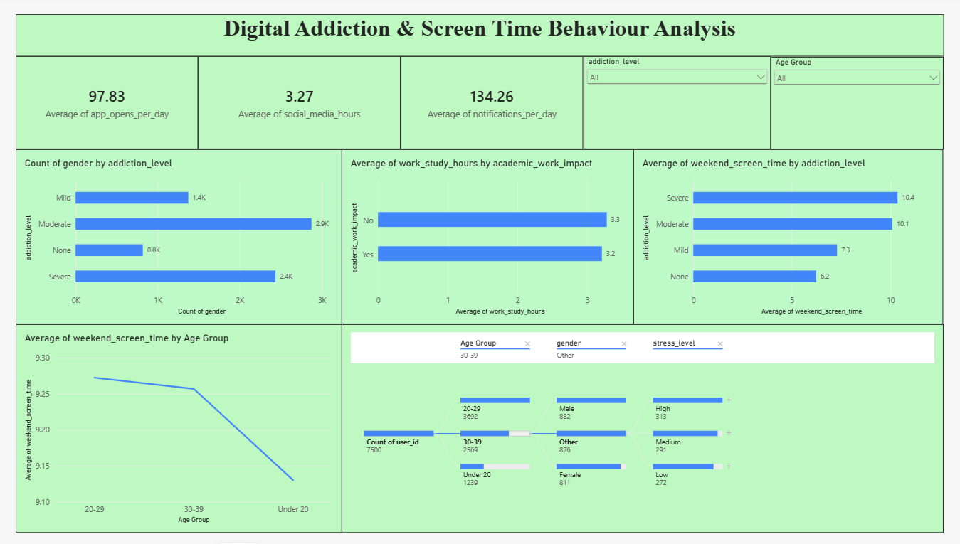

2. Key Findings
- Average social-media usage: 3.27 hours per day.
- Average notifications: 134.26 per day.
- Average gaming time: 2.01 hours per day.
- Average work/study time: 3.24 hours per day.
- Average user age: 26.57 years.
- Average app openings: 97.83 per day

3. Addiction Level
The number of users by addiction level is:
- Moderate: 2.9K
- Severe: 2.4K
- Mild: 1.4K
- None: 0.8K
Moderate addiction has the highest number of users.
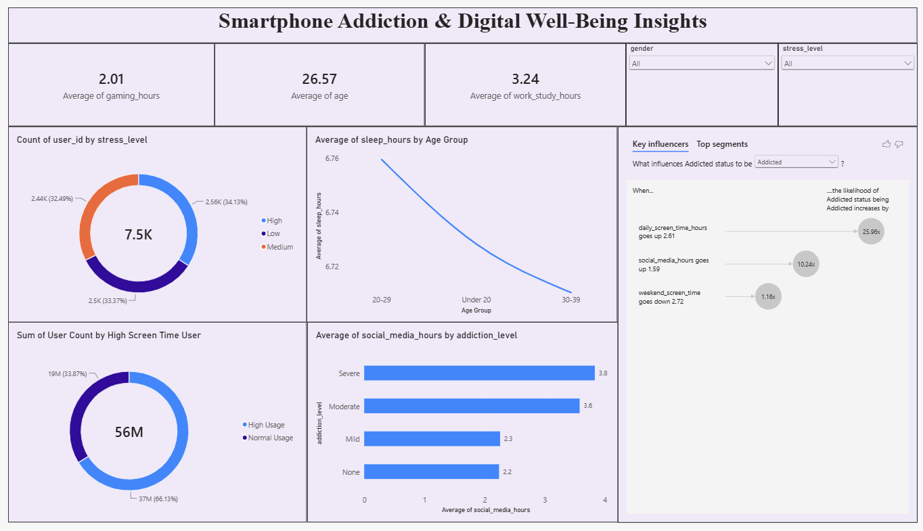

4. Screen Time
Weekend screen time is:
- Severe: 10.4 hours
- Moderate: 10.1 hours
- Mild: 7.3 hours
- None: 6.2 hours
This shows that users with higher addiction levels spend more time on screens during weekends.

5. Social Media Usage
Average social-media usage is:
- Severe: 3.8 hours
- Moderate: 3.6 hours
- Mild: 2.3 hours
- None: 2.2 hours
Higher addiction levels are associated with higher social-media usage in this dataset.

6. Age Group
The number of users in each age group is:
- 20–29: 3,692
- 30–39: 2,569
- Under 20: 1,239
The 20–29 age group has the most users.

7. Stress and Sleep
Stress levels are fairly balanced:
- High: 34.13%
- Low: 33.37%
- Medium: 32.49%
Average sleep is around 6.7 hours across the age groups shown.

8. Key Influencers
The Power BI analysis identifies three important factors associated with addicted status:
- Daily screen time above 2.61 hours
- Social-media usage above 1.59 hours
- Weekend screen time above 2.72 hours

