Library Management System

Project Report

Dated: 18-06-2014

Abstract

The project titled Library Management System is Library management software for monitoring and controlling the transactions in a library .The project “**Library Management System”** is developed in java, which mainly focuses on basic operations in a library like adding new member, new books, and updating new information, searching books based on book title, author and subject, searching members based on name and ID, recording issue dates and return dates of the issued books to members and also combing out the books that are unwanted and that are torn out .

Development Platform

**Front End**:Java

**Back End**: MS Access

Developers

1. M.PUJITHA RAJ
2. S.VAISHNAVI

Problem Definition

In our existing system all the transaction of books are done manually, So taking more time for a transaction like borrowing a book or returning a book and also for searching of members and books. Another major disadvantage is that to preparing the list of books borrowed and the available books in the library will take more time, currently it is doing as a one day process for verifying all records. So after conducting the feasibility study we felt that the Library management system would be better if it is computerized.

Solution Specification

Proposed system is an automated Library Management System. Through our software admin can add members, remove members, add books, and remove books, search members, search books, update information, edit information, issue and return books in quick time. Our proposed system has the following advantages.

* User friendly interface
* Fast access to database
* Less error
* More Storage Capacity
* Search facility
* Look and Feel Environment

All the manual difficulties in managing the Library have been rectified by implementing computerization.

Hardware Requirements

Processor : Pentium III 630MHz

RAM : 128 MB

Hard Disk : 20GB

Monitor : 15” Color monitor

Key Board : 122 Keys

Software Requirements

Operating System : Windows NT,

Windows 98,

Windows XP.

Language : Java

Development Tool : NetBeans IDE 7.3.1

Database : MS Access2010.

**Software Interface**

Login Page

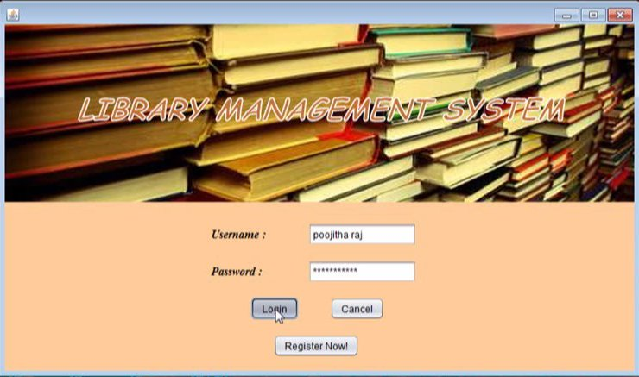

Admin Page

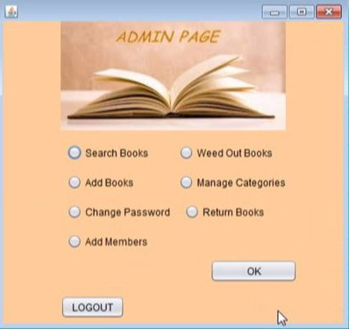

Search a Book

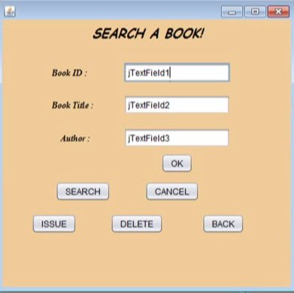

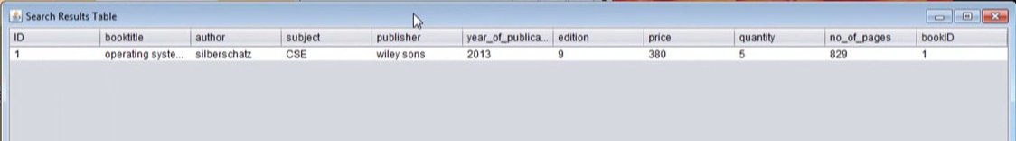

Add New Book

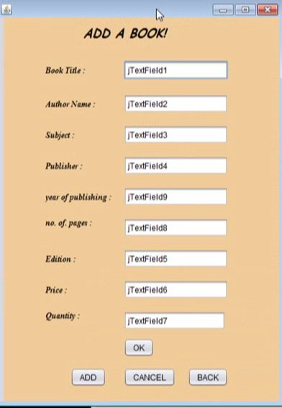

Remove a Book

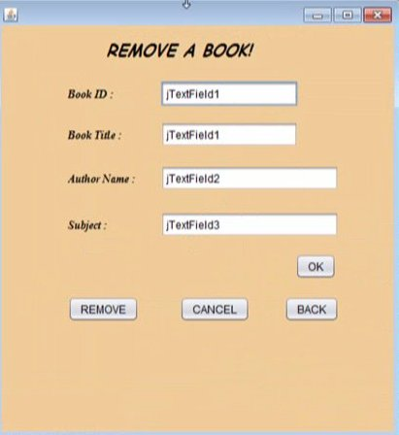

Issue the Book

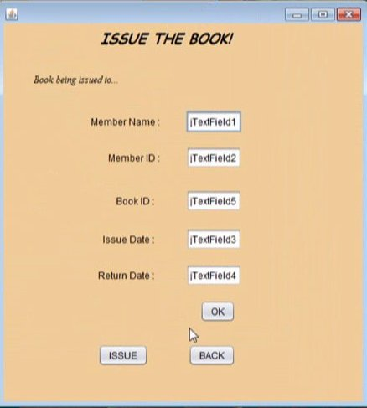

Return The Book

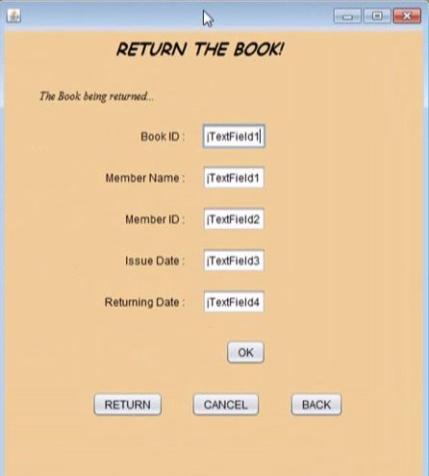

Listing All the Books

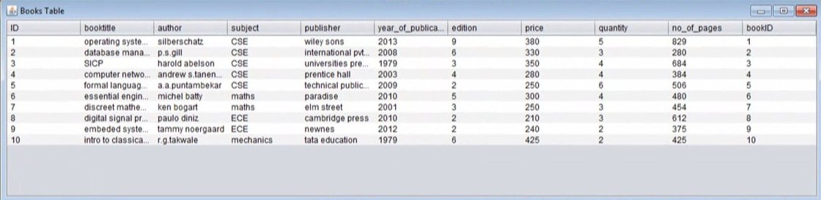

Listing All the Members

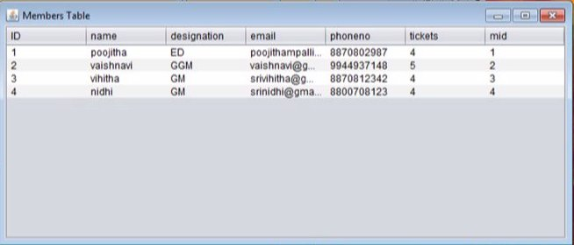

Database Design

The general theme behind a database is to handle information as an integrated whole. A database is a collection of interrelated data stored with minimum redundancy to serve many users quickly and effectively. After designing input and output, the analyst must concentrate on database design or how data should be organized around user requirements. The general objective is to make information access, easy quick and flexible for other users. During database design the following objectives are concerned:-

* Controlled Redundancy
* Data independence
* Accurate and integration
* Recovery from failure
* Privacy and security
* Performance
* Ease of learning and use

Tables Used

1. Books

|  |  |  |
| --- | --- | --- |
| **Field Name** | **Data Type** | **Description** |
| Id | AutoNumber | Primary Key |
| Subject | Text (30) | - |
| Title | Text (30) | - |
| Author | Text (25) | - |
| Publisher | Text (25) | - |
| Year | Number |  |
| Edition | Number | - |
| No_of_Pages | Number | - |
| Price | Number | - |
| Quantity | Number | - |

1. Members

|  |  |  |
| --- | --- | --- |
| **Field Name** | **Data Type** | **Description** |
| ID | AutoNumber | Primary Key |
| NAME | Text(25) | - |
| Designation | Text(5) | - |
| E-Mail | Text(25) | - |
| Phone No. | Number | - |
| Tickets | Number | - |

1. Admin

|  |  |  |
| --- | --- | --- |
| **Field Name** | **Data Type** | **Description** |
| ID | AutoNumber | Primary Key |
| Name | Text(25) | - |
| Password | Text(5) | - |
| E-Mail | Text(25) | - |
| Phone No. | Number | - |

Conclusion

Our project is only a humble venture to satisfy the needs in a library. Several user friendly coding have also adopted. This package shall prove to be a powerful package in satisfying all the requirements of the organization.

References

1. http://www.java2s.com/
2. http://www.javaworld.com/javaworld/jw-01-1998/jw-01-bookreview.html
3. Java 2-The complete reference by Herbert Scheldt
4. Database system concepts 6th edition by Silberschatz
5. http://java.sun.com/javase/technologies/desktop/