Test1 & Test2 of Infy tech test:

The code base for docker files and jenkins files and javascript files can be found under
Git repo: https://github.com/pujithaz/infytest.git

Here are the high level steps involved:
Clone the source code from git:

git clone https://github.com/pujithaz/infytest.git

From code base build multi stage docker image:

docker build -t infytest .

Run the docker image to standup Jenkins CI/CD server exposing the UI on port 49001

docker run -d -p 49001:8080 -p 3000:3000 --name jenkins -t infytest

Jenkins can now be accessed at http://localhost:49001

Get the admin password using docker exec as below:
docker exec jenkins cat /var/jenkins_home/secrets/initialAdminPassword
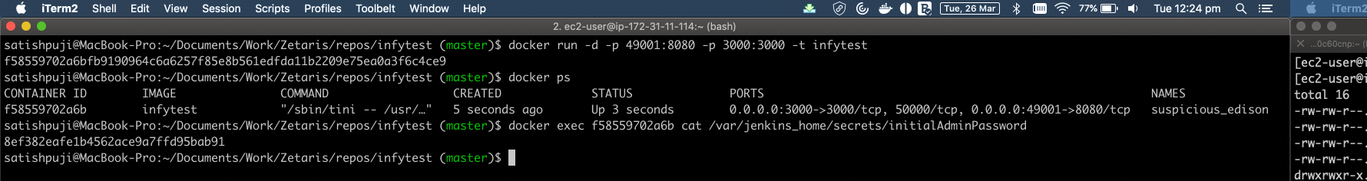
Install the default plugins and setup the admin user/password
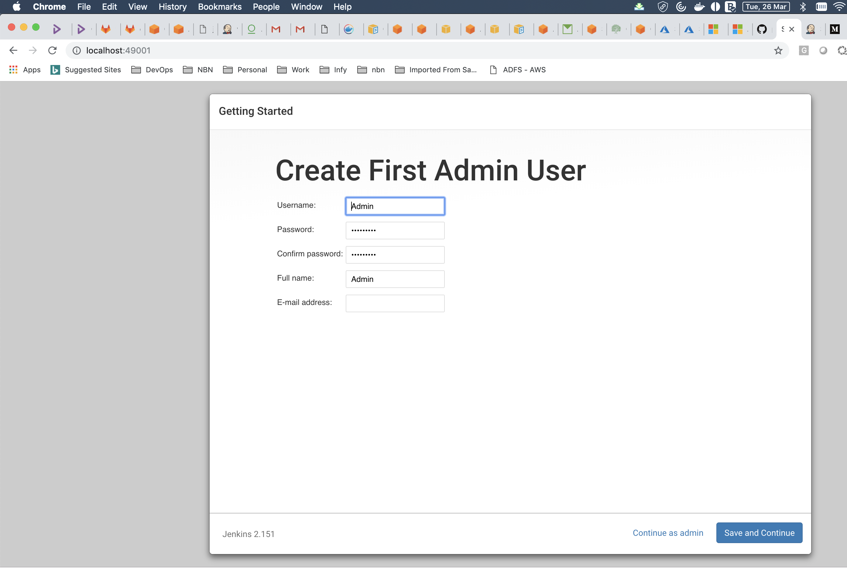

Create a jenkins pipeline job:
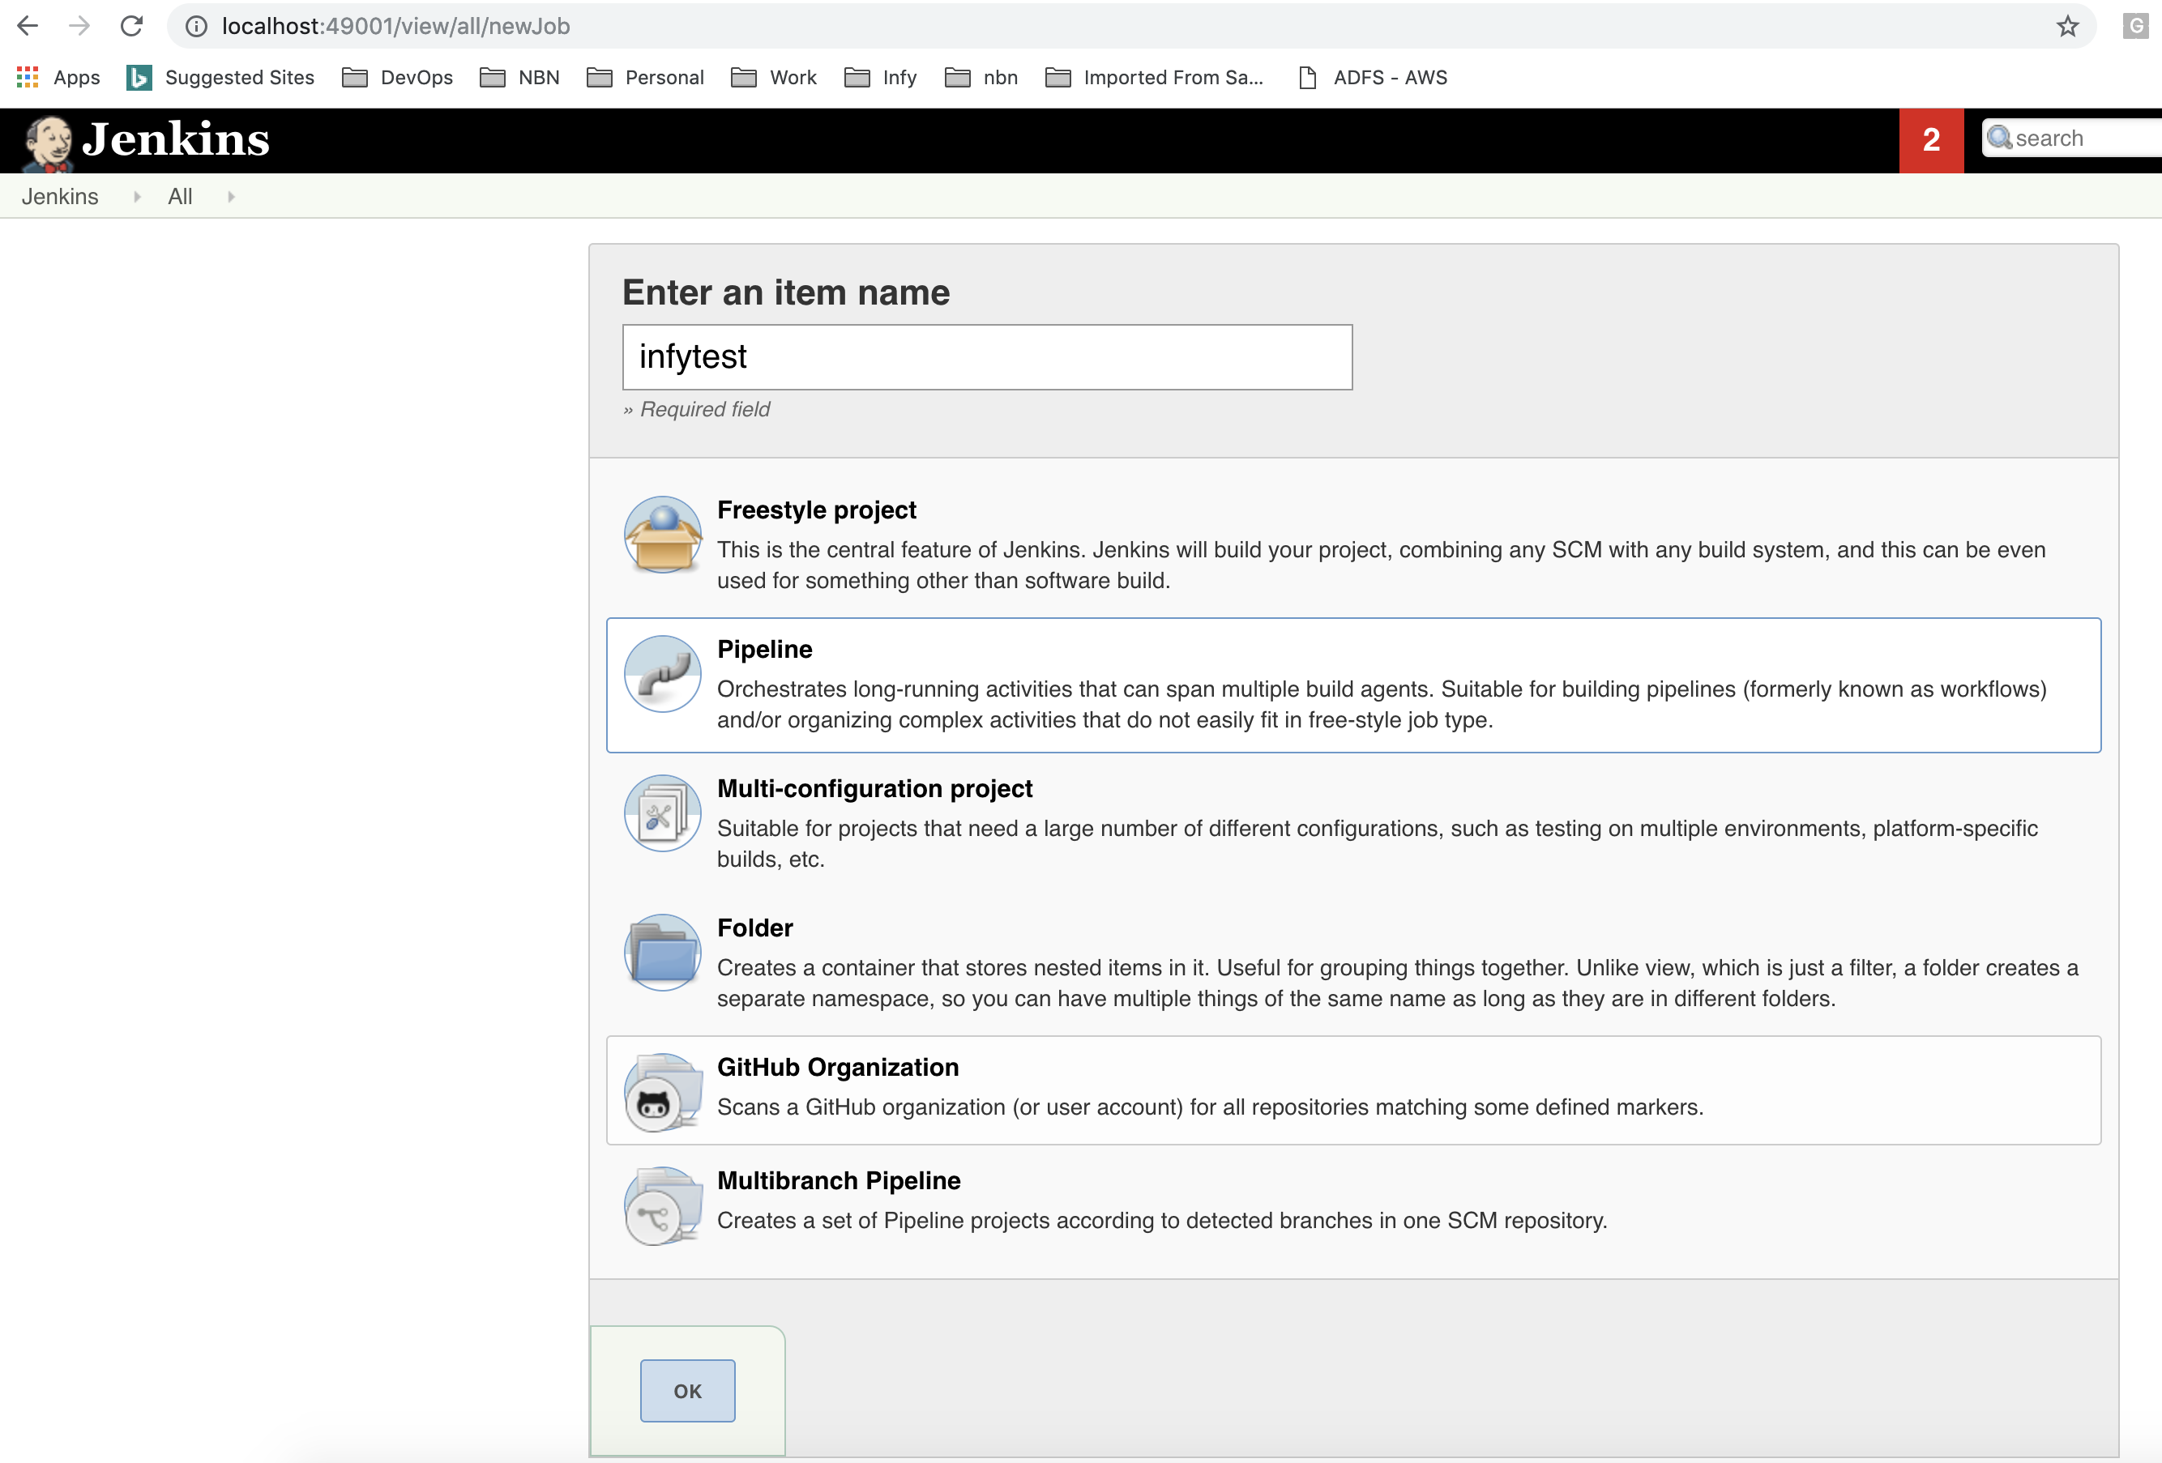
Configure the job as below:
Under Build Triggers section configure jenkins to poll SCM every minute in order to scan for changes and trigger the build in case of new changes.
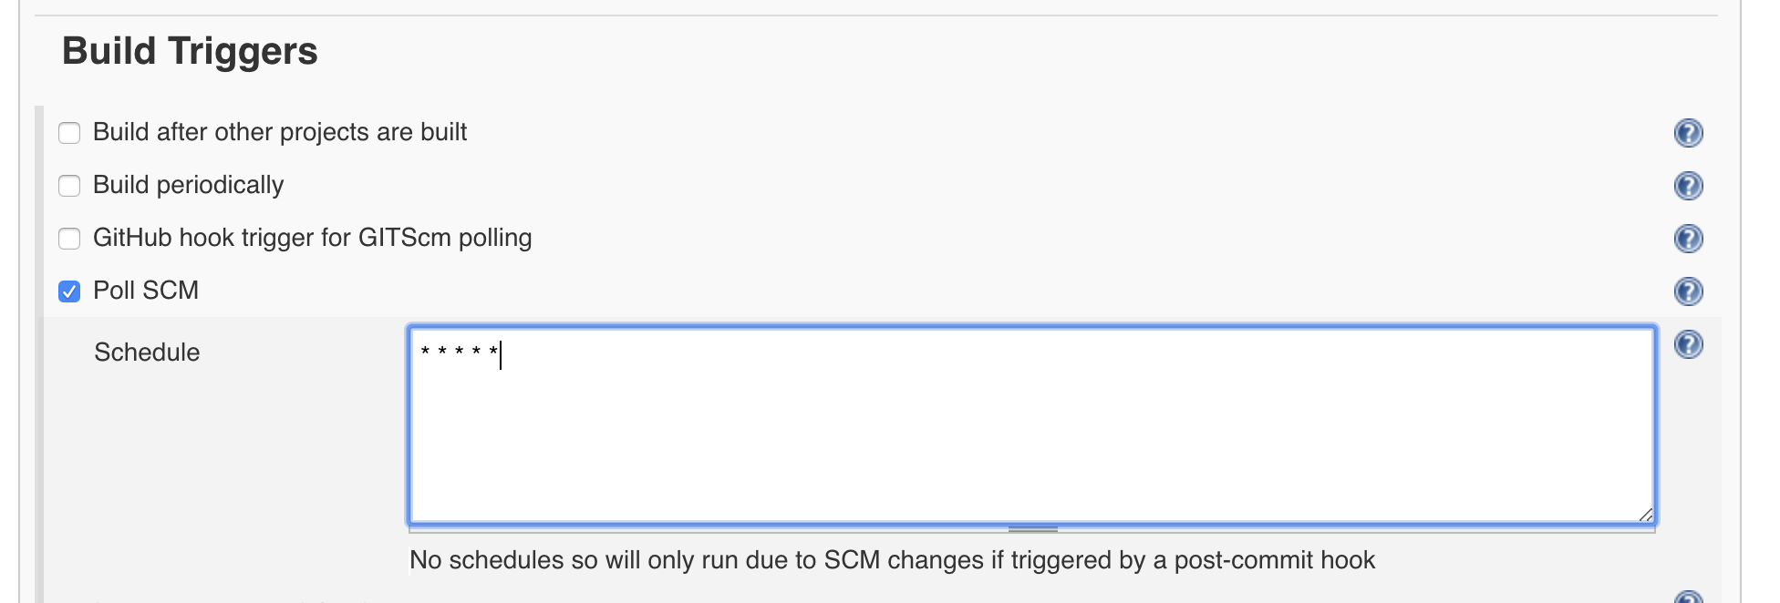
Under pipeline section select Definition to be 'Pipeline script from SCM' and provide the git repo details. Leave the rest of the settings to default.
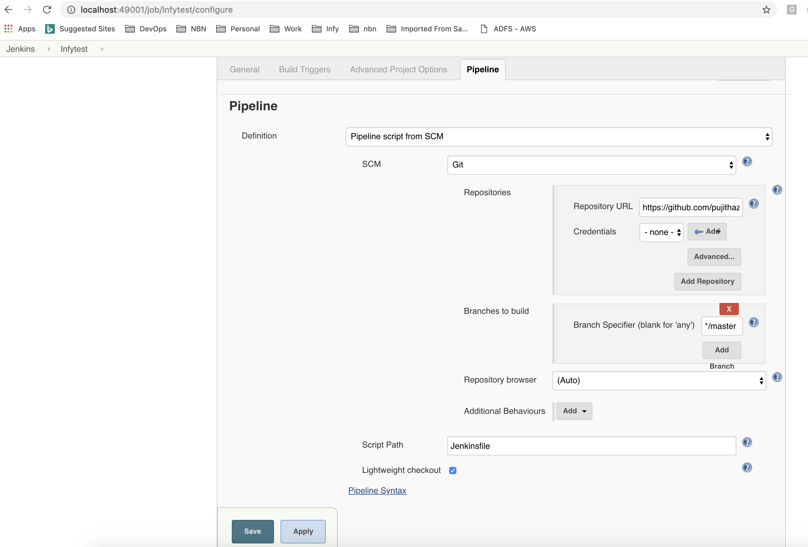

Once saved, the pipeline should automatically get triggered when a commit is made to git repo as below.
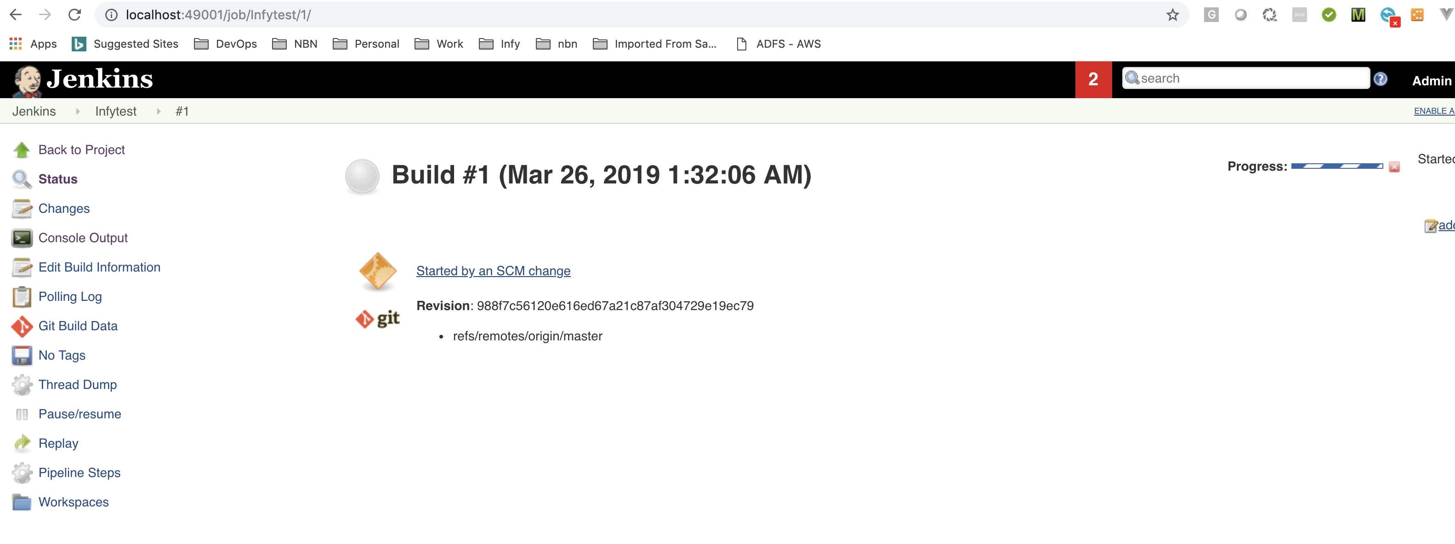
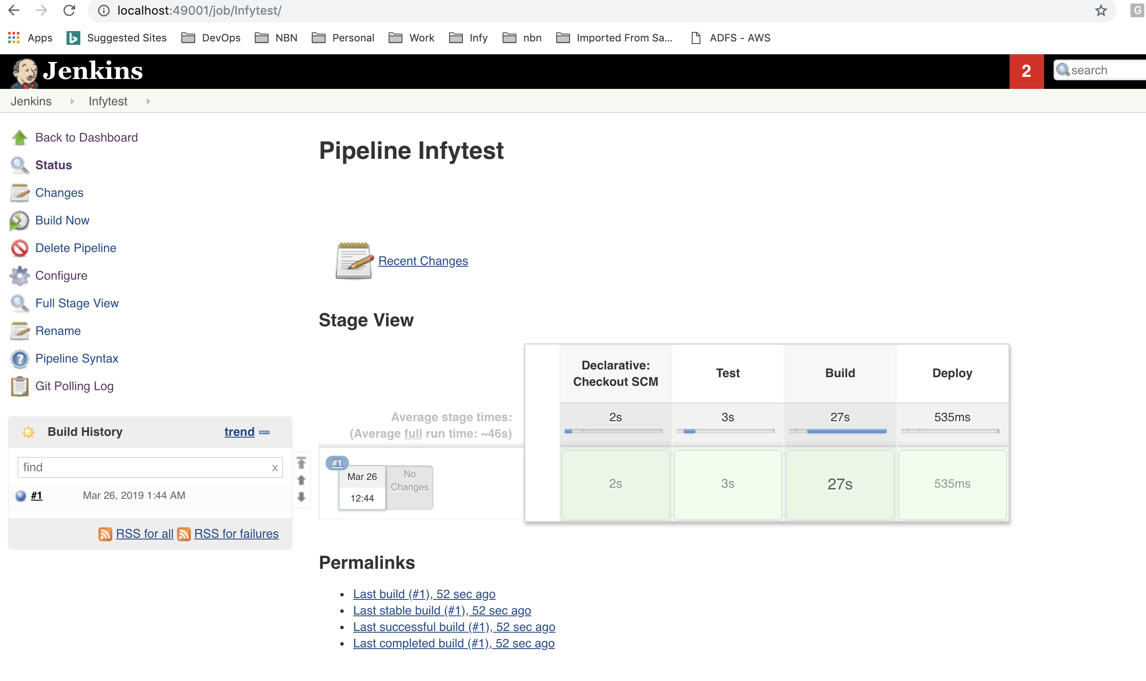
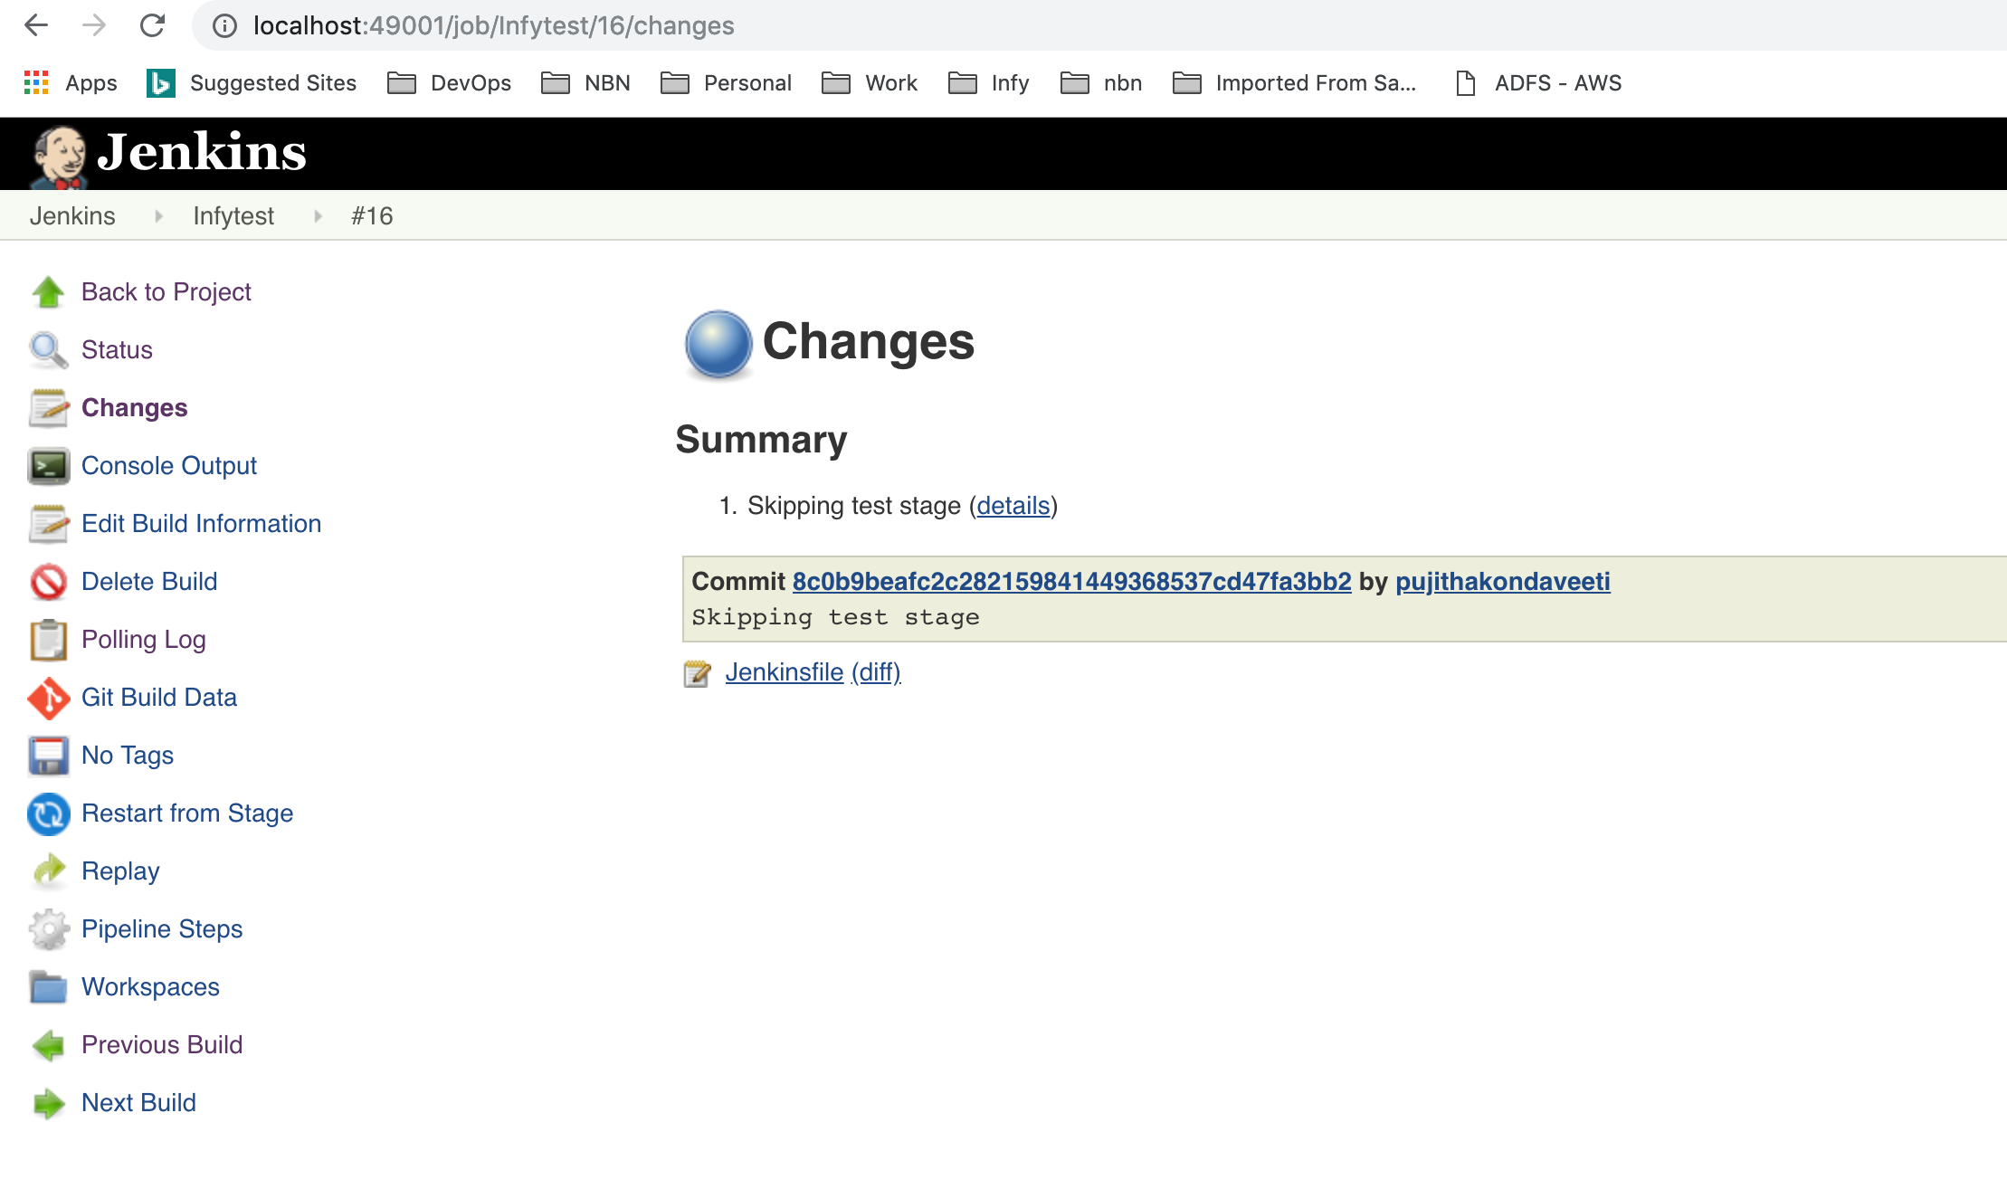
Test results can be found under job details page:
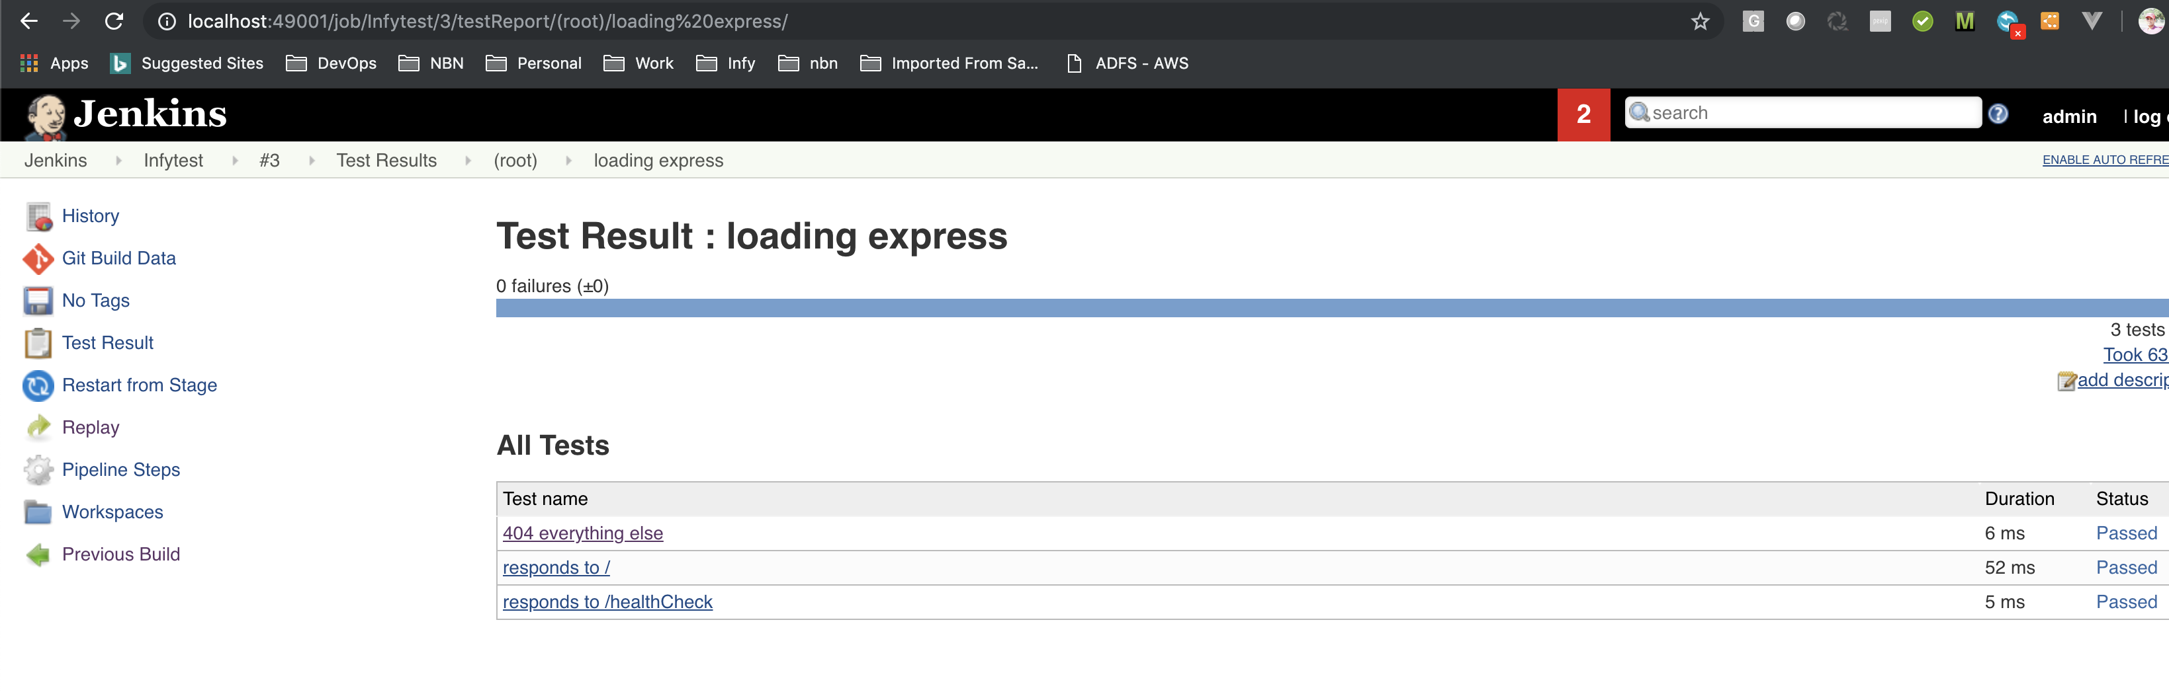

Once the pipeline execution is finished, the healthcheck app can be accessed at http://localhost:3000/healthcheck as shown below

