1. History by vendor transaction report.

* It provide voucher wise detail for vendor and depend upon filtering.
* Click on below link for detail analysis of this report.
* <https://technet.microsoft.com/en-us/library/aa598048.aspx>.
* Snap shot for understanding purpose.

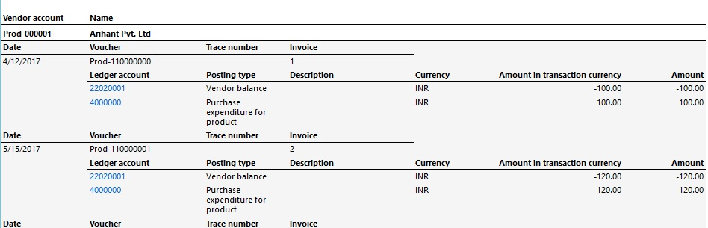

1. Invoice journal report

* It provides detail about each invoice of vendor i.e. how much tax calculated on invoice and discount and all I short line detail.
* Click on below link for detail analysis of this report.
* <https://technet.microsoft.com/en-us/library/aa585532.aspx>.
* Snap shot for understanding purpose.

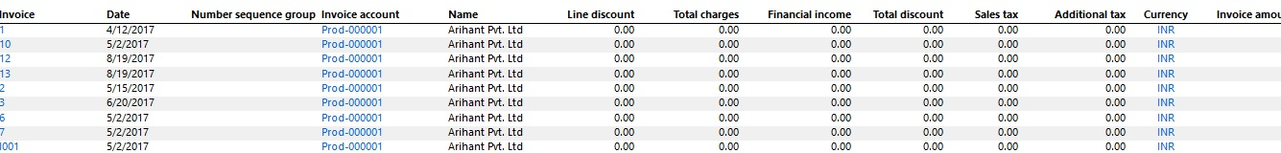

1. Invoice specification report

* This report is same as above on additional part it provide whole detail about invoice for particular vendor.
* Click on below link for detail analysis of this report.
* <https://technet.microsoft.com/en-us/library/aa558598.aspx>.
* Snap shot for understanding purpose.

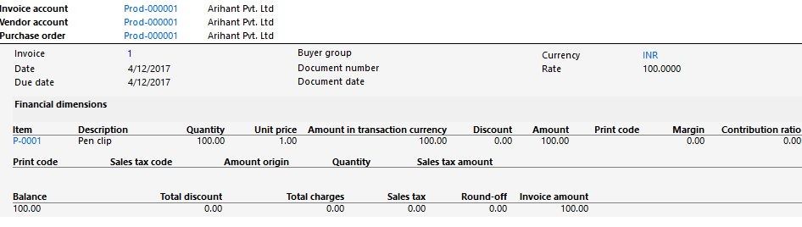

1. Invoice turnover report.

* It shows how much company purchased from particular person.
* Click on below link for detail analysis of this report.
* <https://technet.microsoft.com/en-us/library/aa556369.aspx>.
* Snap shot for understanding purpose.

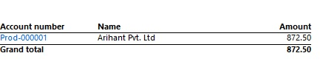

1. Invoices not approved report

* It shows UN approved invoices that have been made. This report only useful when company follows workflow.
* Click on below link for detail analysis of this report.
* <https://technet.microsoft.com/en-us/library/hh538441.aspx>.
* Snapshot is not available.

1. Vendor balance list report.

* It shows transaction of particular vendor like DR/CR and its closing balance.
* Click on below link for detail analysis of this report.
* <https://technet.microsoft.com/en-us/library/aa596500.aspx>.
* Snap shot for understanding purpose.



1. Vendor balance list with credit limit report.

* It shows vendor balance with credit limit allow to him with difference.
* Click on below link for detail analysis of this report.
* <https://technet.microsoft.com/en-us/library/aa589252.aspx>
* Snap shot for understanding purpose.

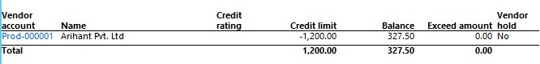

1. Vendor base data report

* Use the Vendor base data report to print information about a vendor or a group of vendors.
* Click on below link for detail analysis of this report.
* <https://technet.microsoft.com/en-us/library/aa599417.aspx>.
* No need of snapshot.

1. Vendor currency conversion reconciliation report

* It shows reconciliation between ledger account and vendor account i.e. when on group have more than one vendor account and that ledger contain only one ledger this report helps in that situation.
* Click on below link for detail analysis of this report.
* <https://technet.microsoft.com/en-us/library/aa615501.aspx>.
* Snap shot for understanding purpose.

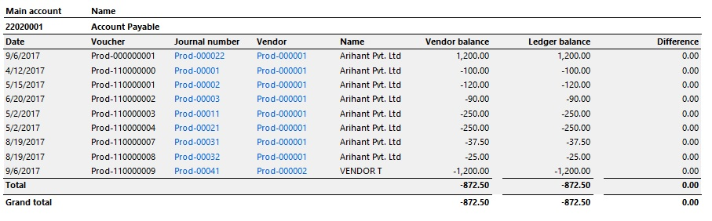

1. Vendor internal account statement report.

* You can call it as “VENDOR LEDGER ACCOUNT”. This is most important Report for client.
* Click on below link for detail analysis of this report.
* <https://technet.microsoft.com/en-us/library/bb220729.aspx>.
* Snap shot for understanding purpose.

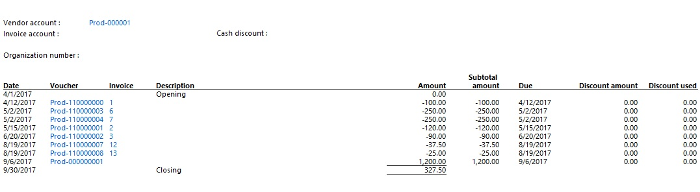

1. Vendor phone list report

* It shows phone number list of all vendor.
* Click on below link for detail analysis of this report.
* <https://technet.microsoft.com/en-us/library/aa572512.aspx>.
* No need of snapshot.

1. Vendor transactions report.

* You may call it as vendor ledger same as 10 number report with some difference.
* Click on below link for detail analysis of this report.
* <https://technet.microsoft.com/en-us/library/aa553670.aspx>.
* Snap shot for understanding purpose.

