1. Customer account statement report.

* You may call same report as customer ledger very important for client prospective view.
* Click on below link for detail analysis of this report.
* <https://technet.microsoft.com/en-us/library/aa615057.aspx>.
* Snap shot for understanding purpose.

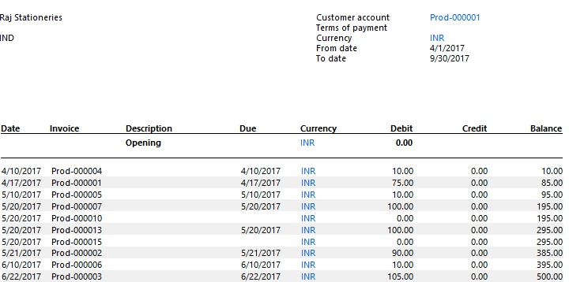

1. Customer aging report.

* It shows amount due from customer by interval of time.
* Click on below link for detail analysis of this report.
* <https://technet.microsoft.com/en-us/library/aa575855.aspx>.
* Snap shot for understanding purpose.

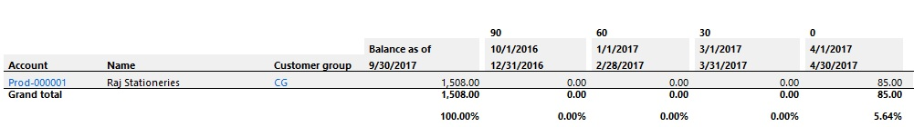

1. Customer auditor report.

* It shows Balance of each customer by posting profile.
* Click on below link for detail analysis of this report.
* <https://technet.microsoft.com/en-us/library/aa586399.aspx>.
* Snap shot for understanding purpose.

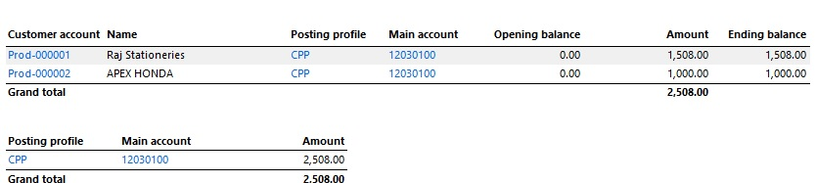

1. Customer balance list report

* It shows DR/CR transaction of Particular customer in selected period and its closing balance.
* Click on below link for detail analysis of this report.
* <https://technet.microsoft.com/en-us/library/aa550100.aspx>.
* Snap shot for understanding purpose.

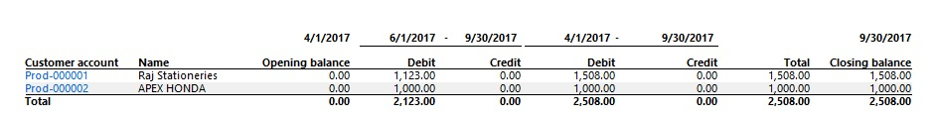

1. Customer balance list with credit limit report.

* It shows credit limit of particular customer with closing balance.
* Click on below link for detail analysis of this report.
* <https://technet.microsoft.com/en-us/library/aa548550.aspx>.
* Snap shot for understanding purpose.

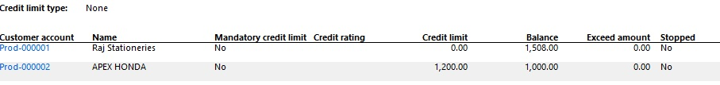

1. Customer base data report.

* Use this report to review the account information about selected customers, such as contact information, credit rating, terms of payment, and so on.
* Click on below link for detail analysis of this report.
* <https://technet.microsoft.com/en-us/library/aa590149.aspx>.
* No need snapshot.

1. Customer currency conversion reconciliation report.

* It provides details regarding customer balance in particular ledger account like if we post two or more customer entries in one ledger than it shows bifurcation of same in customer wise.
* Click on below link for detail analysis of this report.
* <https://technet.microsoft.com/en-us/library/aa620739.aspx>.
* Snap shot for understanding purpose.

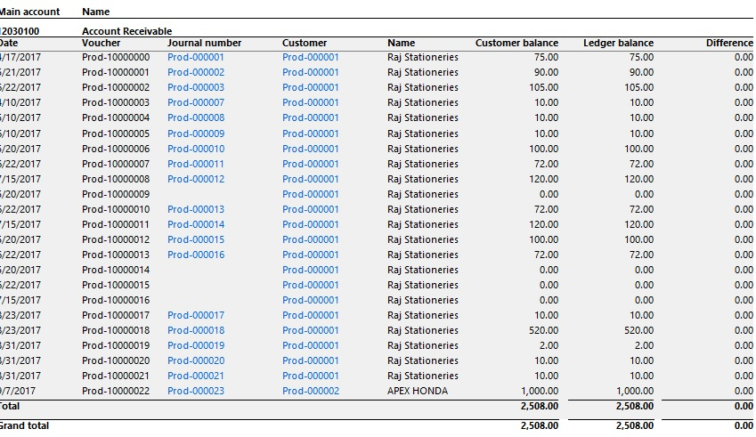

1. Customer invoice journal report.

* It shows invoice wise detail of specific customer and some important detail like line discount and sales tax.
* Click on below link for detail analysis of this report.
* <https://technet.microsoft.com/en-us/library/aa597472.aspx>.
* Snap shot for understanding purpose.

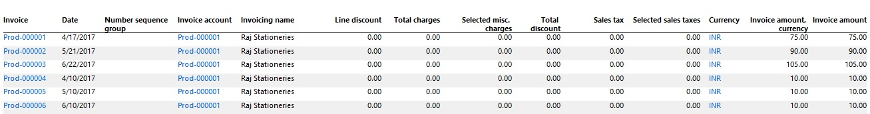

1. Customer invoice transactions report.

* It provides detail about all invoices or can be customer wise if filter with SO number.
* Click on below link for detail analysis of this report.
* <https://technet.microsoft.com/en-us/library/aa634260.aspx>.
* Snap shot for understanding purpose.

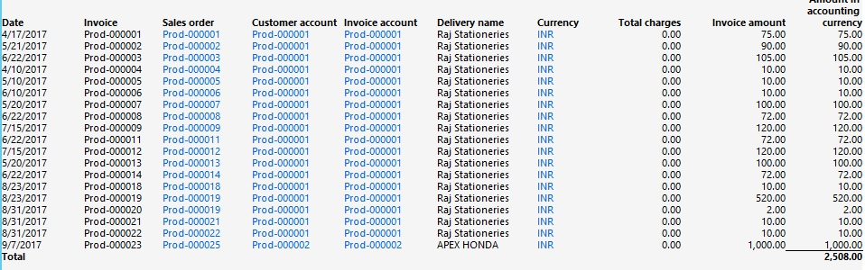

1. Customers report.

* Use this report to print a list of customer accounts. The report also displays contact information, customer group, sales group, currency, terms of payment, and discount information for the customer accounts.
* Click on below link for detail analysis of this report.
* <https://technet.microsoft.com/en-us/library/hh527790.aspx>.
* No need of snap shot.

1. Detailed due day list report

* This report provides detail of customer payment due on particular day.
* Click on below link for detail analysis of this report.
* <https://technet.microsoft.com/en-us/library/aa551818.aspx>.
* Snap shot for understanding purpose.

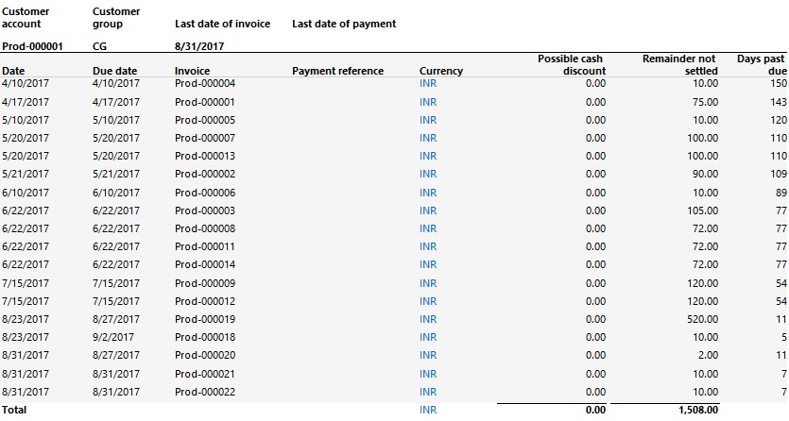

1. History by customer transaction report.

* It shows voucher wise detail of particular customer.
* Click on below link for detail analysis of this report.
* <https://technet.microsoft.com/en-us/library/aa599765.aspx>
* Snap shot for understanding purpose.

.

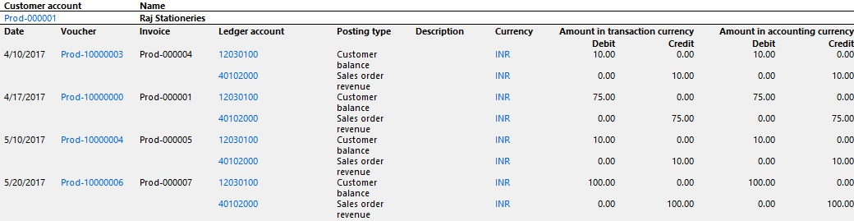

1. Invoice specification report

* This report is same like no 8 report but it shows additional item wise detail.
* Click on below link for detail analysis of this report.
* <https://technet.microsoft.com/en-us/library/aa558453.aspx>.
* Snap shot for understanding purpose.

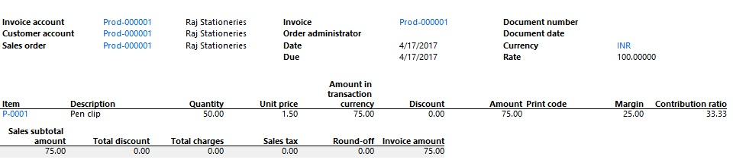

1. Invoice turnover report.

* Provide Detail about sale to particular Customer.
* Click on below link for detail analysis of this report.
* <https://technet.microsoft.com/en-us/library/aa558245.aspx>.
* No need snapshot.

1. Open transactions report

* It provides detail of all invoices of customer which is pending for payment.
* Click on below link for detail analysis of this report.
* <https://technet.microsoft.com/en-us/library/aa618471.aspx>.
* Snap shot for understanding purpose.

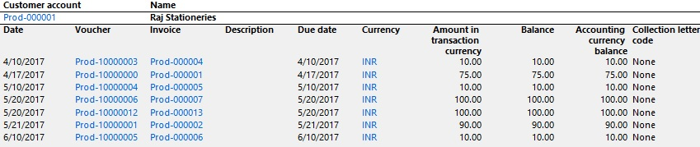

1. Transactions report

* It provides detail of all credit and debit in customer with voucher number. We may call it vendor ledger.
* Click on below link for detail analysis of this report.
* <https://technet.microsoft.com/en-us/library/aa589792.aspx>.
* Snap shot for understanding purpose.

