**How to get products from the "Add Product" button in the Purchase Requisition form**

**Step 1:** Create product and release it.

**Step 2:** Create Category hierarchies

Open the form from the below navigation.

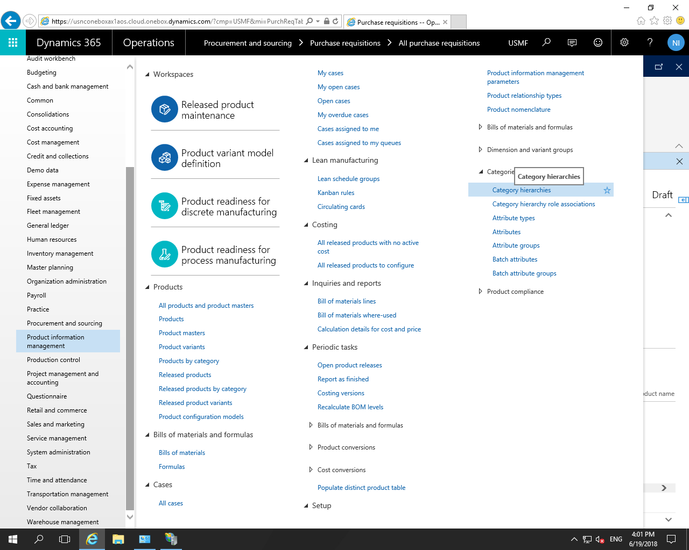

Click on the “New” button ,the below form will be displayed.

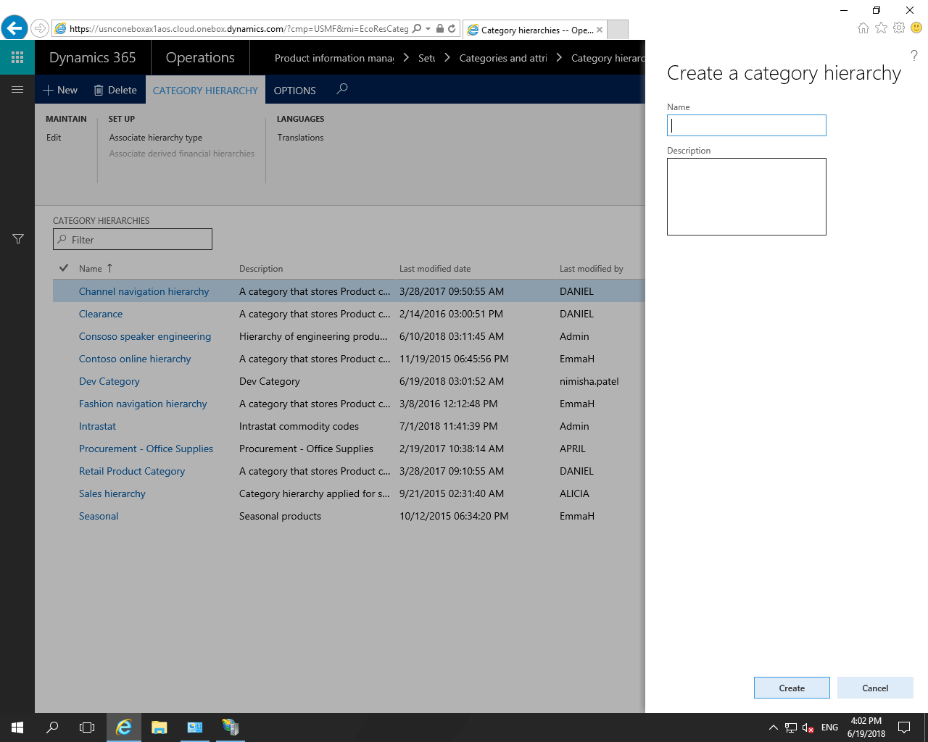

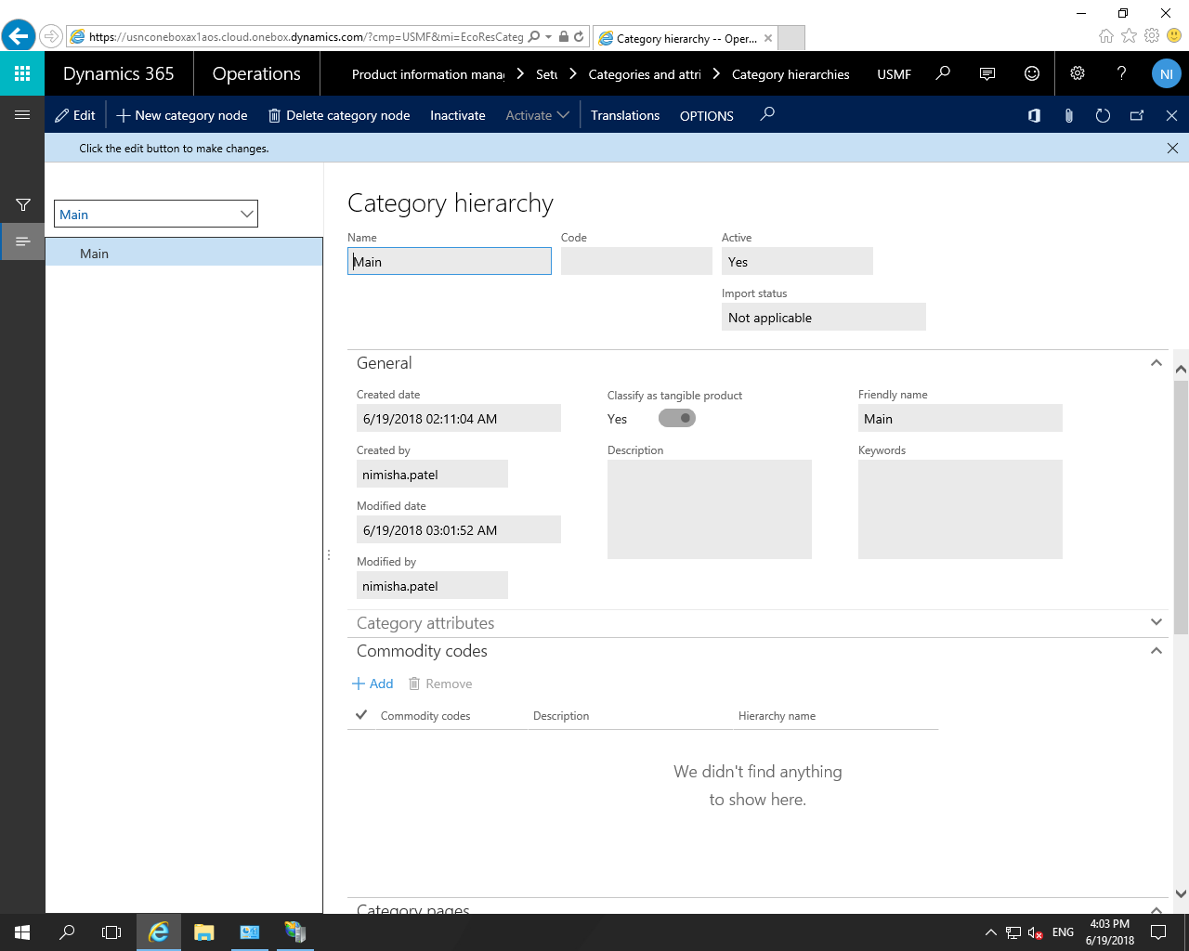

Then go to the “Categories hierarchy role associations form and set the new created category as a “Procurement category hierarchy.

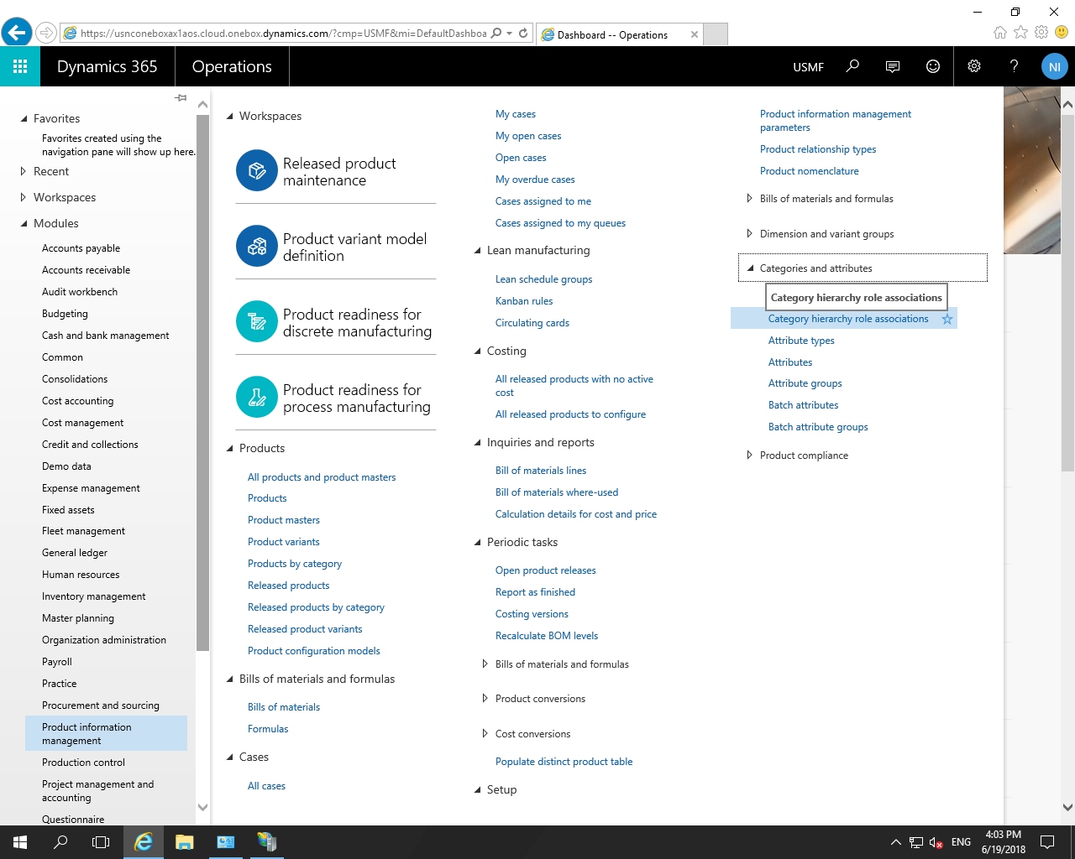

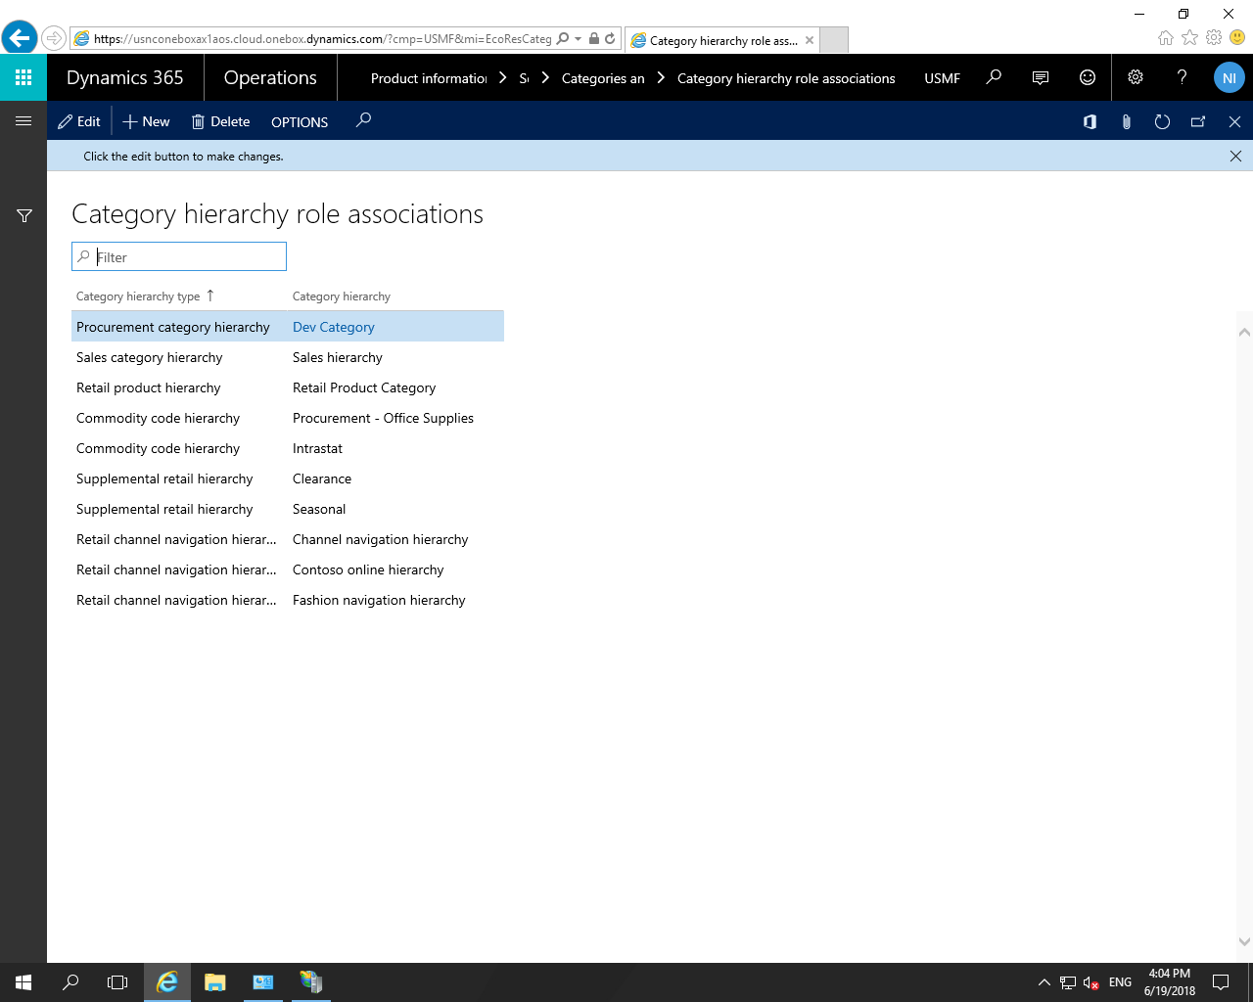

**Step 3:** open the procurement categories form.

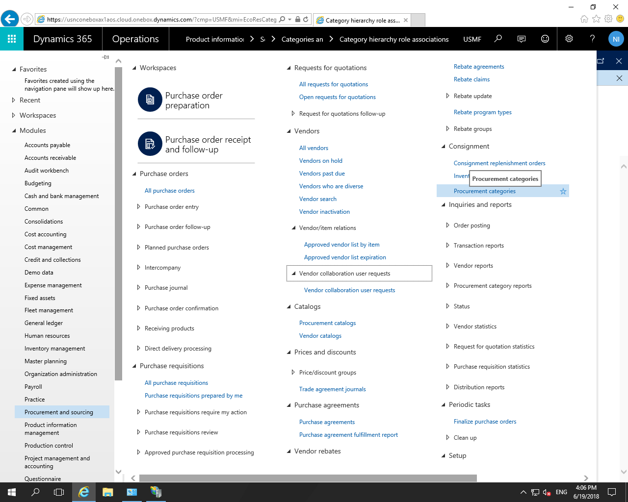

Add products and add vendor in the form as below.

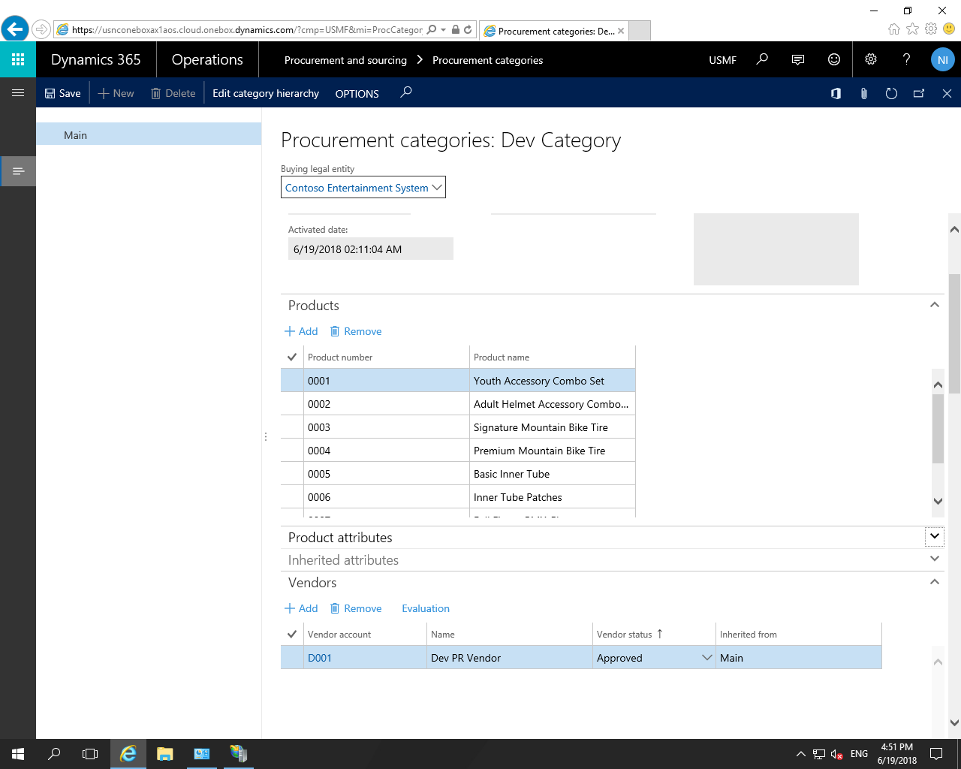

**Step 4:** Now add the newly created category in the procurement catalogs form. Go to Procurement and sourcing > Catalogs > Procurement catalogs as below.

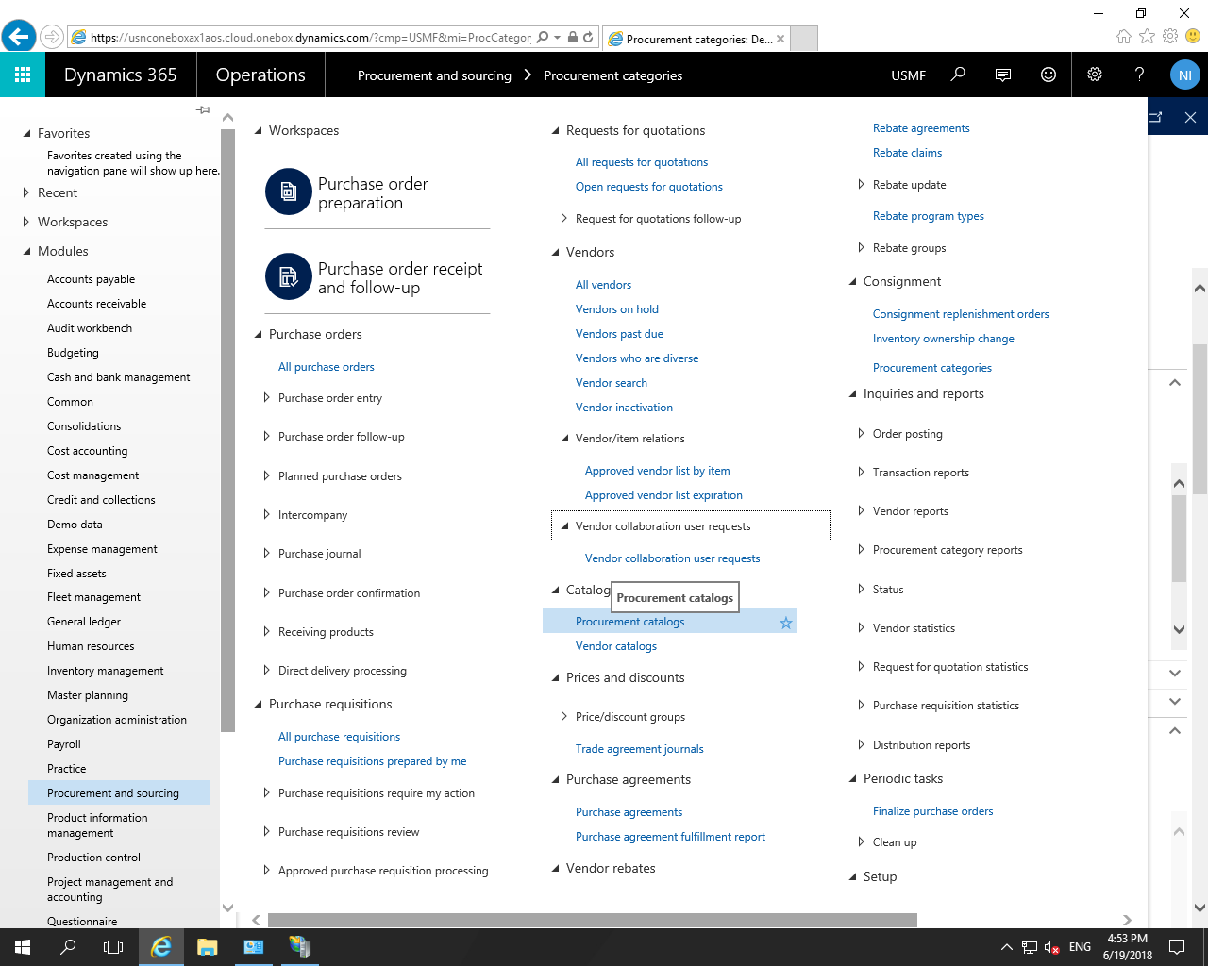

Create the new catalog as “PR Catalog” and click on the OK button.

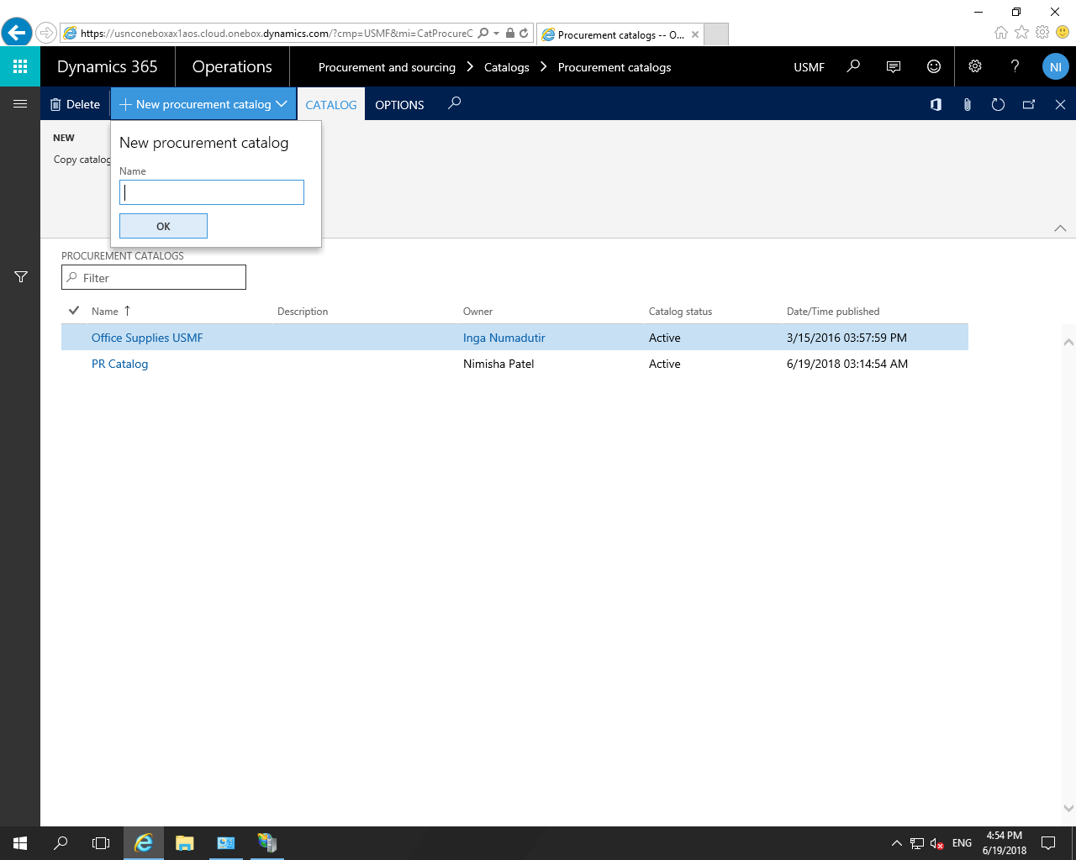

You can see the procurement category name under the “PR Category” in the left side and The products from the procurement category are displayed in the list in the grid.

Default update type : If the update type is set to Dynamic, changes are visible immediately. If the update type is Static, new products are only visible to people using the catalog after the catalog has been re-published.

Then Active the catalog by clicking in the “Active Catalogs” button, then publish it using the “Publish catalogs button.

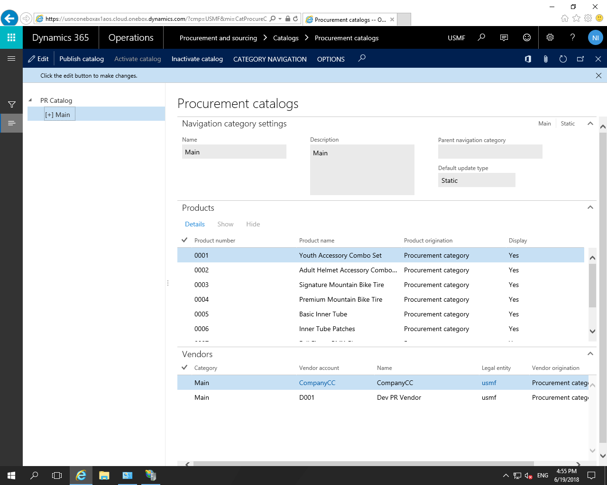

**Note**: If you want to add/delete products then go to procurement categories form, add or delete the products in it then you must have to publish it. For that you have to go “Product Catalogs” form and publish it.

**Step 5:** Go to Procurement and sourcing > Setup > Policies > Purchasing policies

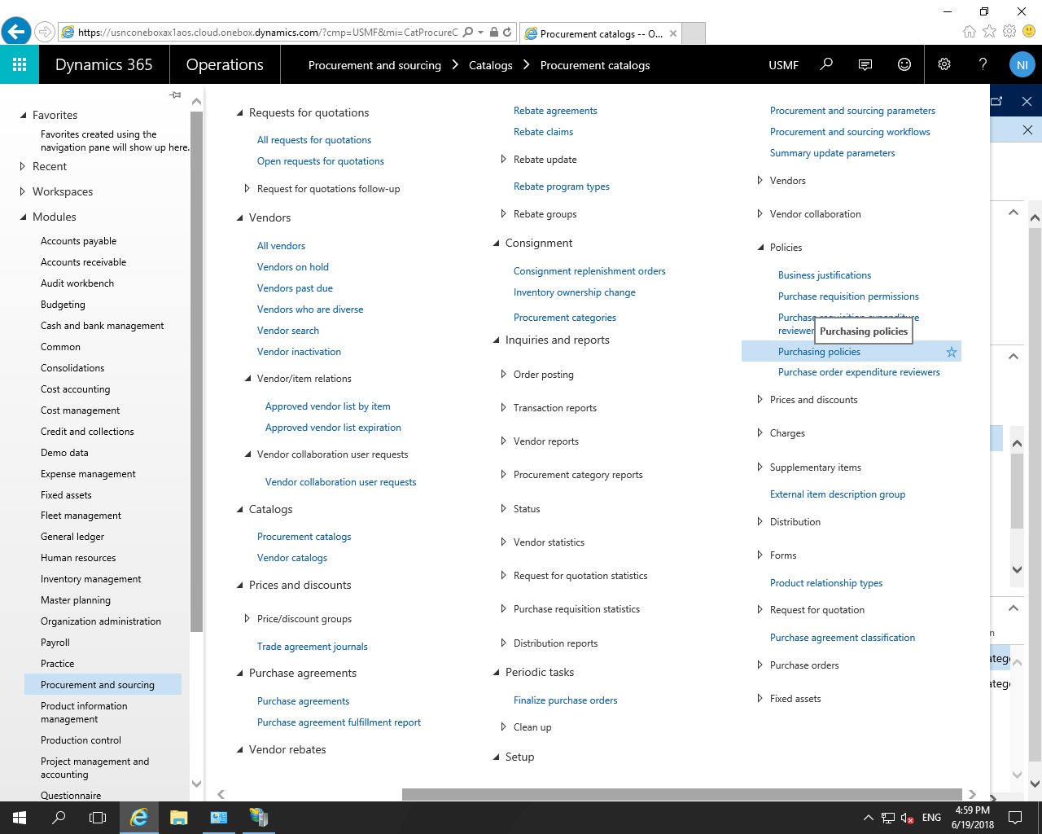

Select Procurement Policy USMF.

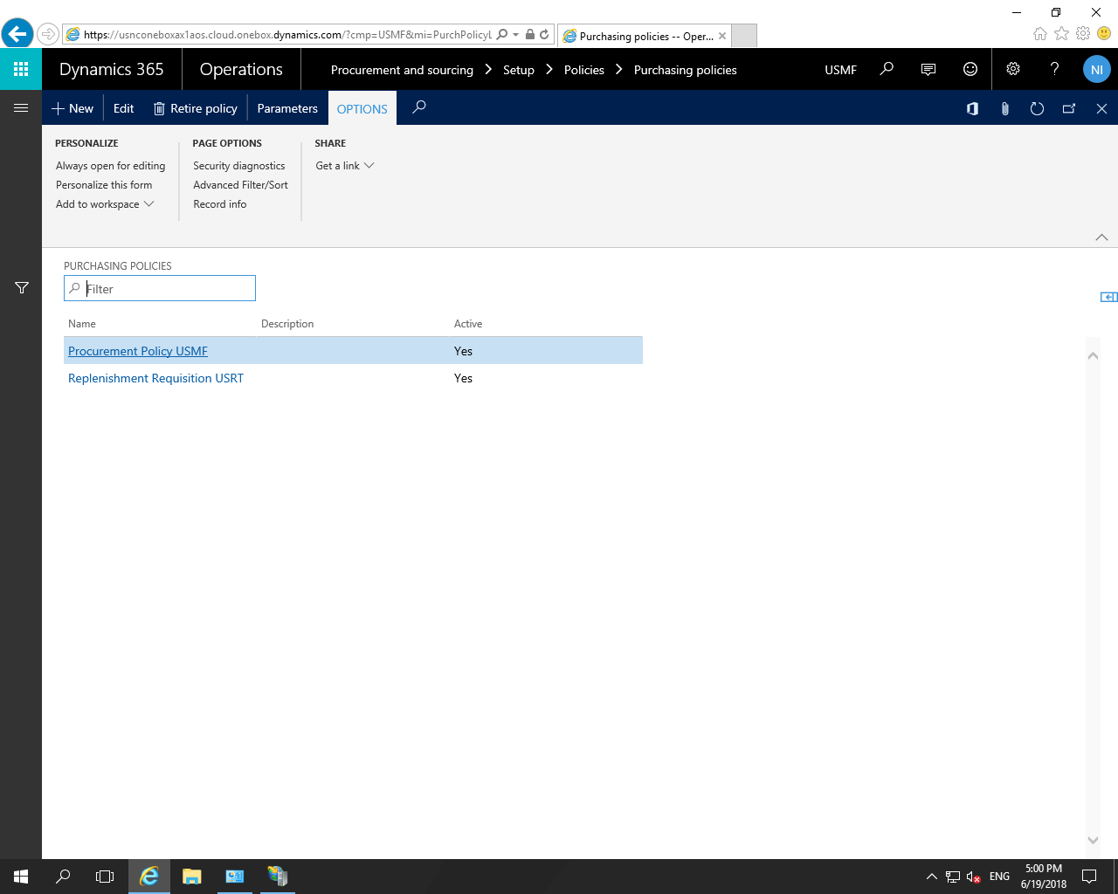

By default entity is selected in the “Selected Organizations” which you are in it.

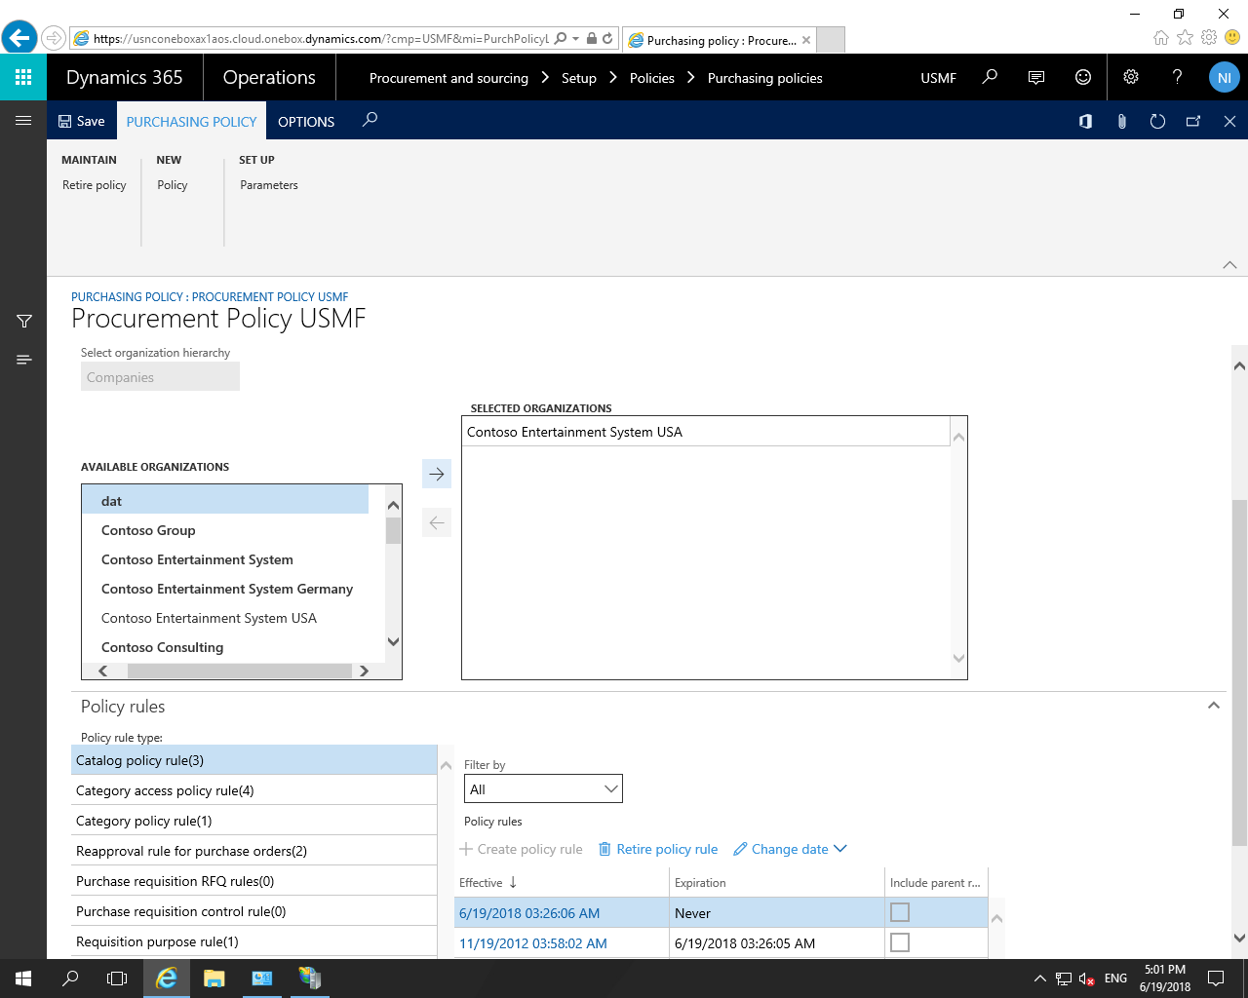

Now select the “Catalog policy rule” in the Policy rules. Click in the effective date field which has expiration date as “Never”.

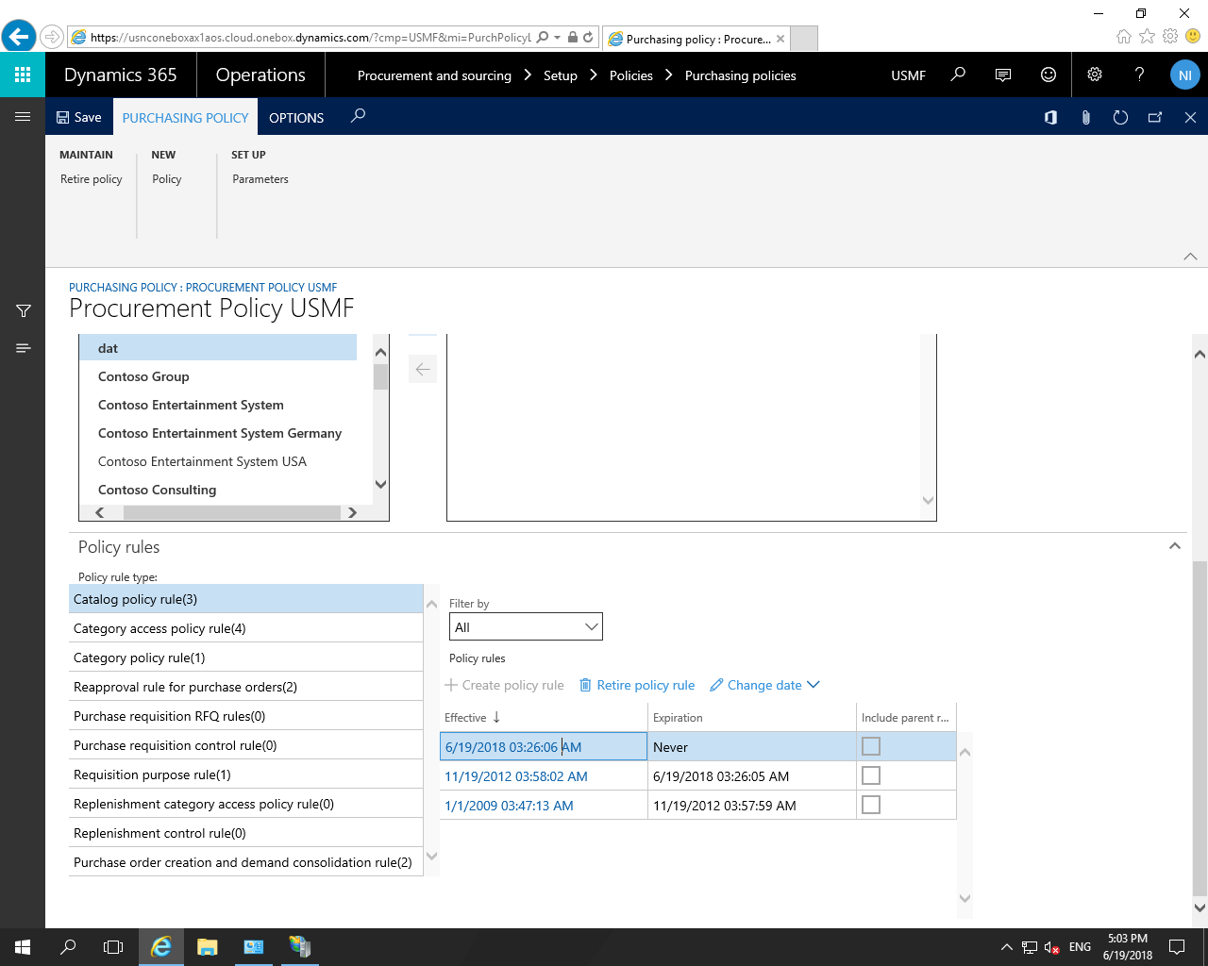

You can see the list of catalog in the catalog drop down, select the catalog which you want to see.

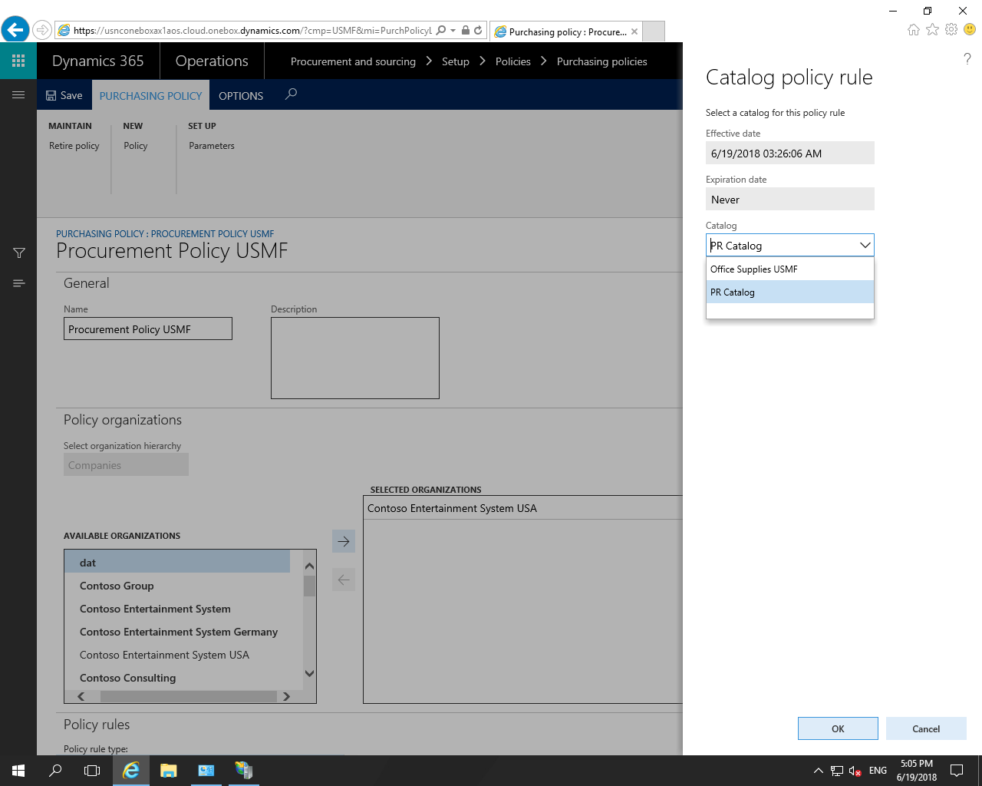

Now select “Catalog access policy rule” as per below screen shot:

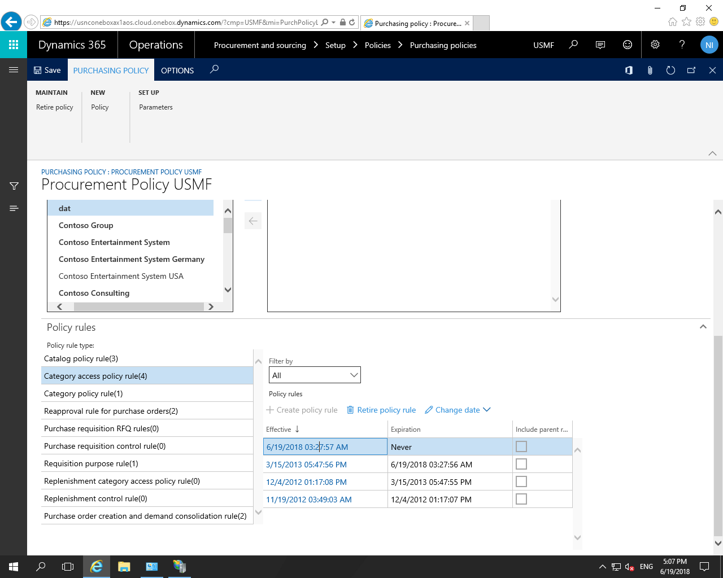

Add the newly created catalog in the “Selected categories” as per below screen shot and click on the “OK” button.

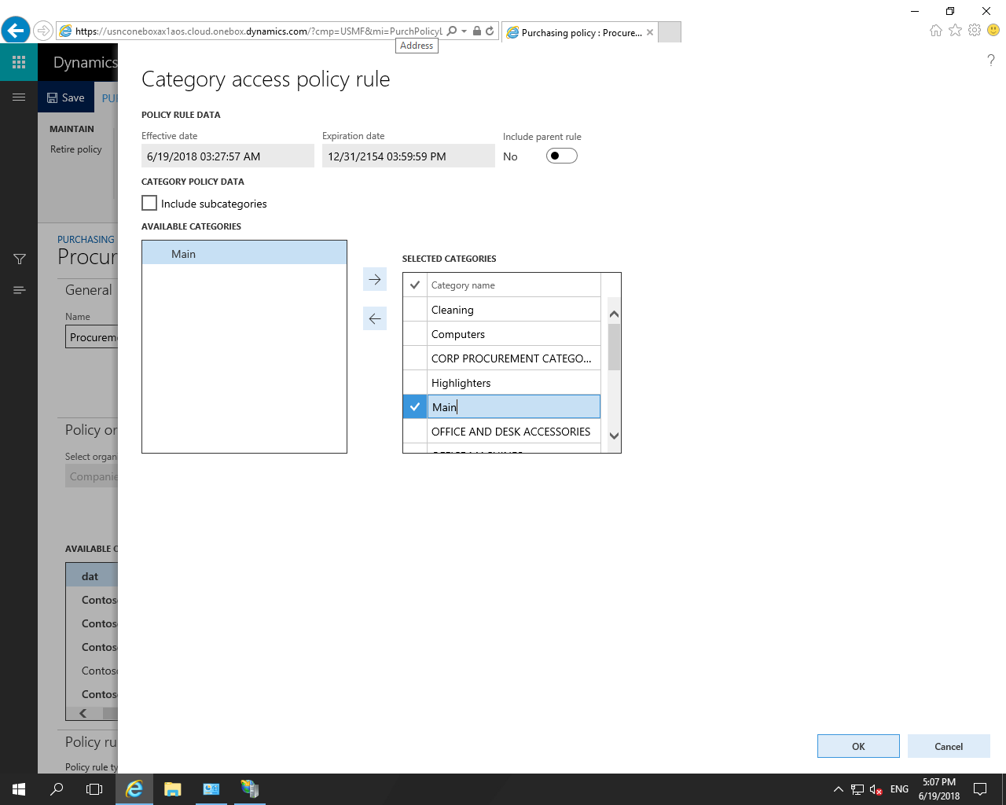

**Step 6 :** now Go to Procurement and sourcing > Purchase requisitions > All purchase requisitions

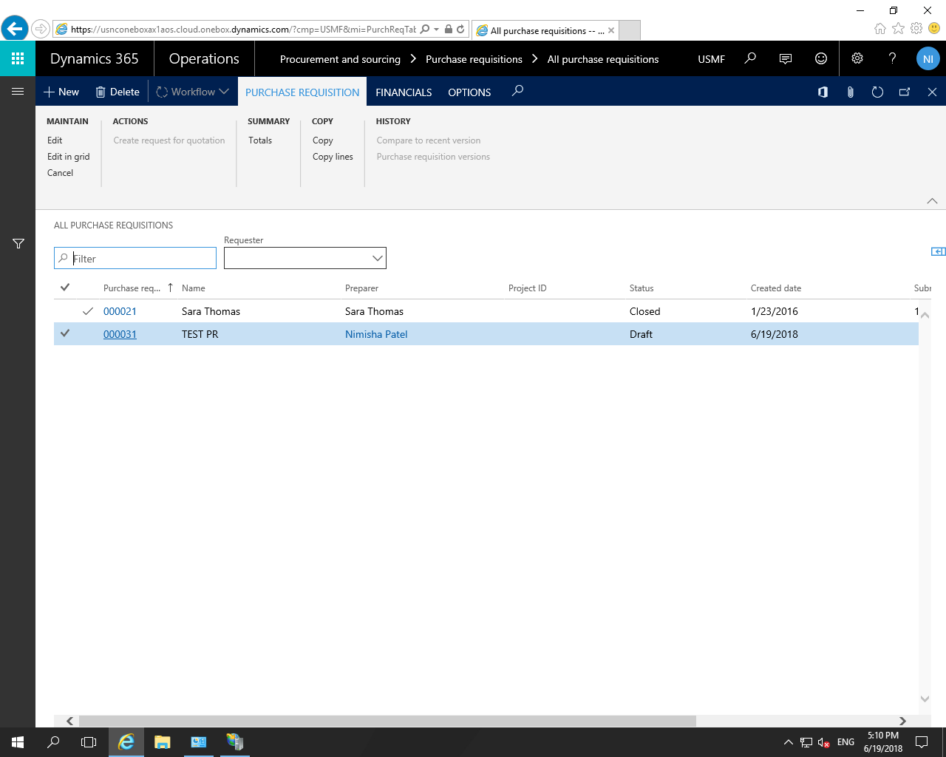

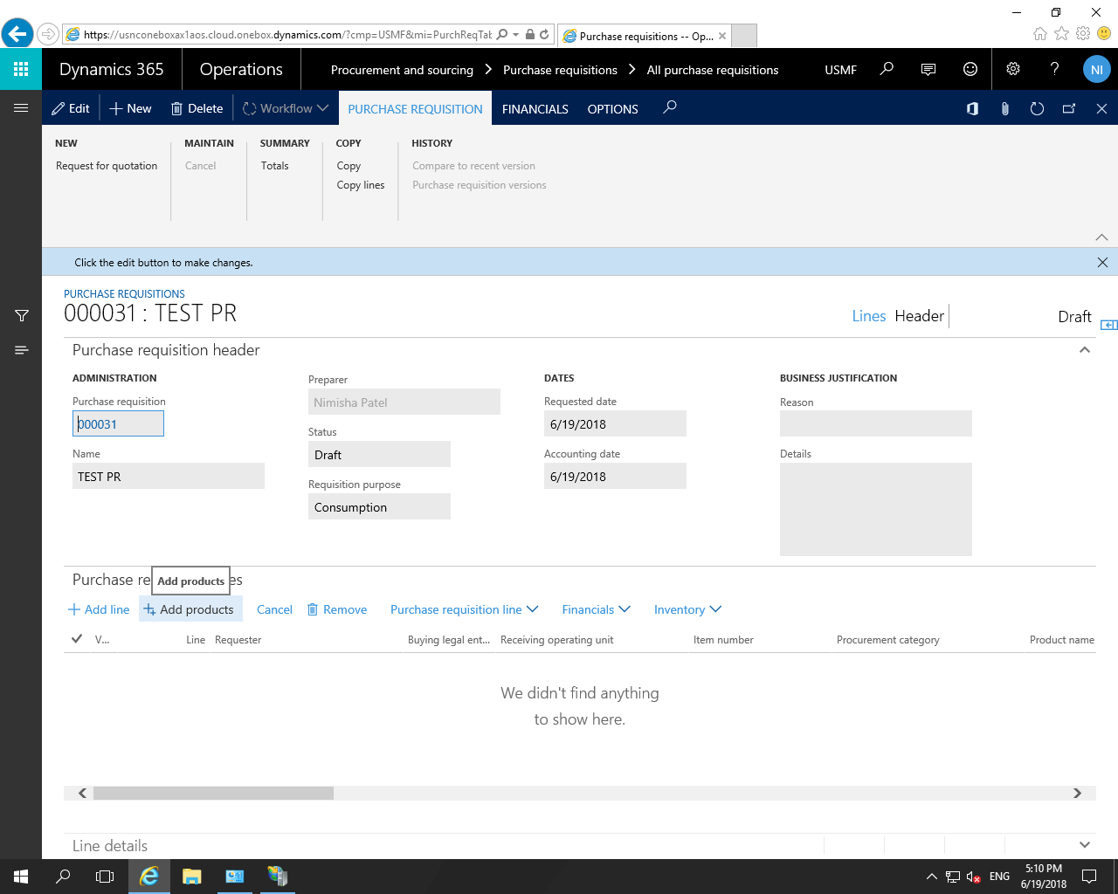

Click on the “Add products” , you can see the product category and related products as per below screen shot. Now select product and continue your work.

