# Add reference not showing options on number sequence

Issue : Add reference not showing options on number sequence.

Above issue may raise if customized number sequence is created through code.

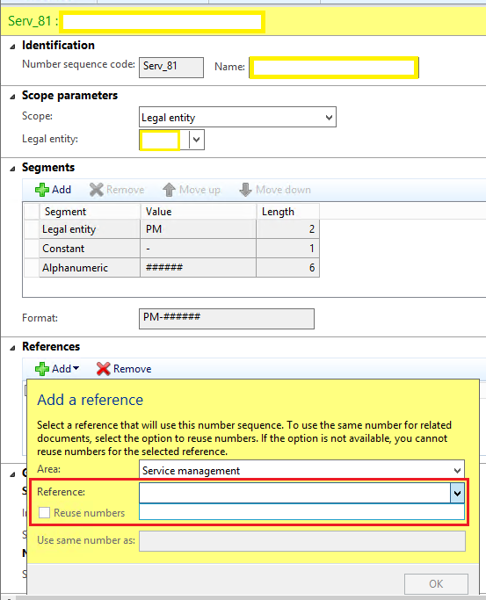

Solution:

1. Go to AOT>Tables> NumberSequenceTable
2. Open table and find for number sequence created and note recid.

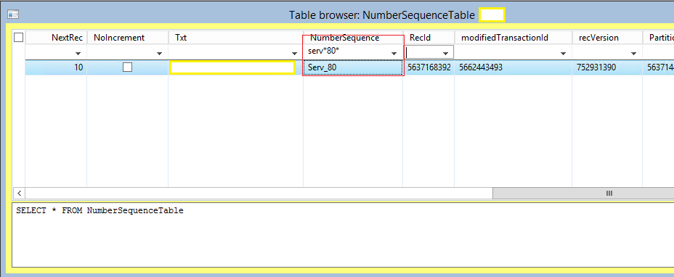

1. Open NumberSequenceScope table and find dataArea for which number sequence created. *Note recId*.
2. Open NumberSequenceDataType table and find datatype created (number sequence required for ex. Service order id). *Note recid*.

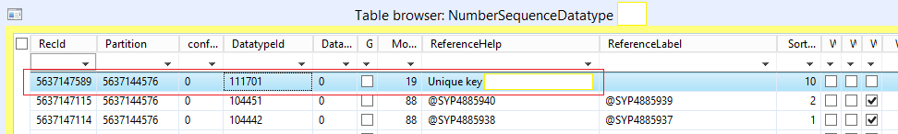

1. Open NumberSequenceReference table and filter datatypeid field with recid of NumberSequenceDataType table .
2. It will show missing number sequence id. Set number sequence table recid in numberSequenceId field.

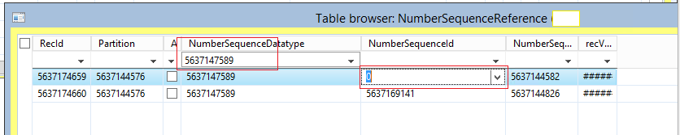

1. Update NumberSequenceScope field on NumberSequenceTable .

NumberSequenceTable _NumberSequenceTable;

;

ttsBegin;

select forupdate * **from** **_NumberSequenceTable** **where** **_NumberSequenceTable.RecId** == **5637168392**;

**if**(_NumberSequenceTable.RecId > **0**)

{

_NumberSequenceTable.selectForUpdate(true);

_NumberSequenceTable.NumberSequenceScope = **5637144826**;

_NumberSequenceTable.update();

info('updated');

}

ttscommit;

