Contents

Create Webservice in .net 1

Consume the webservice in Dynamics project 5

Import exchange rate in AX using <http://currencyconverter.kowabunga.net/converter.asmx>

# Create Webservice in .net

Create Webservice in .net project consuming the external web service

* Go to Visual Studio 2015 and create a New Project
* Select an ASP.NET Web Application
* Go to Solution Explorer, right click on your project and select add service reference.

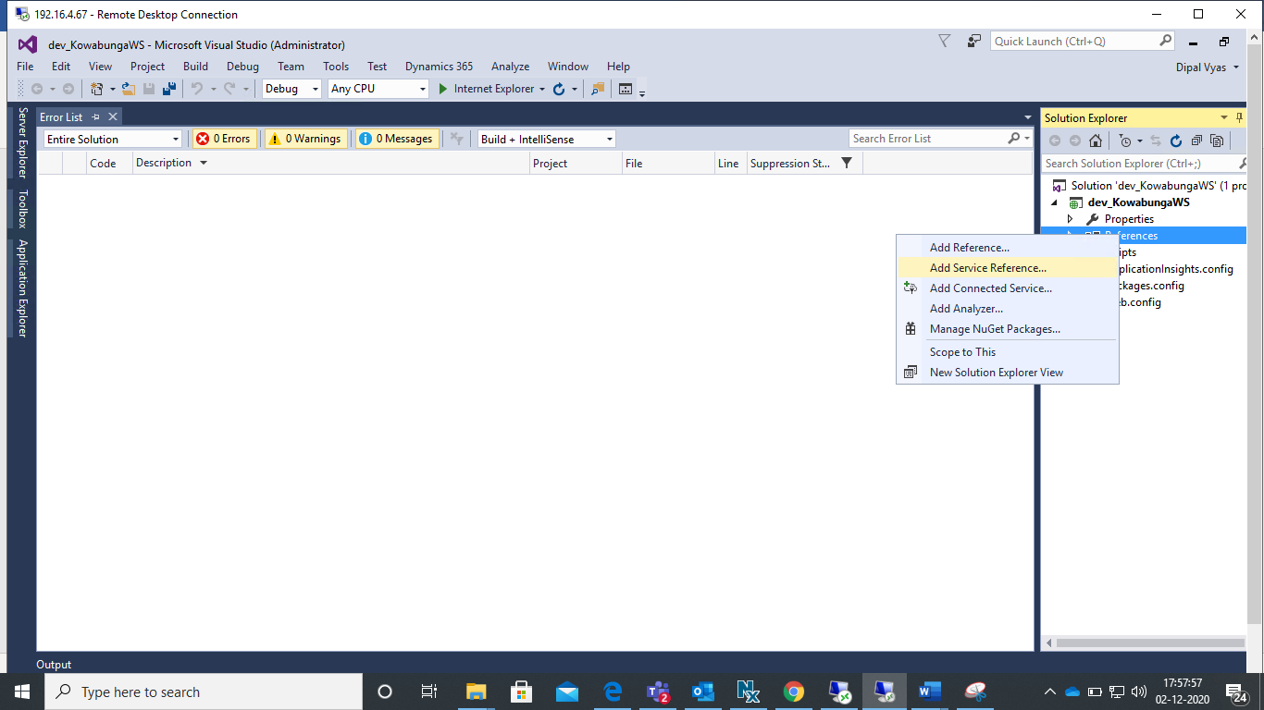

Add web service URL <http://currencyconverter.kowabunga.net/converter.asmx> and click on the “Advanced” button as shown in the screen below.

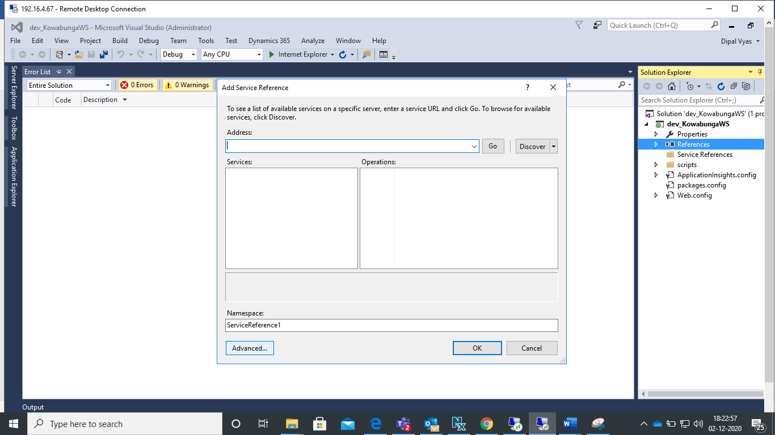

New window as shown in the screen below will be opened as below:

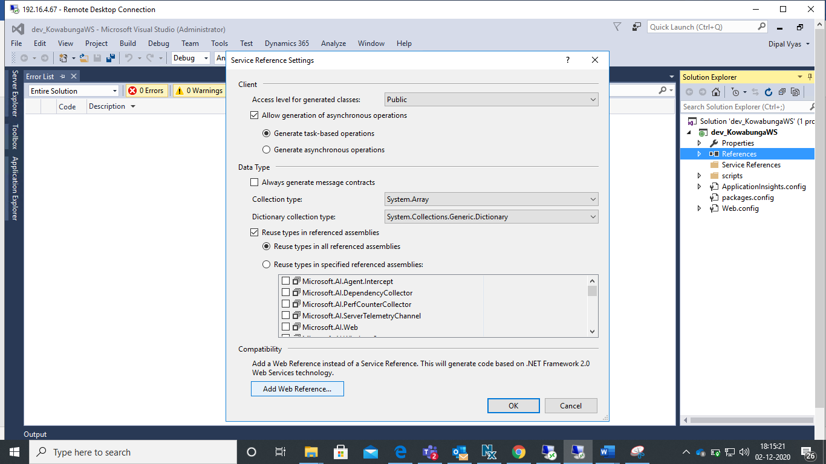

Click on the “Add Web Reference” button, add web service URL and update web reference name as shown in the screen below and click on the button “Add Reference”

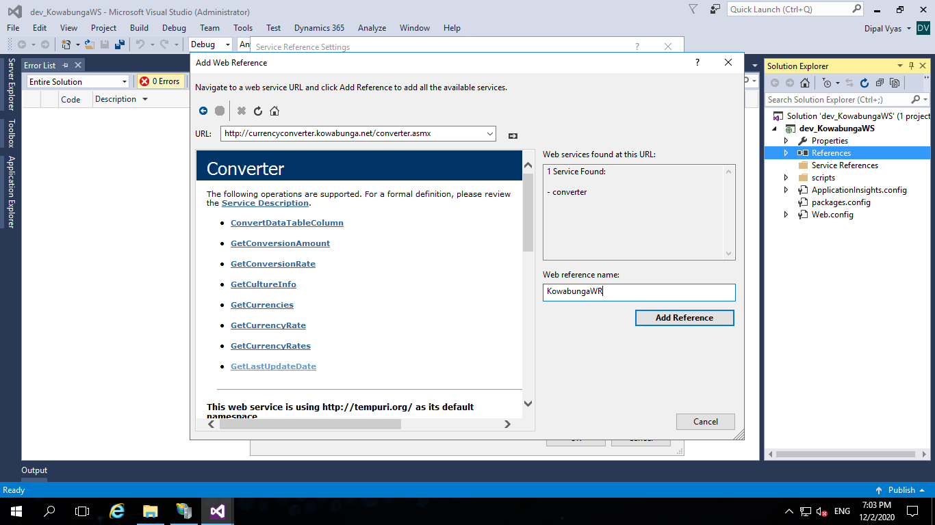

The web reference will be added in your project as below:

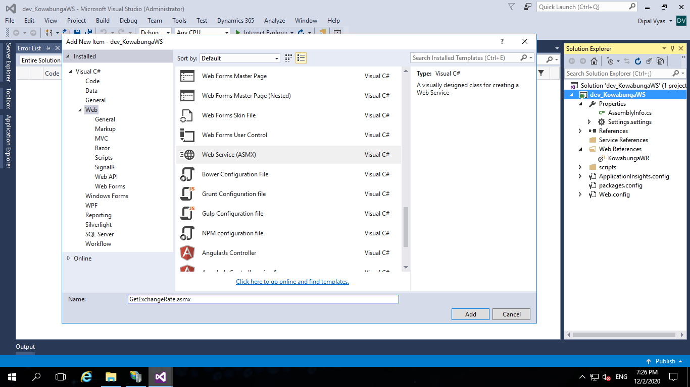

* Add New Item “GetExchangeRate.asmx”

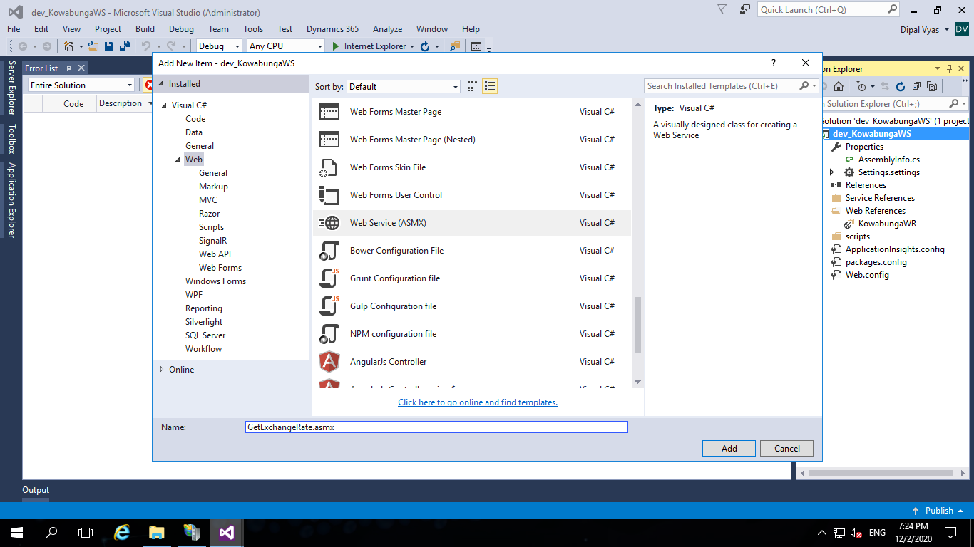

* Add method to access external web service method

Add code as below to access methods of the Kowabunga web service:

using System;

using System.Collections.Generic;

using System.Linq;

using System.Web;

using System.Web.Services;

using dev_KowabungaWS.KowabungaWR;

namespace dev_KowabungaWS

{

/// <summary>

/// Summary description for GetExchangeRate

/// </summary>

[WebService(Namespace = "http://tempuri.org/")]

[WebServiceBinding(ConformsTo = WsiProfiles.BasicProfile1_1)]

[System.ComponentModel.ToolboxItem(false)]

// To allow this Web Service to be called from script, using ASP.NET AJAX, uncomment the following line.

// [System.Web.Script.Services.ScriptService]

public class GetExchangeRate : System.Web.Services.WebService

{

[WebMethod]

public string HelloWorld()

{

return "Hello World";

}

[WebMethod]

public string GetLastUpdateDate()

{

KowabungaWR.Converter cr = new KowabungaWR.Converter();

return cr.GetLastUpdateDate().ToString();

}

}

}

* Build and run the project, add GetExchangeRate.asmx in the url as shown below:

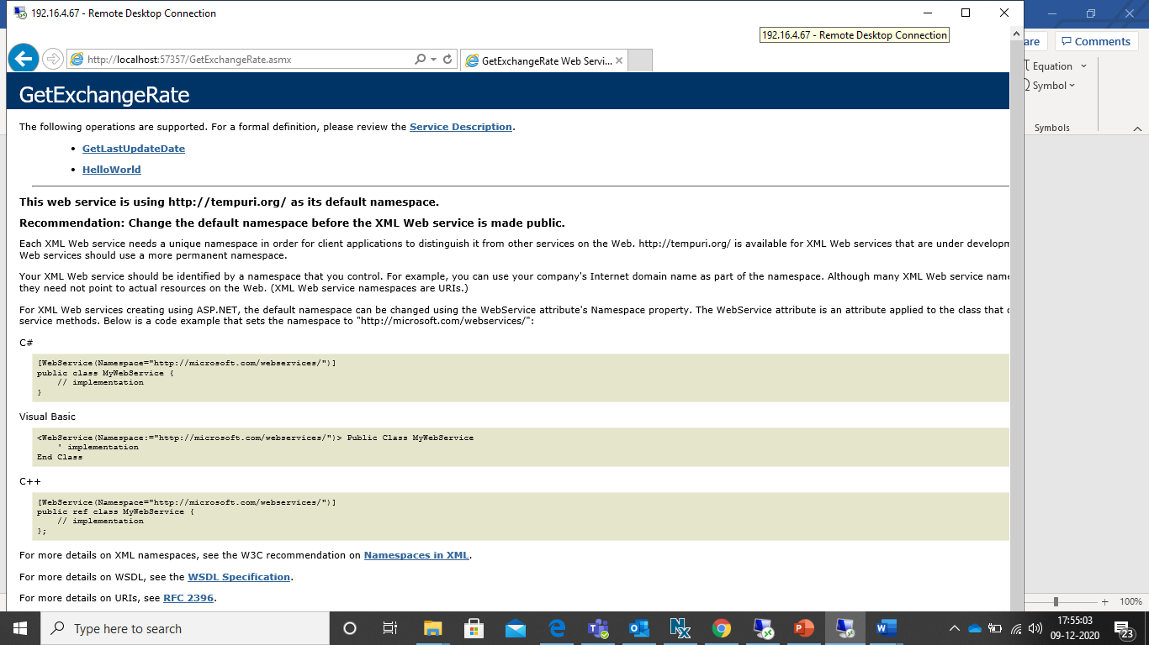

Click on the method, GetLastUpdateDate to call the webservice method.

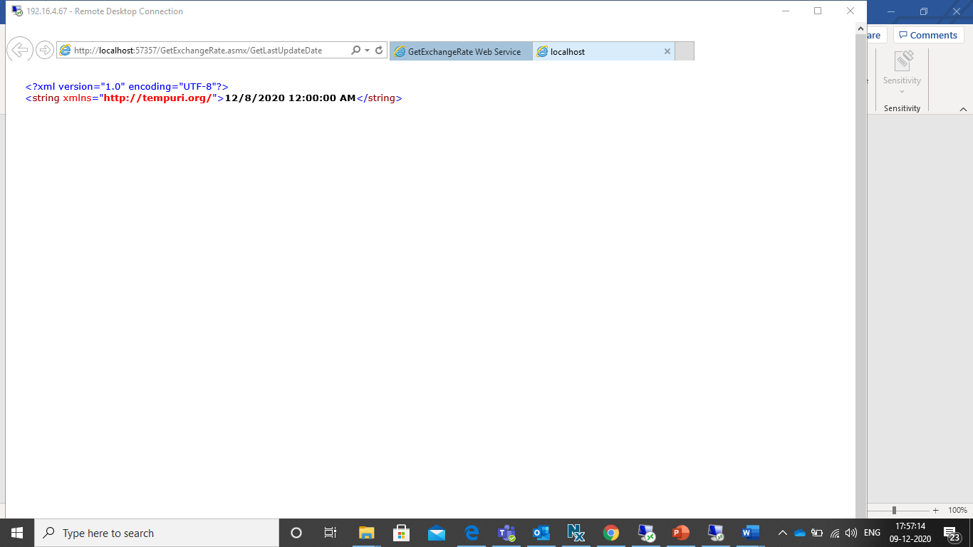

# Consume the webservice in Dynamics project

Create Model and project for Dynamics.

Right click on the solution explorer project, add reference, browse to the .dll and add .dll of .net webservice project in the Dynamics Project.

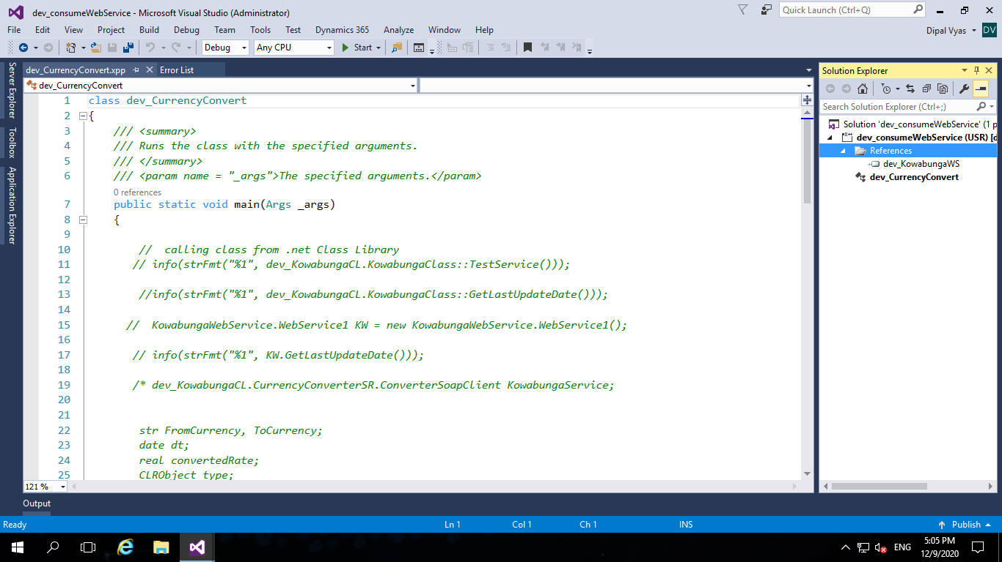

To verify the service, add new Item Runbase Class (Job) and code as below:

dev_KowabungaWS.GetExchangeRate KW = new dev_KowabungaWS.GetExchangeRate();

info(strFmt("%1", KW.GetLastUpdateDate()));