**Copy legal entity into Dynamics 365 for Finance and Operations**

Here is how you can solve this scenario easily in Dynamics 365 for Finance and Operations:

**First of all**, I recommend that you have a “template” legal entity setup in your environment. Either do it manually or import it via Data management from another environment.

For this example, I will use Microsoft’s ready-made templates. These are templates for a specific area such as Accounts payable, Product information management or System setup etc... That consist of **multiple**entities sorted in sequence for easy import.

Here are the steps:

**1**. Go to the “Data management” workspace.

**2**. Choose the “Templates” tile in the “Data management” workspace and then choose “Load default templates” and in the dialog box “Load all”:

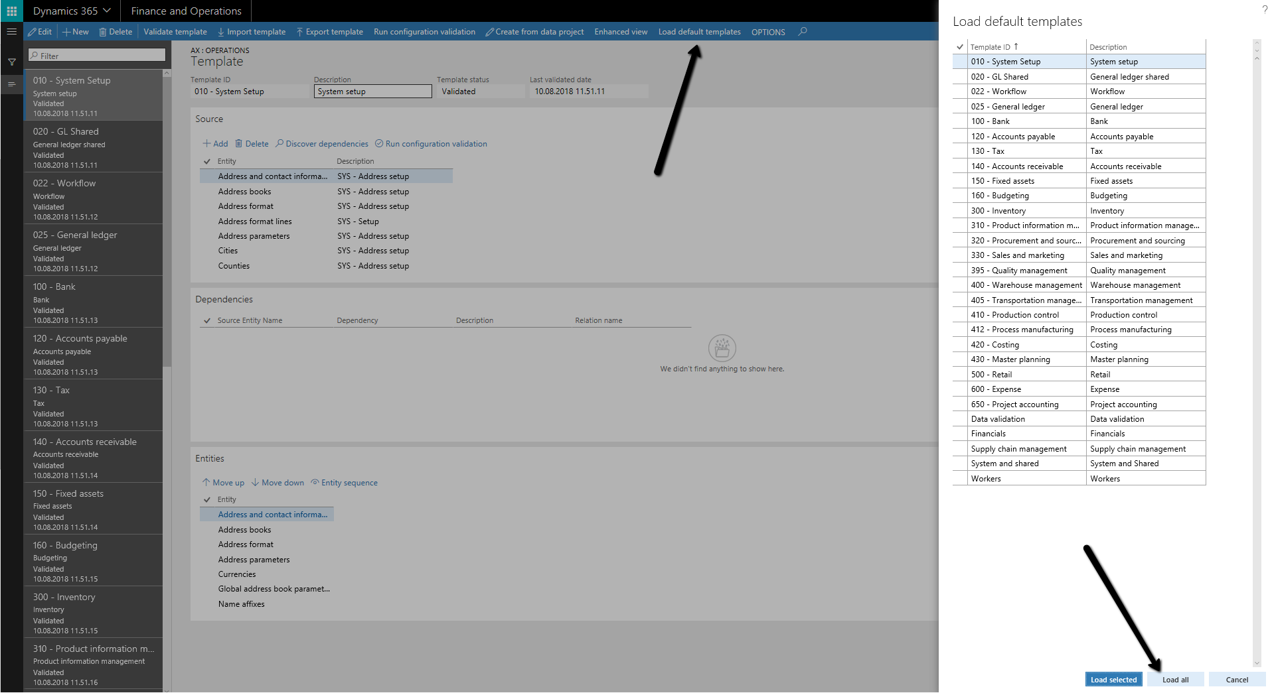

**3**. Go back to the Data management workspace and choose the “Copy into legal entity” tile.

In the “Copy into legal entity” section, add Group name, Description, Data project operation type (Copy into legal entity), Project category (Project), Source legal entity (your template company or the company you are copying from).

In the “Destination legal entities” section select “Yes” for both “Copy number sequences” and “Reset to smallest values”. Number sequences are always a hazzle to create manually, so yes please.

Further, you have two options on how to proceed:

1. Let’s say you have already created a new legal entity in “Organization administration” with basic info such as company name, addresses, contacts, tax reg. numbers, and other company specific information, then you choose “Select from existing” and select that legal entity you have created in advance.
2. The other scenario is when you want to create a new legal entity from the project and later update the information mentioned above in 1. Then choose “+Create legal entities” and input Company, Company name and Country/Region. I will continue with this scenario in this example.

**4**. In the “Selected entities” section, choose “+Add template” and choose the areas that you want to copy from the template legal entity. Remember to note the last sequence of the imported template, before adding the next template. And after your next templates is added, renumber the sequences of the new entities, continuing from the last sequence number of the previous template’s entity. This is in my opinion a minor design flaw, because you would expect the sequence to continue when choosing the “Merge” option.

For this example I choose the templates listed below and in that specific order:

1. System setup
2. GL Shared. Remember to choose the “Merge” alternative in the dialog box. This means that the entities in this templates will be added to the entities from 1. If the “Replace” is chosen, all entities from 1. will be replaced.
3. General ledger. Remember to choose “Merge”.

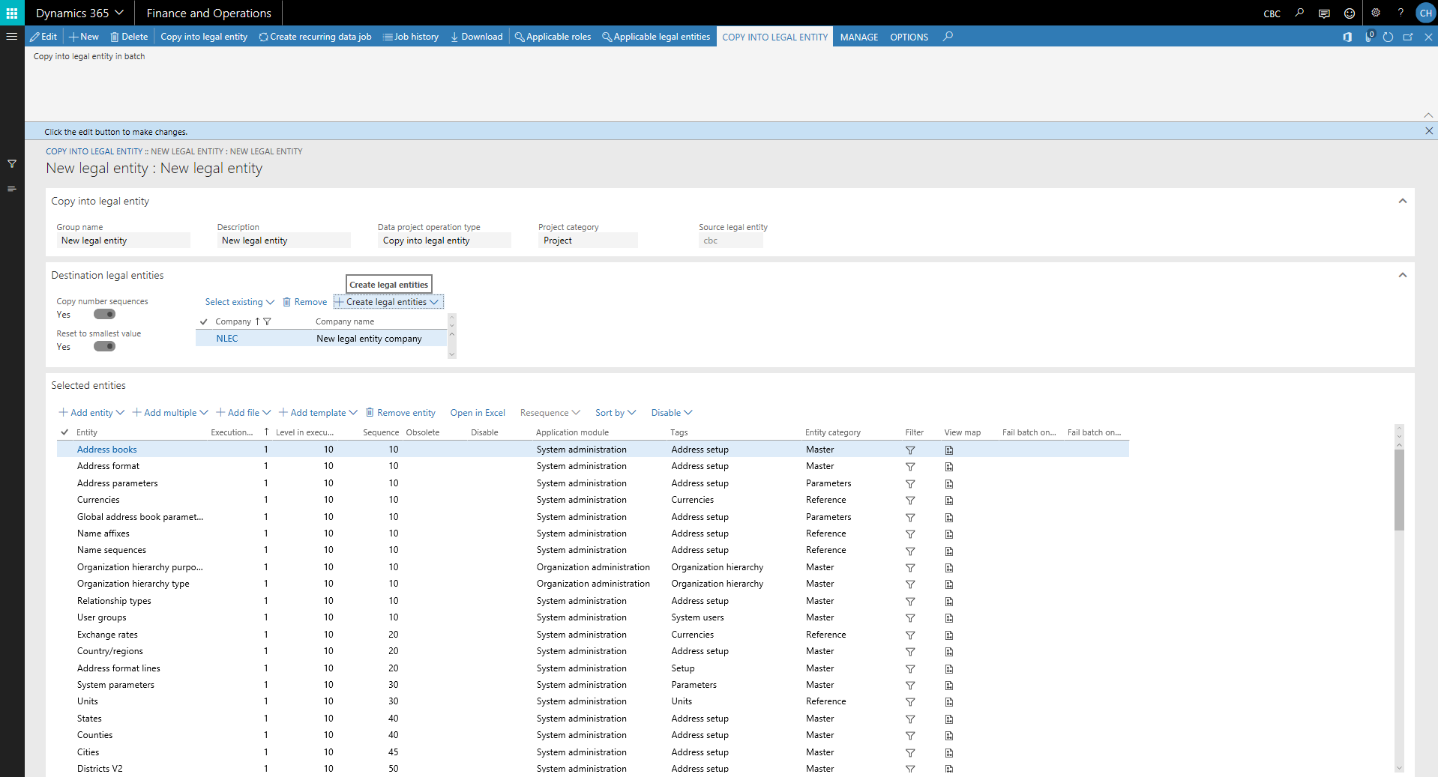

Which templates you choose can be different from case to case. However I am keeping it a bit simple for this example.

Once the templates are added and you have fixed the sequencing, hit “Copy into legal entity” on the action pane and let the magic happen. After a couple of minutes process will done.

if everything is going smooth then, new legal entity will be created successfully with the basic system setup.