**DEVOPS and Dynamics 365 F&O Configuration**

1. **Create DEVOPS Account and configure from below link** 
   1. <https://azure.microsoft.com/en-in/services/devops/>
   2. Create Organization
   3. Create Project and add users

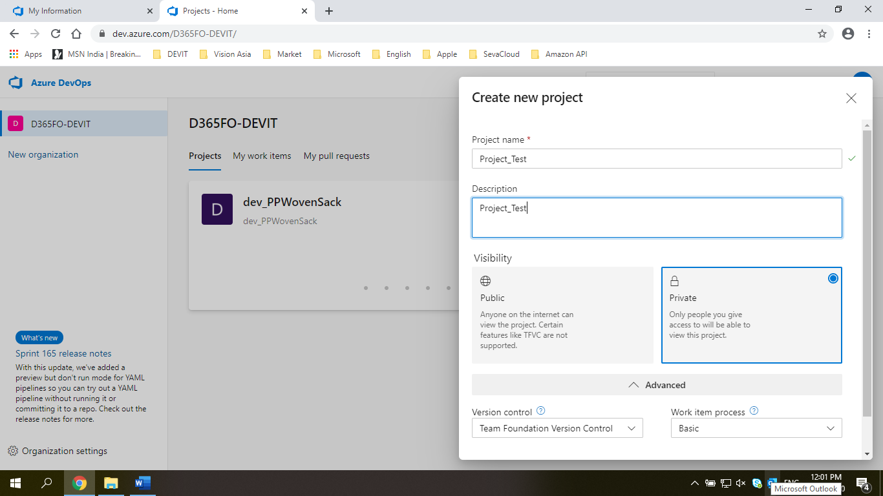

1. **1st Developer Setup** 
   1. VM must ready with Visual Studio and D365F&O application
   2. Open Visual Studio as a ‘Run as Administrator’
   3. Sign In into Visual Studio
   4. Open Team Explorer

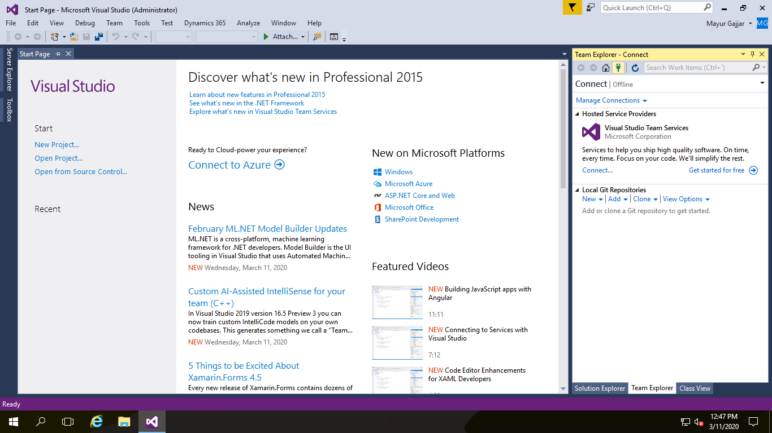

* 1. Connect to Team Project

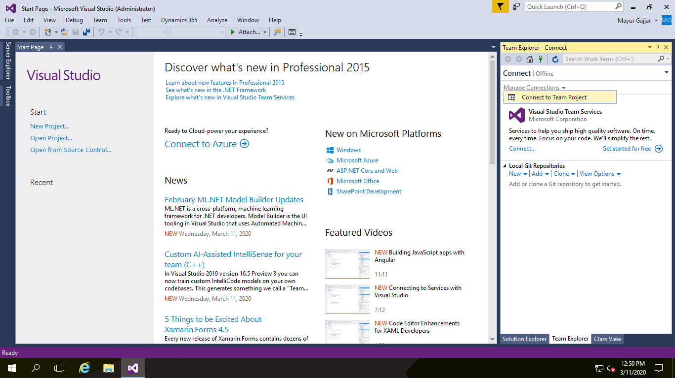

* 1. Select Team foundation Server and Project

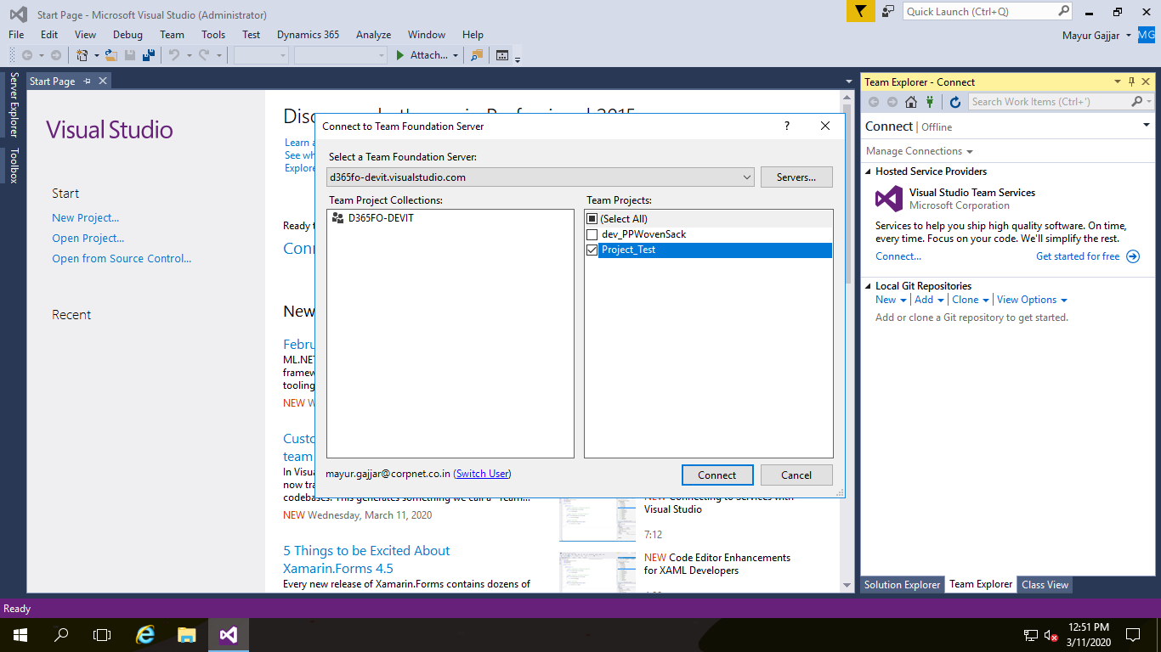

* 1. Click on Source Control Explorer button and Map the folders

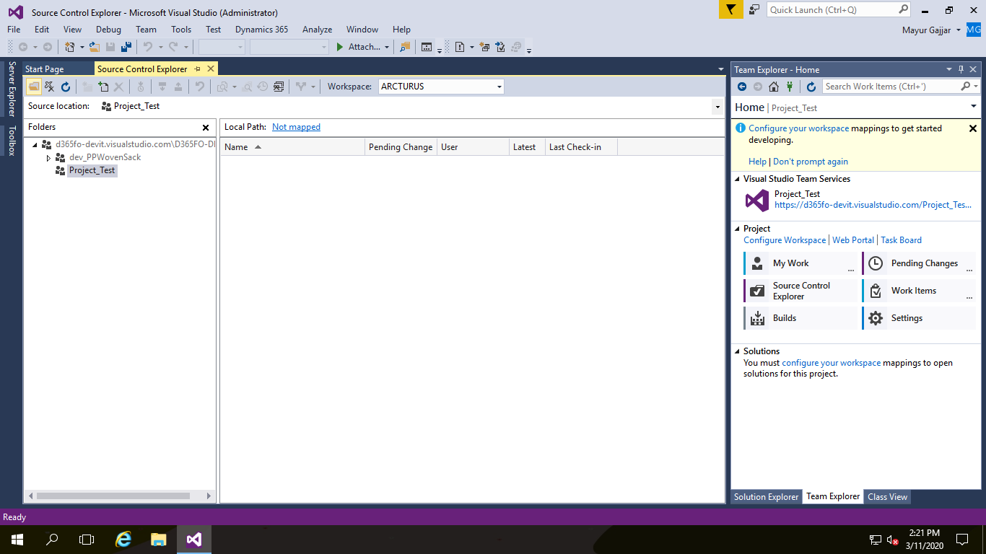

Select Project ‘Project_Test’ on left side and click on ‘Not mapped’ link and map the folder as below,

Create ‘VSTS’ folder if not available

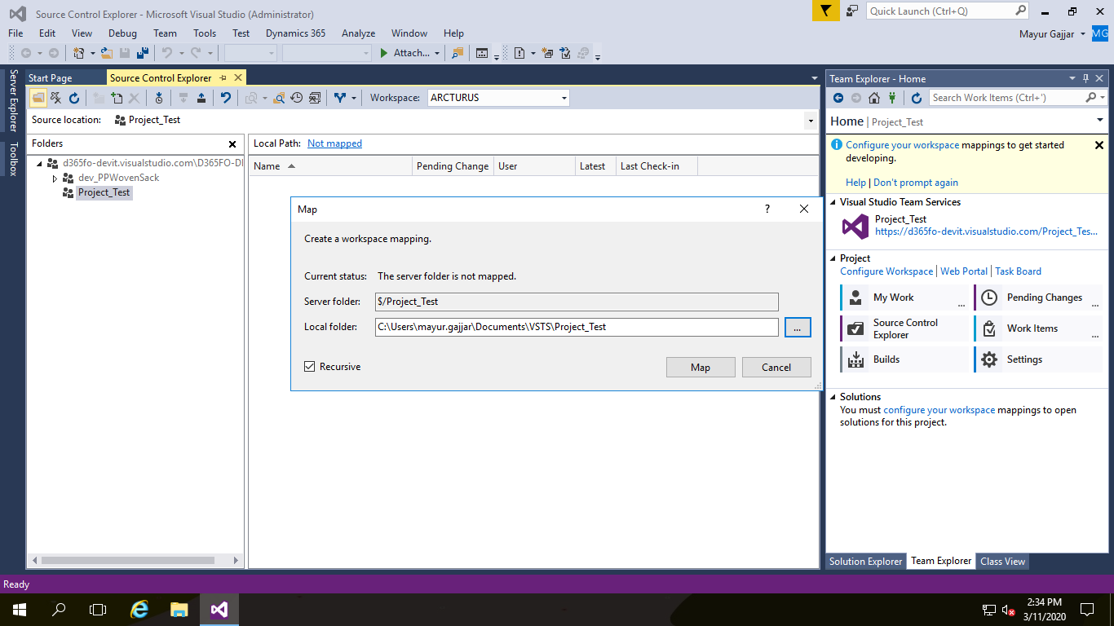

Click on ‘No’ button as per below screen shown,

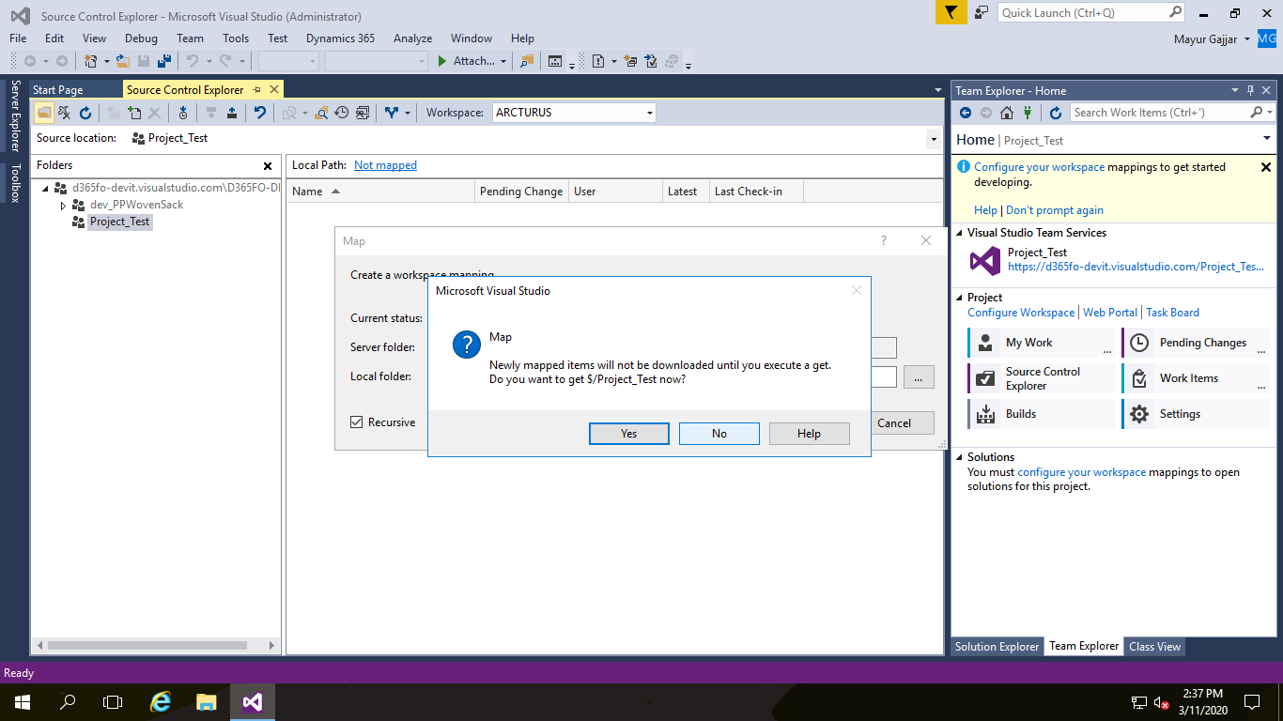

Afterwards use the source control explorer to create two new folders. One for Visual Studio Projects and one for metadata.

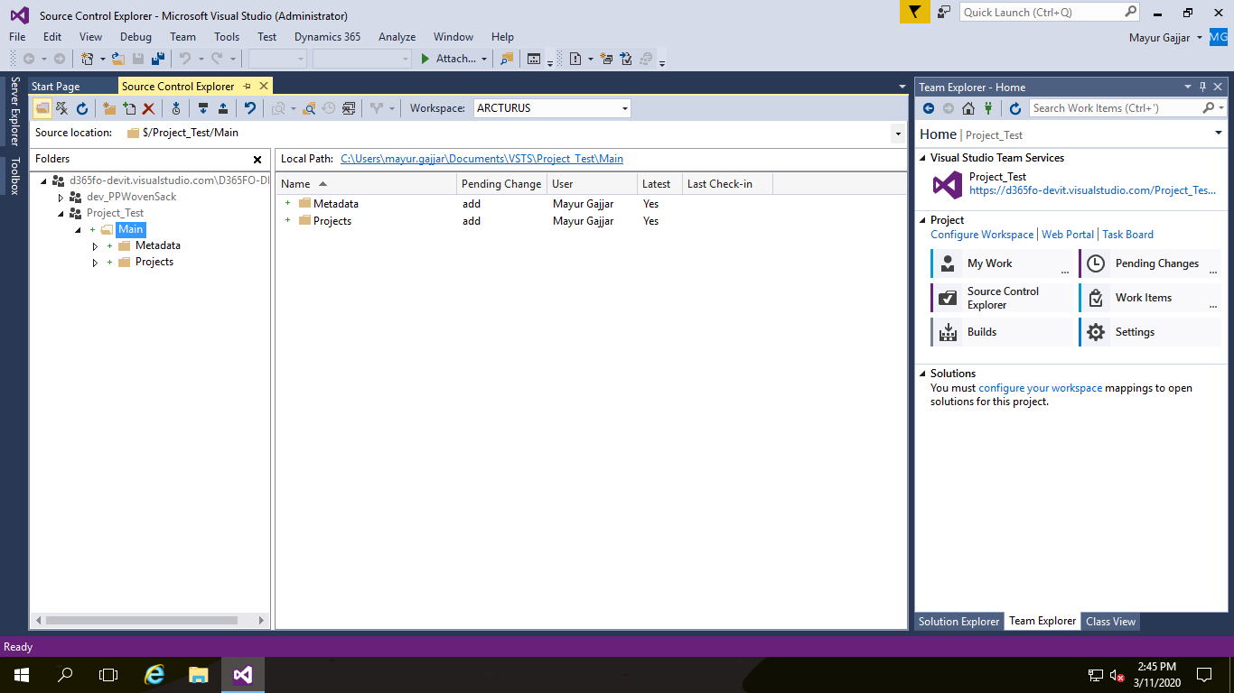

‘Check – In’ and new folder will be created on Source control

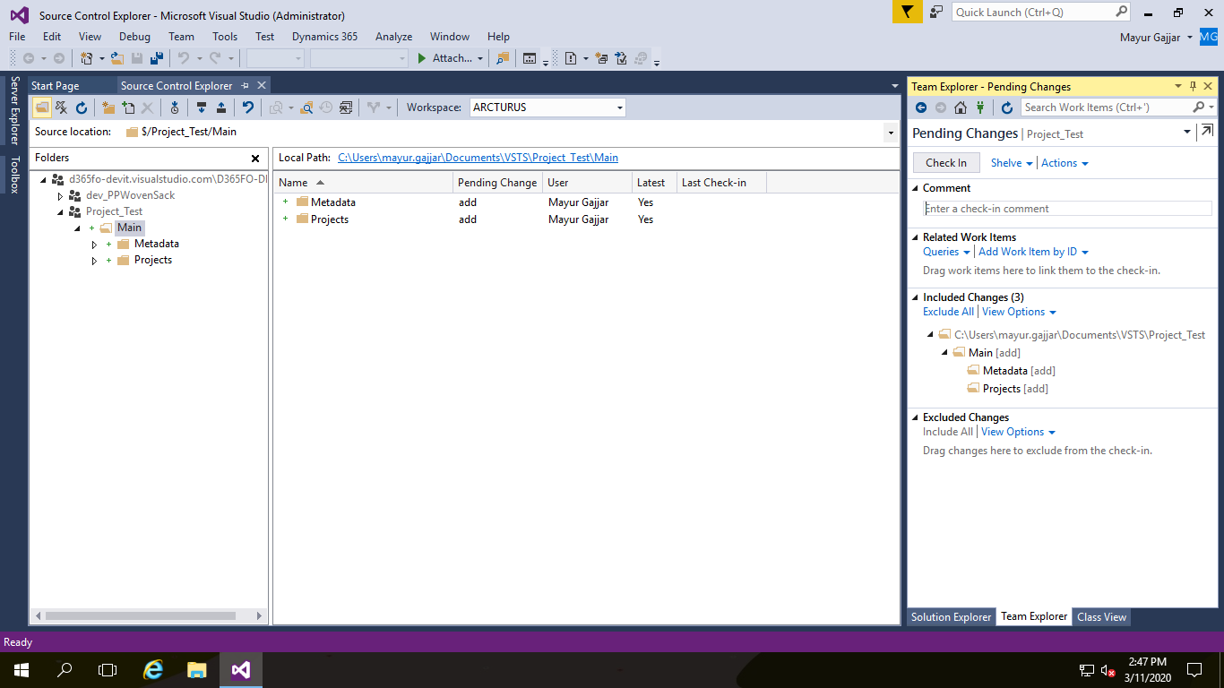

Now, in the Source Control Explorer open the dropdown Workspace and edit your workspace. Map the metadata folder to C:\AOSService\PackagesLocalDirectory

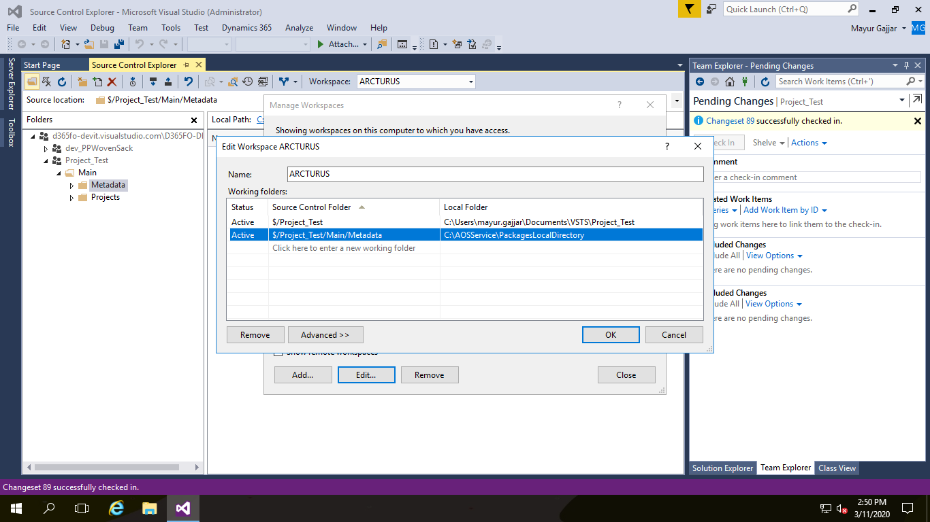

Click on ‘Yes’ button to update map this folder

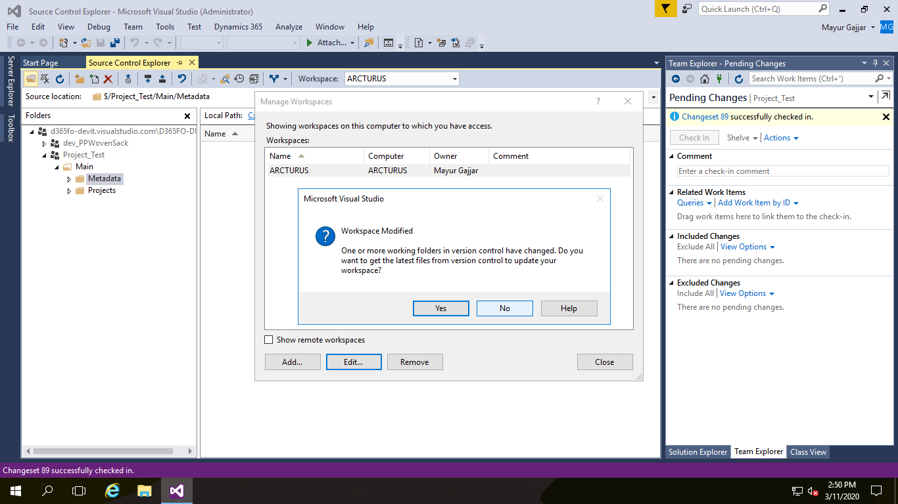

‘Metadata’ folder mapped with Local folder ‘PackagesLocalDirectory’

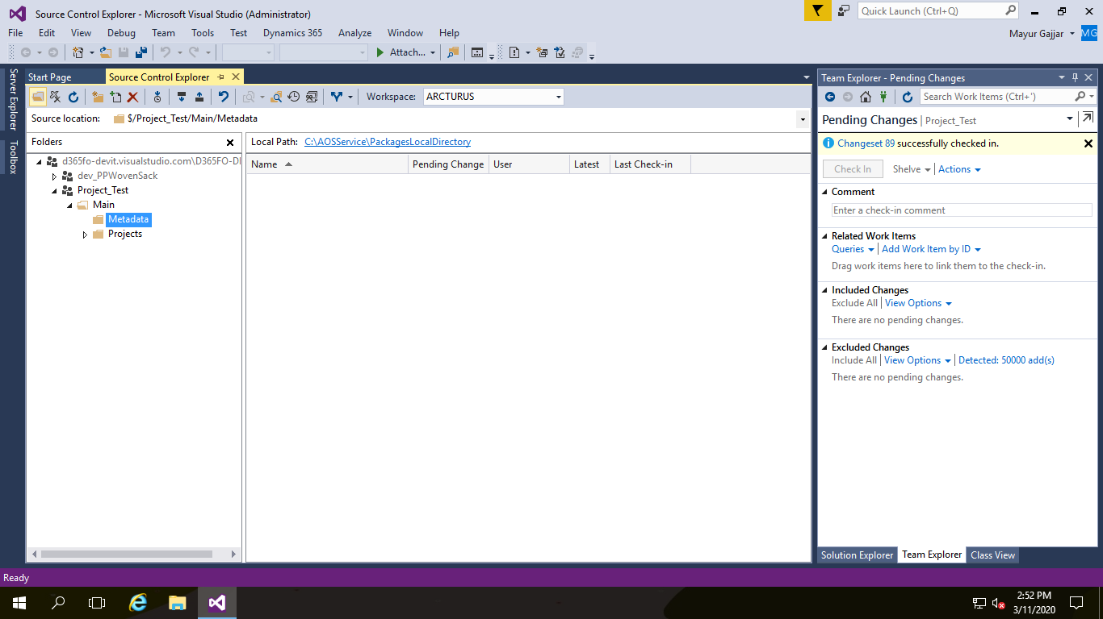

* 1. From the menu bar > Dynamics 365 > Model Management > Create a new model. Give it a name and complete the wizard. This will ask you to create a new Dynamics X++ project.

Create Model and click on finish button as per below

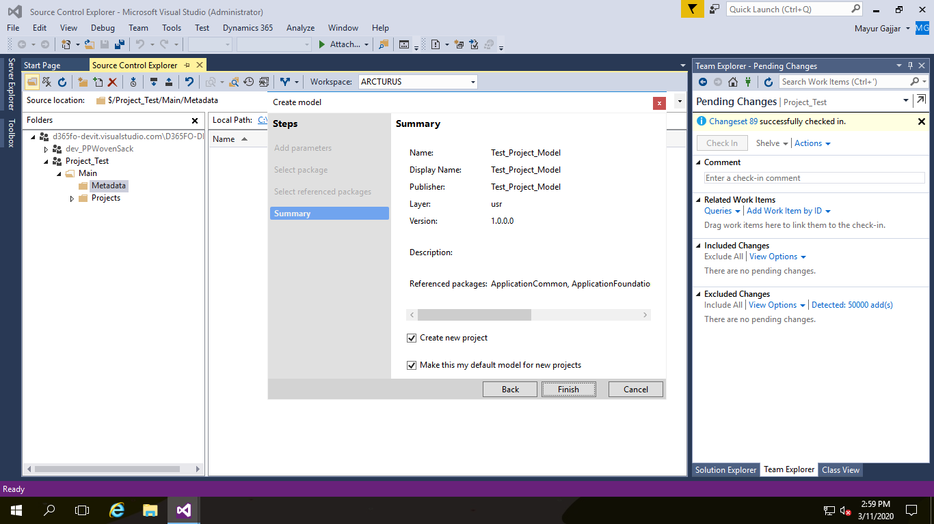

Create Project as per below screen,

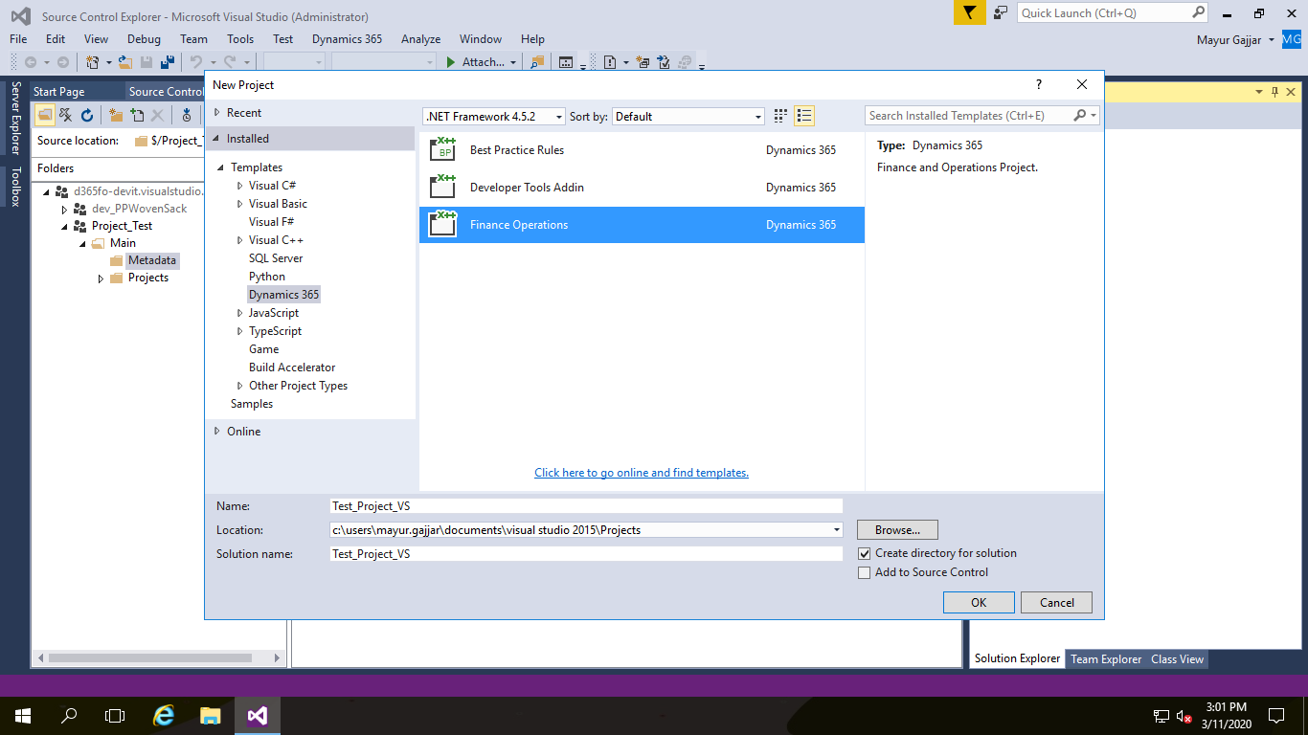

In the solution explorer, right click on the project and add to source control.

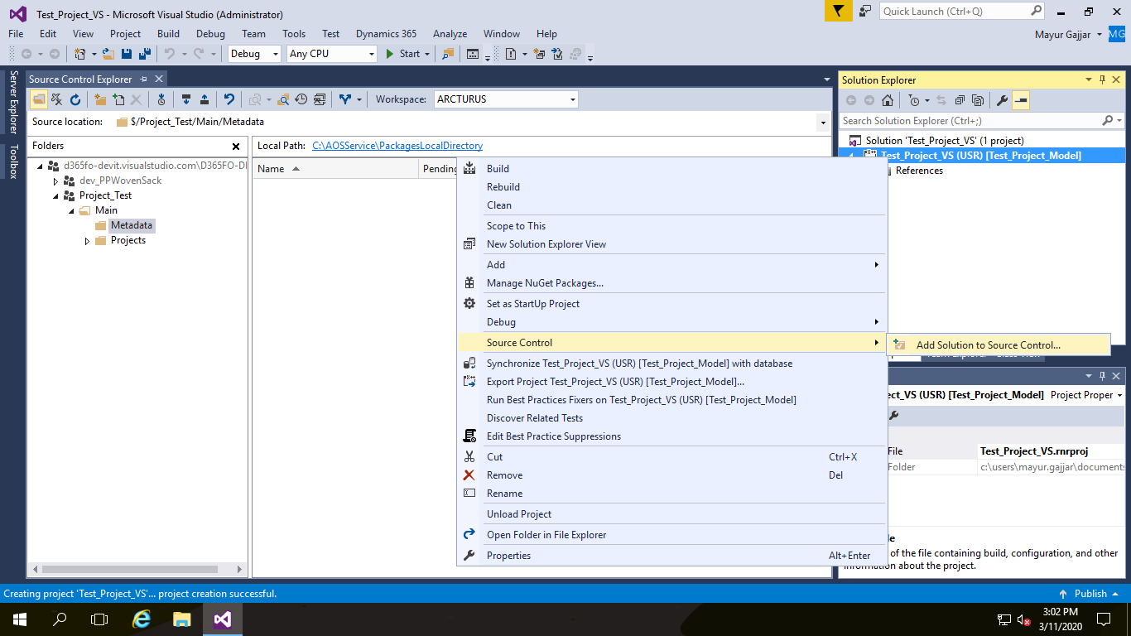

Add Local Project in Project folder on source control and new folder will be created for Project Name as below on source control

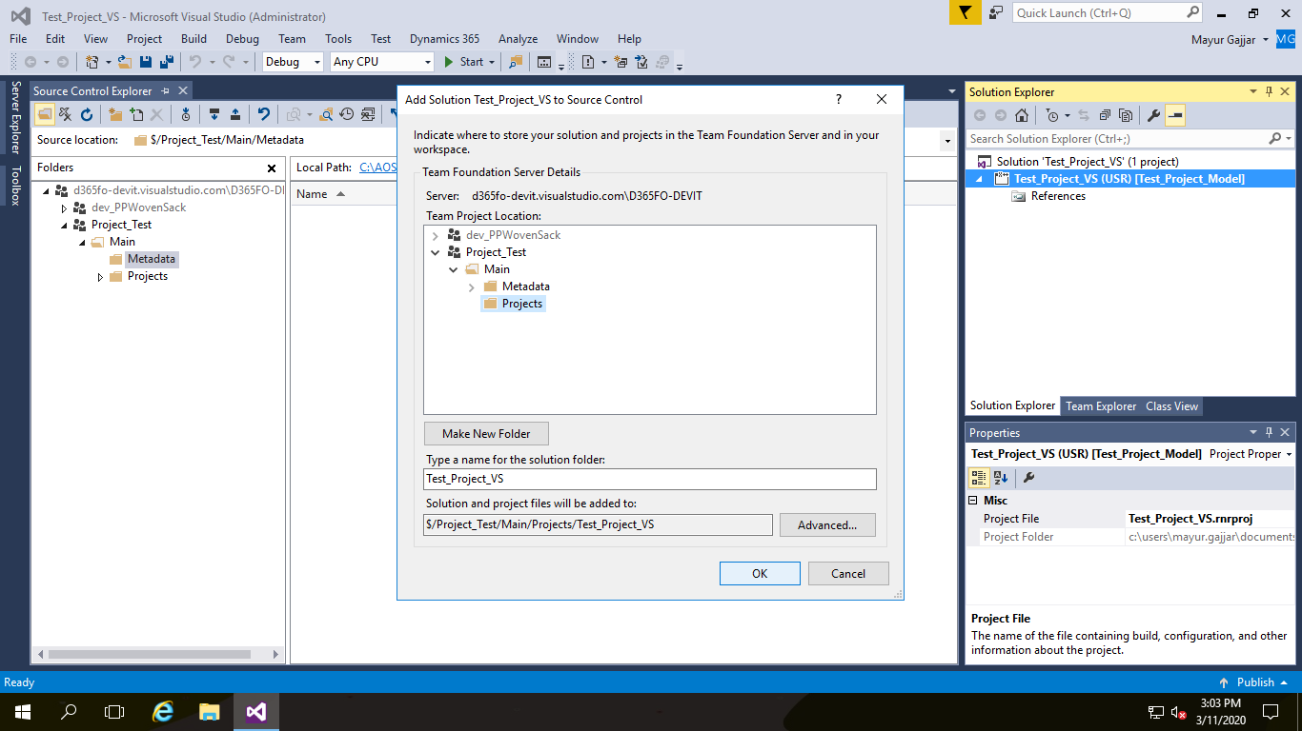

Add new element in Project,

Example

* Add new EDT ‘dev_Name’
* Build solution
* Check – In pending changes

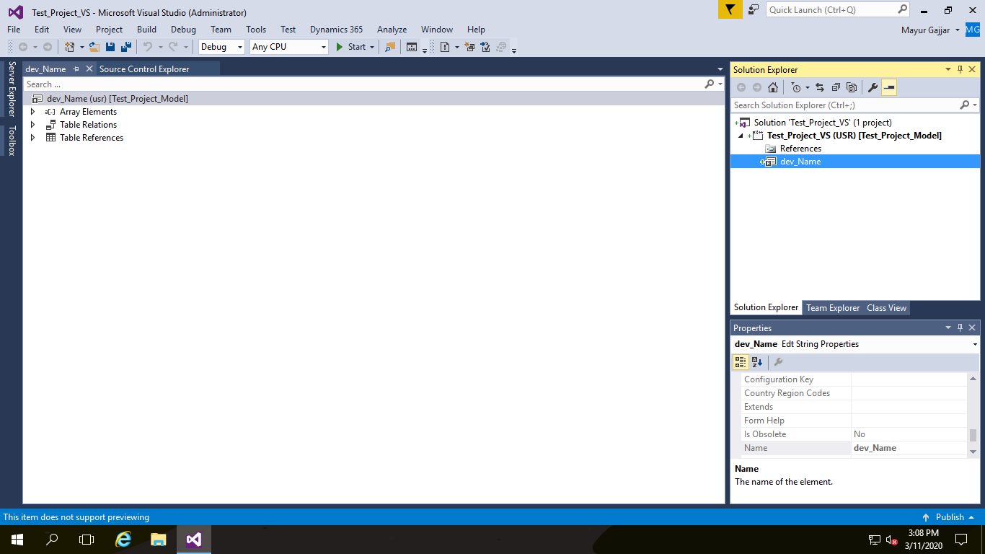

Your solution will be uploaded on source control and new EDT folder created on source control as per below screen,

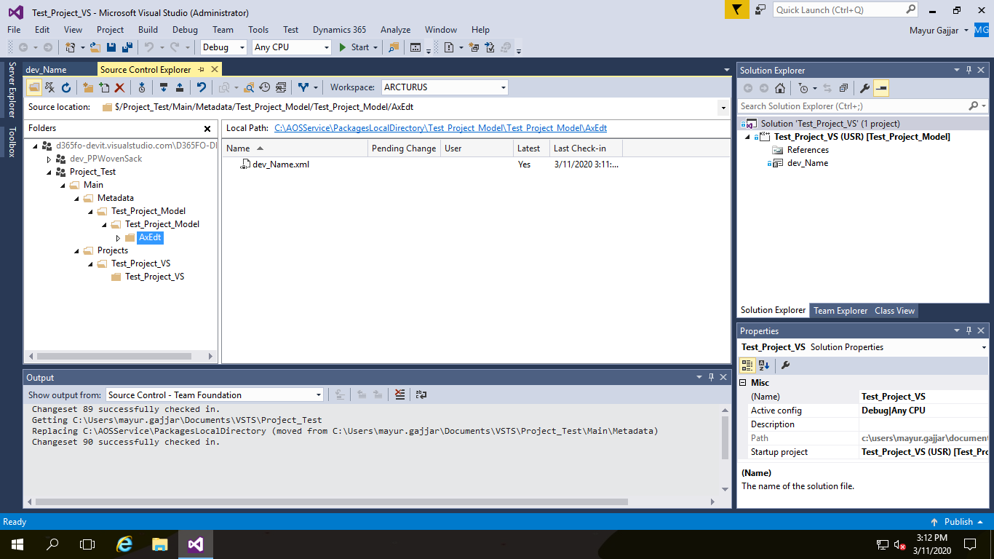

Next, from the Team Explorer open the Source Control Explorer. You should see the model structure in the tree view. Right click on the metadata folder and select “Add items to folder”. Navigate to your model folder and there to the Descriptor folder. Add the Model Descriptor XML file. Unfortunately, you have to do this manually, otherwise the second developer can sync the Folders and Extended Datatypes etc. but will not see the model in the AOT.

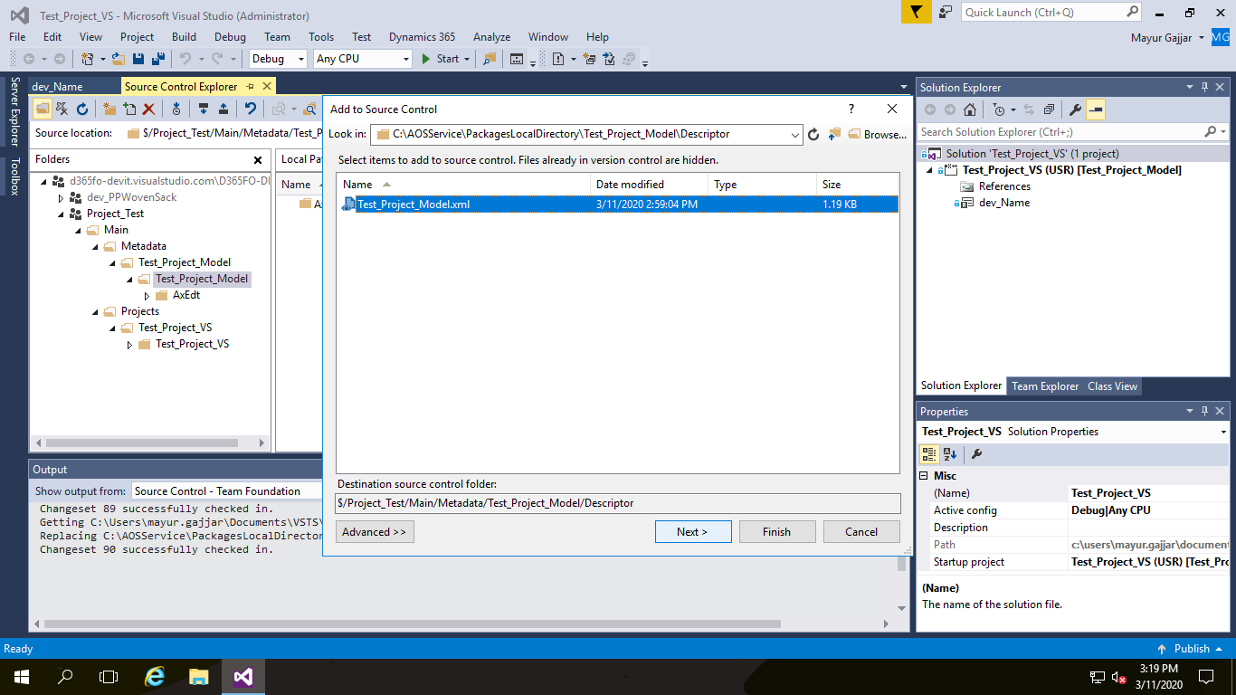

Check – In all pending changes

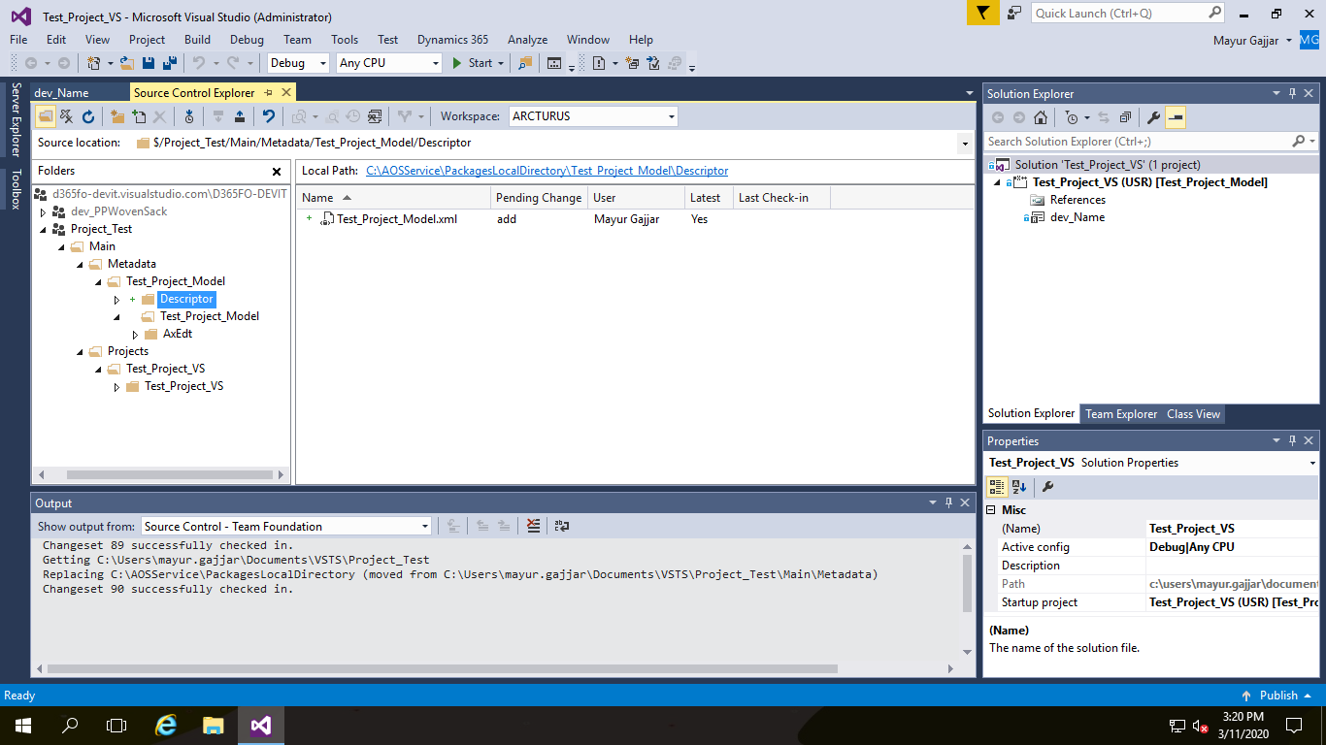

You can also review all codes on DEVOPS

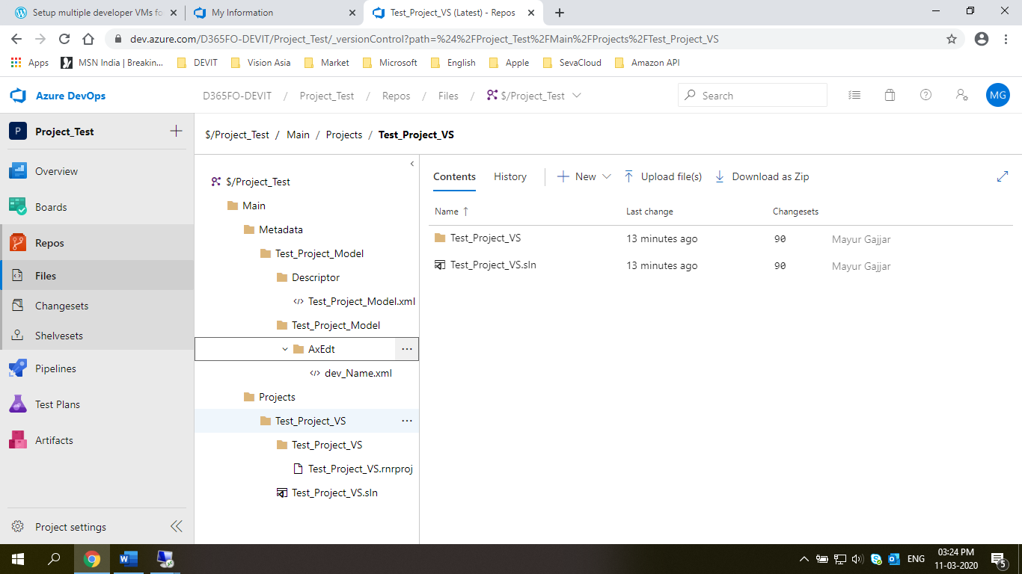

1. **2nd Developer Setup** 
   1. Create User on DEVOPS and login into Visual studio as ‘Run as administrator’

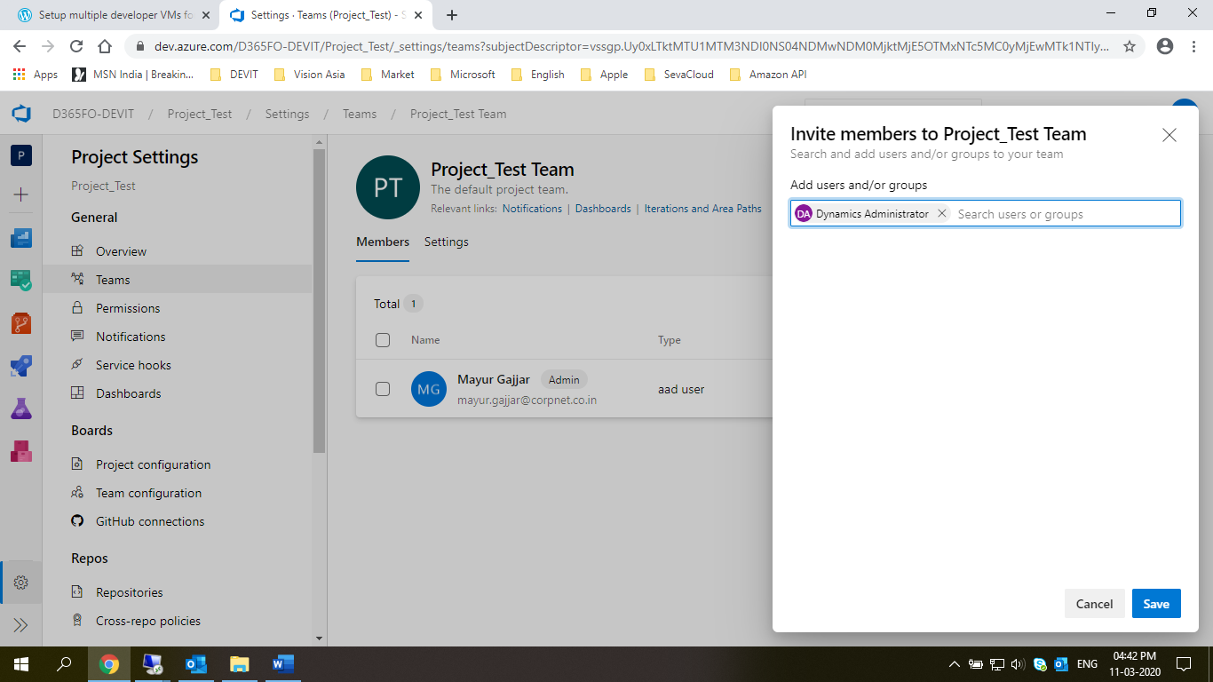

* 1. Sign in by second user in Visual Studio

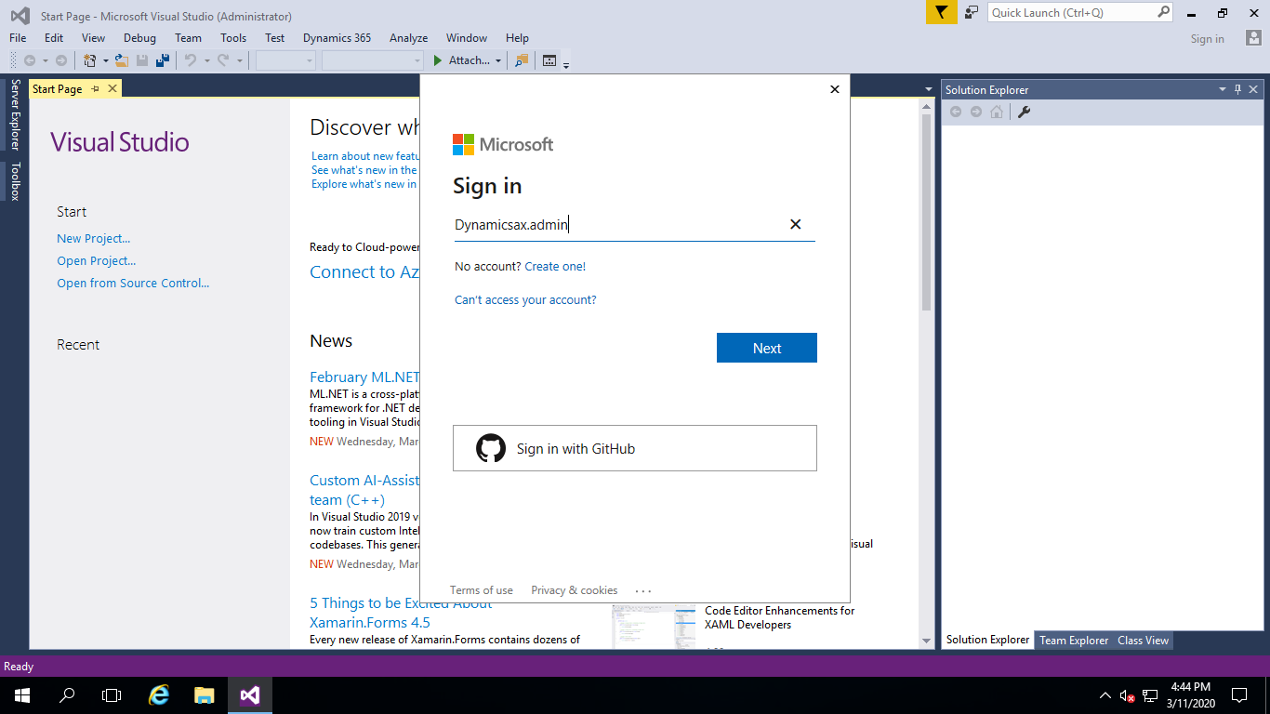

* 1. Open DEVOPS and Copy URL from as per below screen,

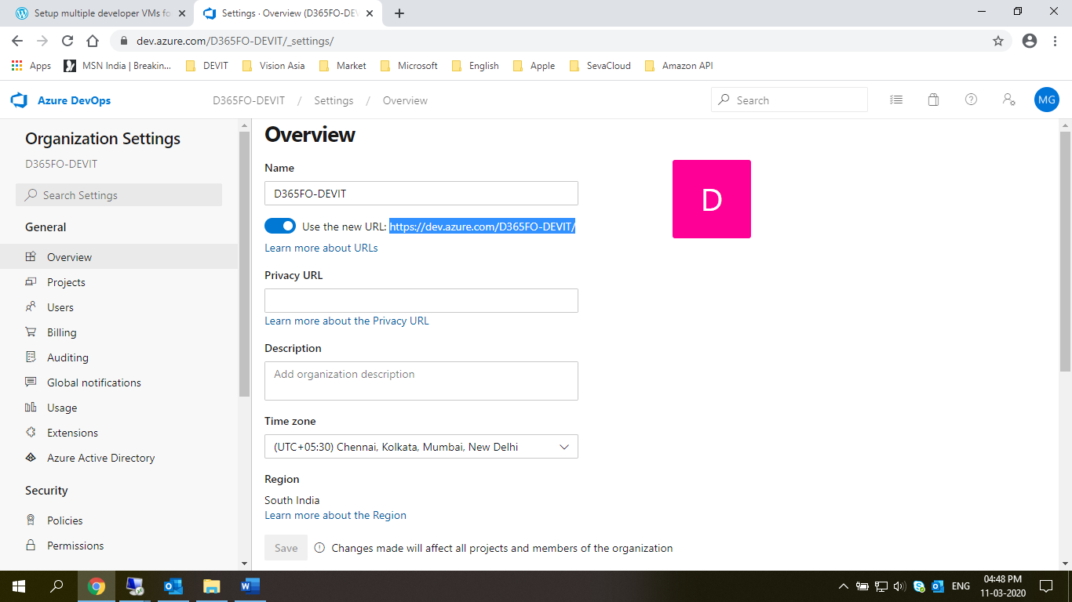

* 1. Connect Team Foundation Server in 2nd developer as per below screen,
* Click on Server button
* Click on Add button
* Paste DEVOPS URL link and click on ok button

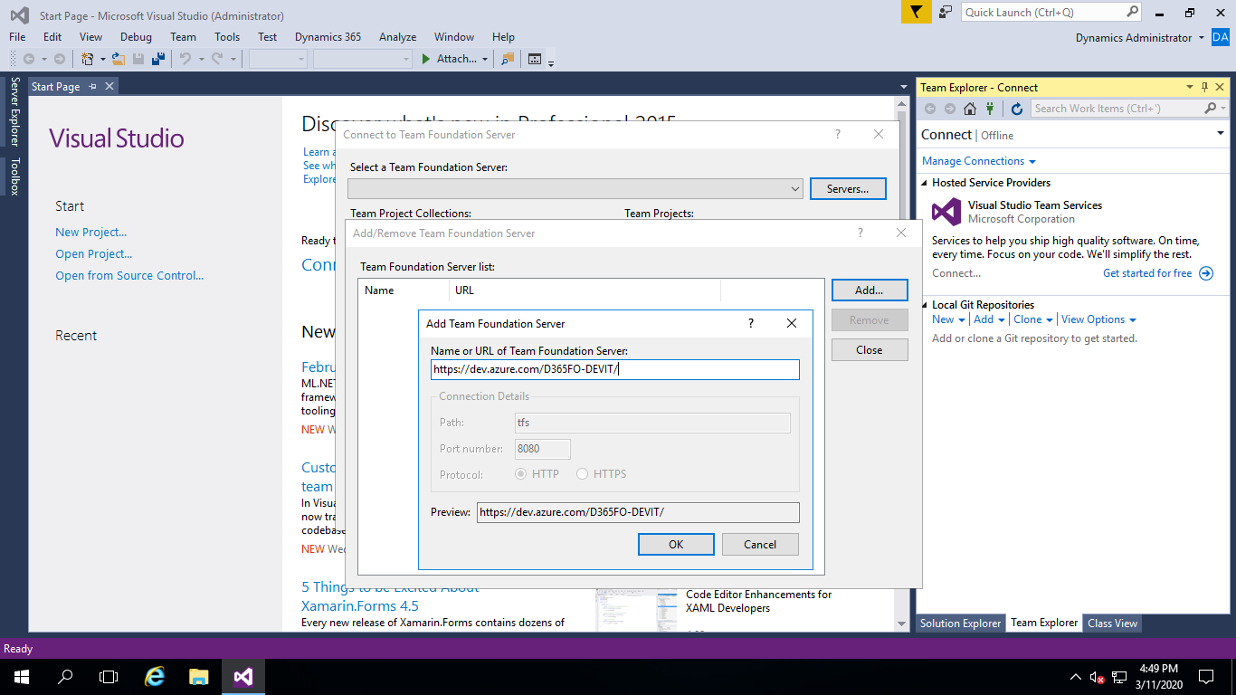

* 1. Select Project and click on connect button,

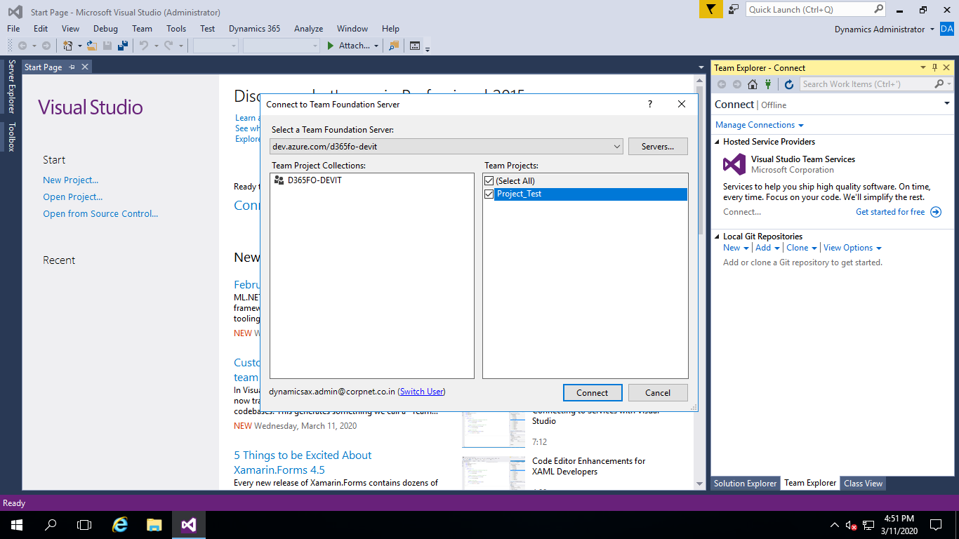

* 1. Mapping

Map ‘Project_Test’ and ‘Metadata’ folder with ‘PackagesLocalDirectory’ as per below screen and Open Solution ‘Test_Project_VS.in’

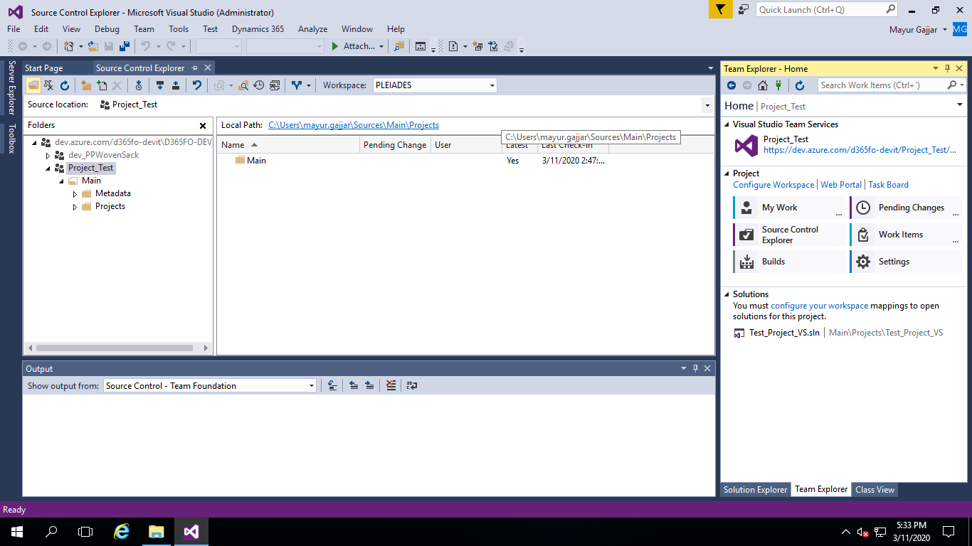

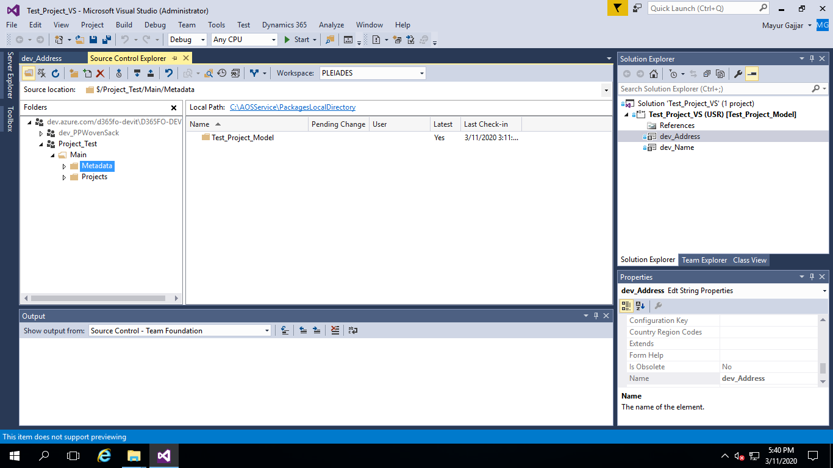

* 1. Add new control in project and ‘Check in’ and Get latest in 1st Developer VM and review.

