**Export data from AX to XML format using DIXF**

## Processing group

Create processing group for Vendors for exporting data from AX

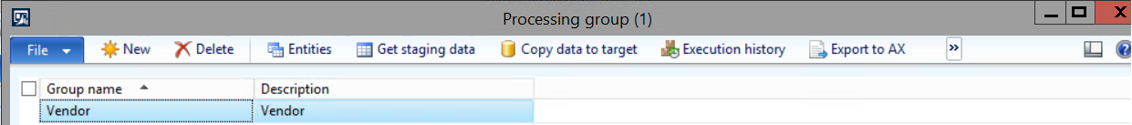

Click on entities. Source will be AX as we want to export data from AX.

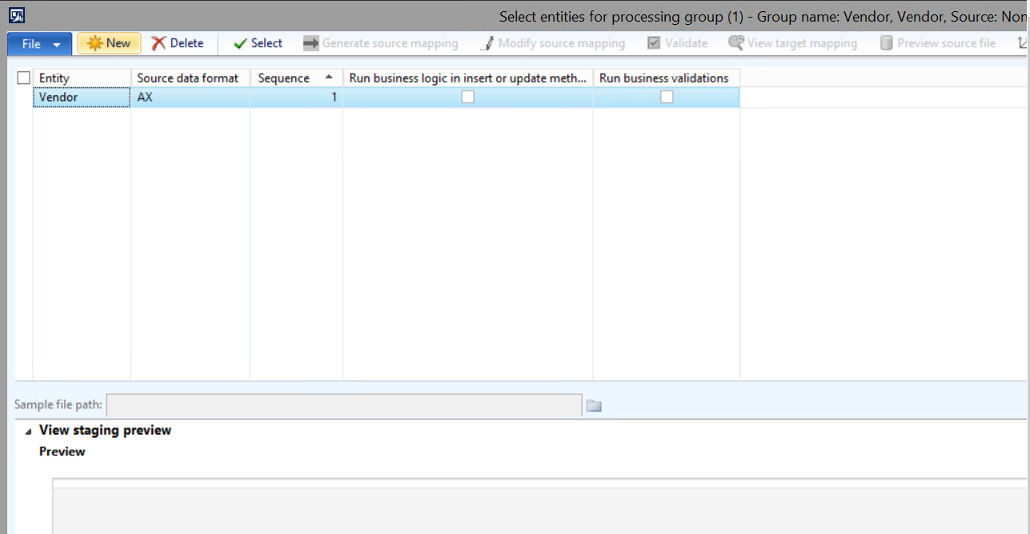

## Get staging data

Close this form and go back to the previous form, click on get staging data.

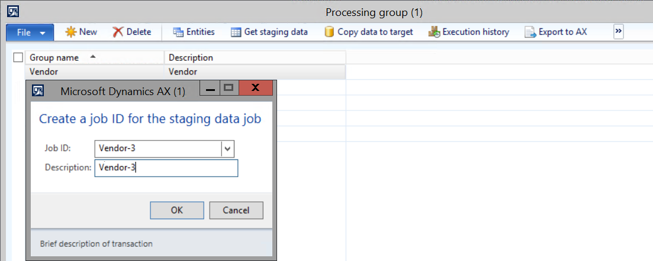

Click on OK button, so that the below screen will open.

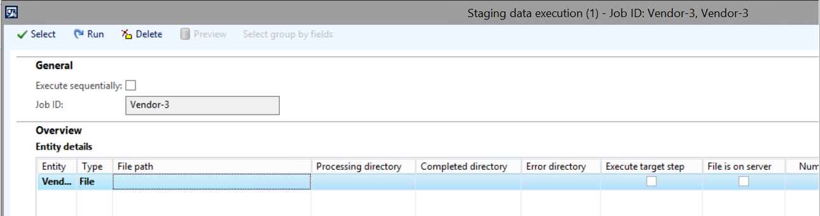

Click on Run button. After that below screen will open.

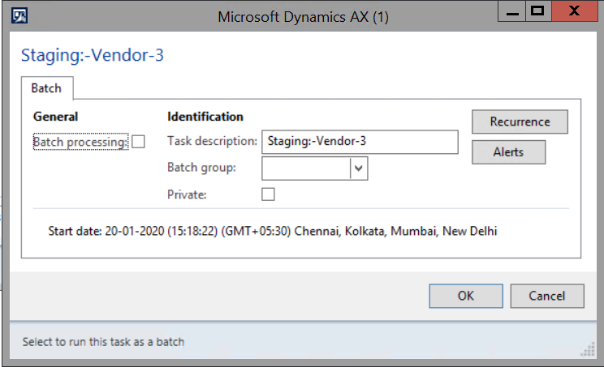

Click on OK button. So that below message screen will be populated.

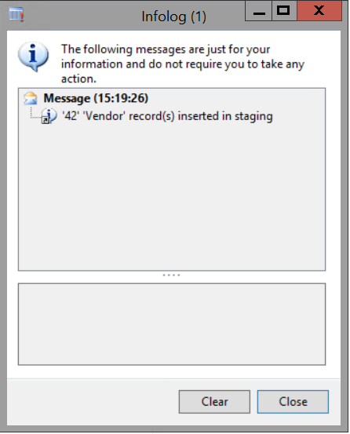

Click on export to file button at the top and select a batch job id in the form that opens.

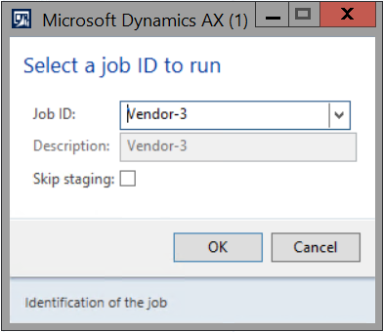

Click on ok button. After that new screen as displayed below will open. In this screen, select a processing group created for XML format. Steps to create processing group with XML format have been mentioned at the end of the document.

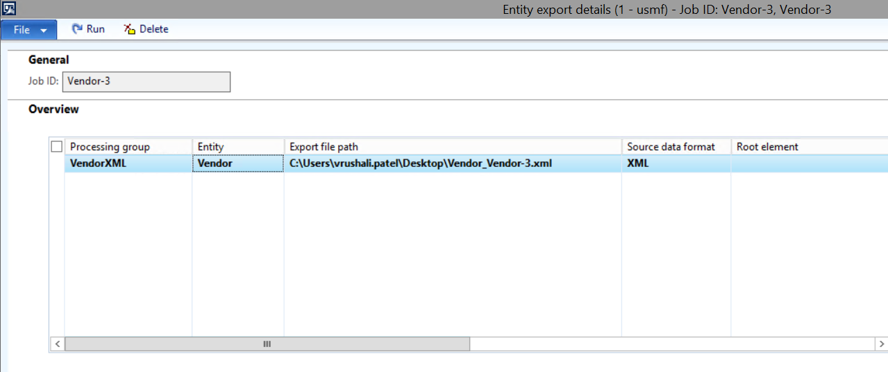

Click on Run button.

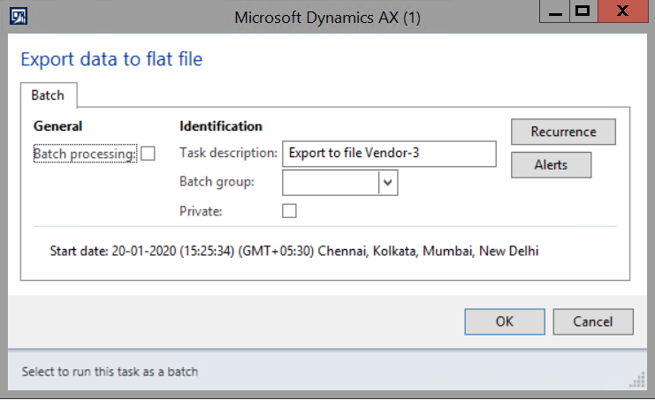

Click on OK button.

Data will be exported to the file as shown below.

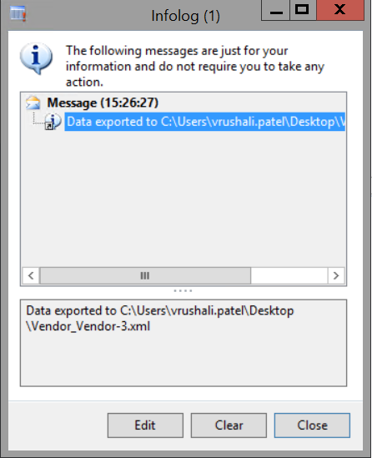

You can view the data in the file as below:

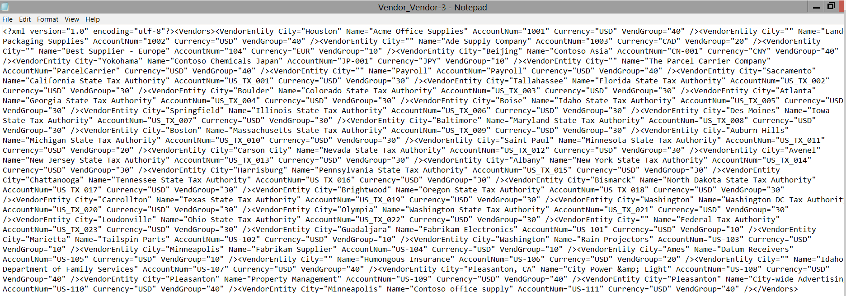

**Create a processing group with XML format**

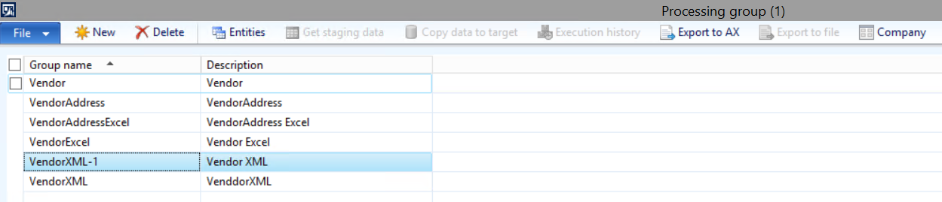

Click on Entities button. Select “XML” as the source data format.

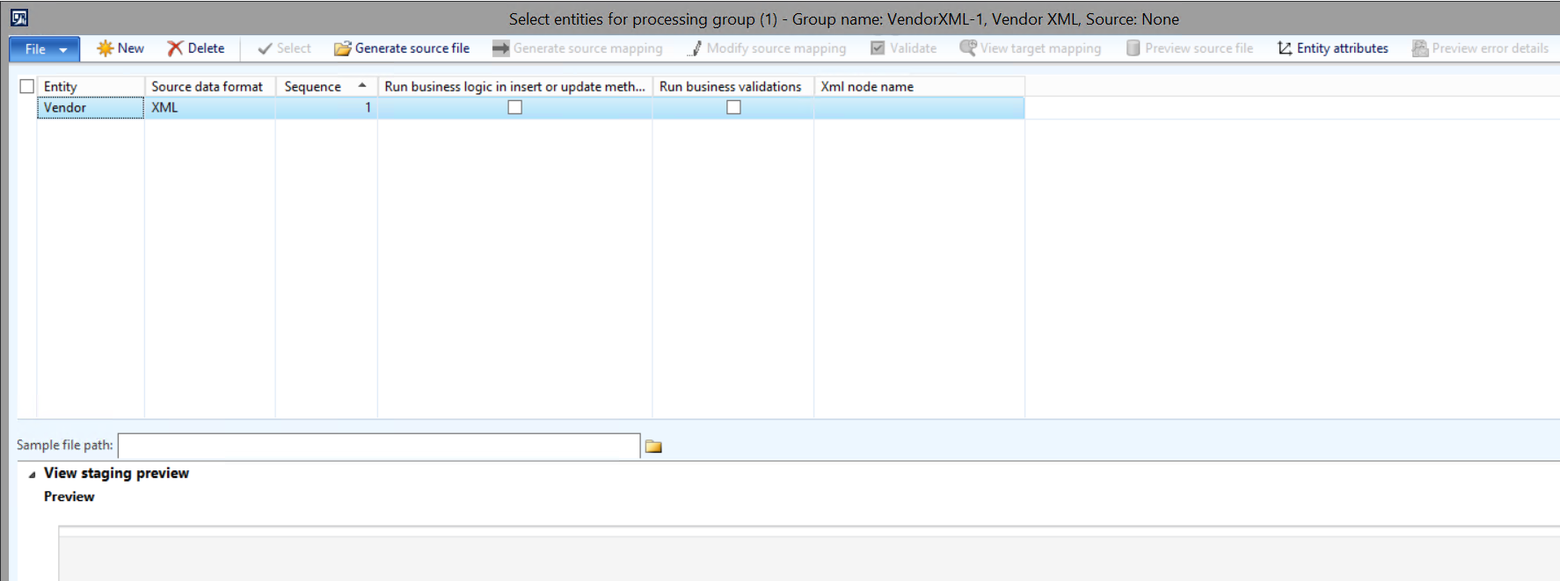

Click on Generate source file. Wizard will open as displayed below.

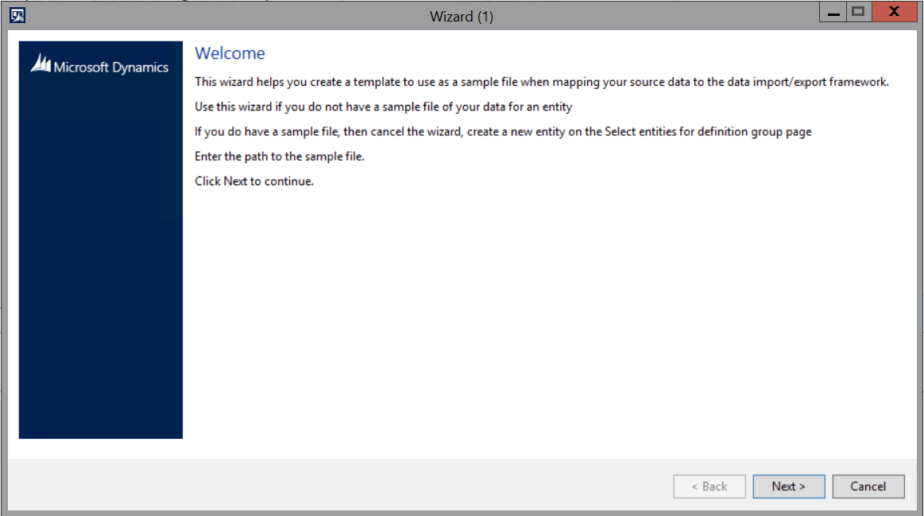

Click on Next button.

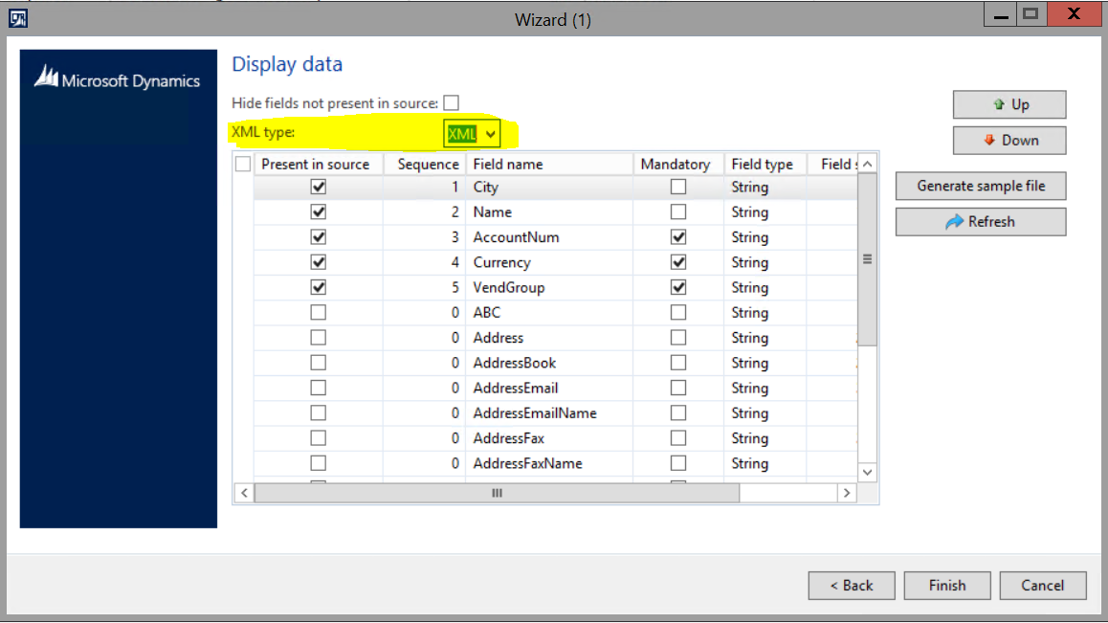

In the above screen, select “XML” in the XML type field. Select the fields that you want to exports from the vendors table.

Click on Generate Sample file.

The file with below format will open. Now you need to save the file as XML on your desired location.

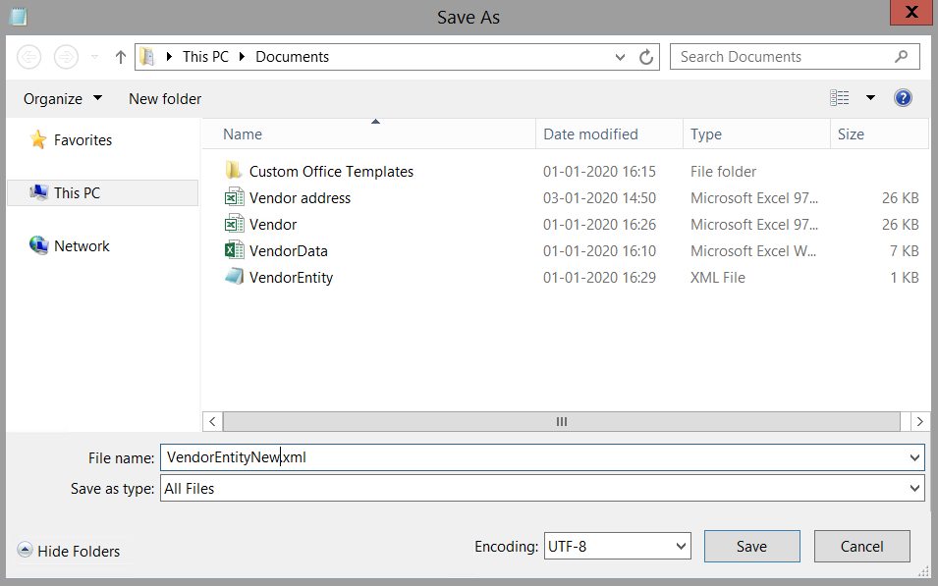

Click on save button.

Click on Finish button in the wizard.

Now go to the processing group and click on Entities button. In this form, need to select the path of the sample XML file that we have created in the above step.

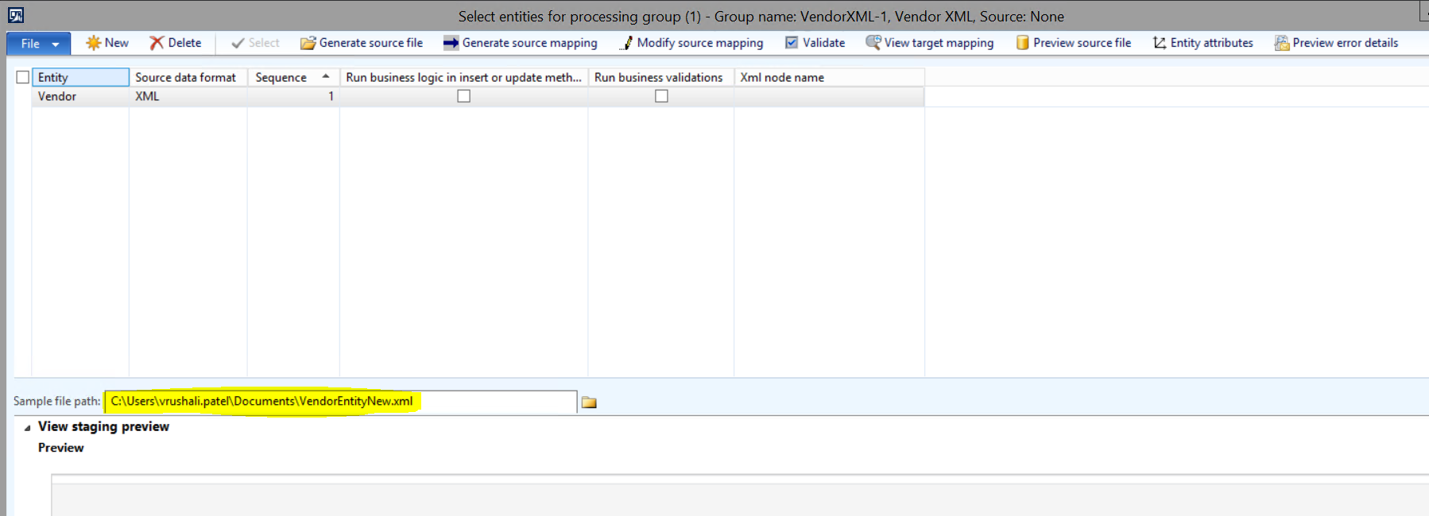

Click on Generate Source mapping button. If mapping is done successfully, then below screen will open.

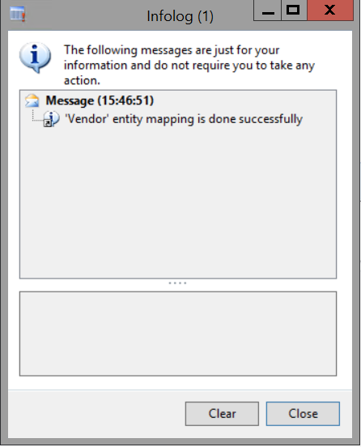

Click on Validate button.

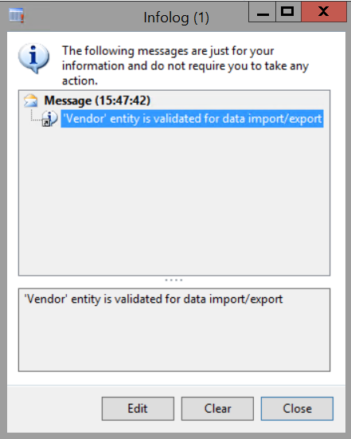

Now you can use this processing group to export data in the XML format.