Contents

Create Format File (CSV/Excel) 1

Create custom entity for data import/export 1

Create Target Entity 3

Processing group 3

Convert CSV to Excel 5

Export data from AX to the created format file 8

Processing group 8

Get staging data 8

Import data from the updated file 13

Processing group 13

Get staging data 14

Copy Data from one company to another without exporting the data to the file 17

**Define the format of your source data** 17

**Define a processing group to export data from Microsoft Dynamics AX** 17

**Process data from source to staging** 17

**Validate the data in staging** 18

**Switch companies to copy data to another company** 18

**Validate the data in target** 18

Reference Link 19

Issue Resolution 19

In this document, I have provided the flow to export project category group from one company (USMF) and import the same to the other company (PLTD).

# Create Format File (CSV/Excel)

## Create custom entity for data import/export

When creating entity in the target entities, if the entity does not exist, then create the custom entity from Data import export framework > Common > Create a custom entity for data import/export as shown below:

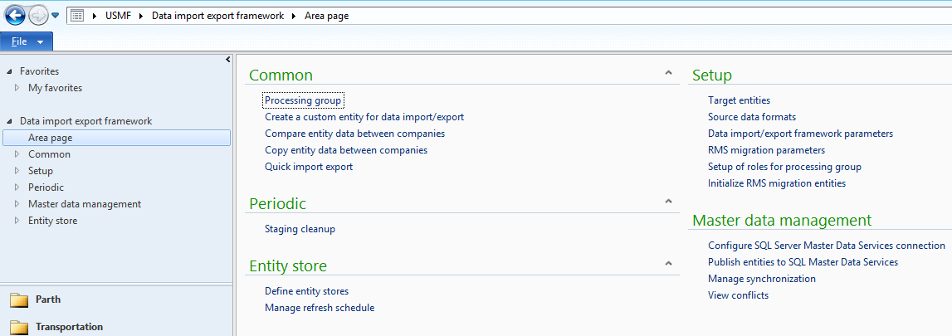

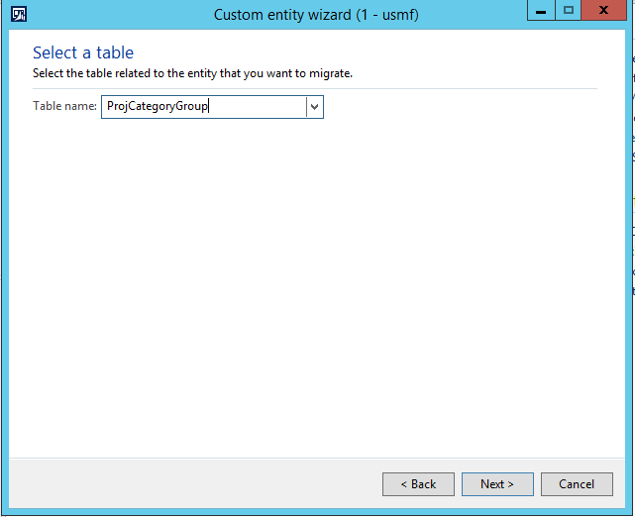

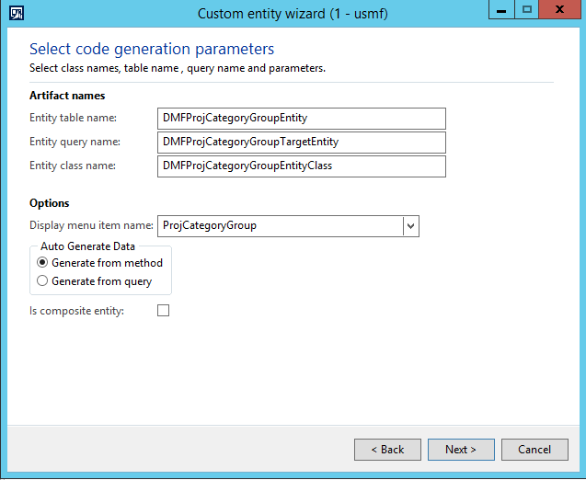

Next > Finish

## Create Target Entity

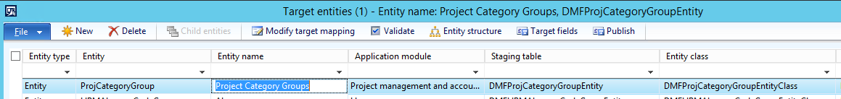

## Processing group

Create processing group, to create the format of the file, either CSV or Excel.

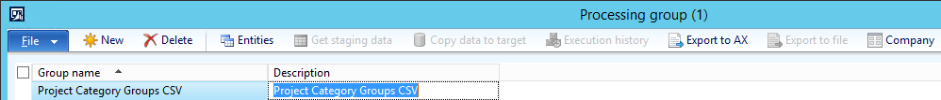

Click on entities and enter source file as csv or excel, in which data to be exported or from which data to be imported in to AX.

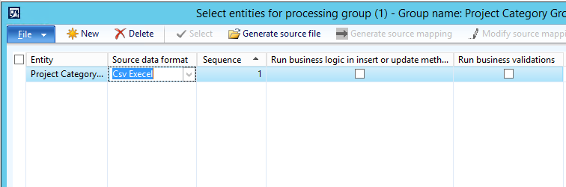

Click on generate source file and run wizard. Click on next button. Select all the columns which are to be imported or exported.

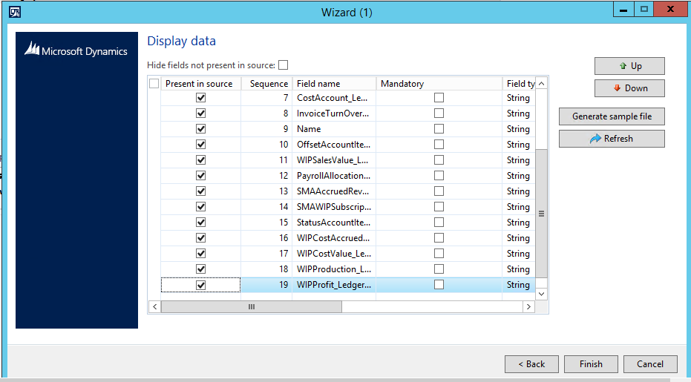

Click on Generate sample file. New csv file will be populated as shown below.

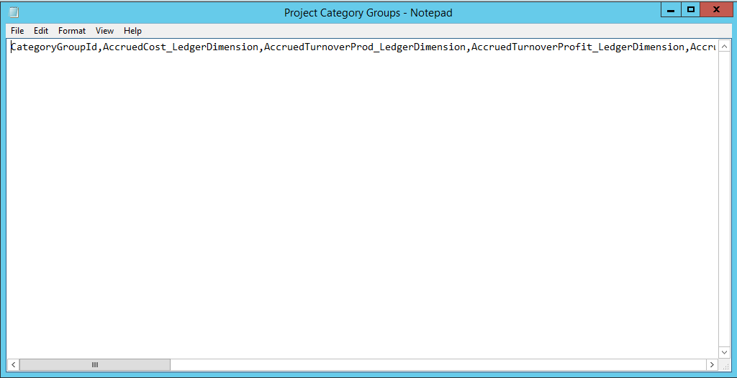

Save the file say name as projectcategorygroupdmf and close the file.

Click on finish button and close the wizard.

Update the sample file path where above file has been stored.

# Convert CSV to Excel

Open Microsoft excel.

Click on tab Data > From Text

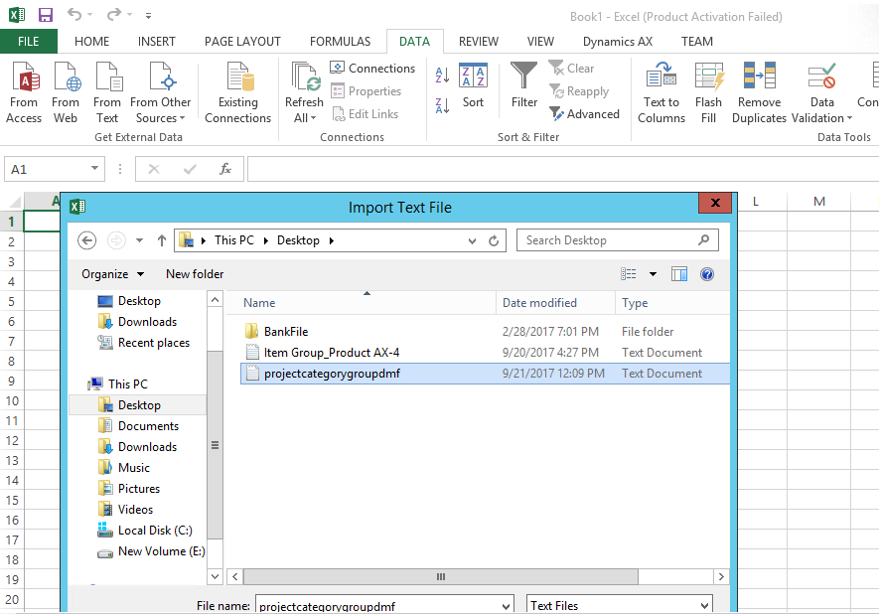

Click on import button. Click on next. Select comma as delimiters.

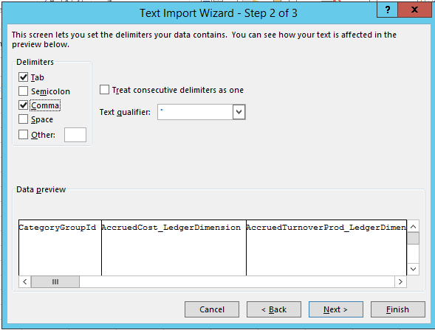

Click on next, finish button and click ok.

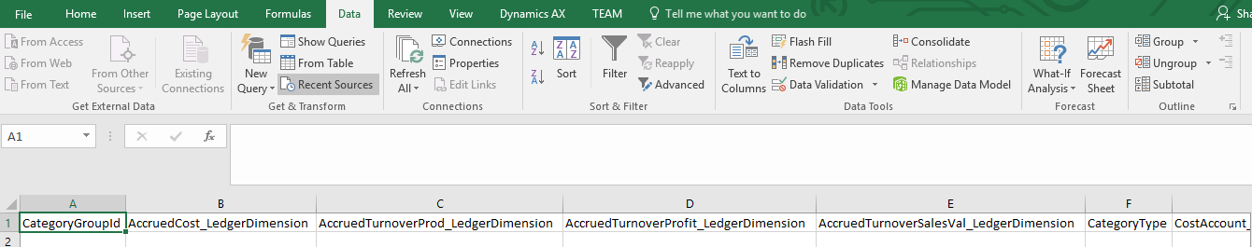

# Export data from AX to the created format file

## Processing group

Create processing group for project category group for exporting data from AX

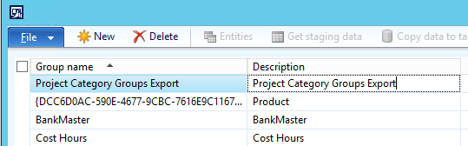

Click on entities. Source will be AX as we want to export data from AX.

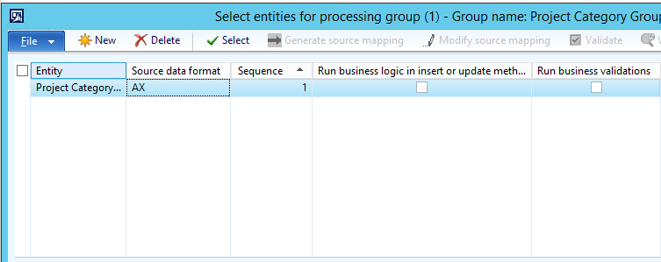

## Get staging data

Close this form and go back to the previous form, click on get staging data.

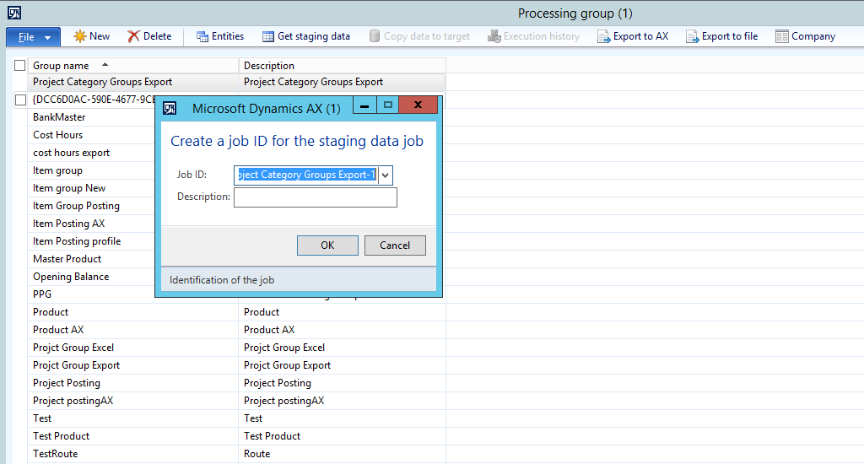

Click on Run.

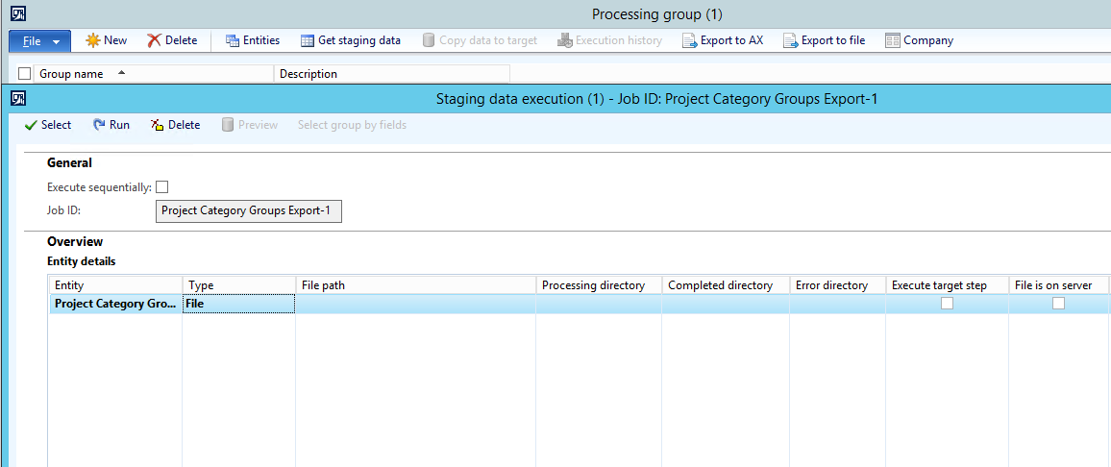

Click on Ok.

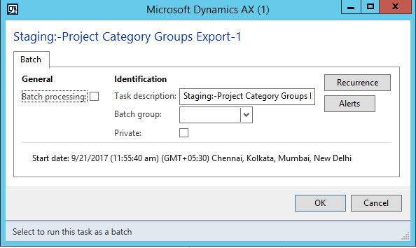

Message will be populated as below:

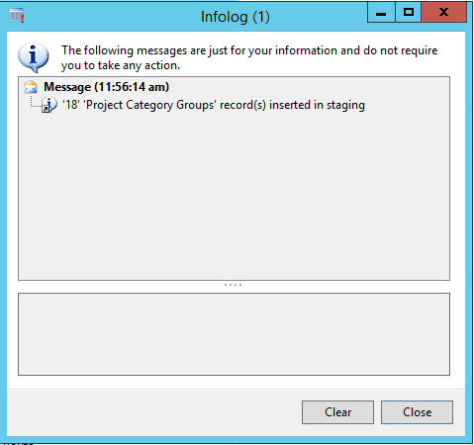

Click on export to file button at the top and click on ok button on populated new form.

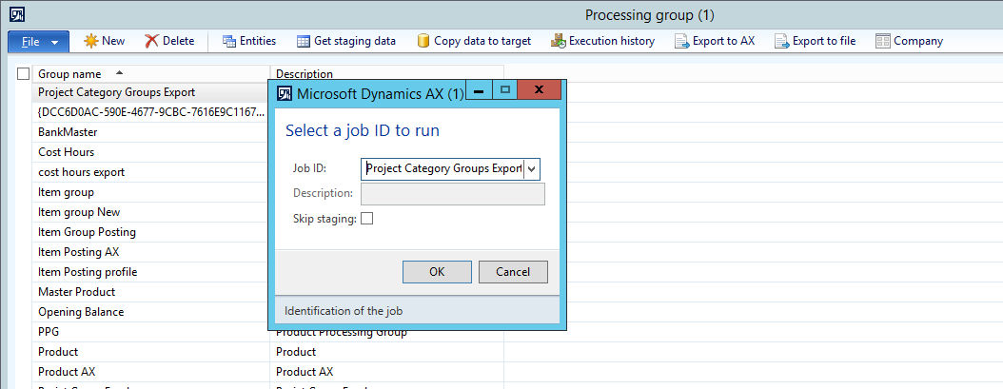

Select processing group with csv or excel file.

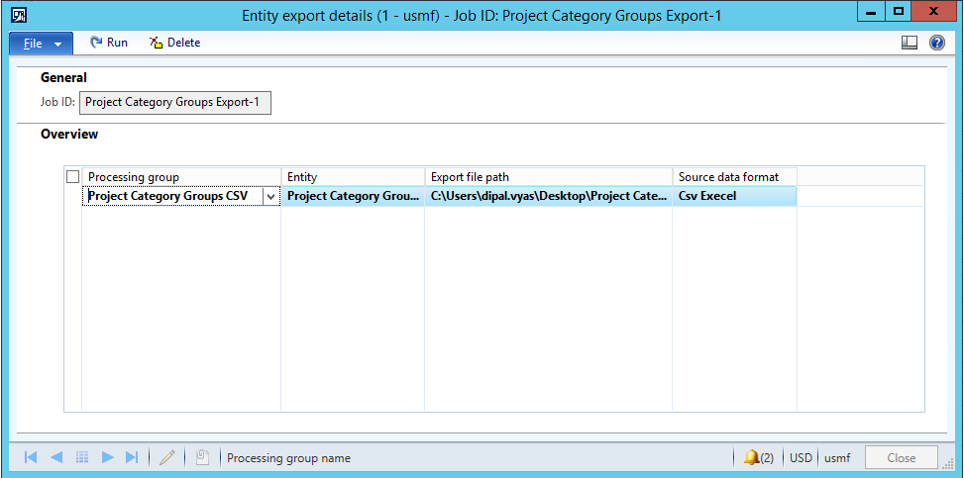

Click on run.

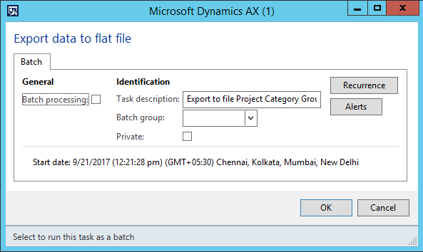

Click ok. Data will be exported to the file as shown below:

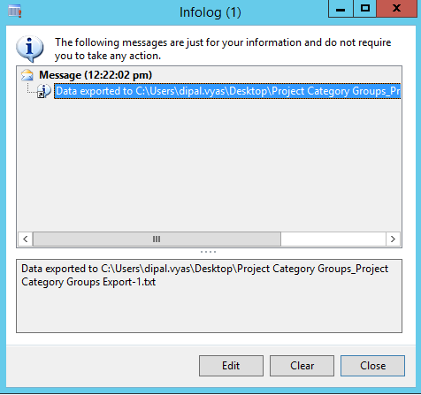

You can view the file as shown below:

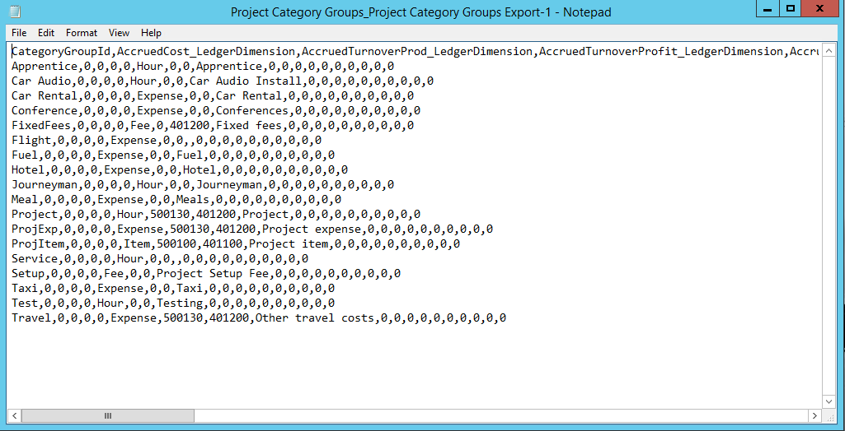

# Import data from the updated file

## Processing group

To import the data from csv or excel file. Verify the company to which data to be imported. Select the processing group with csv or excel as source.

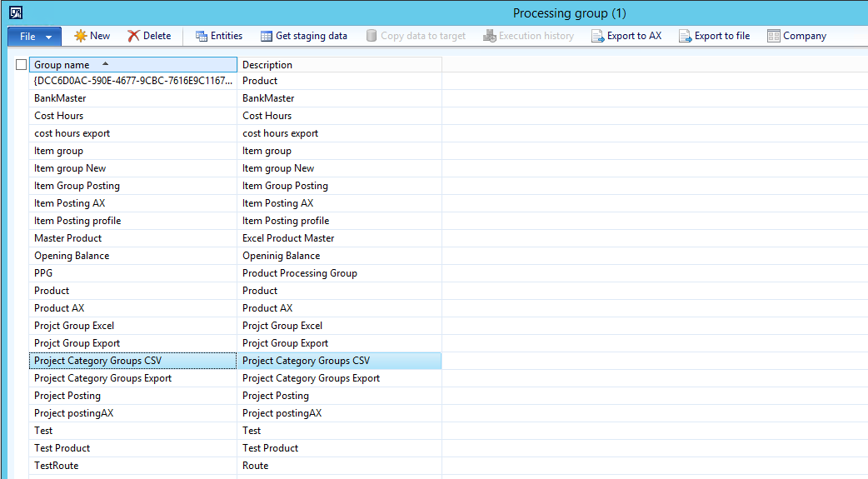

Click on entities and verify/update the file from which data to be imported.

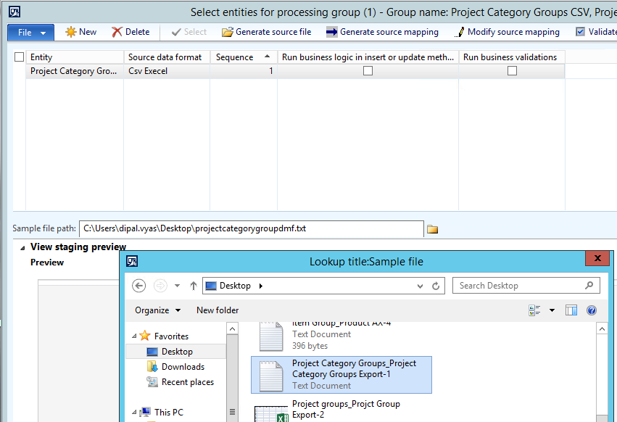

## Get staging data

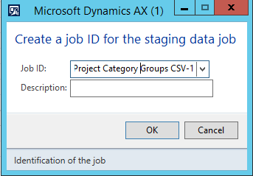

Click on run.

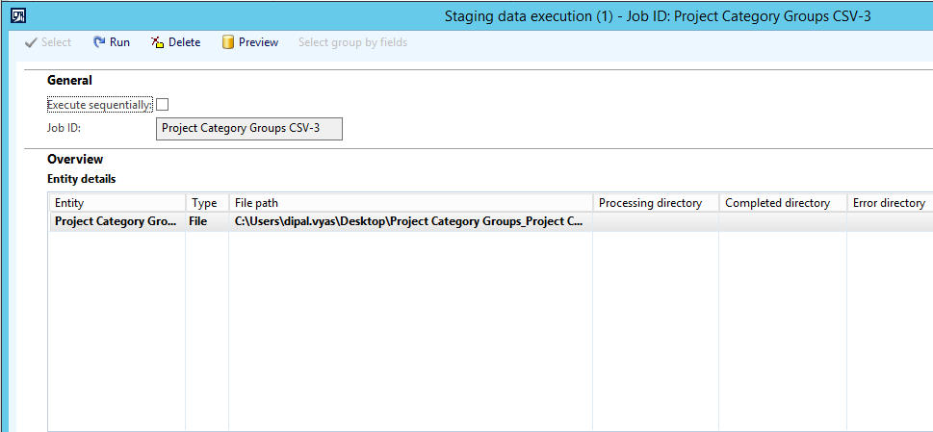

Data imported message will show as below:

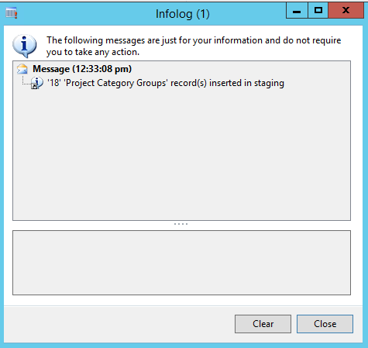

Click on button Copy data to target.

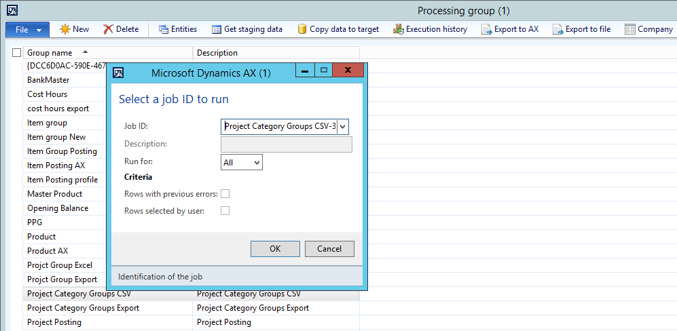

Click ok. Click on run.

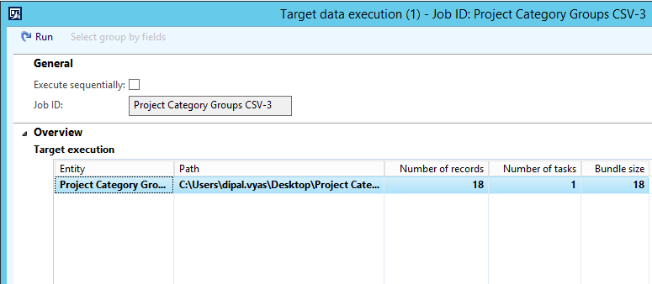

Message as below will be populated.

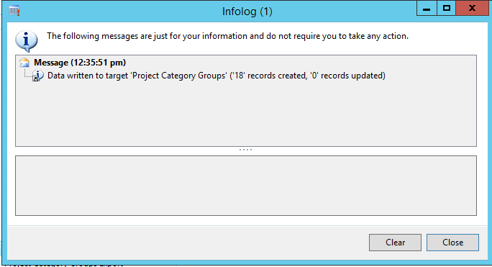

After that, you can verify data in the project category form in new company as below:

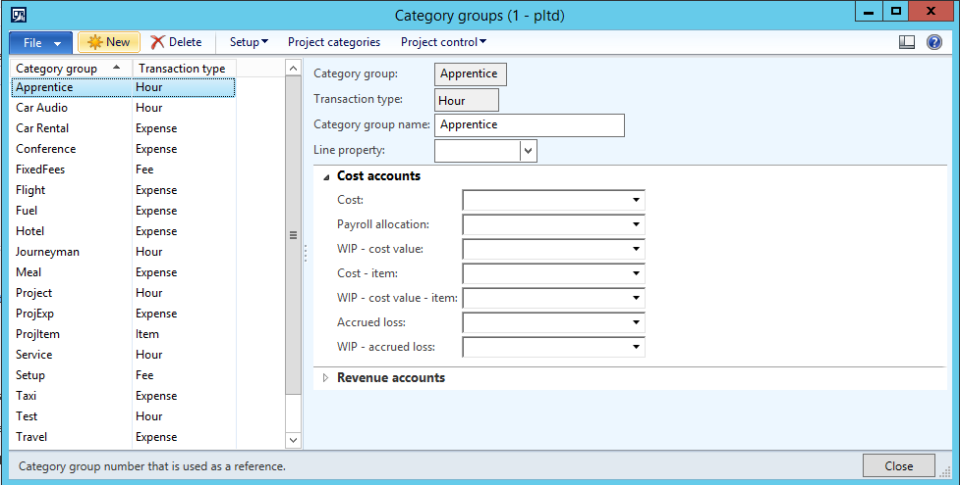

# Copy Data from one company to another without exporting the data to the file

**Define the format of your source data**

1. Open **Data Import/Export Framework** > **Setup** > **Source data formats**.
2. Click **New**, enter a name and a description, and then select **AX** from the **Type** list.

**Define a processing group to export data from Microsoft Dynamics AX**

1. Change the company to **CEU**.
2. In **Data Import/Export Framework**, click **Common** > **Processing group**, and then click **New** to create a new processing group.
3. Set the group name to **Export-Cust** and add a description.
4. Click **Entities** to select the entities to include in the processing group.
   1. In the **Select entities for processing group** form, click **New**, and then, for an entity name, select **Customer**.
   2. In the **Source data format** field, select the Microsoft Dynamics AX source data format that you created.
   3. Click **Select**, and then in the **DMFCustomerTargetEntity** form, on the **Range** tab, for **Field**, select **Customer group**, and for **Criteria**, select **20**, and then click **OK**.
   4. Close the **Select entities for processing group** form.

**Process data from source to staging**

1. In the **Processing group** form, select the Export-Cust group that you created, and click **Get staging data**.The **Create a job ID for the staging data job** form opens.
2. By default, an ID for the job is generated. If needed, you can modify the ID and add a description. Click **OK**.The **Staging data execution form** opens.
3. In the **Get data from source to staging** form, click **OK** to run immediately.The source data is copied to the staging tables.

**Validate the data in staging**

1. In **Data Import/Export Framework**, click **Common** > **Processing group** > **Execution history**, and then select the job that ran.
2. Click **View staging data**.
3. Review the staging data to validate that it matches the source.
4. Click **Validate all** to verify that all the related reference data is correct and present in the system.

**Switch companies to copy data to another company**

1. Switch to the **CEC** company.
2. In **Data Import/Export Framework**, click **Common** > **Processing group**, and then select the processing group to work with.
3. Click **Copy data to target**. The **Select a job ID to run** form opens.
4. Select a job and click **OK**. The **Target data execution** form opens.
5. Click **Run**, and then click **OK**. The data is copied to the target entity.

**Validate the data in target**

Verify that the customer data from the original company is displayed in either of the following ways:

* View staging data:
  1. In **Data Import/Export Framework**, click **Common** > **Processing group** > **Execution history** > **View staging data**, and then select the job that ran.
  2. Review the staging data to validate that it matches the source.
  3. Click **Validate all** to verify that all the related reference data is correct and present in the system.
* Verify that the customer data from the CEU company is now displayed in the **All Customers form**. Click **Accounts receivable** > **Common** > **Customer** > **All Customers **form.

# Reference Link

<https://us.hitachi-solutions.com/blog/data-migration-microsoft-dynamics-ax-2012-r2-r3/>

# Issue Resolution

Issue: System.Exception: Exception from HRESULT: 0xC0202009

Follow below steps in sequence

This time i had the same error on another system / other customer. I played a bit around and it seems to print out the error if the entity mapping is not correctly configured. I just describe the way i did it for exporting vendors.

First I created a definition group 'VendorsToStaging' to put the entities to staging on the source system. I configured the file format to AX. The I run the 'To Staging' and checked the staging files.

Next I created a second entity 'VendorsCSV' to export the entities. I set the file format to CSV and created a "sample file" with all fields. I saved the sample file as Vendors-Sample.txt and set it in the sample path line (via UNC Path). I also clicked regenerate source definition and openden the source definition for a short check if the mappings are done.

Then I switchend back to the first entity 'VendorsToStaging' and clicked export to file. In the (second) dialog I selected the VendorsCSV def group and then the data was exported correctly.

For springstudio

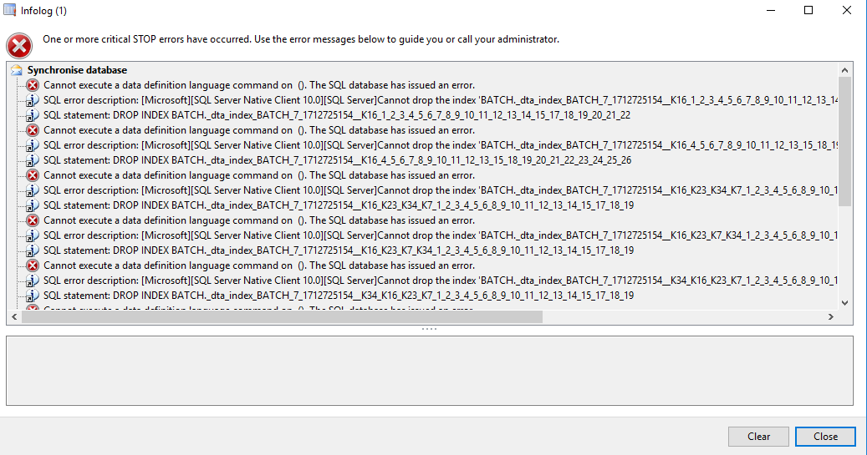

Updated in DMFParameters table

Methos : getServiceConnectionUrl, validateSharedFileFolderPath