Depreciation in bulk (Proposal)

* For computation of Depreciation AX provides two books. Both have their own importance and client use this book as per need.

1. Valuation model
2. Depreciation book

* Value Model Depreciation should always be initiated through the Fixed Assets Journal. (Fixed assets | Journals | Fixed assets).
* Depreciation Book (Tax Book) Depreciation should always be initiated through the Depreciation Book Journal. (Fixed Assets | Journals | Depreciation book journal).
* **In this example, we fully concentrate on depreciation through VALUE MODEL.**
* Here we assume that client have already configure value model for asset and already have asset in AX, so we directly focus on depreciation part
* As previously mentioned we concentrate on VALUE MODEL so we directly go to fixed assets journal.
* Go to Journal > fixed assets.

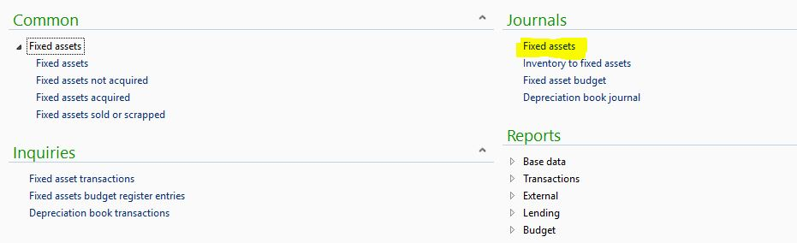

* Create fixed asset journal by new button with following journal type.

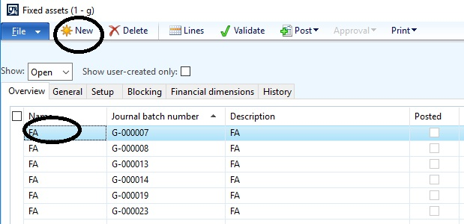

* Journal type would be this.

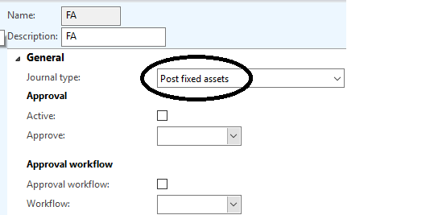

* Than go to lines of that journal and click on proposals and select depreciation proposal.

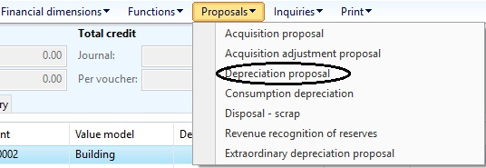

* Afterwards select parameters for run depreciation like value model or fixed assets number

Etc.

* The date given on parameter is very relevant for running depreciation as system calculate

Depreciation till that date from acquisition date or from starting of financial year.

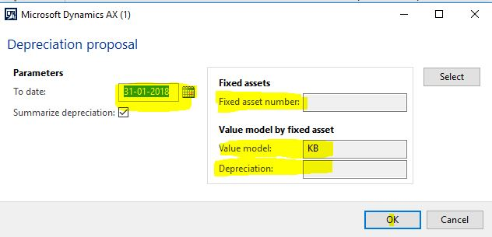

* As result, you find your result that you want as my result comes as per my value model and depreciation profile. Depreciation is calculated by system for value model “KB” as I given in parameter, as my value model “KB” contain two FA ,it calculate depreciation for this two.

