In this example, we explain that how to get Alert dialog box on CRM form and perform the action in form based on Alert Dialog box selection.

Suppose you have requirement like based on Complaint Type the form customization should change process run time and new case form will open based selection on Alert Dialog box selection.

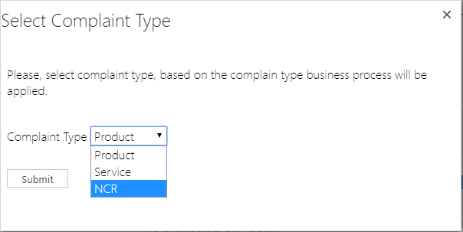

**Step1:** we used HTML web resource to create/display alert dialog box on CRM form. We bind data of Complaint Type in dropdown. On Submit, button value will pass data into CRM Form.

The code is as below.

<html><head>

<title> Complaint Type</title>

<script src="ClientGlobalContext.js.aspx"></script>

<script src="https://ajax.googleapis.com/ajax/libs/jquery/3.3.1/jquery.min.js"></script>

<script language="javascript" type="text/javascript">

function gettypes(){

//function declaration to get data from entity and display in alert popup box.

var complaintTypes;

var oDataUri = GetGlobalContext().getClientUrl() +"/xrmservices/2011/OrganizationData.svc/new_complainttypeSet";

$.ajax({

type: "GET",

async: false, contentType: "application/json; charset=utf-8", datatype: "json",

url: oDataUri, beforeSend: function (XMLHttpRequest) {XMLHttpRequest.setRequestHeader("Accept", "application/json");},

success: function (data, textStatus, XmlHttpRequest) {

var ddlComplainType = document.getElementById("ct");

for(var i=0;i<data.d.results.length;i++)

{

var option = document.createElement("OPTION");

//Set Customer Name in Text part.

option.innerHTML = data.d.results[i].new_name;

//Set CustomerId in Value part.

option.value = data.d.results[i].new_complainttypeId;

//Add the Option element to DropDownList.

ddlComplainType.options.add(option);

//alert(data.d.results[i].new_name);

//alert(data.d.results[i].new_complainttypeId);

}

},

error: function (XMLHttpRequest, textStatus, errorThrown) {

}

});

return complaintTypes;

}

function btnSubmit()

{//Submit button function

var crmWindow = parent.Alert.getCrmWindow();

var ddlText = document.getElementById("ct").options[document.getElementById("ct").selectedIndex].innerHTML;

var ddlVal = document.getElementById("ct").value;

var lookUpItem =new Object();

lookUpItem.id =ddlVal;

lookUpItem.name = ddlText;

lookUpItem.entityType ='new_complainttype';

crmWindow.Xrm.Page.getAttribute("new_natureofcomplaint").setValue([{ id: lookUpItem.id, name: lookUpItem.name, entityType: lookUpItem.entityType}]);

crmWindow.Xrm.Page.getAttribute("new_natureofcomplaint").fireOnChange();

parent.$("#alertJs-wrapper").hide();

}

</script>

</head><body onload="gettypes()" style="font-family: &quot;Segoe UI Light&quot;, &quot;Segoe UI&quot;, Tahoma, Arial !important; font-weight: lighter !important; font-size: 16px !important; word-wrap: break-word;" onfocusout="parent.setEmailRange();">

<br><p>Please, select complain type, based on the complaint type business process will be applied.</p>

<br>

<span>Complaint Type</span> <select id="ct" style=" width:100 ;font-family: Segoe UI Light, Segoe UI, Tahoma, Arial !important;

font-weight: lighter !important; font-size: 16px !important;"></select>

<br> <br>

<input onclick="btnSubmit();" value="Submit" style="height: 24px;font-family: Segoe UI,Tahoma,Arial;border: 1px solid #C6C6C6; background-image: none;margin-top: 10px; width: auto !important; min-width: 80px;white-space: nowrap; color: #444444; background-color: #FFFFFF" type="Button">

</body></html>

**Step2:** Now, we write java script to show alert dialog box on CRM form when form is loaded. After from loaded successfully, set complaint type value as per selection done by user on alert dialog box.

* “Alert.showWebResource” method was used to get data from Popup box and to set in CRM form value.
* “new_PopupBeforeOpeningCaseForm” is the name of html web resource, which is mention in **Step1**.

We used on reference like –

<https://github.com/PaulNieuwelaar/alertjs>

<https://archive.codeplex.com/?p=alertjs>

//To display the popup on new case creation with lookup field.

function displaypopup()

{

var activeProcess = Xrm.Page.data.process.getActiveProcess();

var activeProcessId= activeProcess.getId();

var activeProcessName= activeProcess.getName();

if (activeProcessId.toUpperCase() == "0FFBCDE4-61C1-4355-AA89-AA1D7B2B8792" && Xrm.Page.ui.getFormType()==1)

{

Alert.showWebResource("new_PopupBeforeOpeningCaseForm", 600, 300, "Select Complaint Type");

}

else

{

}

}

**Step3:** Based on the Complaint Type value selection, form customization and process will be set. The code is as below.

function CaseBusinessProcessSwitch()

{

var activeProcess = Xrm.Page.data.process.getActiveProcess();

var activeProcessId= activeProcess.getId();

var activeProcessName= activeProcess.getName();

if (activeProcess != null)

{

if(Xrm.Page.getAttribute('new_natureofcomplaint').getValue() != null)

{

//To get value of Complaint type in the form along with Id.

var name = Xrm.Page.getAttribute('new_natureofcomplaint').getValue()[0].name;

var id = Xrm.Page.getAttribute('new_natureofcomplaint').getValue()[0].id;

//Business Process Flow id in CRM. In CRM, the id of Business Process is unique.

//Please replace your business process ID.

var businessProcessProductId="**DF76721D-D1F2-4CFB-8C8F-4F1743608308**";

var businessProcessServiceId="**ADB7F44A-43B7-41FB-A552-1C0EA832A7AD**";

var businessProcessDefaultId="**0FFBCDE4-61C1-4355-AA89-AA1D7B2B8792**";

if (name.toUpperCase() == "PRODUCT")

//Based on Nature of complaint the business process flow will change on the form.

{

//To set business process flow we used below syntax

Xrm.Page.data.process.setActiveProcess(businessProcessProductId, callbackFunction);

}

else if (name.toUpperCase()=="SERVICE")

{

Xrm.Page.data.process.setActiveProcess(businessProcessServiceId, callbackFunction);

}

else if (name.toUpperCase()=="NCR")

{

//To hide Business process flow on form we use below syntax

Xrm.Page.ui.process.setVisible(false);

}

}

else {

}

}

else {

}

}

// Call back function post Process flow switch

function callbackFunction(response)

{

if (response == "success")

{

//alert("BPF changed !!!");

// Save the form

//Xrm.Page.data.entity.save();

}

else

{

//alert("Error changing BPF!!!");

}

}

function FillLookup(Id,Name)

{

//Set Lookup Value after change BPF.

var lookUpItem =new Object();

lookUpItem.id =Id

lookUpItem.name = Name

lookUpItem.entityType ='new_complainttype';

Xrm.Page.getAttribute("new_natureofcomplaint").setValue([{ id: lookUpItem.id, name: lookUpItem.name, entityType: lookUpItem.entityType}]);

}

function SetLookupValue()

{

//debugger;

//var debt= Xrm.Page.data.entity.getId();

var activeProcess = Xrm.Page.data.process.getActiveProcess();

var activeProcessId= activeProcess.getId();

var activeProcessName= activeProcess.getName();

if (activeProcess != null)

{

//Please replace your business process ID.

var businessProcessProductId="**DF76721D-D1F2-4CFB-8C8F-4F1743608308**";

var businessProcessServiceId="**ADB7F44A-43B7-41FB-A552-1C0EA832A7AD**";

var businessProcessDefaultId="**0FFBCDE4-61C1-4355-AA89-AA1D7B2B8792**";

if (activeProcessId.toUpperCase() == businessProcessProductId)

{

//To set nature of complaint field with Id

FillLookup("**98FBFFB9-4307-E911-A96B-000D3AF29ABD**","Product");

}

else if (activeProcessId.toUpperCase()==businessProcessServiceId)

{

FillLookup("**451960C1-4307-E911-A96B-000D3AF29ABD**","Service");

}

else

{

}

}else

{

}

}

**Step4:**

In above all steps, we explained about the technical stuff and now we will display the screens of form customization.

When New Case form is opened, the alert popup will be displayed as below.

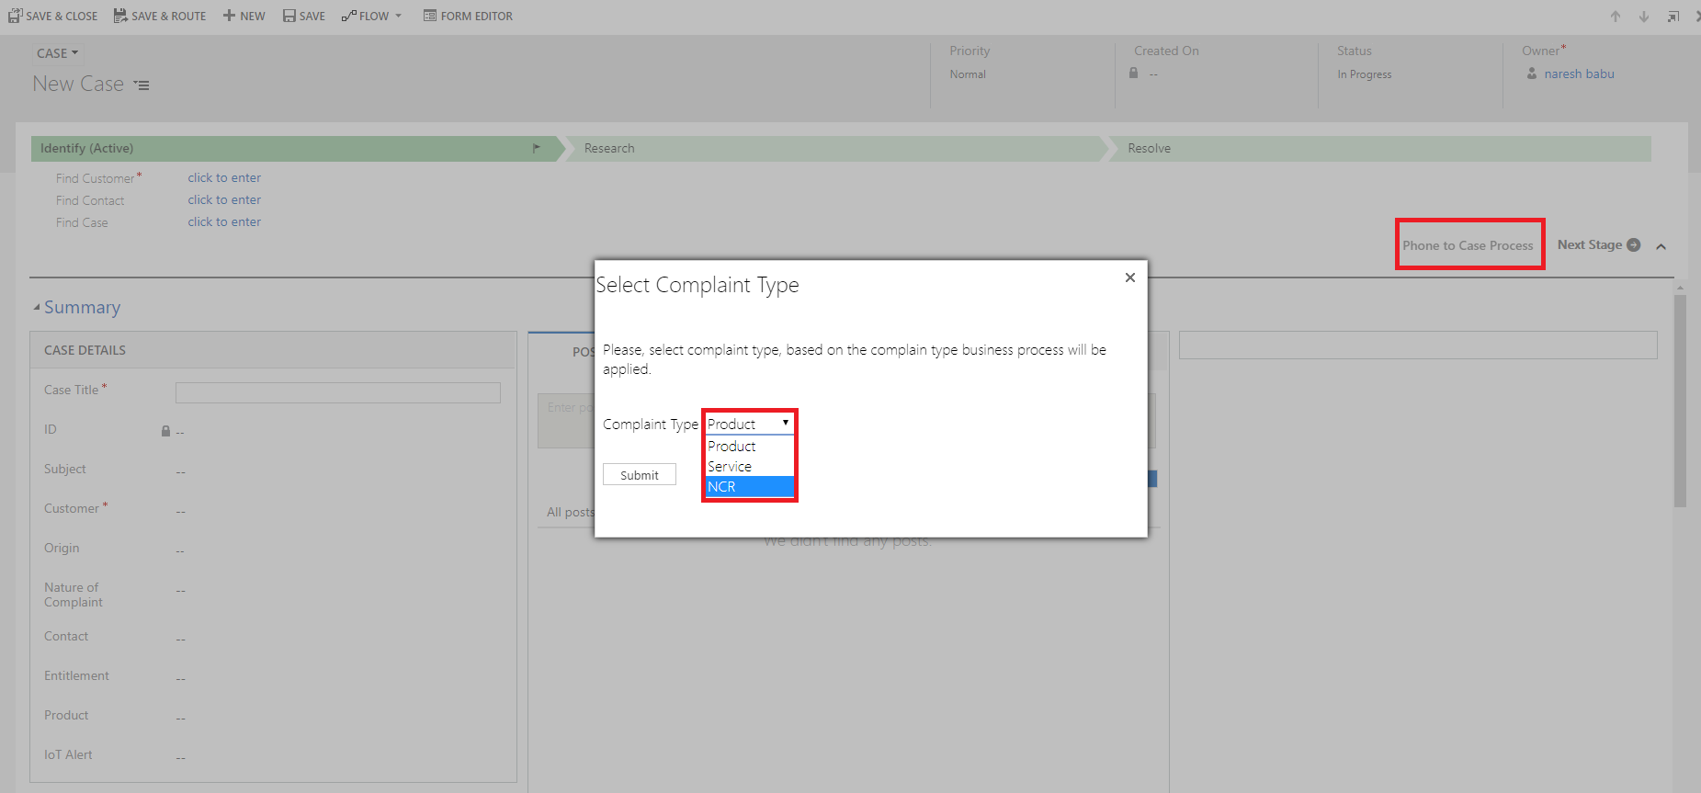

In the above screen, you can see the ***Default Business process*** flow is “***Phone to Case process***”.

Choose the Complaint type and click on “submit” button.

**Step5:** If Complaint Type is “***Product***” then

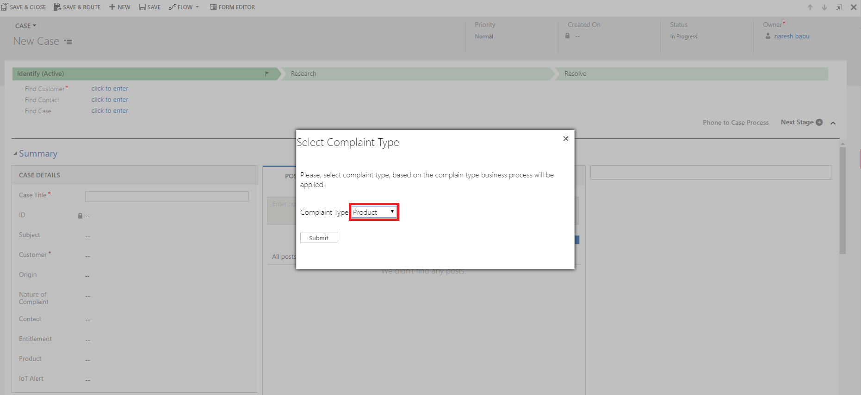

In form, Nature of Complaint field will be “***Product***” and Business process flow will change to “**Product Business Process**”. Refer the below screen.

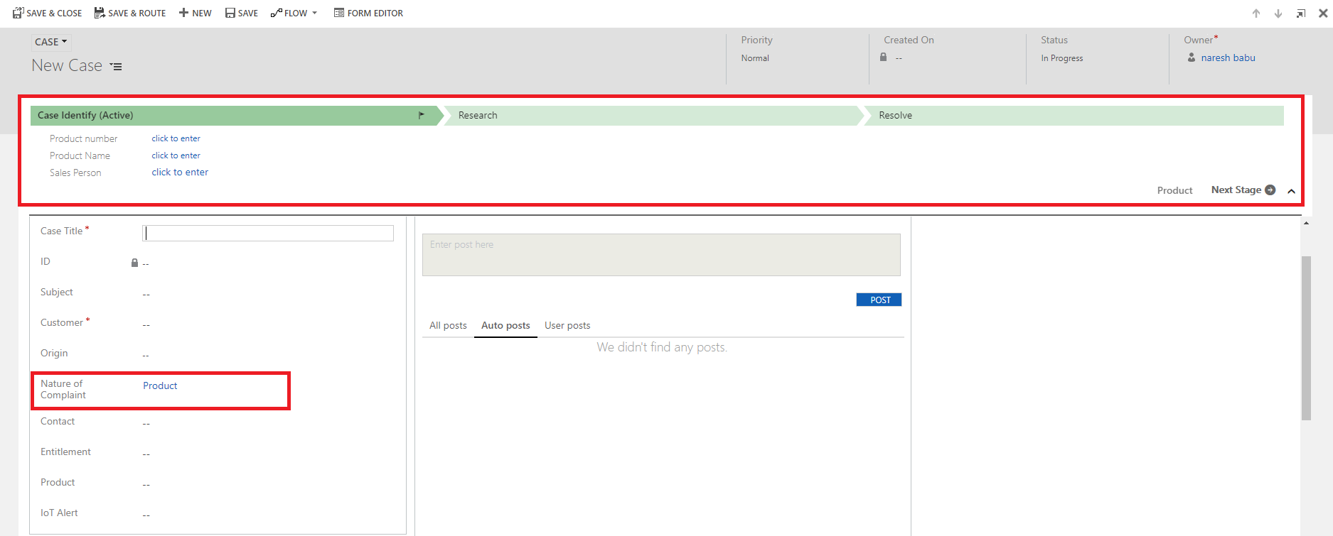

**Step6:** If Complaint Type is “***Service***” then

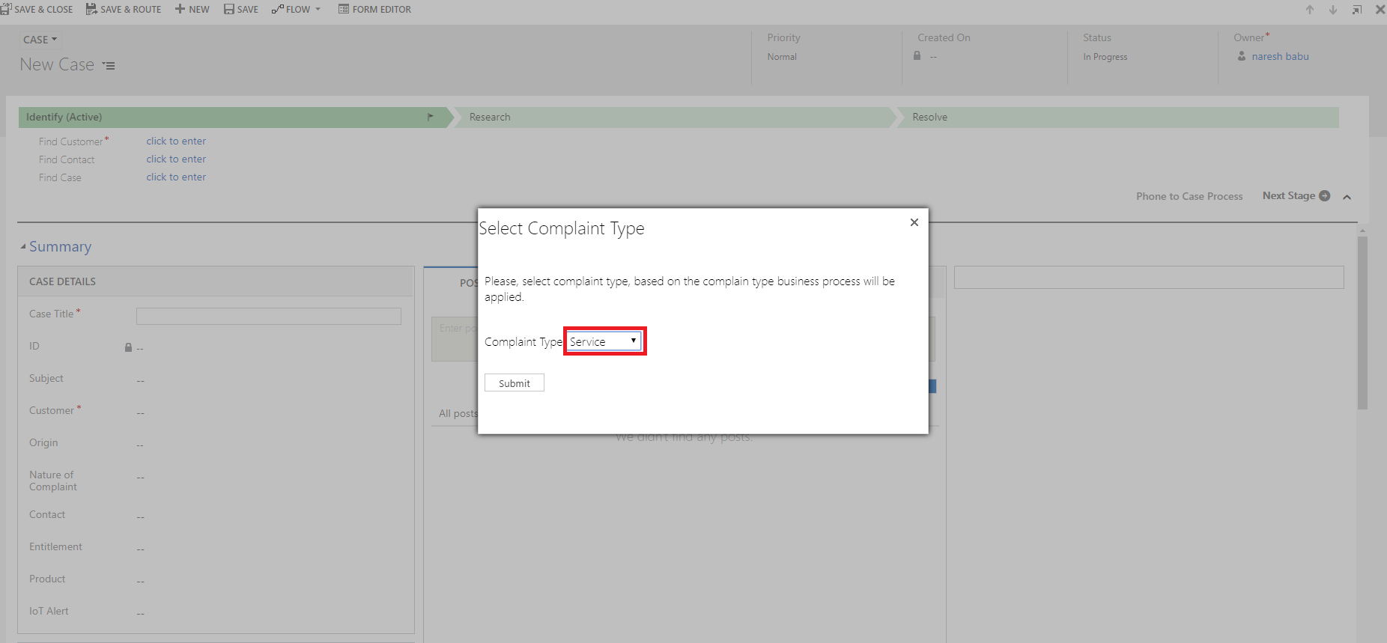

In form, Nature of Complaint field will be “**Service**” and Business process flow will change to “**Service Business process**”. Refer the below screen.

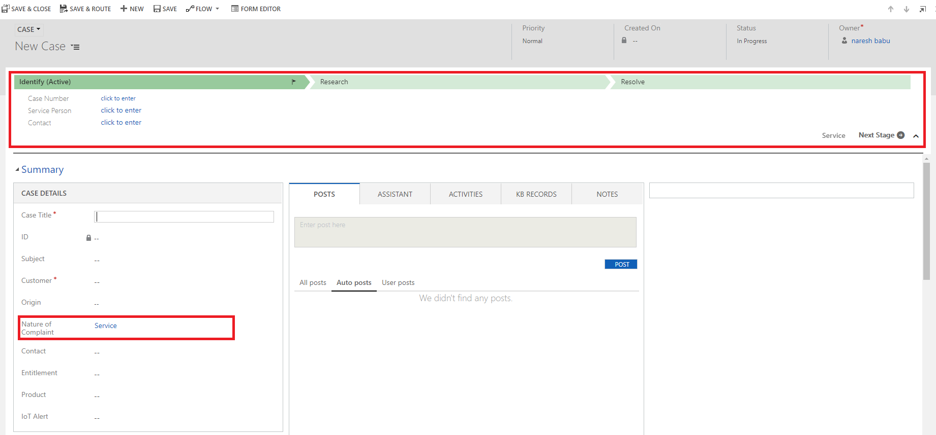

**Step7:** If Complaint Type is “**NCR**” then

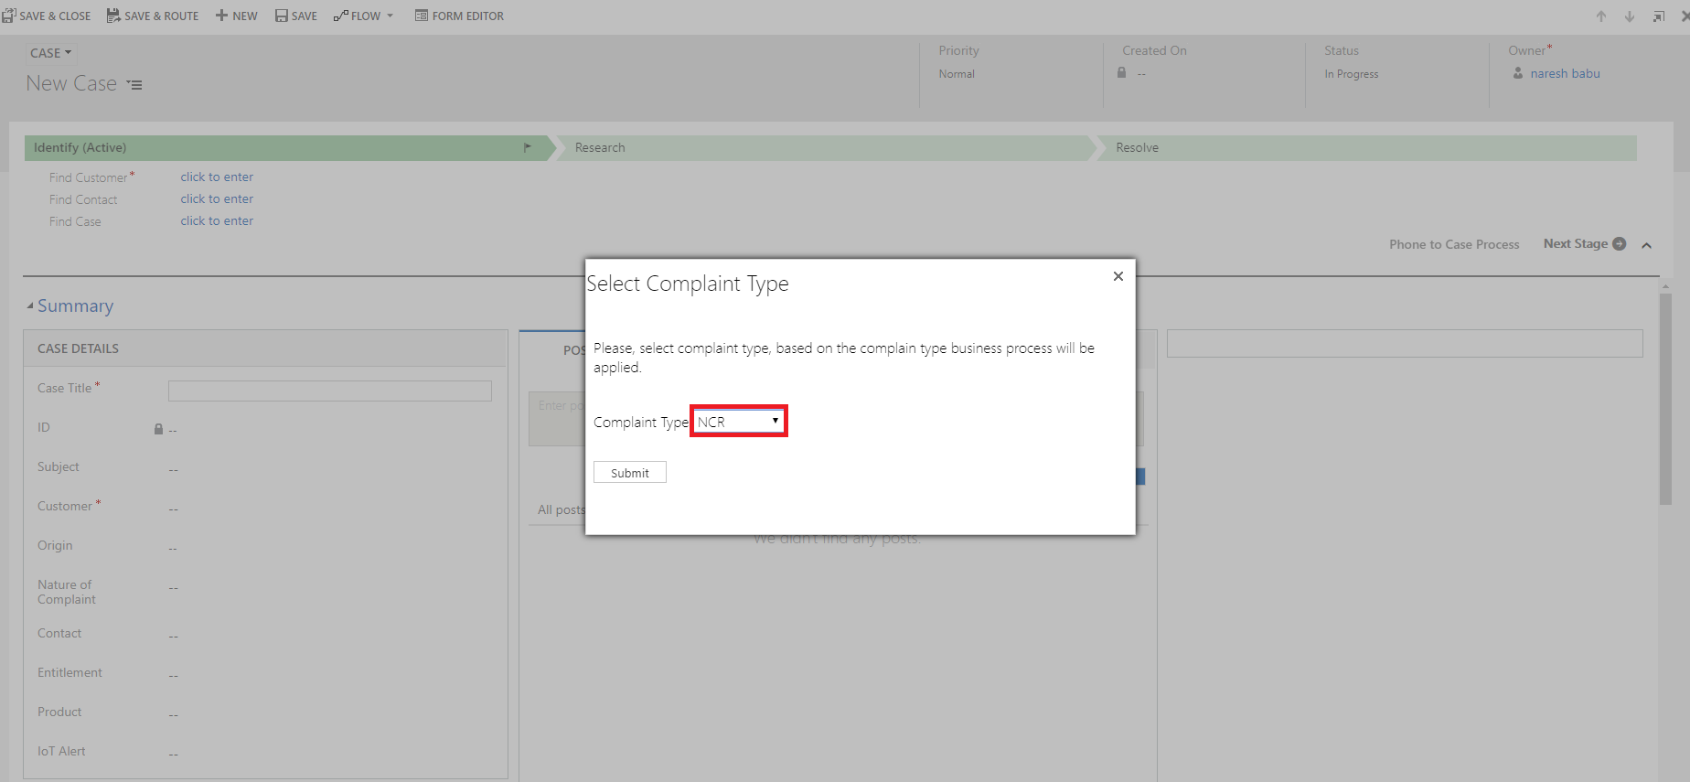

In form, Nature of Complaint field will be “**NCR**” and Business process flow will disabled. Refer the below screen.

