Adding display method in D365F&O

It can be achieved by using the **extension class**.

**Step 1: Create a new class and name it as <Classname>_<Extension>.**

public static class CustTable_Extension

{

}

**Step 2 : Now add the display methods in the class which is required to be shown**.

|  |
| --- |
| public static class CustTable_Extension  {      [SysClientCacheDataMethodAttribute(true)] //This attribute will cache your display method.      public static display Name customerGroupName(CustTable _this)      {          return CustGroup::find(_this.CustGroup).Name;      }   } |

To use your display method on the form, create your new field on the form extension and use the property as below:

[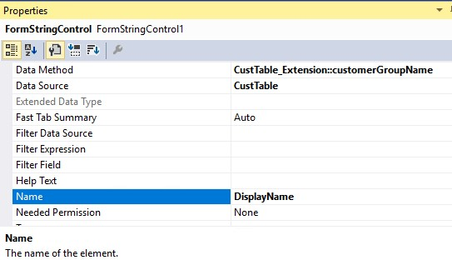](https://1.bp.blogspot.com/-pOtUNsYIXW8/WQnHbpi5i5I/AAAAAAAAGo8/DohclJVkHHsWe8ppZ-szA7IPcJM-qGonwCLcB/s1600/1.jpg)

To cache your display method on the form set on the field the property “Cache Data Method” = yes if you don’t want to use the Attribute above.

[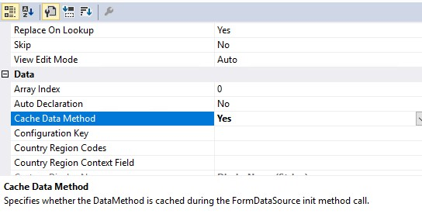](https://1.bp.blogspot.com/-p8TISjaae1A/WQnHb8hroMI/AAAAAAAAGpA/w4daSoXH-6c4tGTSVR-I5NsNnG6UYhhhgCLcB/s1600/2.jpg)

**\*\*Things to remember\*\***

·         The class must be postfixed with “_extension”.

·         The class must be static.

·         The extension methods must be static.

·         The type of the first parameter determines which type is extended.

Reference - <https://community.dynamics.com/365/financeandoperations/b/vishalsblogonmsdynamicsax/posts/dynamic-ax7-d3fo-adding-display-method>