To Enable Inline edit feature in View, Go to Settings, then Customize, then Customize the System.

Select the entity you want to enable the editable grid feature for, then select the Controls tab. Select “Add Control”

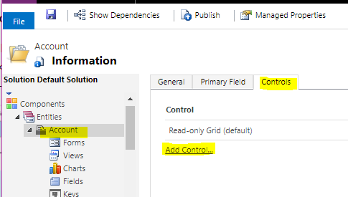

Choose “Editable Grid”:

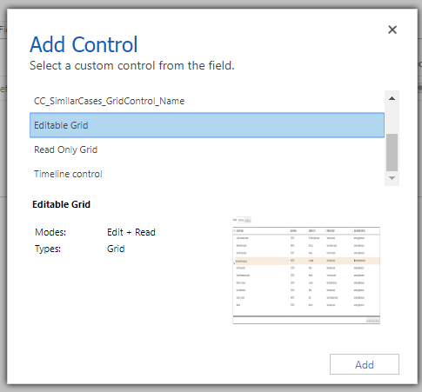

If you want to make a lookup field column editable, you can do so by selecting “Add Lookup” and configuring the options for the lookup column:

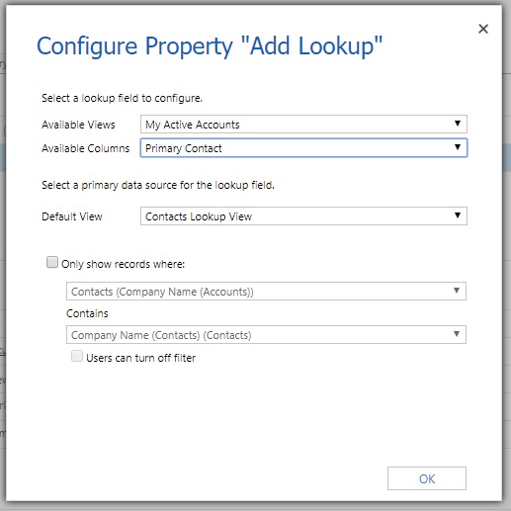

Make sure the radio button under “Web” is selected, then publish your customizations:

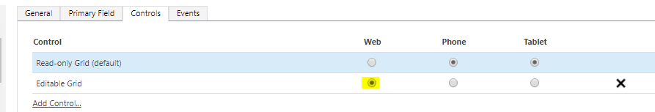

Now, it is possible to edit fields in a View in-line.  Making the view editable also allows you to group records by fields (Accounts by status, or accounts by state, etc):

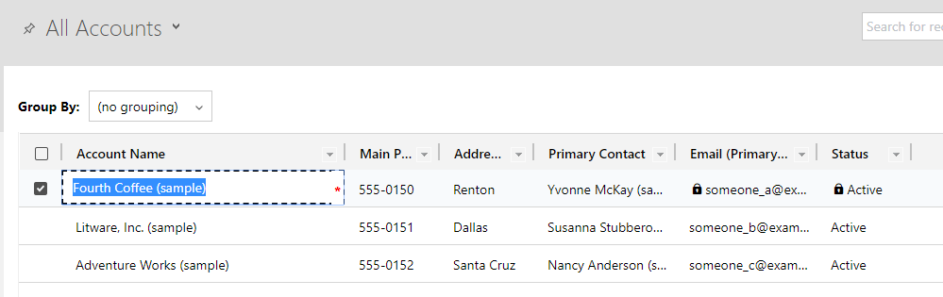

You can also make Subgrids editable by changing the properties on it, and following the same steps to add the “Editable Grid” control.