**How to enable TDSGroup and TCSGroup on PO Invoicing**

TDSGroup and TCSGroup can be enter in Indian localization before posting purchase invoice. TDSGroup and TCSGroup can be enter in either in purchase order lines or purchase order invoicing when posting the purchase order.

To enable TCS group and TDS group for Indian Localization, we have done below setup:

**General Ledger Parameters > Direct taxes > Activate TDS and TCS**

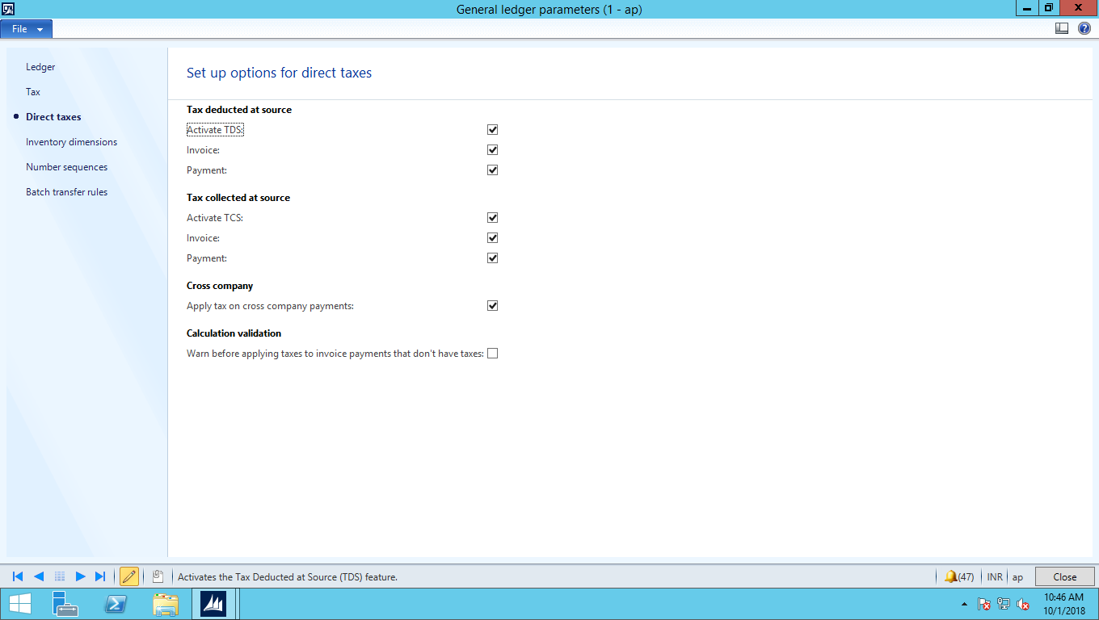

**General Ledger Setup > Withholding > India > Create withholding Authority**

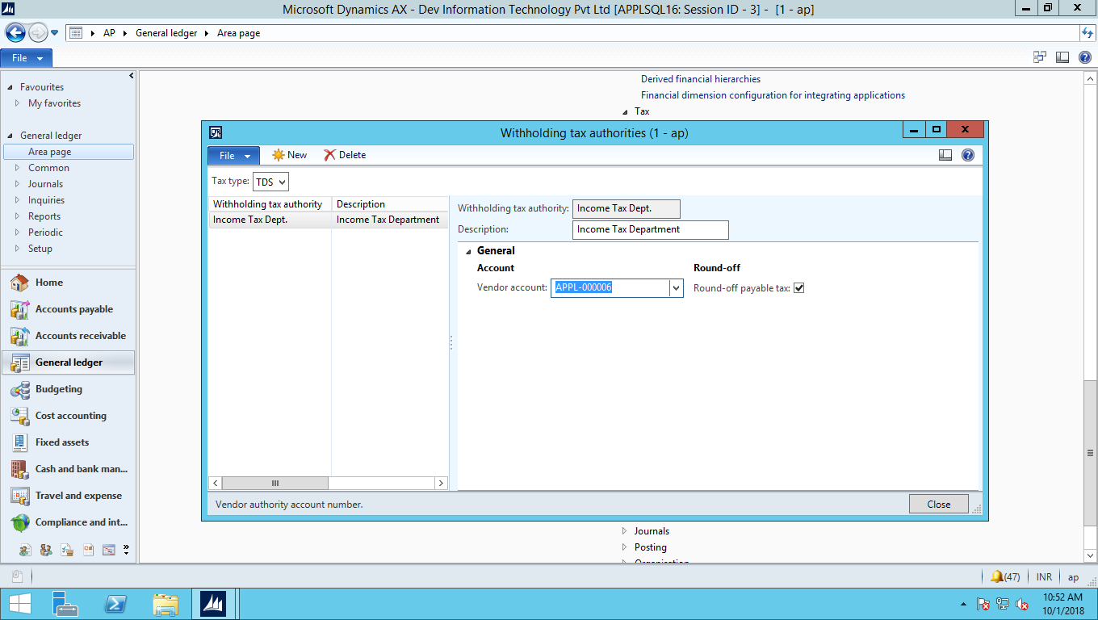

**General Ledger Setup > Withholding > India > Create withholding Component** 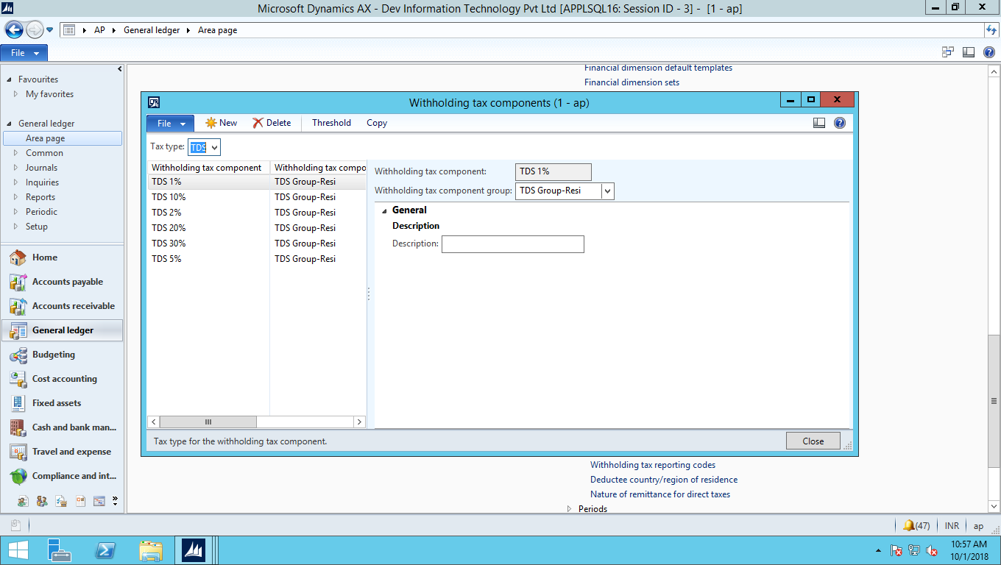

**General Ledger Setup > Withholding > Create withholding tax codes** 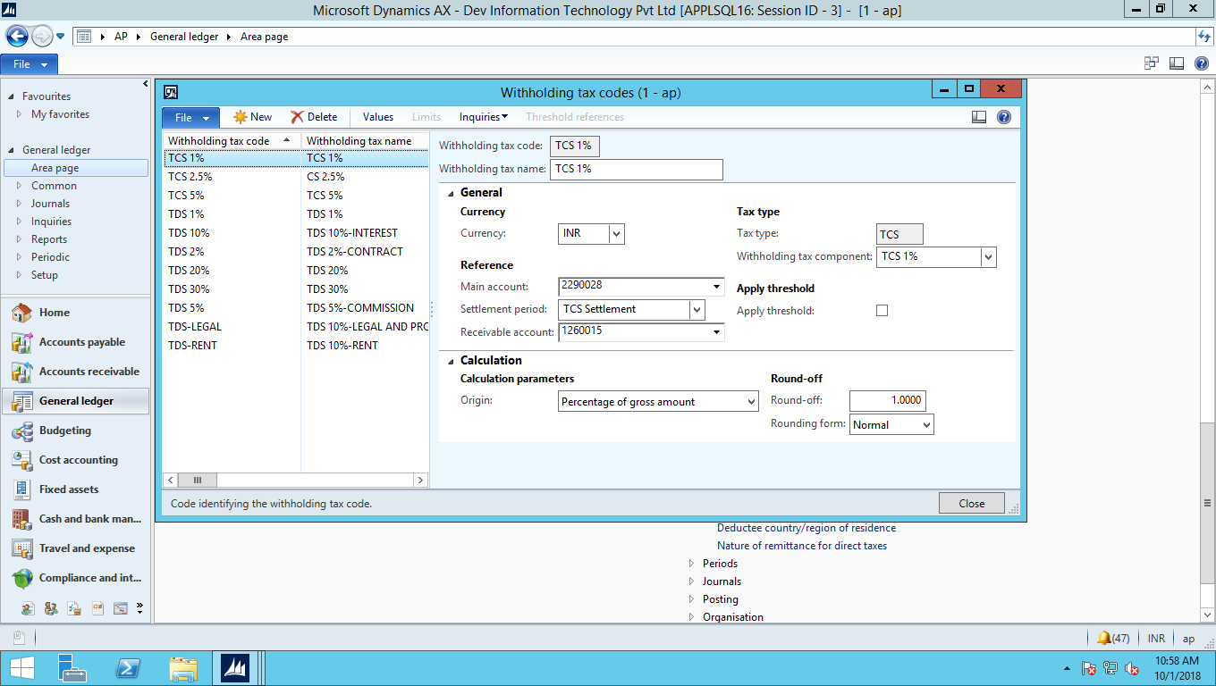

**General Ledger Setup > Withholding > Create withholding tax groups**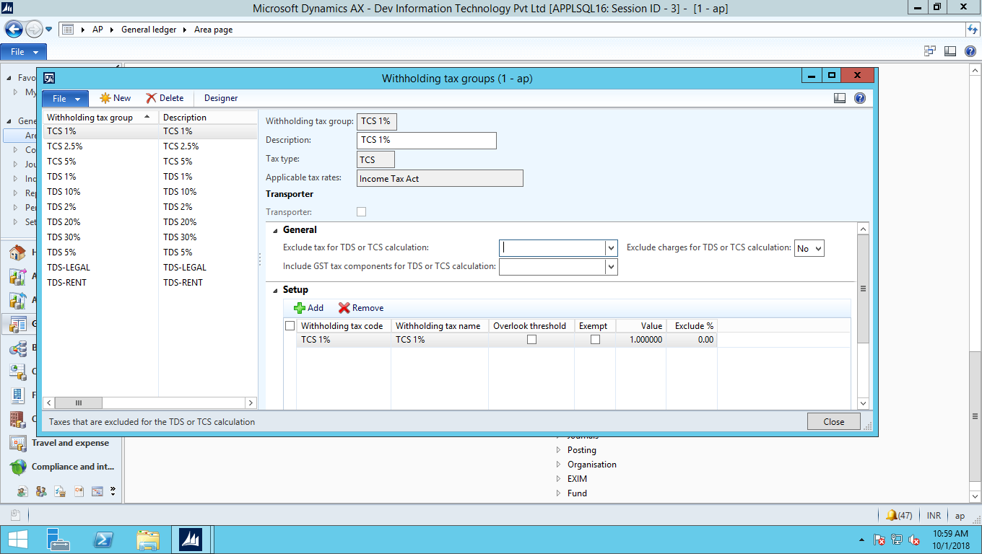

**Edit Vendor > Under Invoice and delivery tab > Click on Calculate withholding tax and select TDS/TCS Group as shown in below screen:**

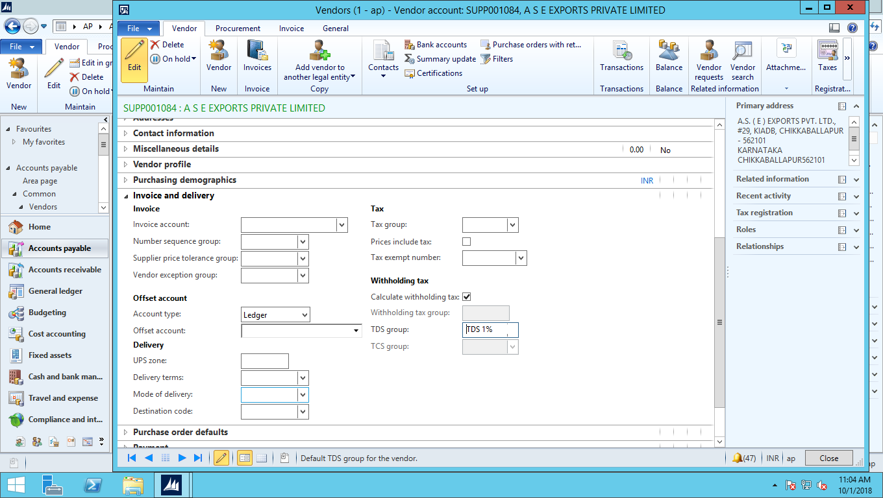

**Edit Vendor > Tax information tab > Click on PAN information change status to receive after that enter PAN Number as shown in below screen:**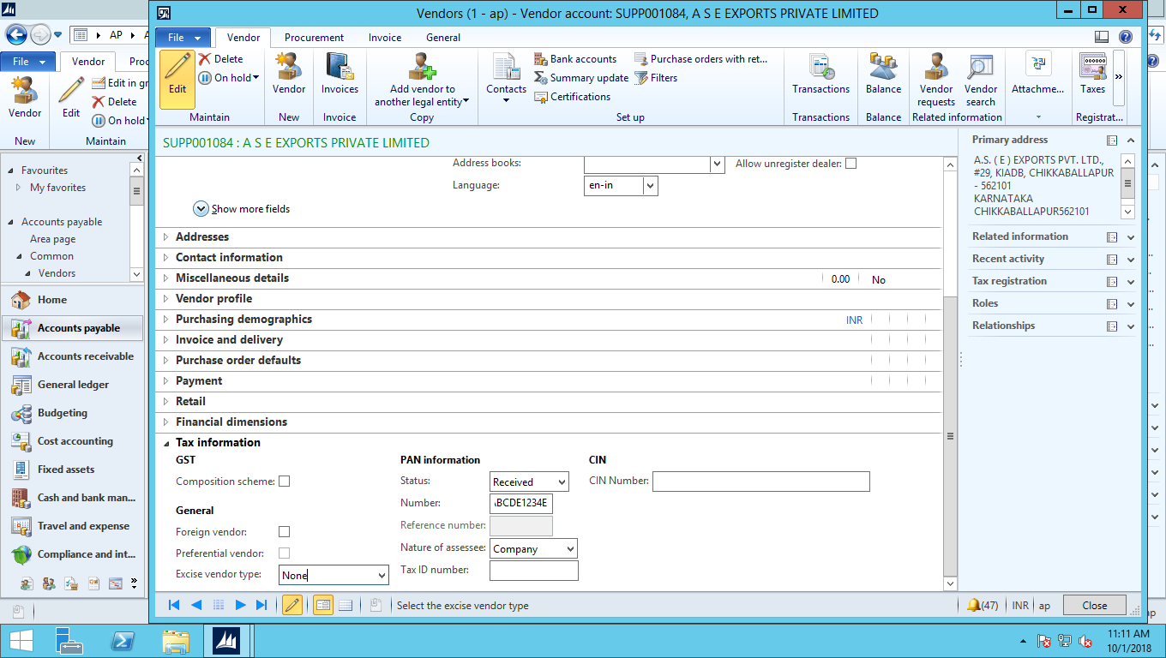

After doing all the above required setting, when generating “Purchase Invoice”, TCS group and TDS group is disable as shown in the screen below:

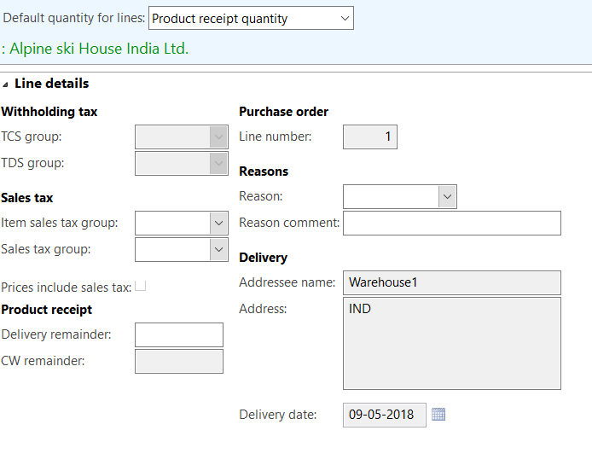

To resolve, comment below lines at

\Forms\VendEditInvoice\Data Sources\VendInvoiceInfoLineTaxExtension_IN\Methods\active

**VendInvoiceInfoLineTaxExtension_IN_ds.allowEdit(  
  
vendInvoiceInfoLine.isNonPO() ||  
  
VendInvoiceInfoTable.InvoiceType == PurchInvoiceType::VendorAdvance);**

After commenting above lines, TDSGroup and TCSGroup will be enable on purchase order posting as shown below:

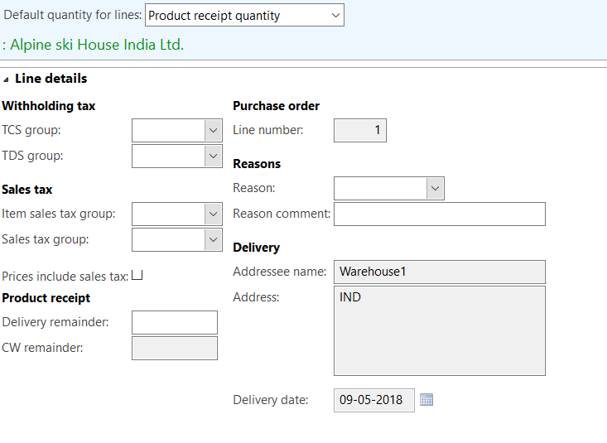

Here is the link for your reference.

<https://dynamicsuser.net/ax/f/technical/93204/how-to-enable-tds-group-control>