Enable/disable form controls:

1. **Job card form:**

* Need to disable button control and Gird control when journal is posted.
* In below screen, Waste details tab, you can enable or disable control by using below code,

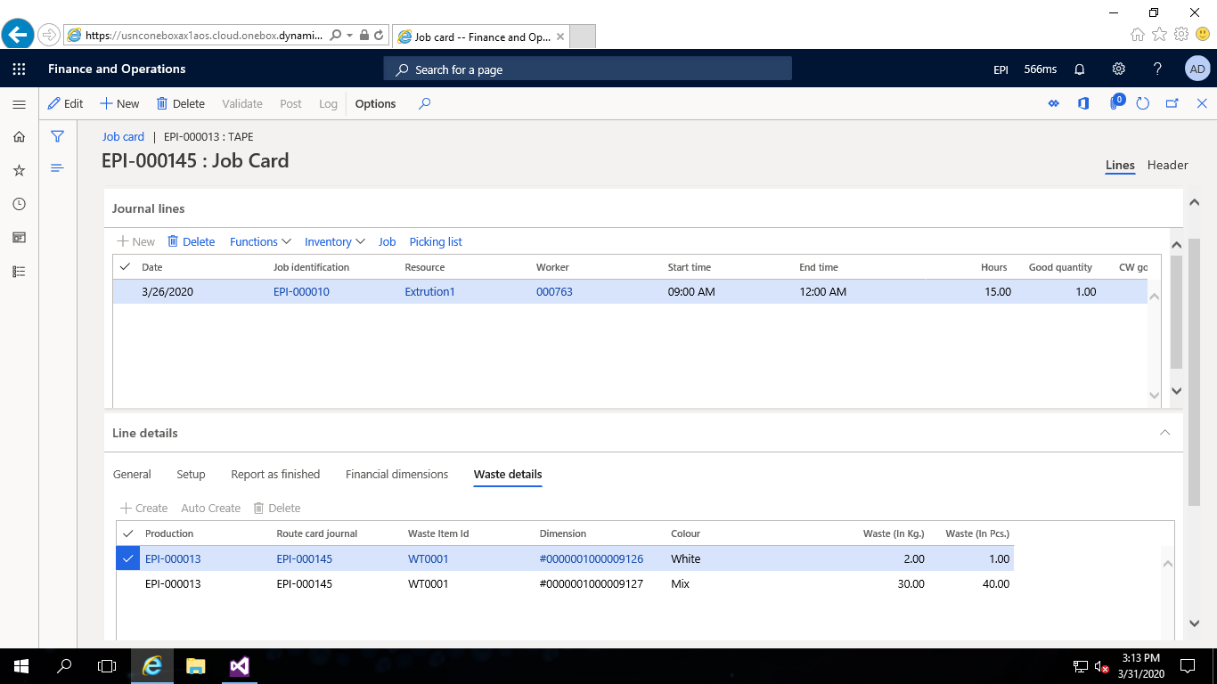

1. **Create Extension**

* Open form and Copy event of OnActivated

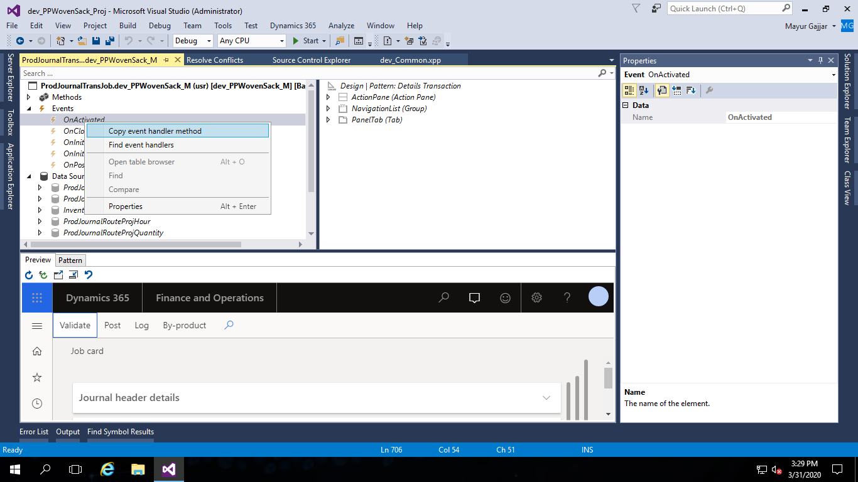

* Create new class and paste extension and write code

[FormDataSourceEventHandler(formDataSourceStr(ProdJournalTransProd, ProdJournalProd), FormDataSourceEventType::Activated)]

public static void ProdJournalProd_OnActivated(FormDataSource sender, FormDataSourceEventArgs e)

{

#define.BUTTONNAME1('FormTabPageControl1') *//Grid control*

#define.BUTTONNAME2('FormButtonGroupControl1') *//Button Control*

ProdJournalTable _ProdJournalTable;

ProdJournalTable caller = sender.formRun().dataSource("ProdJournalTable").cursor();

select * from _ProdJournalTable where _ProdJournalTable.JournalId == caller.JournalId && _ProdJournalTable.Posted == NoYes::Yes;

ProdJournalProd ProdJournalProd = sender.cursor();

FormRun element = sender.formRun();

FormControl YourButton1 = element.design(0).controlName(#BUTTONNAME1);

FormControl YourButton2 = element.design(0).controlName(#BUTTONNAME2);

if(_ProdJournalTable.JournalId != "")

{

YourButton1.allowEdit(false);

YourButton2.enabled(false);

}

else

{

YourButton1.allowEdit(true);

YourButton2.enabled(true);

}

}