## Setup for creation of Row format in financial statement (Traditional).

* General Ledger > Set up > Financial statement (traditional) > Row definition.

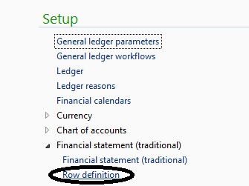

* After that provide name to name definition (in below snap “BS”) and then give this row definition default financial dimension set to use while putting data on report.

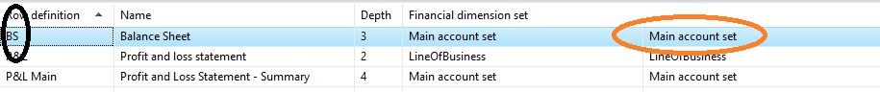

* At third stage User need to build up structure for same Row definition which will be used by system for putting data on board.

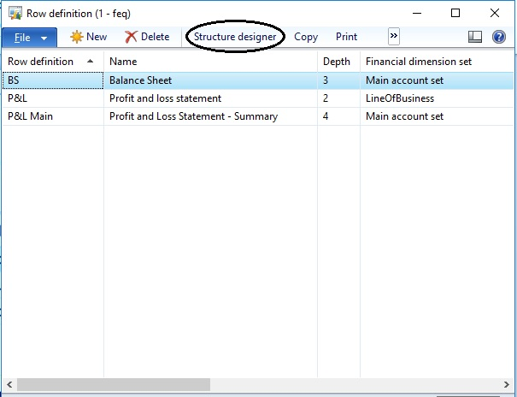

* For building structure in Row definition u need to add nodes as requirement of client as by clicking on create button we created FIXED ASSETS.

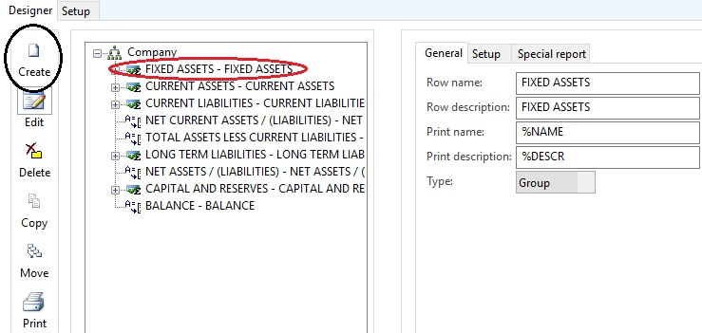

* Now we look up set up of one particular node in three types as generally used in practice.
* Firstly we take first type i.e. type GROUP in general setup.
* We select type Group when that node is representing Grouping of particular nodes which have type DIMENSION which contain values. We will see same in following snap shot.

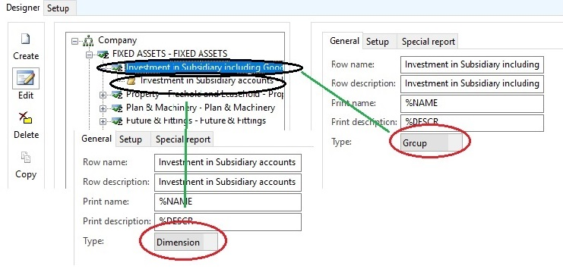

* In above snap investment subsidiary is Group and below same name folder type NODE is his dimension which contains data and dimension value.
* Now we going to see second type i.e. dimension which contain values which will be fetch by system according main account given at set up. See below image for same..

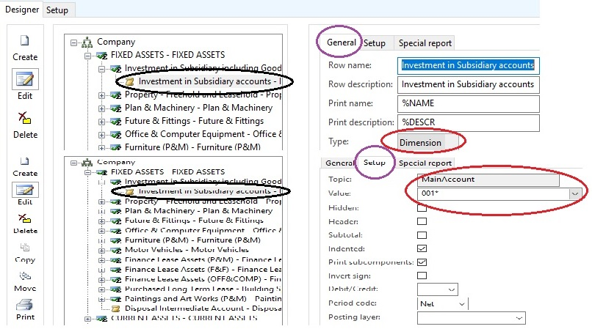

* Type shall be Dimension and on setup tab you need to provide main Account from which you need to show data on financial statement.
* Third type is CALCULATION.it is use when you need to sum or subtract or any mathematical calculation between nodes.
* Example is to find out profit you need to subtract sales and expenses.
* See below snap shot for understanding.

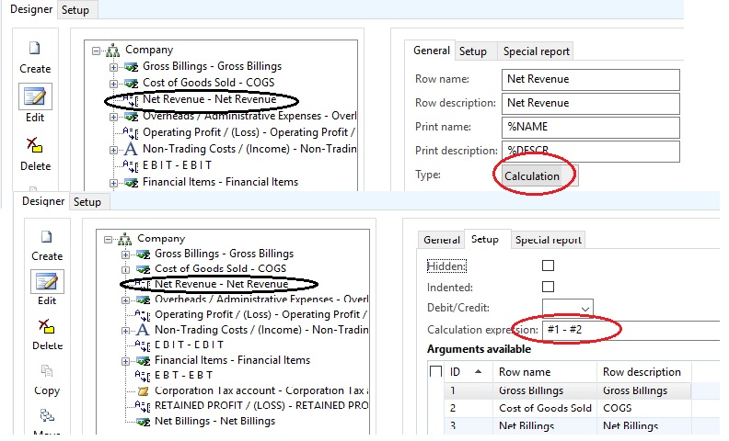

* For calculation, we use calculation expression as we see in red round shape and for putting value in ARGUMENTS user need to use technique of DRAG AND DROP.

Column definition

To set up column definition need to follow following path

* General Ledger > Set up > Financial statement (traditional) > Financial statement (traditional).

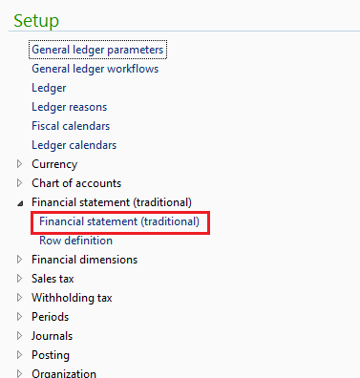

* Basic Understanding of Column definition set up

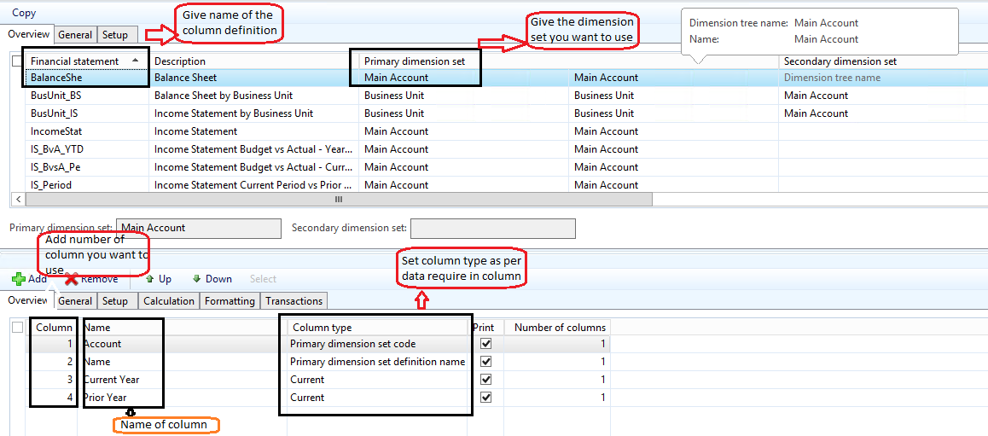

Run the financial statement traditional report

* Path: General Ledger > Report > Transactions > Financial statement (traditional)

In addition, follow the screen shot.

