Contents

Fixed price project with project completion percentage 2

1. Creating Project 2

2. Enter Project Milestone 3

3. Forecast project cost 3

4. Monthly Expense Journal 4

5. Estimate project completion percentage at month end 5

6. Generate and Post Invoice proposal 10

Some important set up for Fixed price project with completed percentage 11

Cost Template 11

Group Setup 12

# Fixed price project with project completion percentage

# Creating Project

Go to the Project Management and Accounting>>Common>>Projects>>All Projects. Create new project with Project Type as Fixed Price, Project group which is defined for Complete Percentage Method.

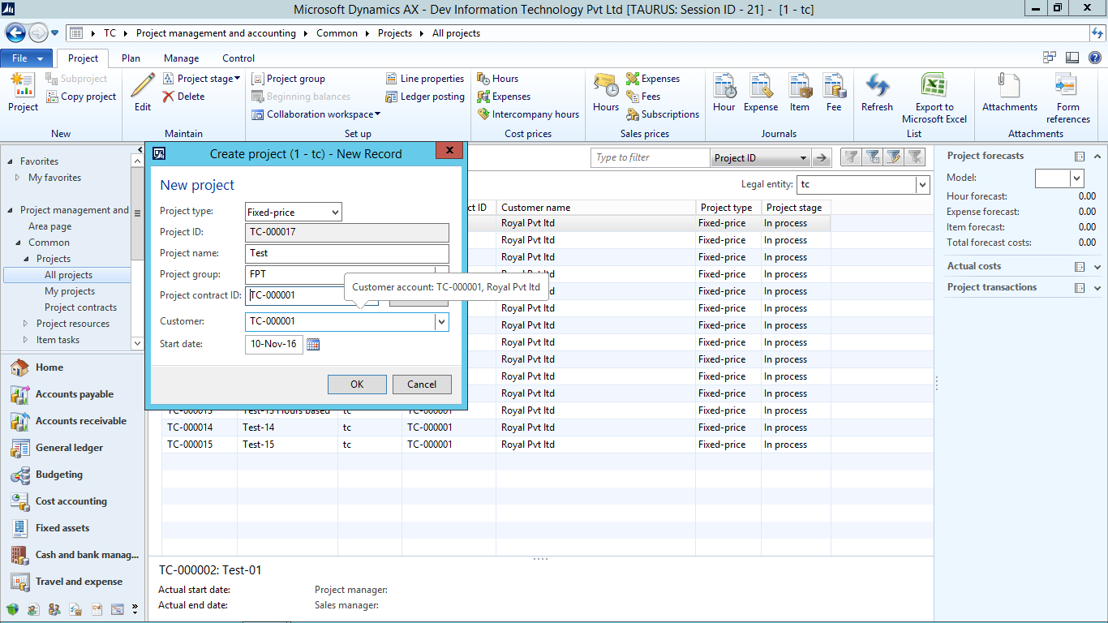

After Clicking Ok. Project Details will open. Go to on account Transactions in manage tab.

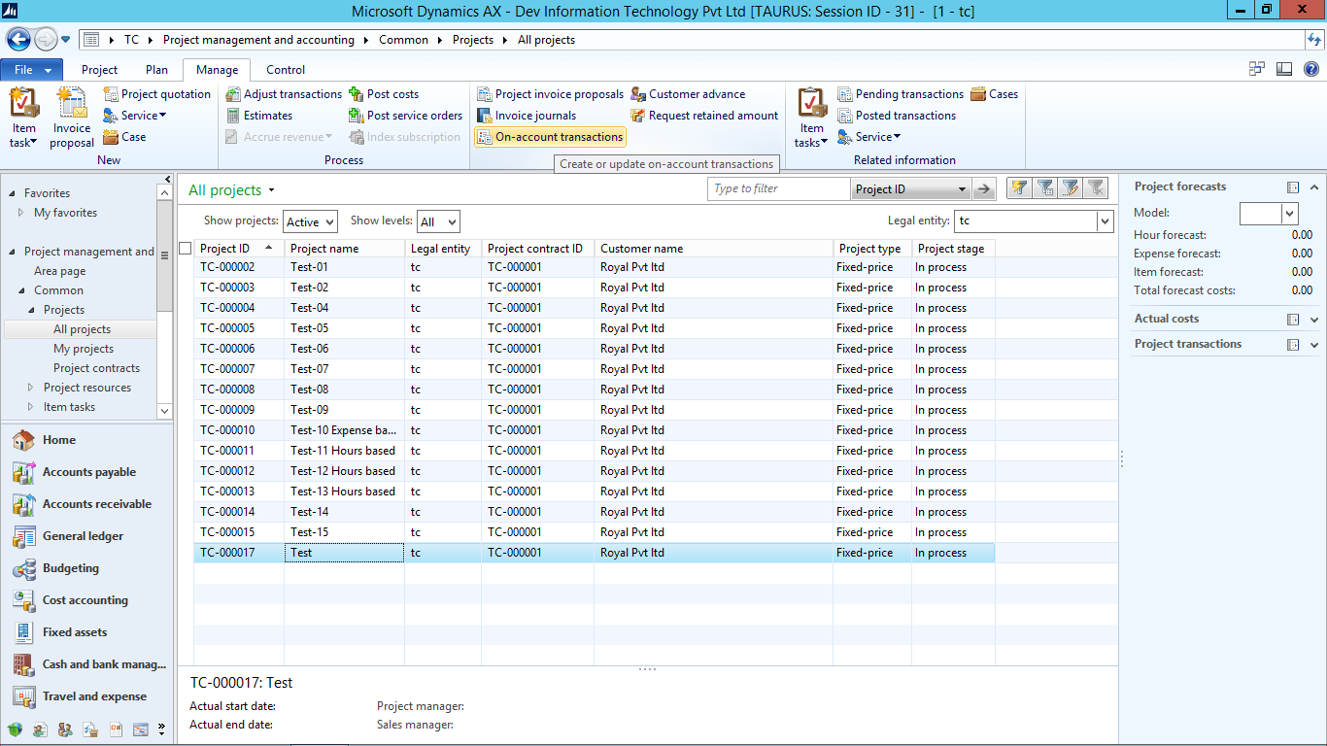

# Enter Project Milestone

Create new on account Milestones as per need, for example I entered three Milestones for November, December and January. Total Contract Value is ($15000+$15000+$15454=$45454):

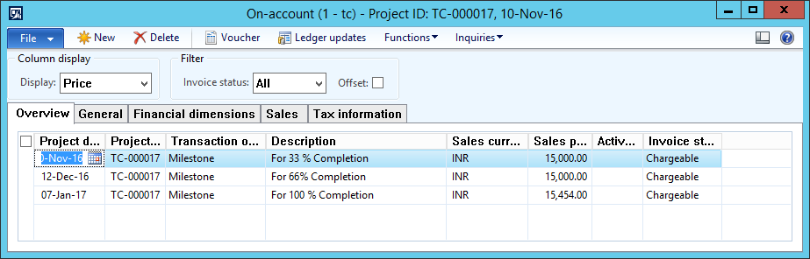

# Forecast project cost

Forecasting is required to do, to calculate the completion of the project in percentage.

Go to the Plan tab and Click on expense Forecast to enter the forecast value.

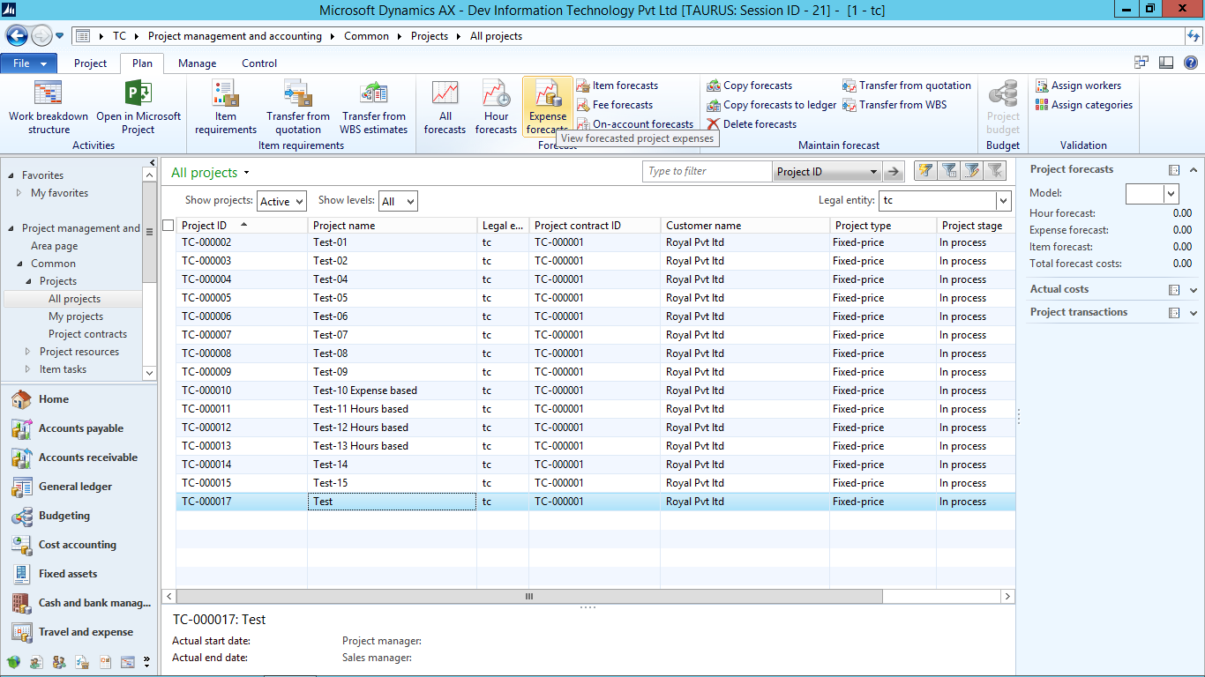

Make a new Expense Forecast as below. In the below forecast $15,000 is entered as forecast value.

This $15000 cost will be considered as 100% at the time of calculating the project completed percentage.

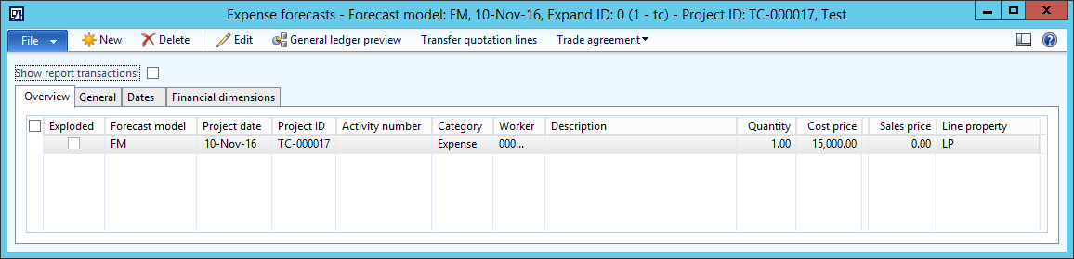

# Monthly Expense Journal

Create expense journal, for the month November 2016 from Project tab >> Expense Journals as shown below:

Click On lines for details entry.

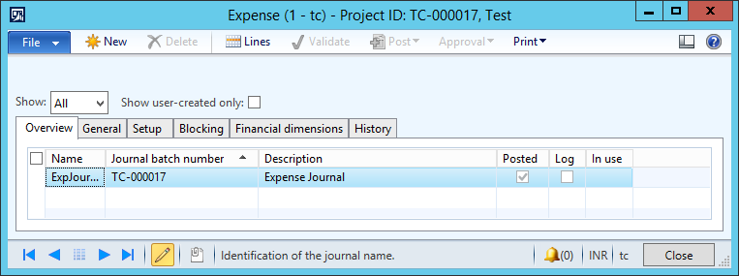

Select date of the month Nov’ 16, Category and Offset ledger. Enter expense in the Cost price.

You can enter multiple line for the same month.

Validate and Post it.

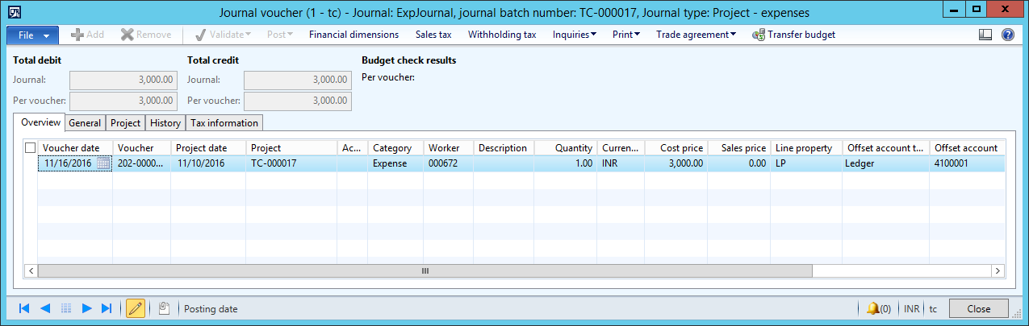

# Estimate project completion percentage at month end

To estimate the project completion percentage, go to Manage tab and click on Estimates as shown below:

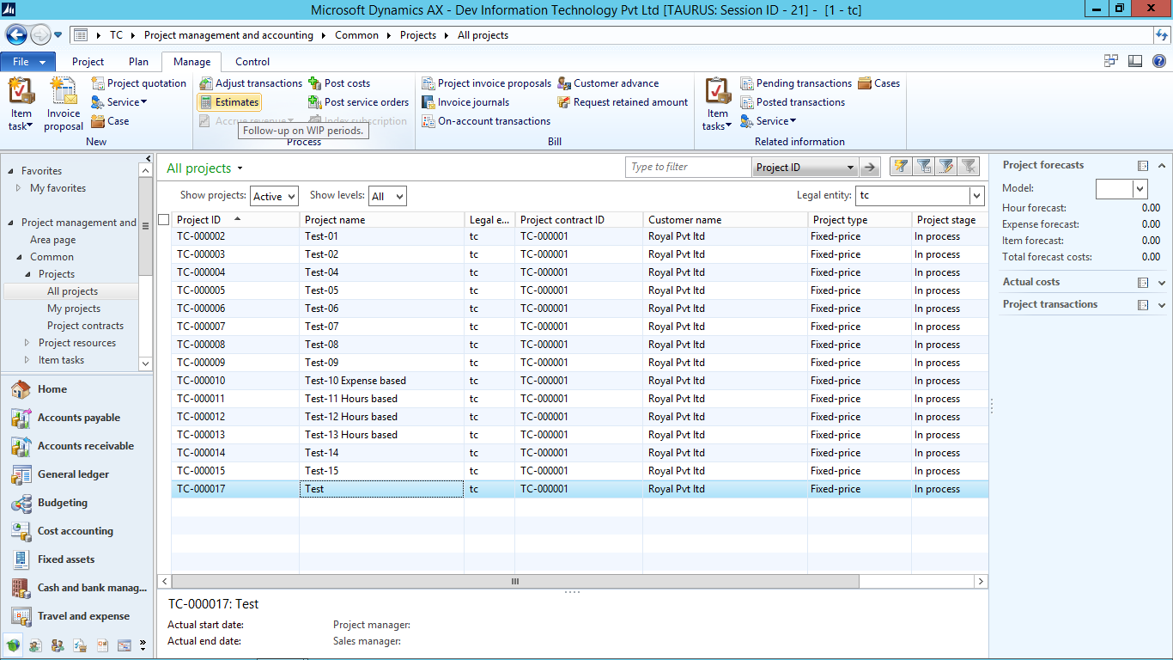

Click On the new Estimate. A new form will open as shown below. Select Estimate date (month end date) and Create Estimate.

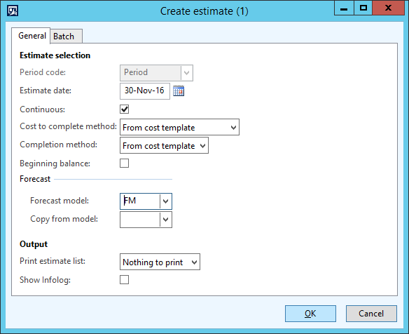

You can see a new Estimate will get Created as shown below, It shows that at the end of the month Nov’16, 20% (as total expense for the month Nov’16 is $3000) has been Completed out of the Forecast value $15000.

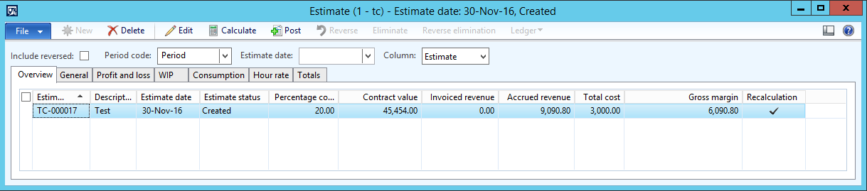

Moving to General Tab, you can find further details as below:

In the screen below,

Estimate column >> shows the details of the Nov’16. (% completed in this month)

Accumulated column >> shows the accumulated detail till Nov’16. (% completed till this month)

Total Column total value (100%).

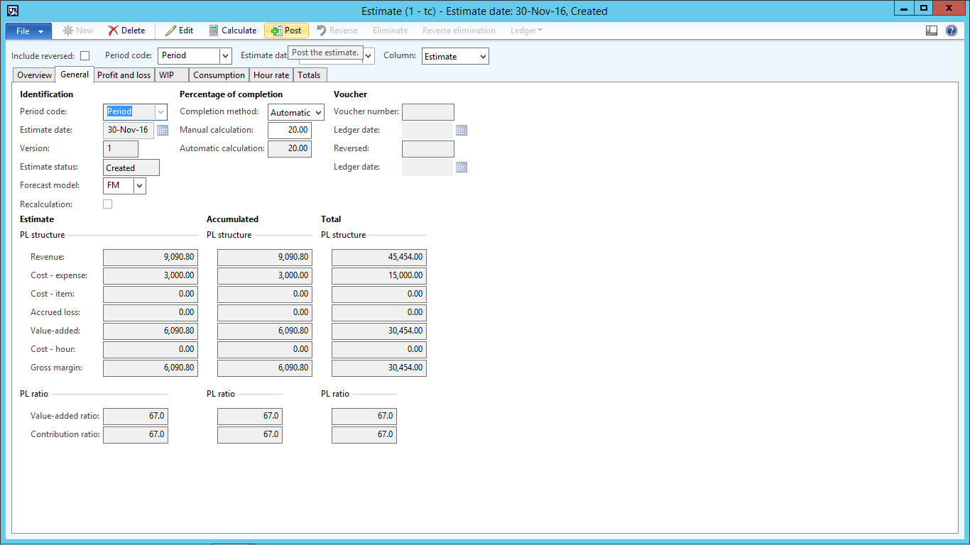

If there are no further entries for Expense, you can post this estimate.

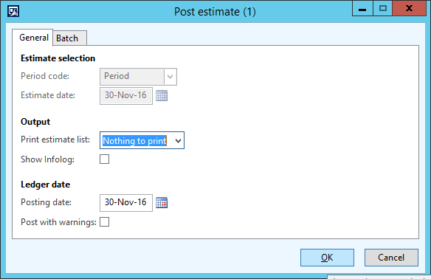

At the end of the moth Nov’16, 20% project has been completed and in on-account form first project milestone has been defined as 33% so we billing is not to be generated at the end of the month Nov’16.

Repeat step 4 and 5 for the month Dec’16 as below:

Create new Expense Journal for December month by going to Project tab >> Expense Journals and Click new.

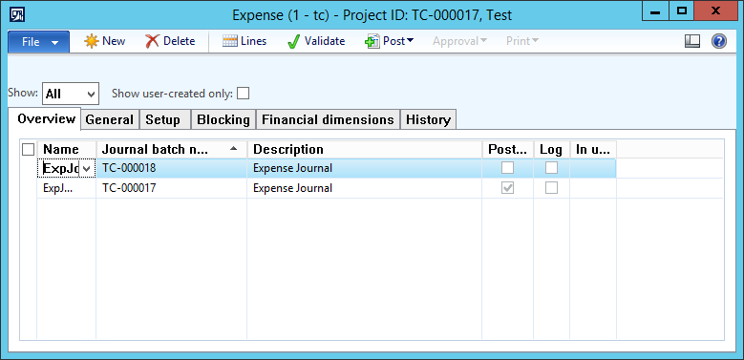

Two lines are Created for the Expense Journal of december of $ 1,500 each as shown below:

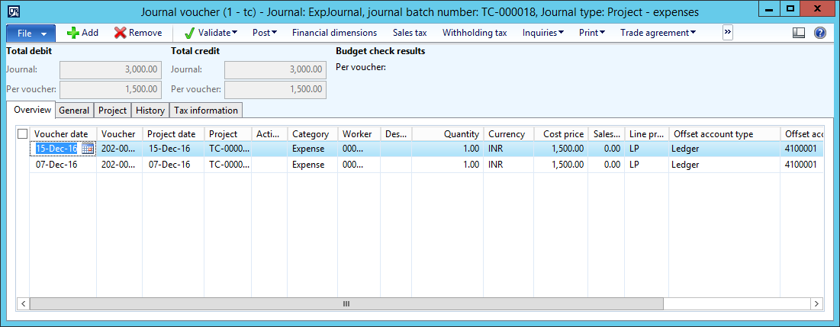

Validate it and Post it.

Now again Manage tab>>Click estimates.



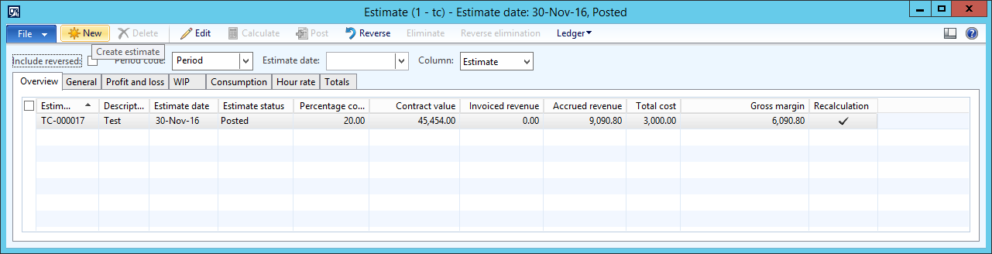

Click New Estimate and below screen will Open, select date of December’16, select forecast model and click Ok.

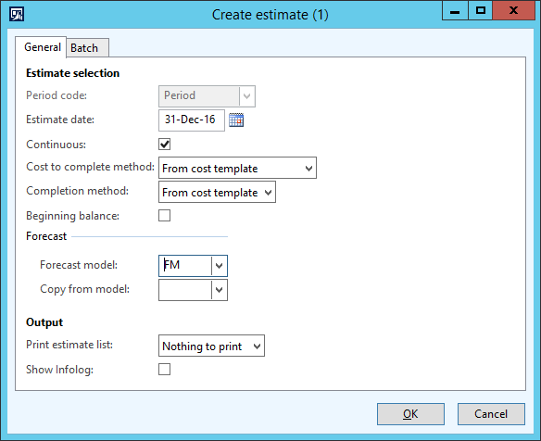

A new Estimate has been Created for December as below. 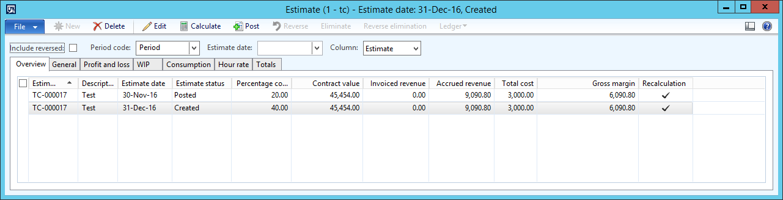

Click on General tab.

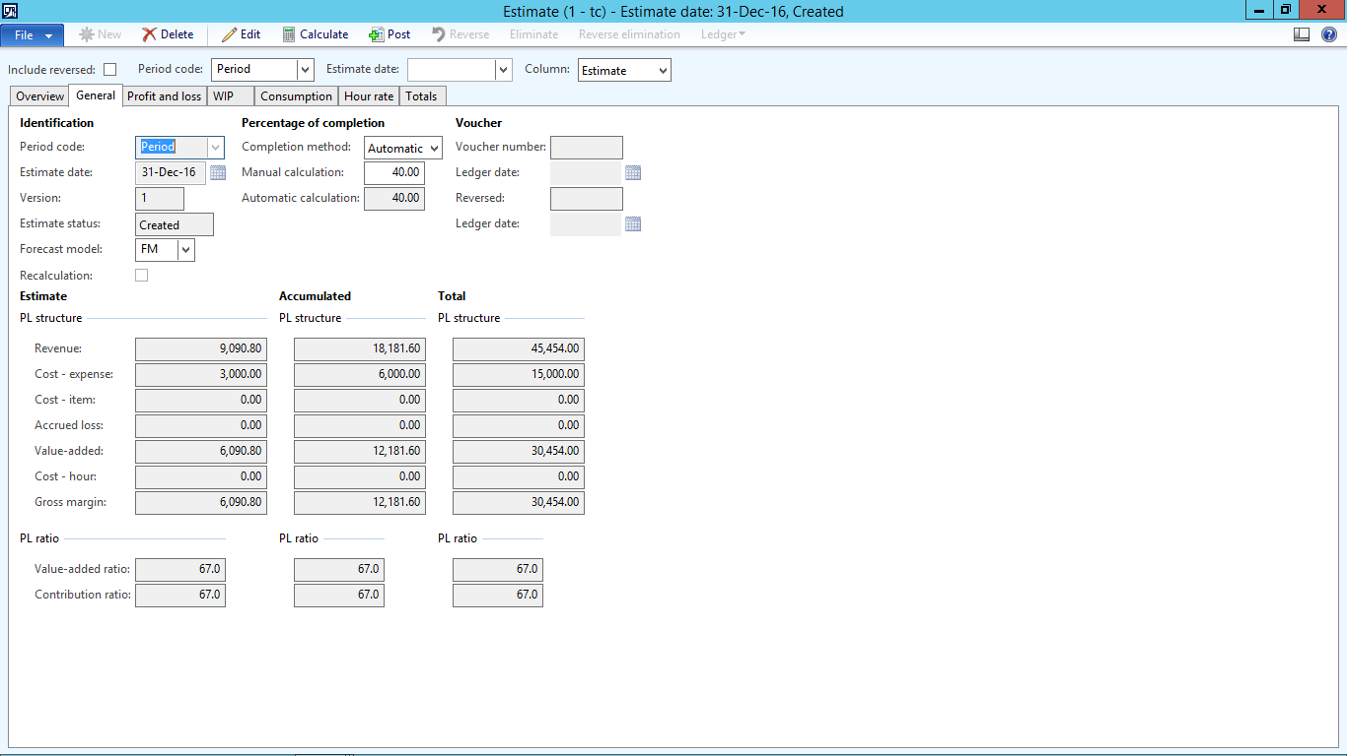

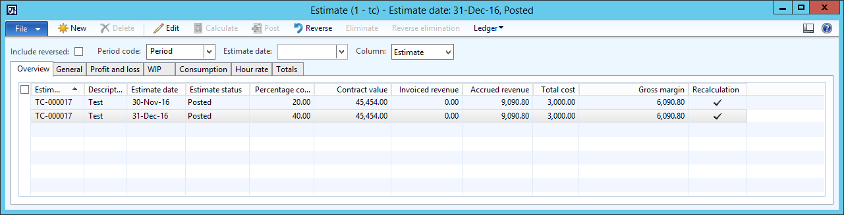

Looking to the above screen, at the end of the month 40% project has been completed and project first milestone is 33% so billing shall be generated at the end of the month Dec’16.

# Generate and Post Invoice proposal

To generate the invoice proposal, go to Project >> Manage tab >> Project invoice proposal.

Click on new Invoice proposal button. Below screen will be open. Select project. Tick mark on only the first milestone of 33% and click ok button.

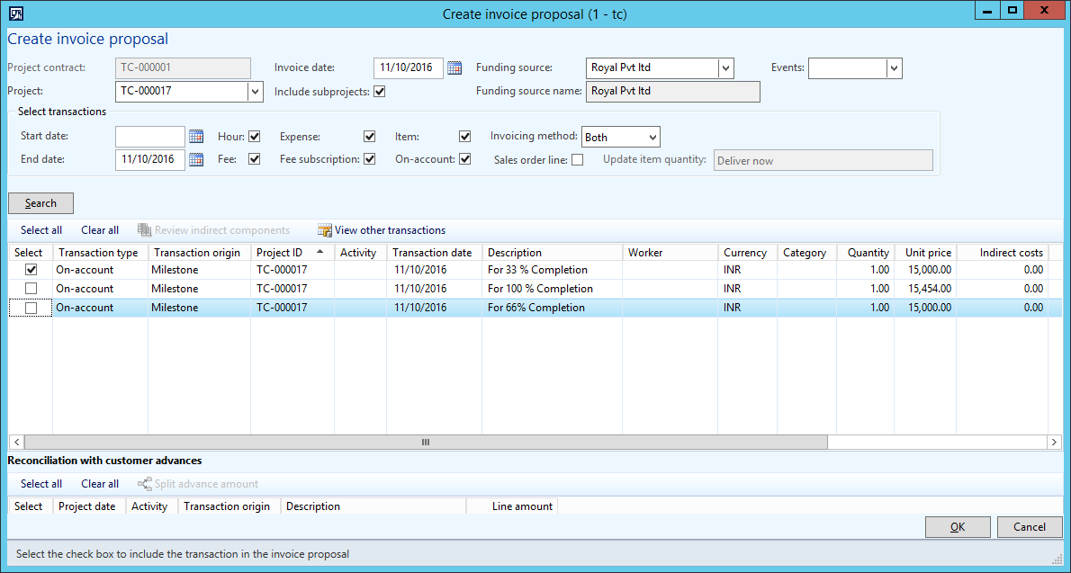

To post the invoice proposal, click on the button Post as shown below:

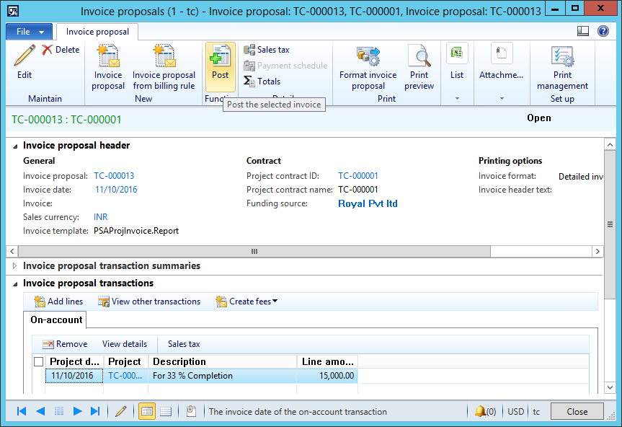

Repeat Step 4, 5 and 6 for next months.

# Some important set up for Fixed price project with completed percentage

## Cost Template

Go to Project Management and Accounting >>Setup>>Estimates>>Cost Template. Make Sure that Cost Template of the Project group you selected has been there with following setup:

1. Completion method: Automatic
2. Completion based on: Cost Amount

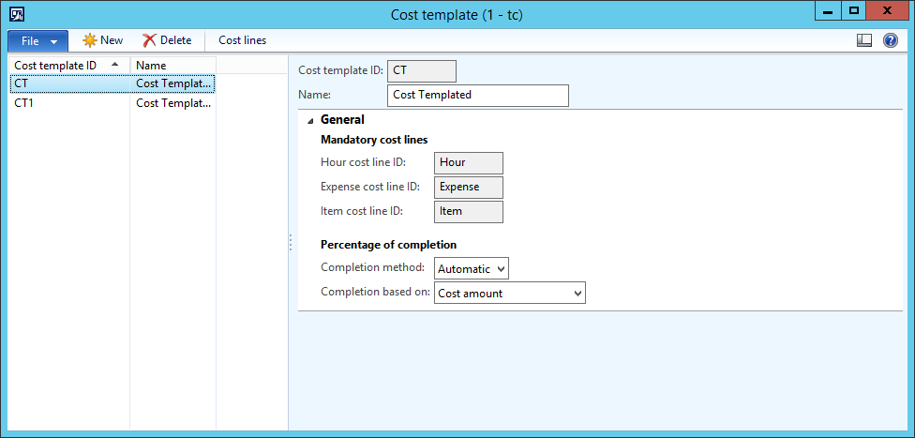

## Group Setup

Go to the Project Management and Accounting>>Setup>>Posting>>Project Groups .Make Sure that Group You Create has following Setup

1. Revenue Recognition Rule as Completed Percentage
2. Matching Principle as Sales value
3. Cost Template with above mentioned steps

