

**Generate Number Sequence for New Module in AX 2012**

*Prepared By Vrushali Patel*

Contents

1. Error definition 2

2. Generate Number Sequence for New Module: 3

# Error in Generating Number Sequences for New module

* 1. While generating number sequences for new module in new company the following error comes if there is not proper setup done :

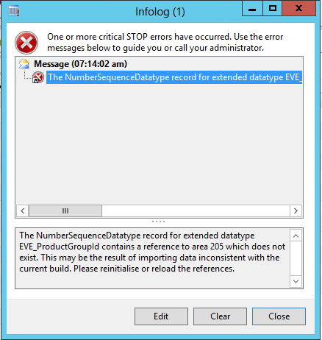

To resolve this error we have to generate number sequence for new module.

# 2. Generate Number Sequences for New module:

* 1. Add a new element in NumberSeqModule base enum with your new module name

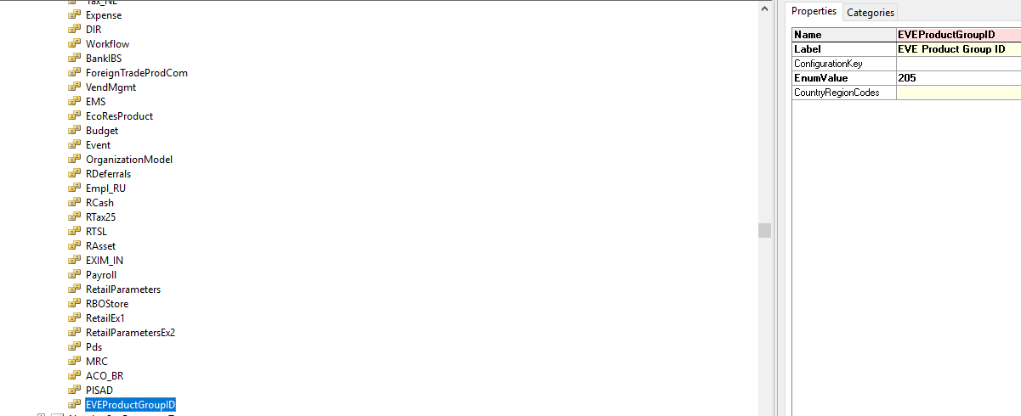

* 1. Create a new Class NumberSequenceModuleModuleName extends NumberSeqApplicationModule

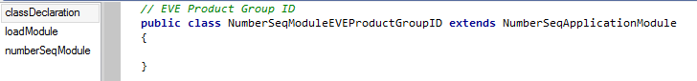

* 1. Override loadModule method by adding the parameters of the sequence

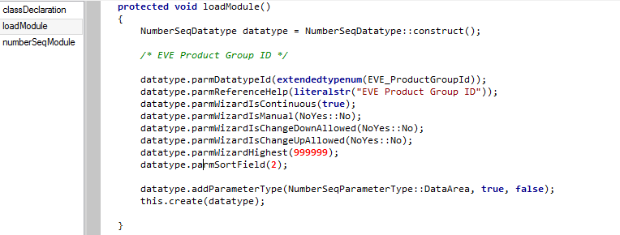

* 1. Override numberSeqModule method

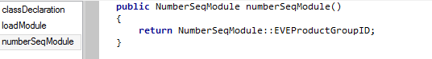

* 1. Create new job to load number sequence

static void Job_NumSeqLoad(Args _args)  
 {  
 NumberSeqApplicationModule::loadAll();  
 }

* 1. Restart Ax client
  2. Go to Organisation Administration >> Common >> Number sequences >> Number Sequences >> Generate and follow the wizard to end to generate number sequence for new module.