**How to Install Jenkins with a WAR File**

Open source Jenkins is a famous device for test automation and for imposing shifting left through non-stop integration and non-stop deployment. Simple way is to put in Jenkins with a WAR (Web utility Archive) document model of Jenkins. This alternative may be used on any Java-supporting platform or OS.

First, install JDK. Jenkins supports Java 8. Now that Java is installed, we can proceed with Jenkins.

# Installing Jenkins

1. Download latest Jenkins WAR file.

2. Copy the **jenkins.war** file to the folder you want. I created a folder named **Jenkins** in the path **C:\Program Files (x86)** and copied the **jenkins.war** file to it.

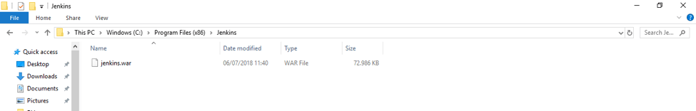

3. Open the command prompt window and browse to the directory where the **jenkins.war** file is present, through the command**cd C:\Program Files (x86)\Jenkins**.

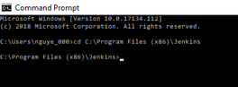

4. Run the command **java -jar jenkins.war**

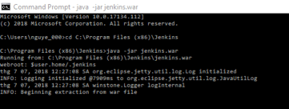

5. Wait until the process completes.

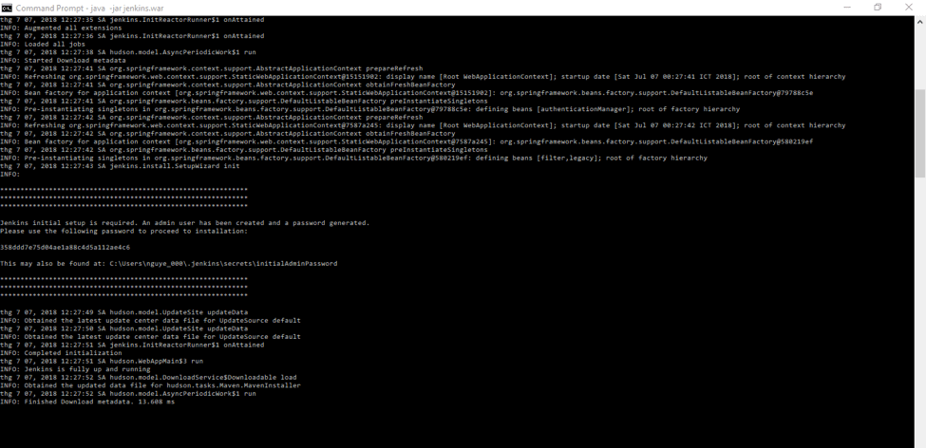

6. Take a look at the line **“INFO: Jenkins is fully up and running”** that indicates that Jenkins is running. Write down the random password that is auto generated. We will use this password for the initial login later.

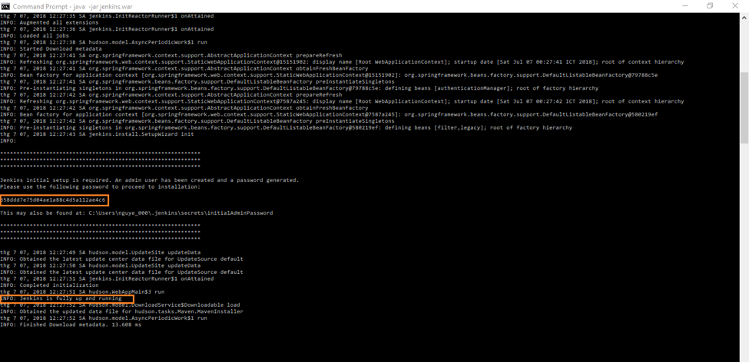

7. Paste the URL [http://localhost:8080](http://localhost:8080/) in your browser to browse to the Jenkins page.

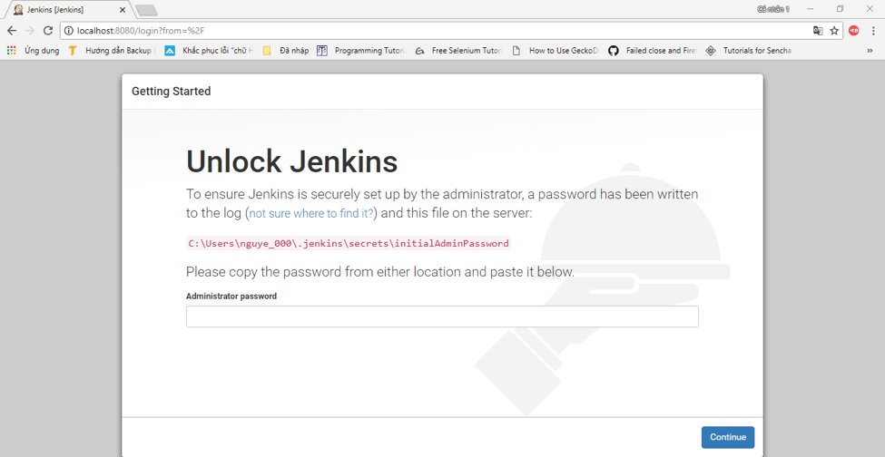

8. To unlock Jenkins, paste the random password that you wrote down in the previous step or copy it from the the user account folder, from the file**C:\Users\<your_user_account_folder_name>\.jenkins\secrets\initialAdminPassword.** Paste it in the **Administrator** password field and click on the **“Continue”** button.

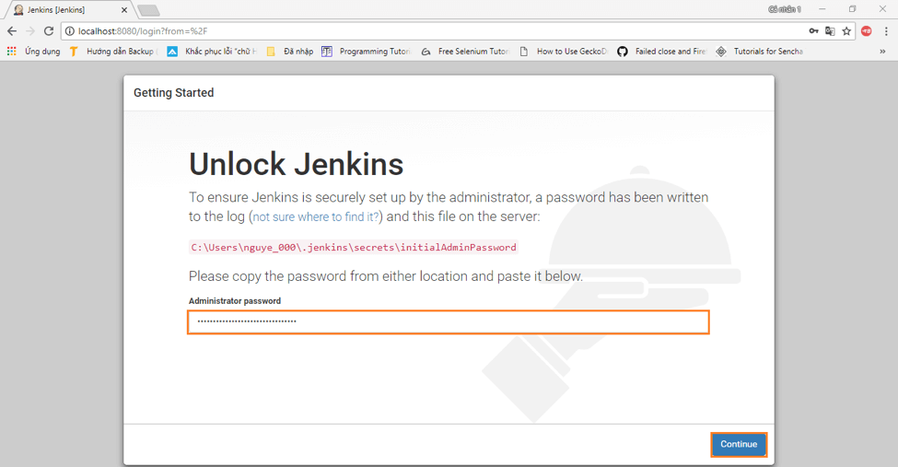

9. Install the suggested plugins or customize plugins installation according to your needs. We will install the default suggested plugins.

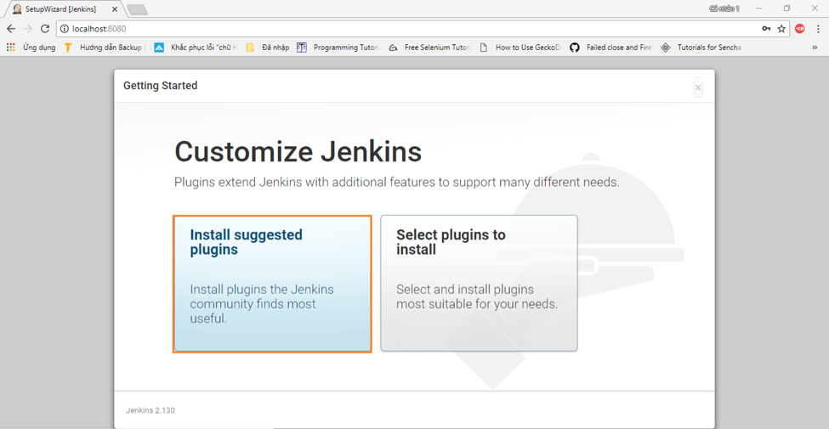

10. Wait for the plugins to complete the installation.

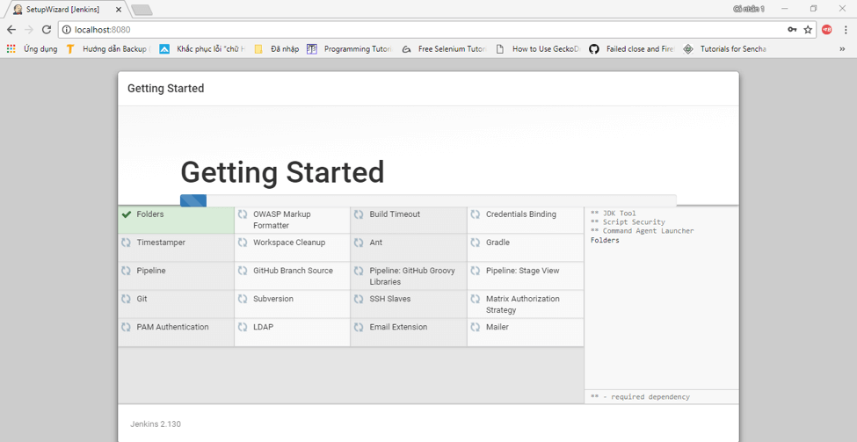

11. Create an admin user and click**“Save and Continue”.**

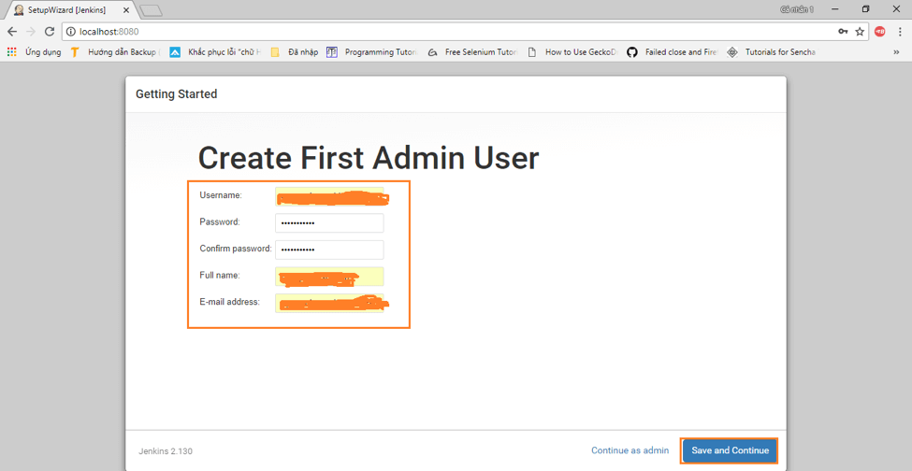

12. Click **“Save and Finish”**to complete the process.

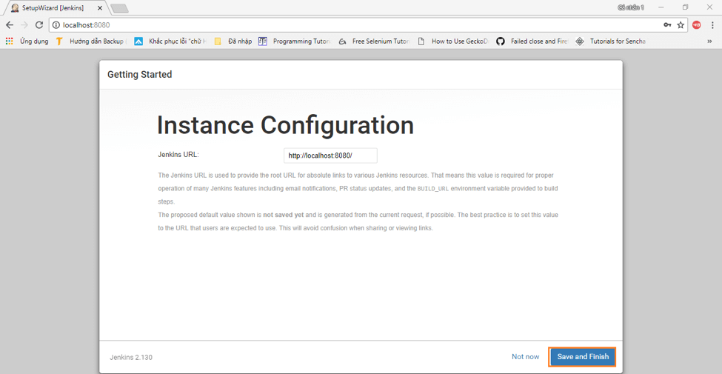

13. Finally! Click**“Start using Jenkins”** to start Jenkins.

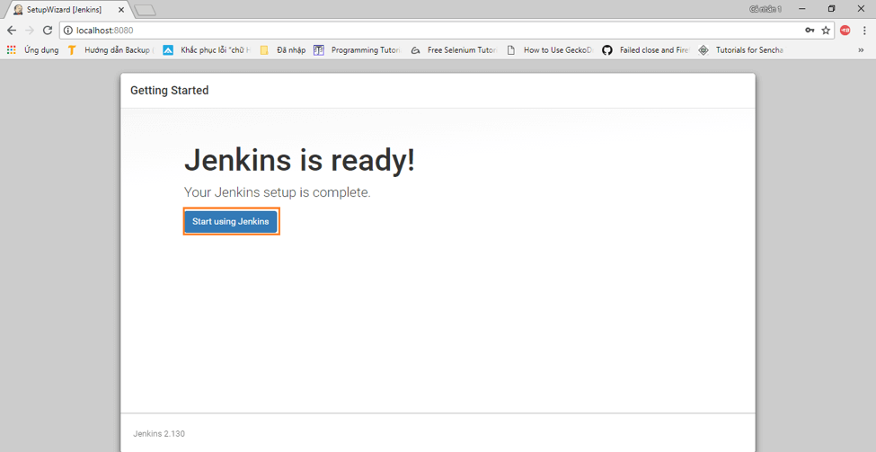

14. Here is the default Jenkins page. You can create your first job!

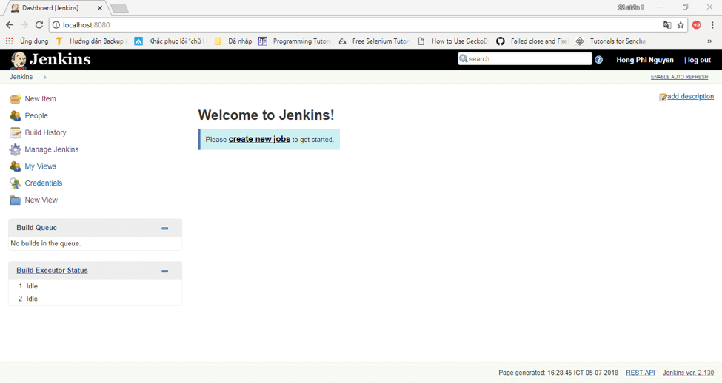

Jenkins is now configured and ready to build and deploy code.

#### **Create build job with SVN**

Now create a Jenkins build job. Select **New Item**, give the build project a name such as svn-tomcat-demo, select **FreeStyle project**, and click **OK**.

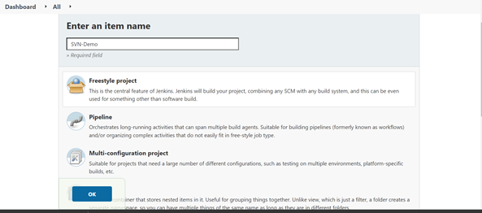

Under **source code management**, select **Subversion** and enter your SVN repository URL and credential.

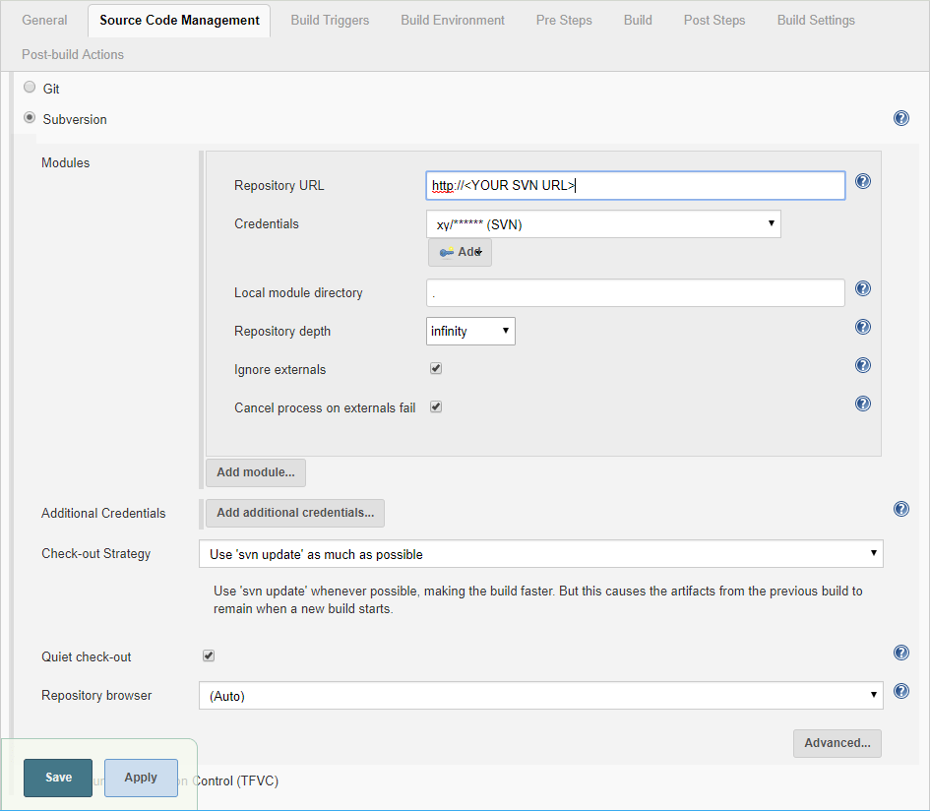

Please download the sample code and check the code into your SVN server.  
Under **Build**, input **package** for **Goals and options**.

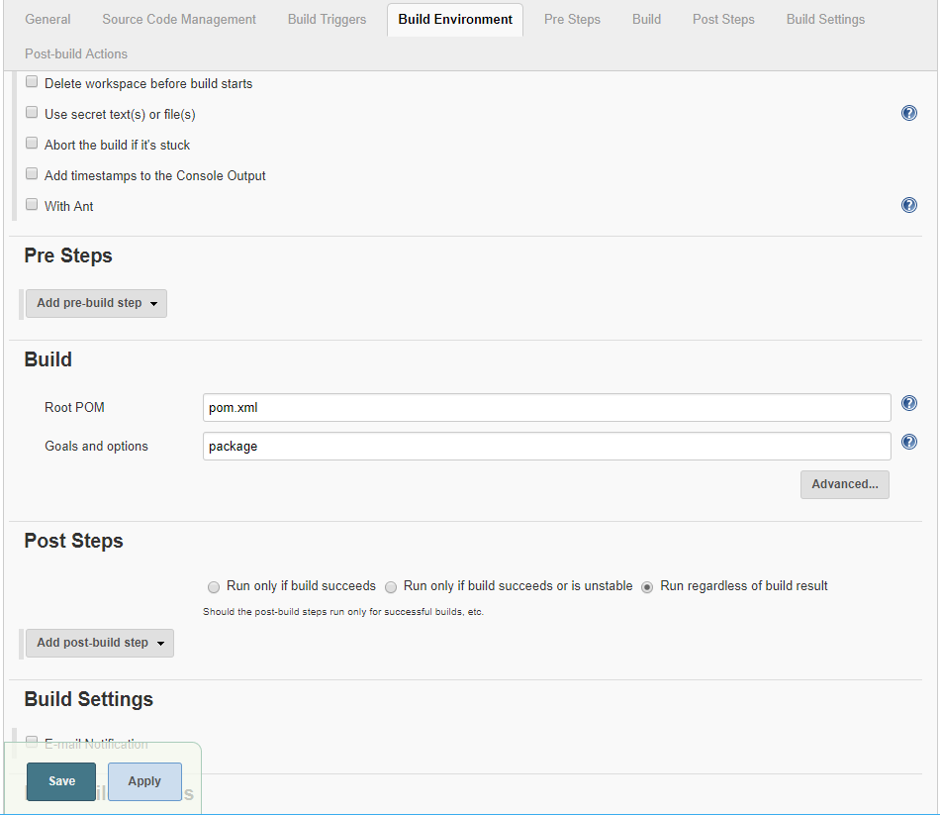

#### **Run the build job**

To test the build job, manually start a build.  
Select Build Now to start a build job. It takes a few seconds for the job to start, when running, you should see status similar to the following images.

