Here we will see about how to change or modify customer/vendor account number in ax, as we know we can’t change/modify customer/vendor account number in dynamics ax because its unique record and maintain unique key, as customization is also not possible to change/modify directly from the table because if we have transaction for that customer/vendor in inventory then it’s not possible to change directly.

Microsoft provided such facility if you want to change/modify account number, then you can change it to record information and it’s modify all table entries directly you don’t have to spend more time into that. Here I have given information for changing the customer/vendor account number in dynamics ax.

Here I have given example for change/modify vendor account number.

Step-1: if you want to change vendor account number then go to All vendor page and select **vendor account** which **vendor account number** you want to change/modify. After right click on it and select “**Record info**”

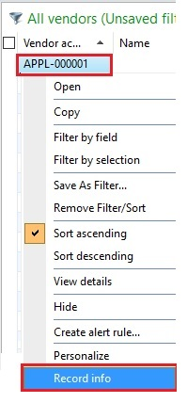

Step-2: after that below pop up will open for record information, with that form click on the Rename button.

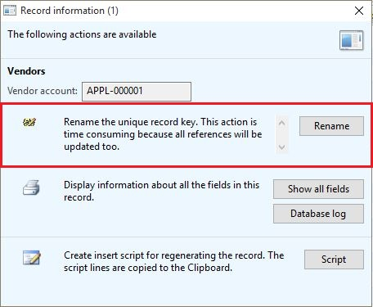

Step-3: after click on rename button one pop up will open for entering the new vendor account number like below and you have to enter a new account number.

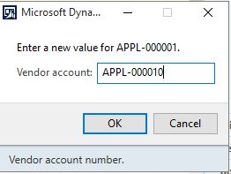

Step-4: after the confirmation popup will open and asked for renaming the vendor account number like “are you sure you want to rename APPL-000001 to APPL-000010”. You have to click on yes and will take some time if you have more transaction for this vendor.

