**Follow below steps to import the different journals using excel files:**

1. Import the table “Dev_ABMAPJournalImport” and the class “dev_ImportJournal” (attached in this KB) in AX
2. Create action type menu item of the imported class “dev_ImportJournal”

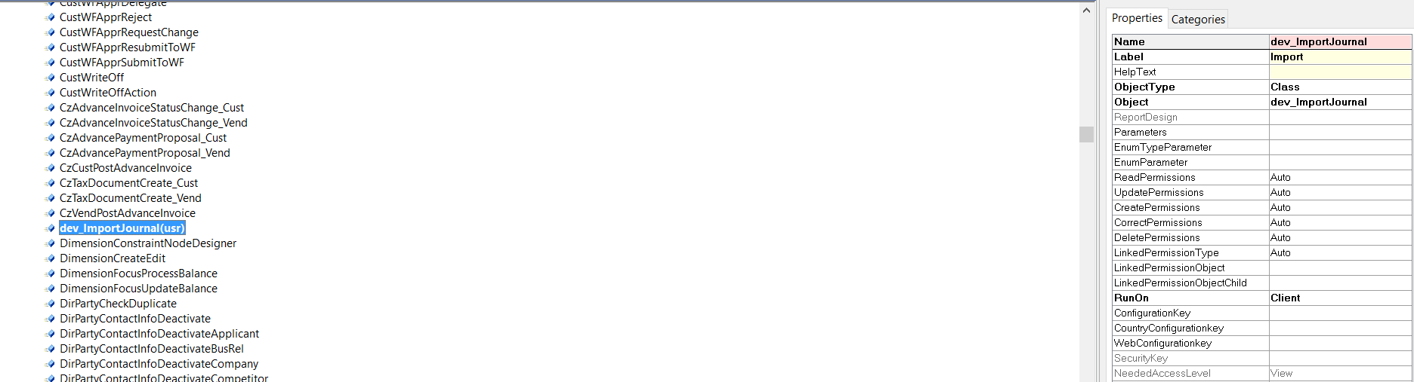

1. Add the Menu Item button in the General journal form to run the imported class

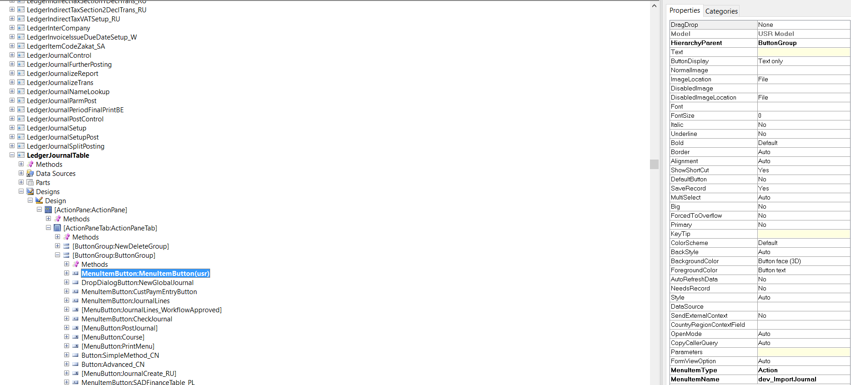

1. Create a new journal, so that new journal number will be generated
2. Click on “Import” button, so that dialog will open
3. Select the file which should have the exact columns format same as attached in this KB
4. Verify the imported lines