Issue: When accessing the project from TFS, if you don’t get the project folder in tree verify user rights.

Solution:

1. Sign in to your organization (https://dev.azure.com/{yourorganization}).
2. Select gear icon **Organization settings**.

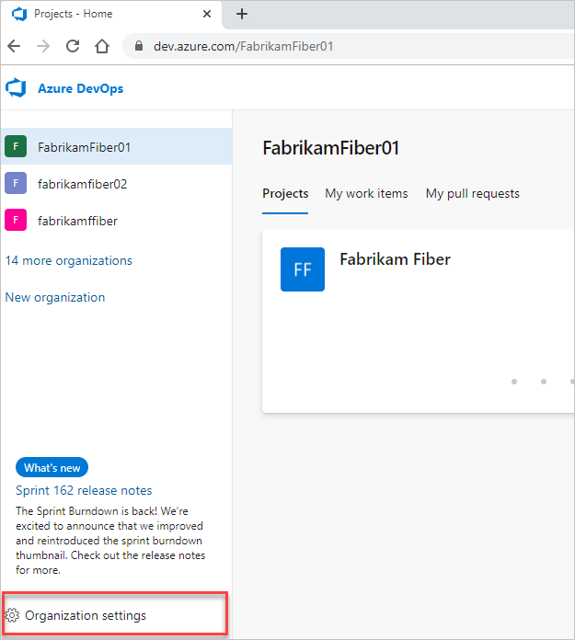

1. Select **Users**.

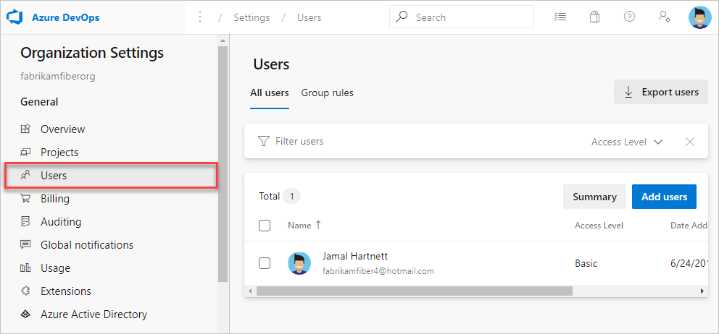

1. Select a user or group of users. Then, select **Actions ...** at the end of the **Name** column to open the context menu.

In the context menu, select one of the following options:

* + **Change access level**
  + **Manage user**
  + **Resend invite**
  + **Remove direct assignments**
  + **Remove from organization** (deletes user)

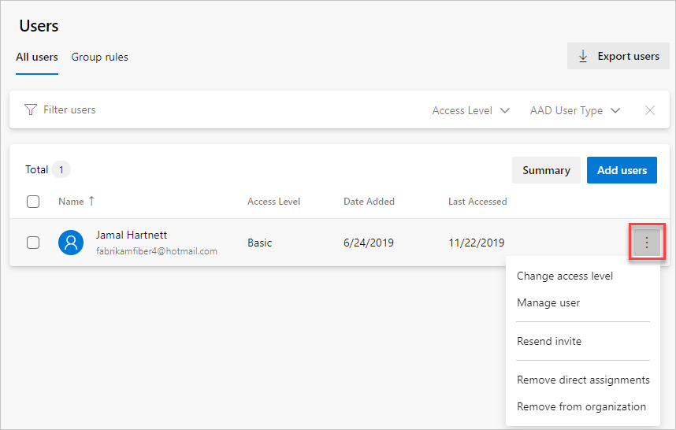

1. **Save** your changes.

Solution suggested here - <https://stackoverflow.com/questions/39006891/tfs-issue-projects-missing-in-the-source-control-explorers-left-pane>

Verify and change access level of user from Stackholder to Basic as specified in here <https://docs.microsoft.com/en-us/azure/devops/organizations/accounts/add-organization-users?view=azure-devops&tabs=preview-page>