Issue:

One of our clients had an issue with the VAT amount in general journal.

Though, VAT amount was calculating and updating when enter the data in General Journal; after posting the transaction, VAT amount was not affecting and updated with 0.

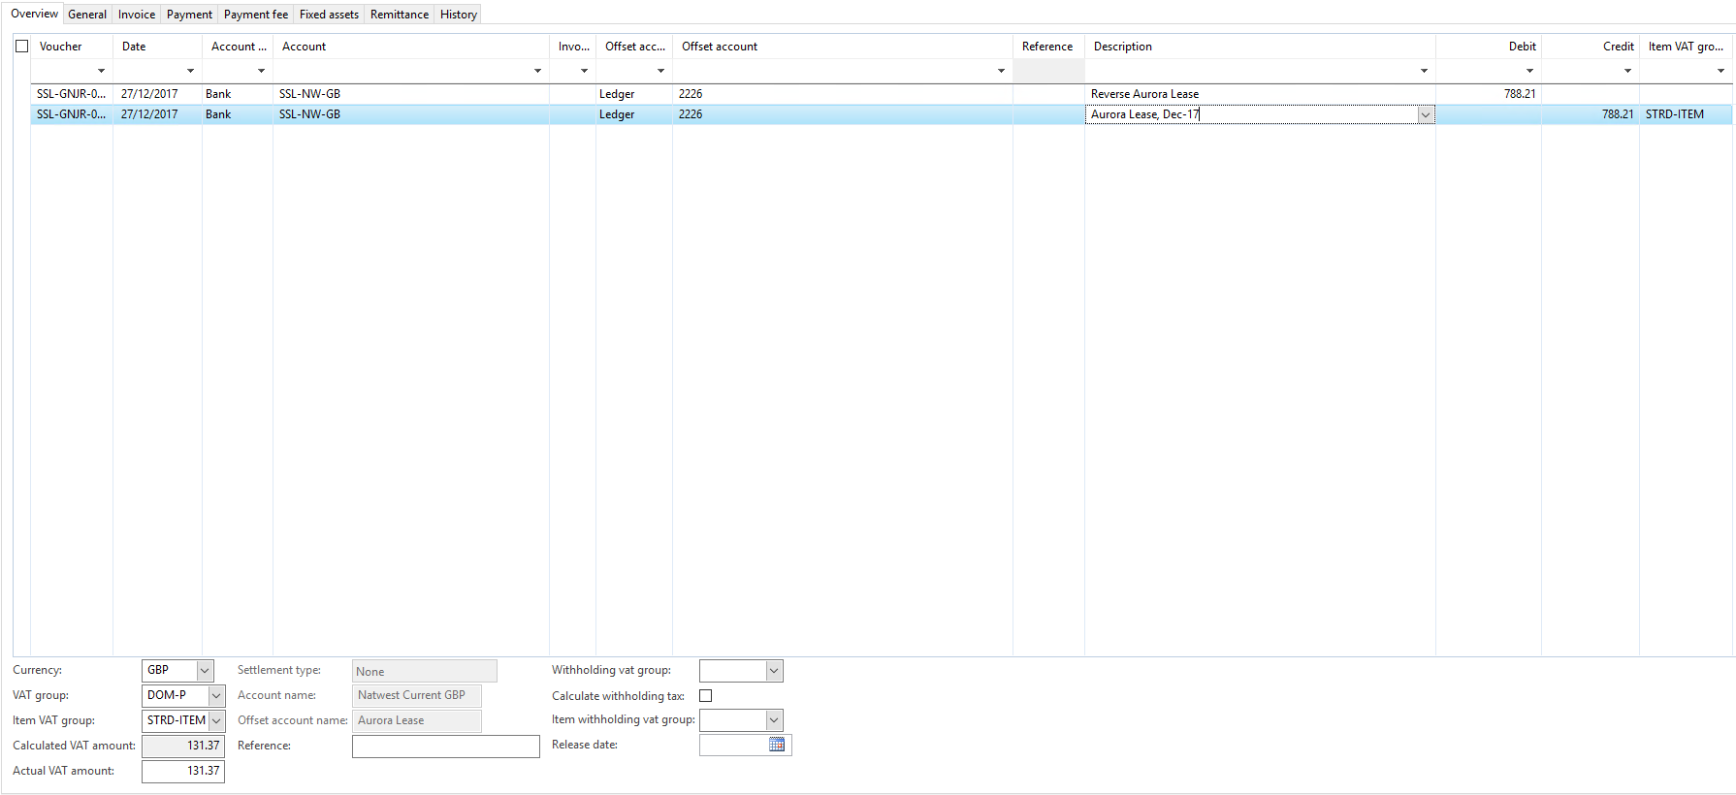

Resolution:

Uninstalling and Installing .net business connector on the server resolved this issue Permanently.