**Introduction:**

This KB is on the topic of **Delta Pre-processing script,** which is the part of the **Data upgradation** of the application from AX 2009 to AX 2012/ AX2012 R3.

**What is Delta Pre-processing script?**

You run the delta pre-processing scripts after you complete the **Global address book country/region upgrade** task on the Microsoft Dynamics AX source system (AX 2009).

The delta pre-processing scripts check for changes to the production data that have occurred since you started running the live pre-processing scripts. Then, like the live pre-processing scripts, the delta scripts process the updated data into the shadow and dictionary tables.

Like the live pre-processing scripts, the delta pre-processing scripts run while your Microsoft Dynamics AX source system is live and being used for production. To optimize performance, you can pause some or all of the delta scripts by using the **Manage running tasks** form.

You can run the delta pre-processing scripts multiple times until you are ready to enter single-user mode. To minimize downtime, make sure to run the delta pre-processing scripts just before entering single-user mode

Below are the screens of the **Delta Pre-processing script in AX 2009**

Pre-processing Upgrade Checklist >> Pre-process data on Live system >> Run delta pre-processing scripts

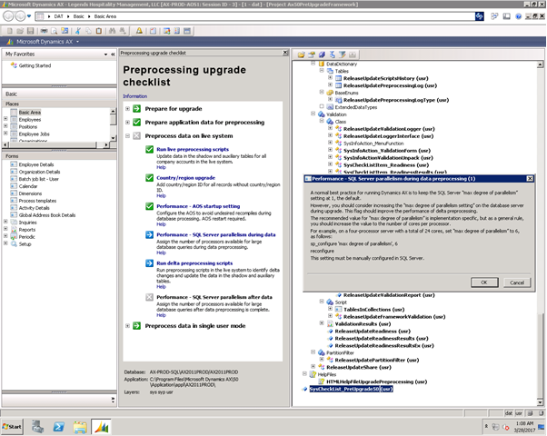

On clicking the link: Run delta pre-processing scripts, the below screen will open. Click on “Run” button, so that the jobs will start to execute. Resolve the errors if in any job and re-run that job.

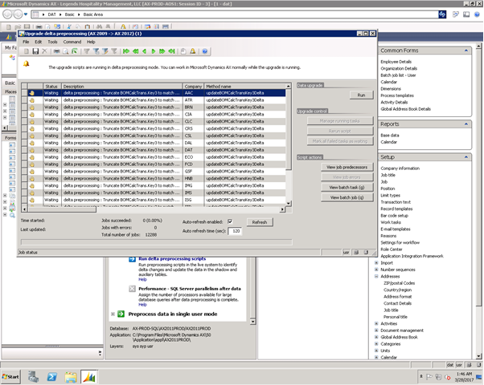

While running the delta pre-processing script in the AX 2009 data upgrade step, if it runs successfully without any error, it means the updated data has not been transferred in the shadow tables.

Please once verify the data in the shadow tables. If updated data is not there then you have to install the **KB #2728470**

**Or**

Follow the below steps:

Go to the AOT 🡪 Classes 🡪 ReleaseUpdateTransformExecute 🡪run method and replace the code as below:

-Compile the project and resolve any error

-Rerun the delta-processing step and take appropriate action for any error.

…..

Catch

{

controlData = appl.globalCache().get(classstr(ReleaseUpdateTransactionManager)

, int2str(classId) + methodName + curext(), connull());

if (controlData != connull())

{

log  = 'Script: ' + dictClass.name() + '.' + methodName + '(' + curext() + '). Last control data: ' + con2str(controlData, ',');

ReleaseUpdatePreprocessingLog::log(log, ReleaseUpdatePreprocessingLogType::Throttling);

}

Else

{

log  = 'Script: ' + dictClass.name() + '.' + methodName + '(' + curext() +')';

}

throw error(log);

}

|  |
| --- |
|  |