Sign in require error in accessing PowerApps.com

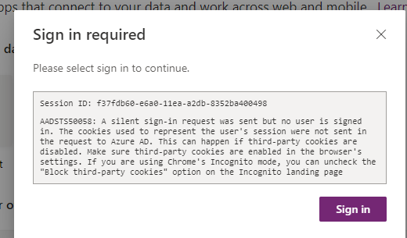

Have you faced this error? You may face when you long to PowerApps.com. The reason behind this error is a silent sign-in request was sent but no user is signed in. The cookies used to represent the user’s session were not sent in the request to Azure AD. This can happen when third-party cookies are disabled.

This error can be avoided if we open PowerApps.com in Incognito, as mention in the error message but what if I am not using Incognito?

We are getting this error message because multiple signing information and credentials accessing PowerApps.com so it will also pass the same information to login.microsoft.com.

This can be solved by clearing cookies. First of all go to Privacy and Security -> See all cookies and site data, here you can see bunch of login.microsoftonline.com, remove all of it.

