**Configure Offline Database in Modern POS**

* A Retail Modern POS device will go offline if the Retail Server is unavailable. When the connection with the Retail Server is lost, the point of sale (POS) automatically switches to the offline database.
* If a data request doesn’t succeed within the time-out interval that is configured in the offline profile form in AX, Retail Modern POS automatically switches to the offline database and continues the sales transaction.

**Note**: **If you not found “Microsoft Dynamics AX for Retail Modern POS Offline Sync Service” in services.msc then you need to configure offlinecmd from PowerShell using below command**

PS C:\Program Files (x86)\Microsoft Dynamics AX\60\Retail Modern POS\Tools> .\ConfigureOffline.cmd 'C:\Program Files (x86)\Microsoft Dynamics AX\60\Retail Modern POS\'

**Below are steps to configure offline database:**

* Before configure offline database, create database manually in client system and give rights with db_dataReader, db_Datawriter, db_ddladmin and db_owner.
* Go to “Retail Channel Configuration Utility” tool
* Click on the “Create offline database” as per below screen shot.
  1. Enter store ID
  2. Enter server name and database name of channel database same as offline database.
  3. Check test connection
  4. Click on the “Apply” button

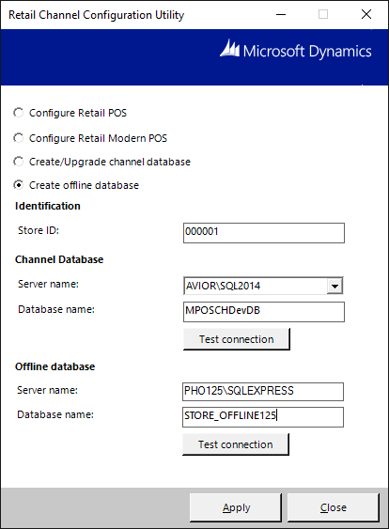

* When database is created successfully then go to “Configure Retail Modern POS” as per below screen shot.

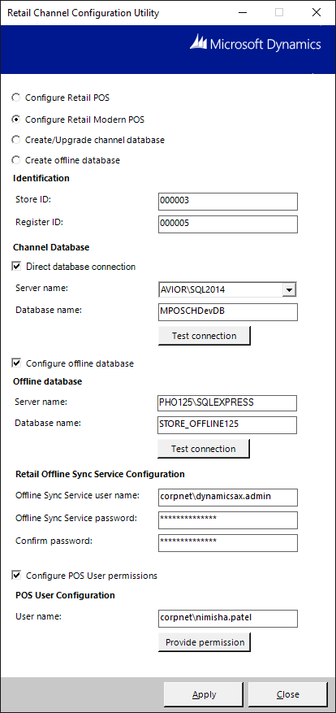

* Open MPOS, add button to manually switch between online and offline modes. Create button of “Database connection status” as per below screen shot.

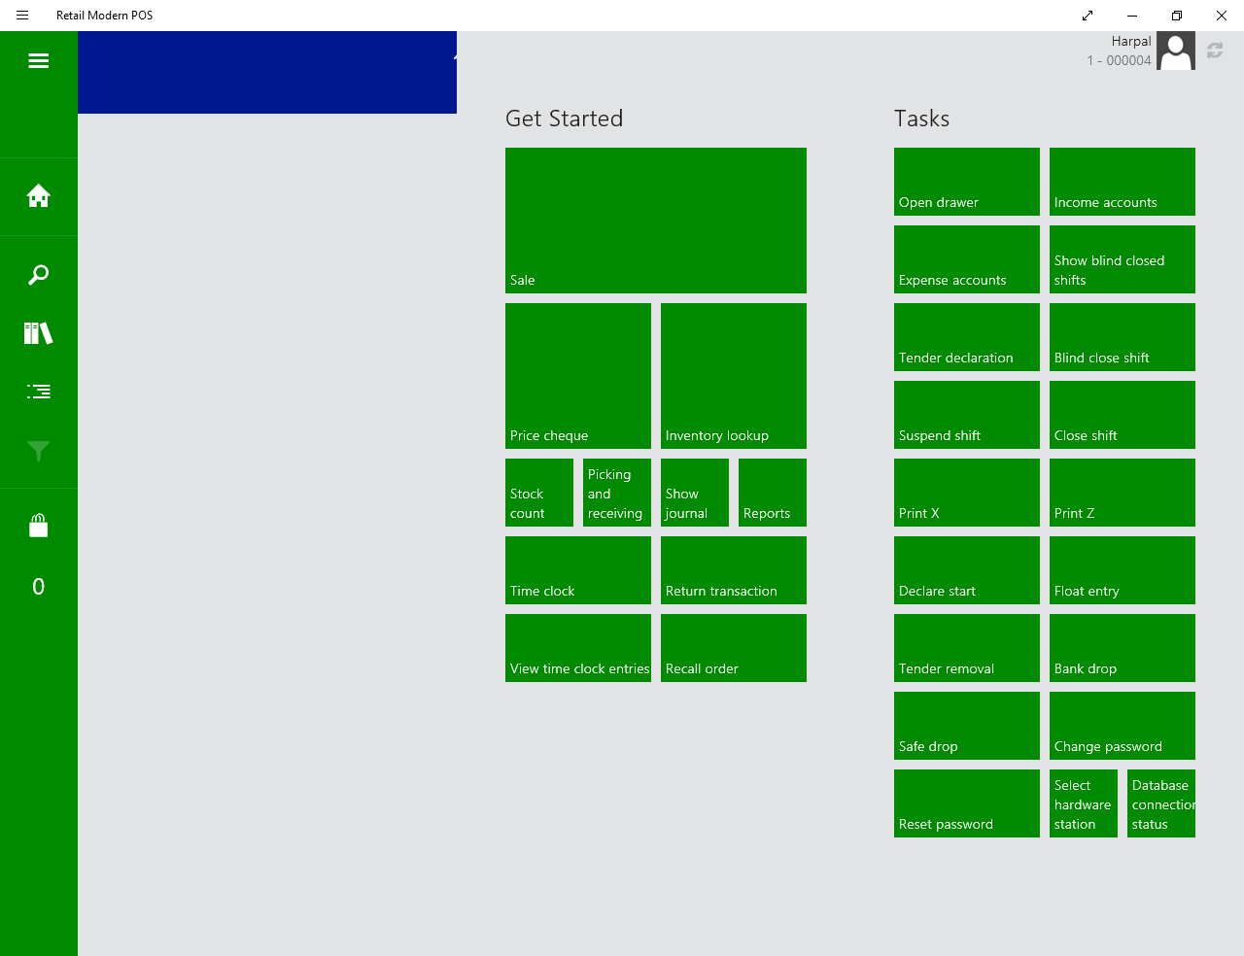

* When you click on this button, you can see connection status.
* The status header of Retail Modern POS indicates the current connection status. 