Table of Contents

Project Structure: 1

Project WIP Report 2

Parameters 2

Output: 3

Steps done for Output Variation:(Taking project as Fixed Price with Completed Percentage) 4

Project Transaction Report: 4

Parameters 4

Project Cash Flow Report: 6

Parameters 6

Output: 8

Project Consumption Report: 8

Parameters 8

Output: 9

# Project Structure:

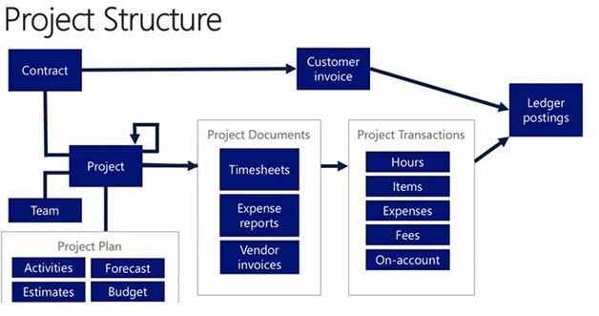

# Project WIP Report

## Parameters

|  |  |
| --- | --- |
| **Include project types** | Select the project types that you want to include on the report. You must select at least one project type. |
| **Include transaction types** | Select the transaction types that you want to include on the report. You must select at least one transaction type. |
| (**Project date**)  **From date** / **To date** | Specify a starting date and an ending date to include transactions that are posted to projects. |
| (**Ledger date**)  **From date** / **To date** | Specify a starting date and ending date to include project transactions that posted to the ledger. |
| **Actual vs. budget** | Select **Actual** to display actual values on the report.  Select **Budget** to display budgeted values on the report. |
| **Forecast model** | Select the forecast model that you want the report to use.   |  | | --- | | **NoteNote** | | If you are using project budget control, select the budget forecast model that is used by this project. | |
| **Project view** | Select the point of view of the output on the report from the drop down list in this field.  For example, the output can be based on the project group, the person in charge of the project, the person financially in charge of the project, or the customer. |
| **Project level** | Specify the number of subproject levels:   * Select 0 to display all projects that are summarized in one line. * Select 1 to display only parent projects. * Select 2 to display subprojects.  |  | | --- | | **NoteNote** | | The subprojects below the parent project level are summarized on one line, and an asterisk (*) indicates that the summarized number includes subprojects below the first subproject level. | |
| **Skip blank ID** | Select whether to exclude transactions that are not associated with a project ID. |
| **Skip zero** | Select whether to exclude all rows on the report where the amounts are equal to zero. |
| **Show amount** | Select how you want decimals to appear on the report. Select from the following options:   * **With decimals** – Amounts are displayed to two decimal places of your company currency. * **Without decimals** – Amounts are rounded to integers. * **Amount in 1,000** – Amounts are rounded to the nearest 1,000 units of your company currency. * **Amount in 1,000,000** – Amounts are rounded to the nearest million units of your company currency. |
| **Show hour** | Select whether to display the quantity of hours, the cost value for hours posted to a project, or both on the report. |
| **Positive WIP** | Select whether to include projects where the WIP amount is a net positive value. WIP is positive when invoiced amounts exceed cost transactions. |
| **Negative WIP** | Select whether to include projects where the WIP amount is a net negative value. |

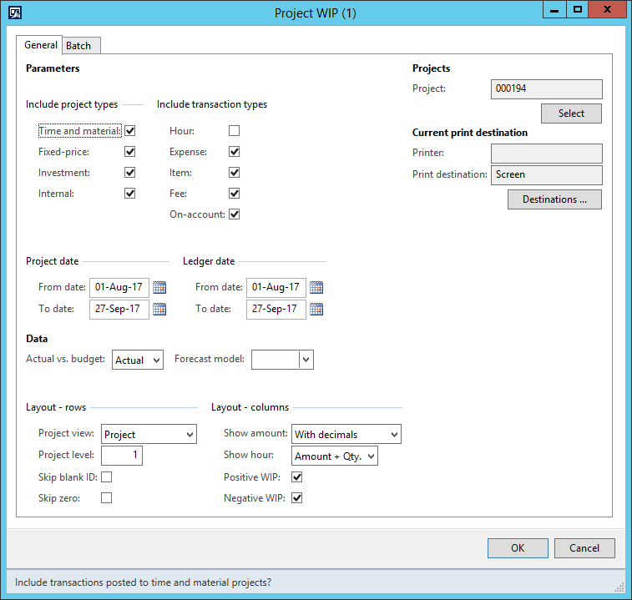

## Output:

**Project:** Id of project

**Project Name**

**Total WIP Costs:** It is sum of Actual costs for hours, expenses, and items are posted to a financial account on the balance sheet. When costs on a project are invoiced to the project customer or an internal project is completed, the costs and associated revenue are posted to profit and loss accounts. This option is available for all project types.

**Total WIP sales:** It is sum of the cost which is being posted to revenue account that is debiting the WIP account. It is applicable only to fixed price and Time and Material project.

**Gross WIP:** Total WIP Costs-Total WIP sales

**WIP Invoiced On account:** It is sum of the total amount of the milestone posted in On account Trans. This field will be seen only when we tick on “On account” in Transaction Type Parameter.

**Net WIP:** Gross WIP- WIP Invoiced On account.

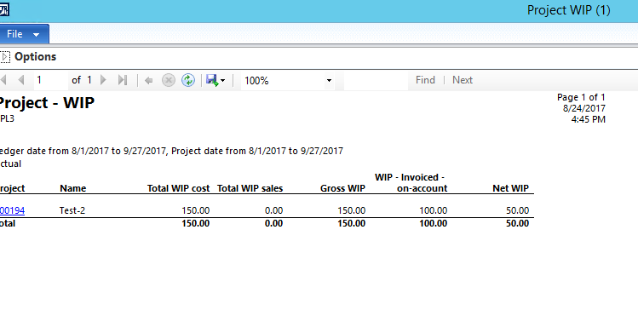

## Steps done for Output Variation :( Taking project as Fixed Price with Completed Percentage)

1. I created entry in Project On account Trans and then done Estimated and Elimination Process but Total WIP Cost was still 0.
2. I created entry in Expense Journal and Post it, Cost Price was still 0.
3. But when Estimate was Created and Posted, then the Cost Price was equal to my Expense Journal Amount.
4. When Elimination is done, Cost Price becomes 0, since all amount get Transferred to Revenue Account.
5. When again reversed the Elimination, Cost Price was equal to my Expense Journal Amount.

# Project Transaction Report:

## Parameters

|  |  |
| --- | --- |
| **Field** | **Description** |
| **Invoice** | Select whether to include transactions on the report from the following options:   * **Nonchargeable** – Include transactions for which you do not invoice a customer. * **Chargeable** – Include transactions for which you send customer invoices. * **Invoiced** – Include transactions that you have already invoiced to customers. |
| **Project ID** | Click **Select**. In the **Transactions - project** form, select a project ID to include on the report. To add more than one project, click **Add**. |
| **Hours** - **Project date** | Click **Select**. In the **Transactions - project** form, select a starting date for hour transactions in projects to include on the report. To add more than one starting date for hour transactions, click **Add**. |
| **Expense** - **Project date** | Click **Select**. In the **Transactions - project** form, select a starting date for expense transactions in projects to include on the report. To add more than one starting date for expense transactions, click **Add**. |
| **Fee** - **Project date** | Click **Select**. In the **Transactions - project** form, select a starting date for fee transactions in projects to include on the report. To add more than one starting date for fee transactions, click **Add**. |
| **Items** - **Project date** | Click **Select**. In the **Transactions - project** form, select a starting date for item transactions in projects to include on the report. To add more than one starting date for item transactions, click **Add**. |
| **On-account** - **Project date** | Click **Select**. In the **Transactions - project** form, select a starting date for on-account transactions in projects to include on the report. To add more than one starting date for on-account transactions, click **Add** |

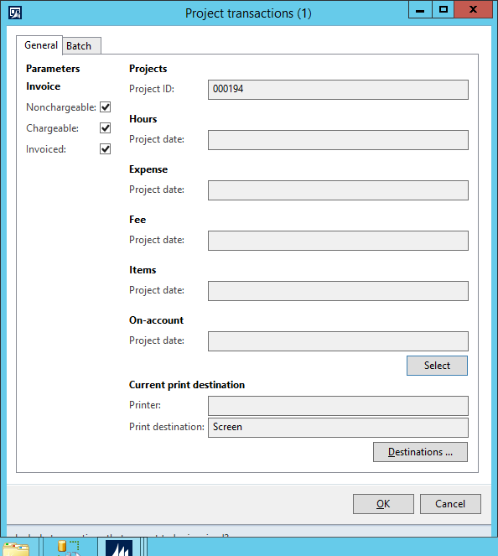

**Output:**

1. Project Name
2. Project Category: Categories represent types of costs or revenues that are defined for an entire organization. Each category must be assigned to a category group. Categories and category groups are organized by type. These types correspond to the transaction types that are available in Project management and accounting.
3. Category groups are divided into four types:

* **Fee**
* **Hour**
* **Expense**
* **Item**

1. Parent Project : If it is subproject, then parent project is displayed else project itself is being shown.
2. Project Date: Transaction date
3. Line Property: That is Billable or not billable.
4. Description
5. Journal Voucher
6. Invoice Voucher
7. Quantity
8. Currency
9. Sales Price: Price for hour or fee defined at the Project level or for all projects. For item, it is the price defined in Manage Cost of Item.
10. Line Amount: Product of Quantity and Sales Price.
11. Grand total: It is sum of the Line amount of all Transactions.

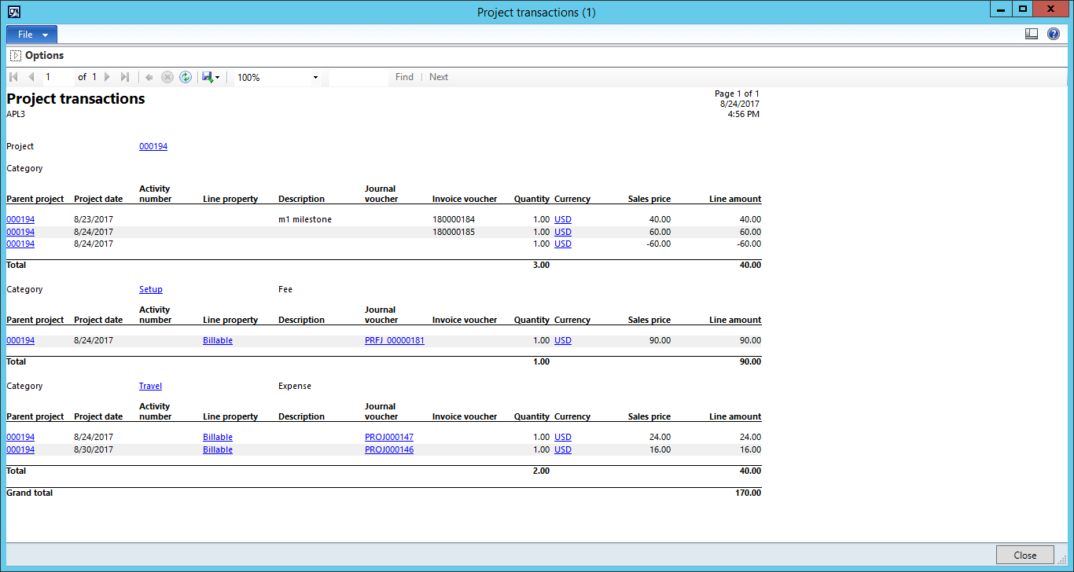

# Project Cash Flow Report:

## Parameters

|  |  |
| --- | --- |
| **Field** | **Description** |
| **Include project types** | Select the project types that you want to include on the report. You must select at least one project type. |
| **Include transaction types** | Select the transaction types that you want to include on the report. You must select at least one transaction type. |
| (**Project date**)  **From date** / **To date** | Specify a starting date and an ending date for project transactions to include on the report. |
| (**Payment date**)  **From date** / **To date** | Specify a starting date and an ending date for project-related payments to include on the report. |
| **Actual vs. budget** | * Select **Actual** to display actual transaction values on the report. * Select **Budget** to display budget values on the report. * Select **Deviation** to display the difference between actual values and budgeted values. * Select **Sum** to display the actual values plus budgeted values. |
| **Forecast model** | Select the forecast model that you want the report to use.   |  | | --- | | **NoteNote** | | If you are using project budget control, select the budget forecast model that is used by this project. | |
| **Include paid payment** | Select whether you want to include payments already made. |
| **Include expected payment** | Select whether you want to include pending payments. |
| (**Expected sales payment date**)  **Add days to due payment** / **Minimum payment date** | Enter the number of days from today to include in the calculation of unpaid customer invoices, or you can enter a future date. The number of days is automatically calculated from today's date to the date you select.   |  | | --- | | **NoteNote** | | This control is available only if you select the **Include expected payment** check box. | |
| (**Expected cost payment dates**)  **Add days to due payment** / **Expected cost payment dates** | Select the number of days from today to include in the calculation of pending payments to vendors, or you can enter a future date. The number of days is automatically calculated from today's date to the date you select.   |  | | --- | | **NoteNote** | | This control is available only if you select the **Include expected payment** check box. | |
| **Project view** | Select how you want to display the first column of the report. |
| **Project level** | Specify the number of subproject levels:   * Select 0 to display all projects that are summarized on one line. * Select 1 to display only parent projects. * Select 2 to display subprojects.  |  | | --- | | **NoteNote** | | The subprojects below the parent project level are summarized on one line, and an asterisk (*) indicates that the summarized number includes subprojects below the first subproject level. | |
| **Skip blank ID** | Select whether to exclude transactions that are not associated with a project ID. |
| **Skip zero** | Select whether to exclude all rows on the report where the amounts are equal to zero. |
| **Show amount** | Select how you want decimals to appear on the report. Select from the following options:   * **With decimals** – Amounts are displayed to two decimal places of your company currency. * **Without decimals** – Amounts are rounded to integers. * **Amount in 1,000** – Amounts are rounded to the nearest 1,000 units of your company currency. * **Amount in 1,000,000** – Amounts are rounded to the nearest million units of your company currency. |
| **Project ID** | Click **Select**. In the **Cash flow - project** form, in the **Criteria** field, select a project ID to include on the report. To add more than one project ID, click **Add**. |

## 

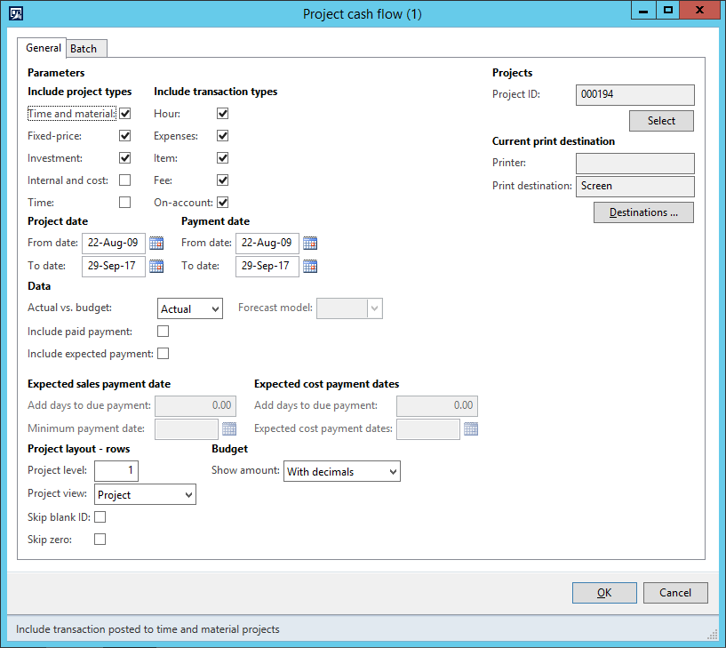

## Output:

It shows total net inflow and total net outflow.

For Example I have entered the Journal for Expense, hour, Item or fee, then the Cash Outflow will be the sum of this Journals.

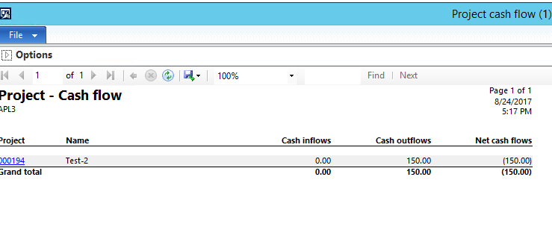

# Project Consumption Report:

## Parameters

|  |  |
| --- | --- |
| **Field** | **Description** |
| **Include project types** | Select the project types that you want to include on the report. You must select at least one project type. |
| **Include transaction types** | Select the transaction types that you want to include on the report. You must select at least one transaction type. |
| (**Project date**)  **From date** / **To date** | Specify a starting date and an ending date for project transactions to include on the report. |
| (**Ledger date**)  **From date** / **To date** | Specify a starting date and an ending for ledger transactions to include on the report. |
| **Actual vs. budget** | Select **Actual** to display actual values on the report.  Select **Budget** to display budgeted values on the report.   |  | | --- | | **NoteNote** | | If you select **Budget**, you must select a value in the **Forecast model** field. | |
| **Forecast model** | Select the **Forecast model** that you want the report to use.   |  | | --- | | **NoteNote** | | If you are using project budget control, select the budget forecast model that is used by this project. | |
| **Project view** | Select how you want to display the first column of the report. |
| **Project level** | Specify the number of subproject levels.   * Select 0 to display all projects that are summarized in one line. * Select 1 to display only parent projects. * Select 2 to display subprojects.  |  | | --- | | **NoteNote** | | The projects under the parent project level are summarized on one line. An asterisk (*) indicates whether the summarized number includes subprojects under the first subproject level. | |
| **Skip blank ID** | Select whether to exclude transactions that are not assigned to a project ID. |
| **Skip zero** | Select whether to exclude rows where the amounts are equal to zero. |
| **Show amount** | Select how you want decimals to appear on the report from the following options:   * **With decimals** – Amounts are displayed to two decimals of your company currency. * **Without decimals** – Amounts are rounded to integers. * **Amount in 1,000** – Amounts are rounded to the nearest 1,000 units of your company currency. * **Amount in 1,000,000** – Amounts are rounded to the nearest million units of your company currency. |
| **Show hour** | Select whether to display the quantity of hours, the cost value for hours posted to a project, or both on the report. |
| **Project** | Click **Select**. In the **Project consumption** form, select the projects to include on the report. To add more than one project, click **Add**. |

## 

## Output:

**Project:** Id of project

**Project Name:** Name of project.

**Hour Quantity:** It is the total sum of hour’s entered in hour journals of projects.

**Hour:** It is the multiplication of Sales Price for hour defined at the Project level or for all and Hour Quantity. It can be accessed by Project Management and Accounting>>Sales Price-Hour.

**Expense:** It is the total sum of expense entered in Expense Journals of project.

**Item :** It is the sum of the Cost Price of item entered in Item Journal of Project. Cost Price is the multiplication of the quantity entered and price of item. Price of item is price defined in Product Information Management>>Released Products>>Edit>>Manage Costs>>Prices.

**Total Consumption:** It is the sum of the all of the expenses entered that is sum of above three fields.

