**Project integration in D365**

1. **Install Project.**



1. **Open Project templates click on Blank Project**

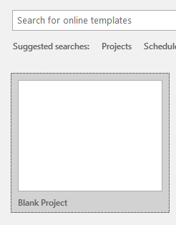

1. **Click on File tab**

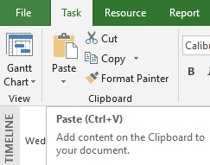

1. **Click on Account tab and check Product key is updated or not. (If not then update product key)**

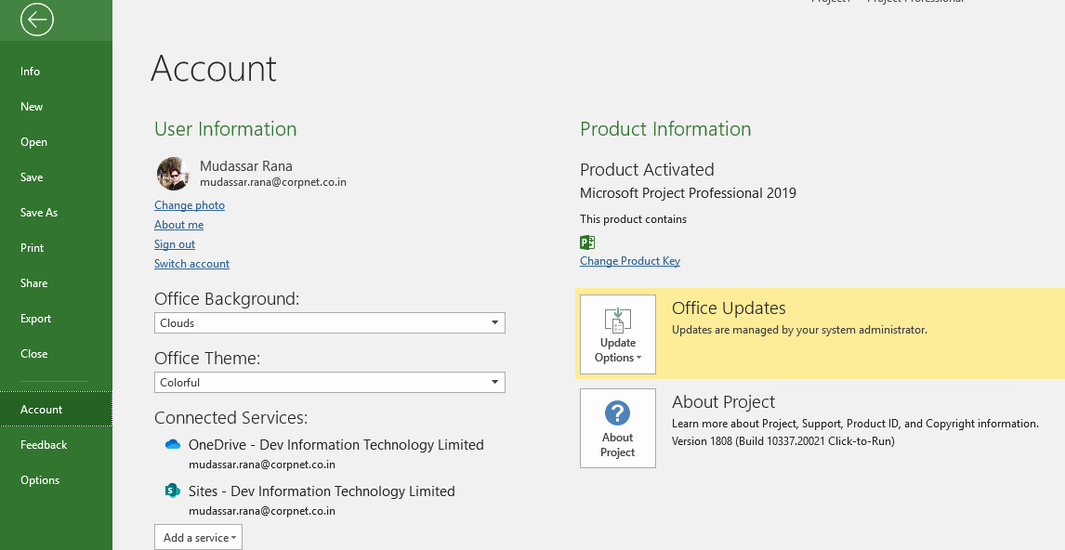

1. **After Click on Option and then click on Add-ins tab (Add Add-ins as per below screen shot).**

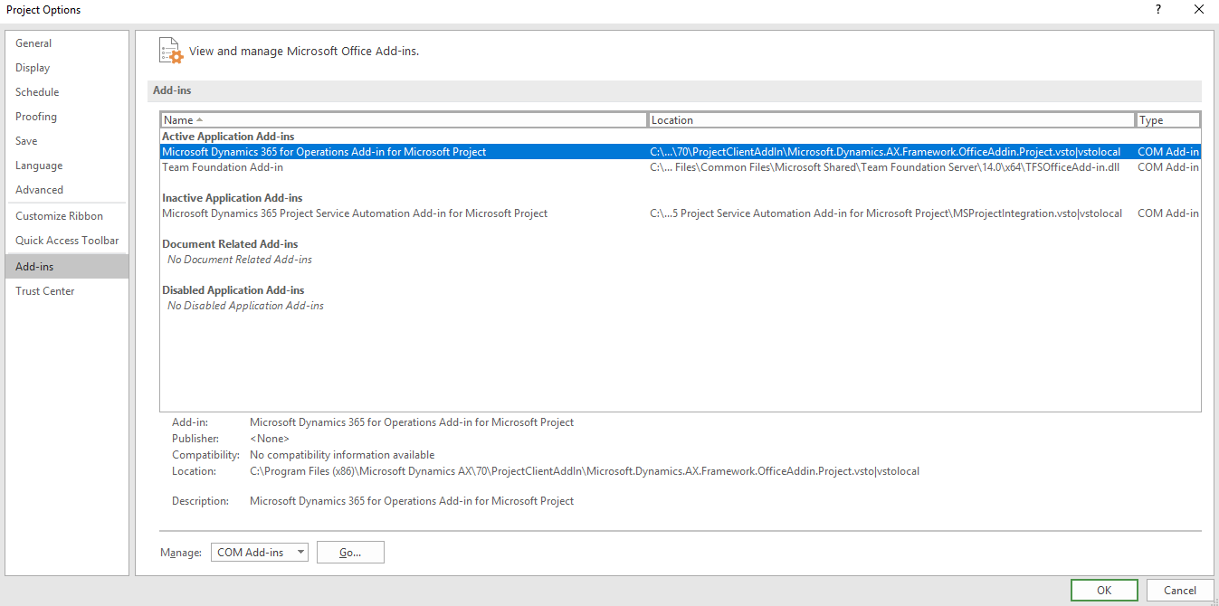

1. **After that open Internet Information Services->Site->AOSService and then click on Browse Website**

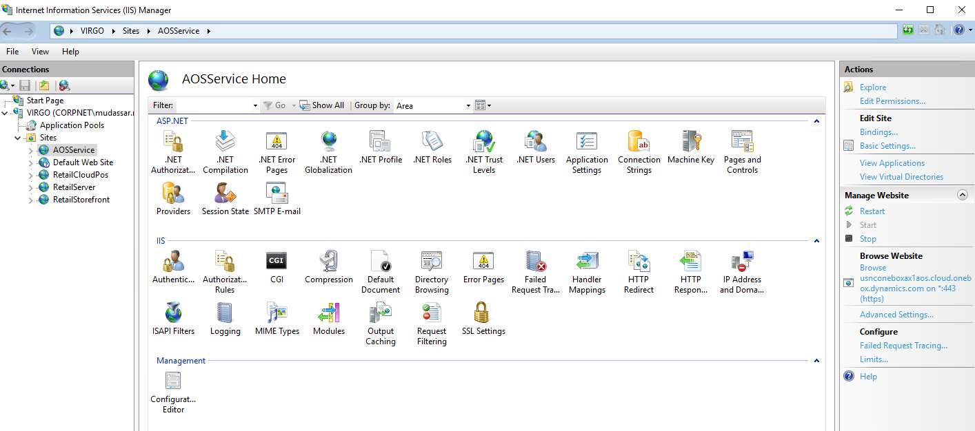

1. **After that go to Project management and accounting -> Workspaces->Project management**

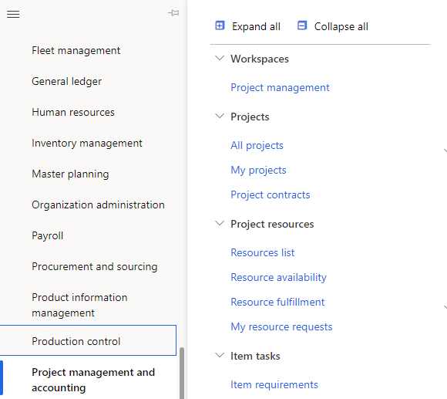

1. **After that click on Configure project client add-in (Pop up will be display on browser to click on that and install file).**

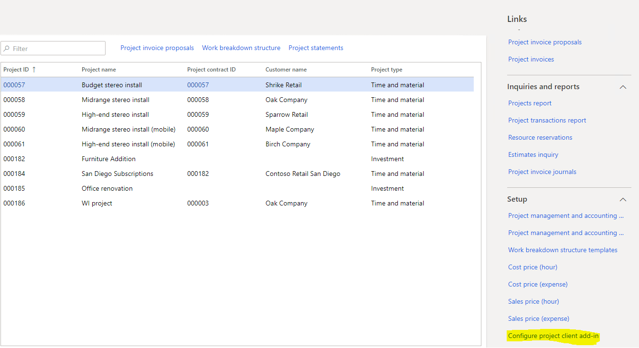

1. **After that go to Project management and accounting->Set up ->Project management and accounting parameters**

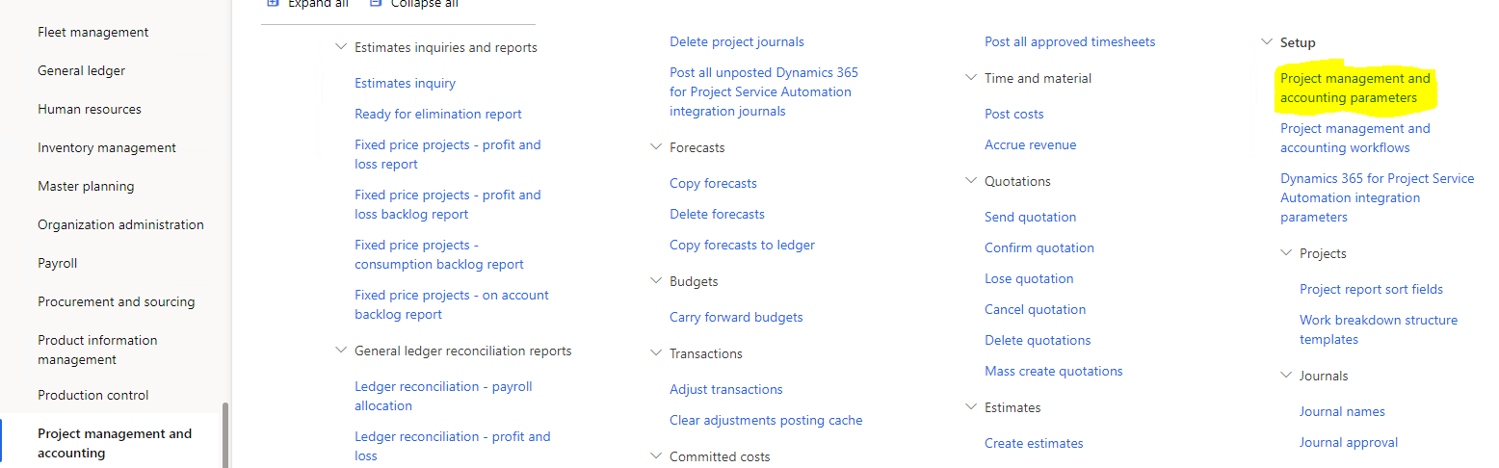

1. **Select “Yes” in “Prevent project closure if open transaction”.**

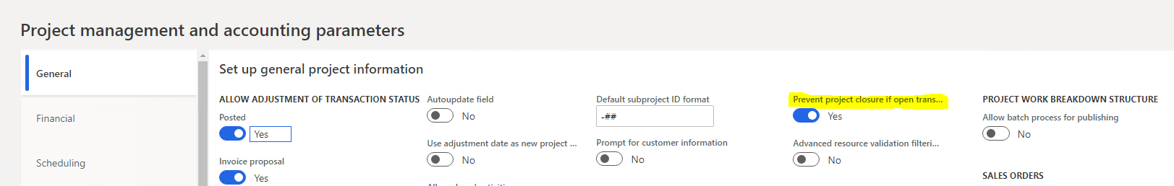

1. **Go to Project management and accounting -> Projects->All Projects**



1. **Select any Project in grid and then click on Work background structure.**

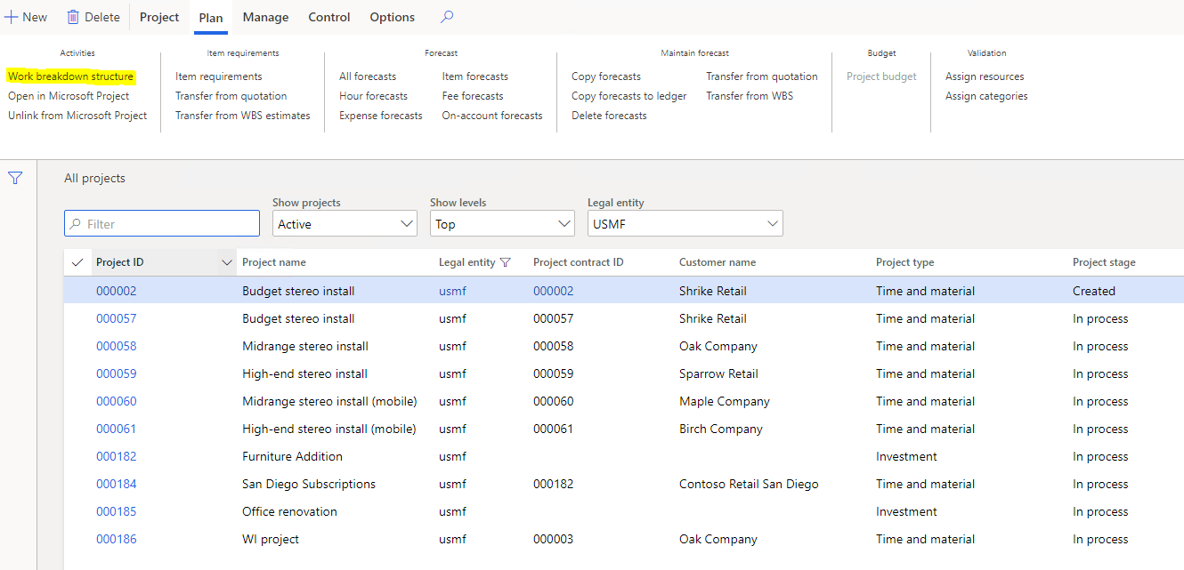

1. **Add Lines for Project.**

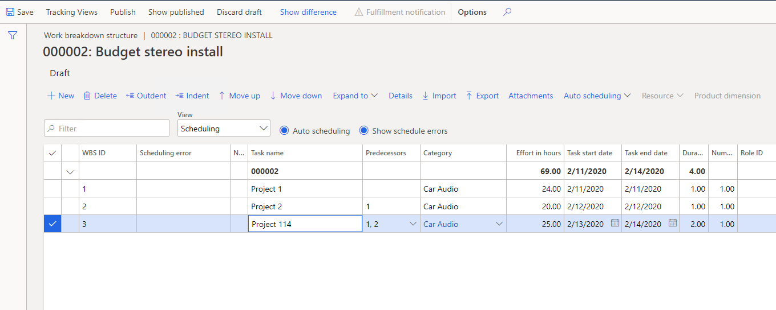

1. **After that click on Open in Microsoft Project.**

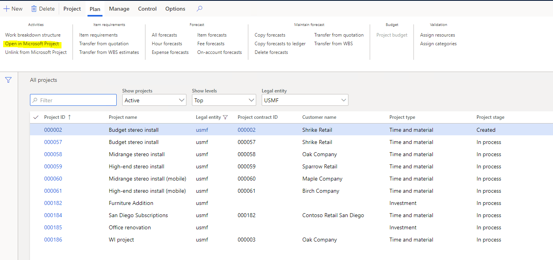

1. **File will be downloaded in browser, click on file (the file open in Project template to showing data as per D365 Project->Work background structure)**

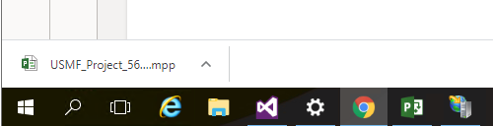

1. **When click on file the pop up will be generate so enter your email id and password.**

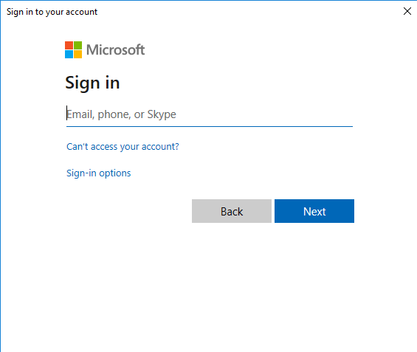

1. **After that data will be display on Project template. (this is for display data as per D365 Project)**

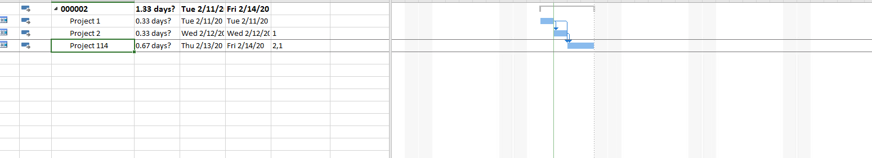

1. **Also, you have to change Project data and update on D365 Project from Project template so now first of all I have change Name (Project 114 to Project 115) and go to Microsoft Dynamics 365->Save changes->Replace existing project (this is updated for existing project records which are already existing in D365 projects in Work background structure).**

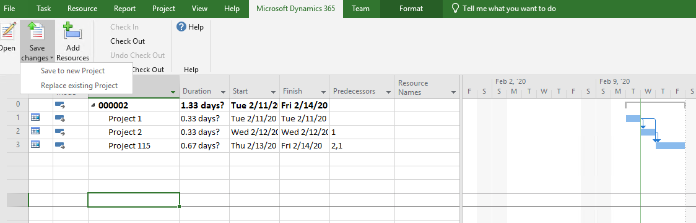

1. **After that pop up will be display as per below screen (click on Ok for replace on Existing project in D365 Project)**

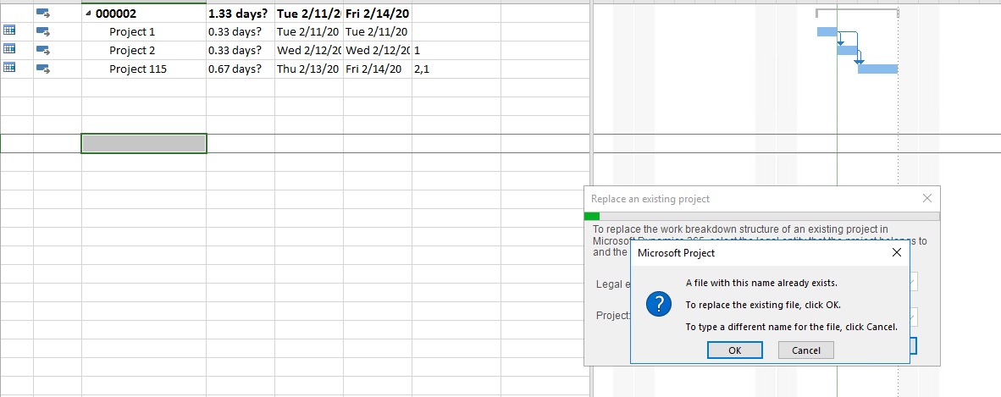

1. **Now check updated record in D365 Project->Work background structure so click on Work background structure.**

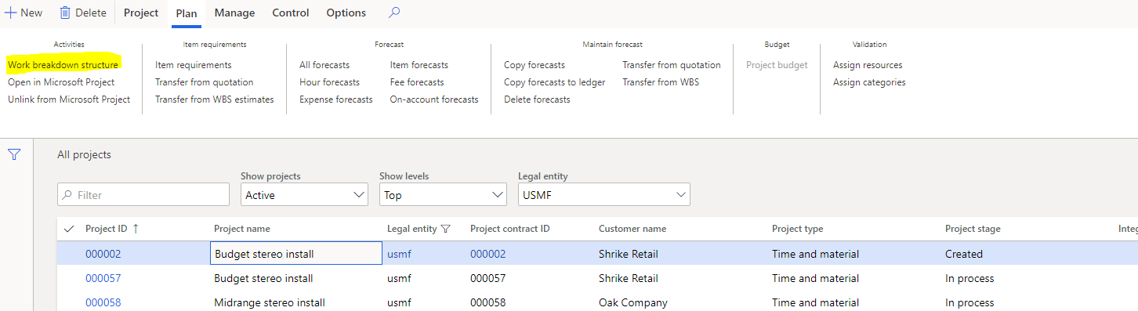

1. **The record will be updated as per below screen.**

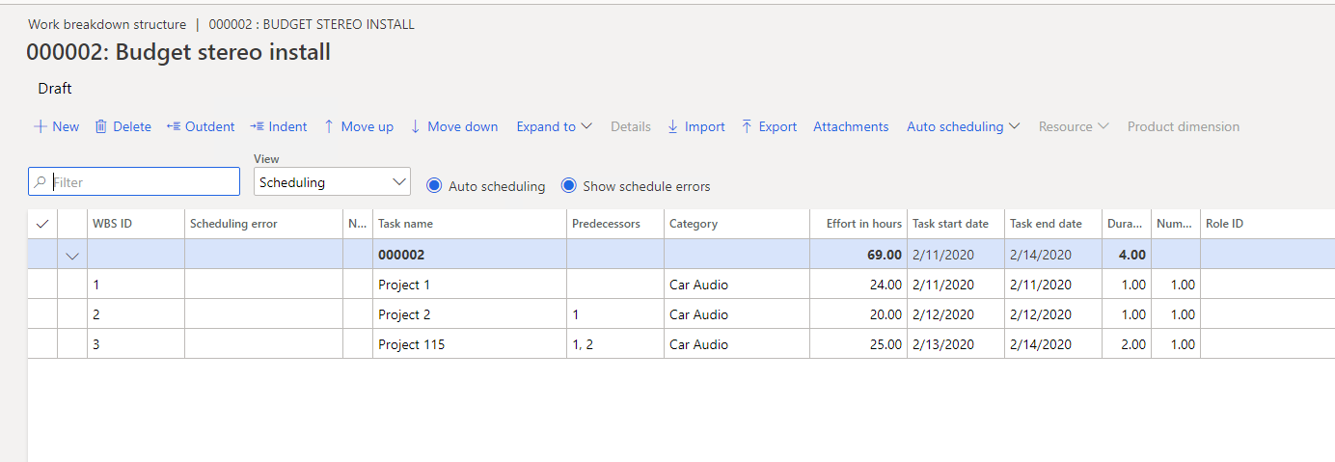

1. **Now another way to Update record form Project template to D365->Projects. So open Project template and select Blank Project.**

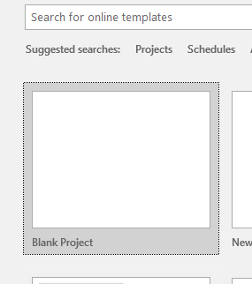

1. **Go to Microsoft Dynamics 365 -> Open tab, the Pop up will be display for Email id and Password.**

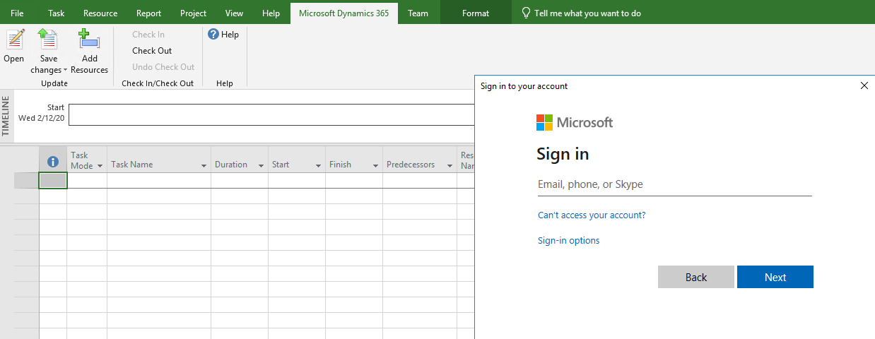

1. **After enter Email id and password another pop up will be display for Select Legal entity for select which company you want to change Project data.**

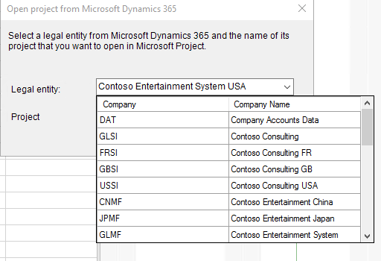

1. **Another is select for project which you want to change data for particular project.**

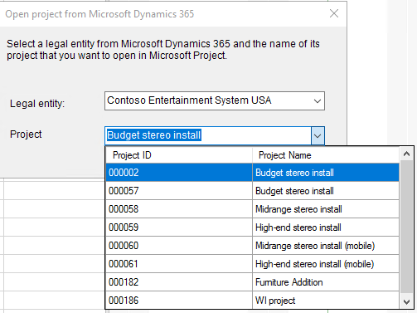

1. **After that the data will be display as per below screen.**

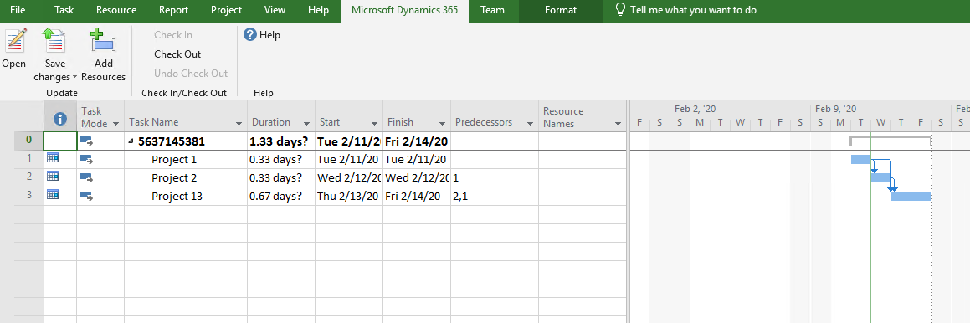

1. **This screen shot is display for change Name of project (Project 13 to Project 14). After that click on Microsoft Dynamics 365-> Replace existing Project.**

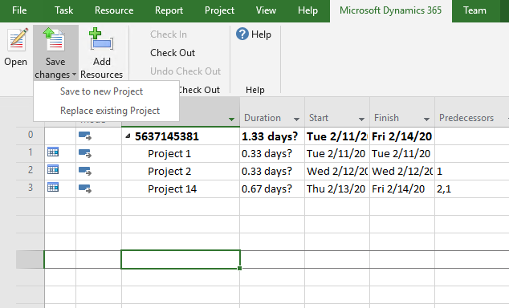

1. **Pop up will be display for which project you want to update data.**

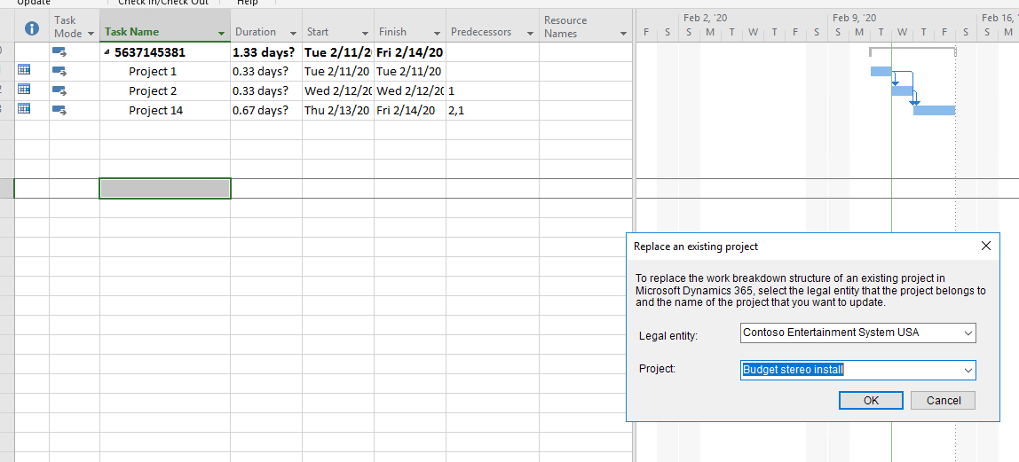

1. **Another pop up displaying for replace existing project to click on OK button.**

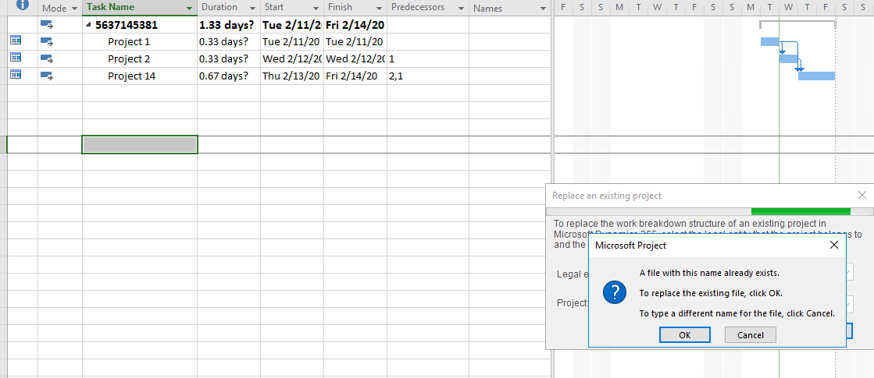

1. **After that go to Project then select project for updated record in Project template and then click on Work background structure.**

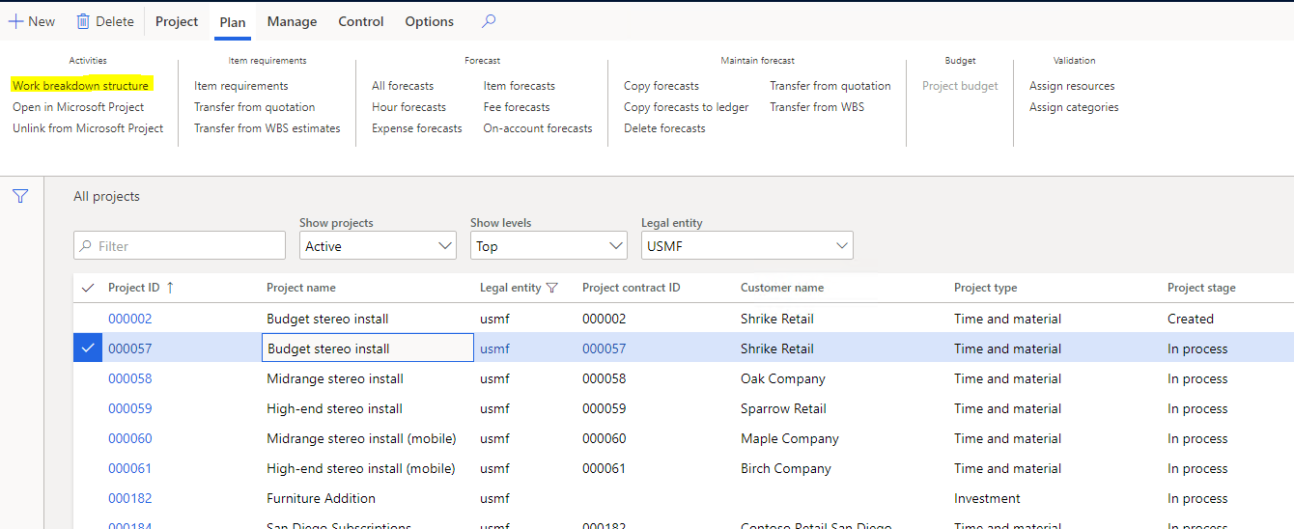

1. **Records are updated as per below screen shot.**

