Reason behind “settlement” transactions in customer transactions

Once a while, our client had an issue with the customer transactions of type “settlement”. How these transactions had been generated? Is it something customized or is through the standard AX?

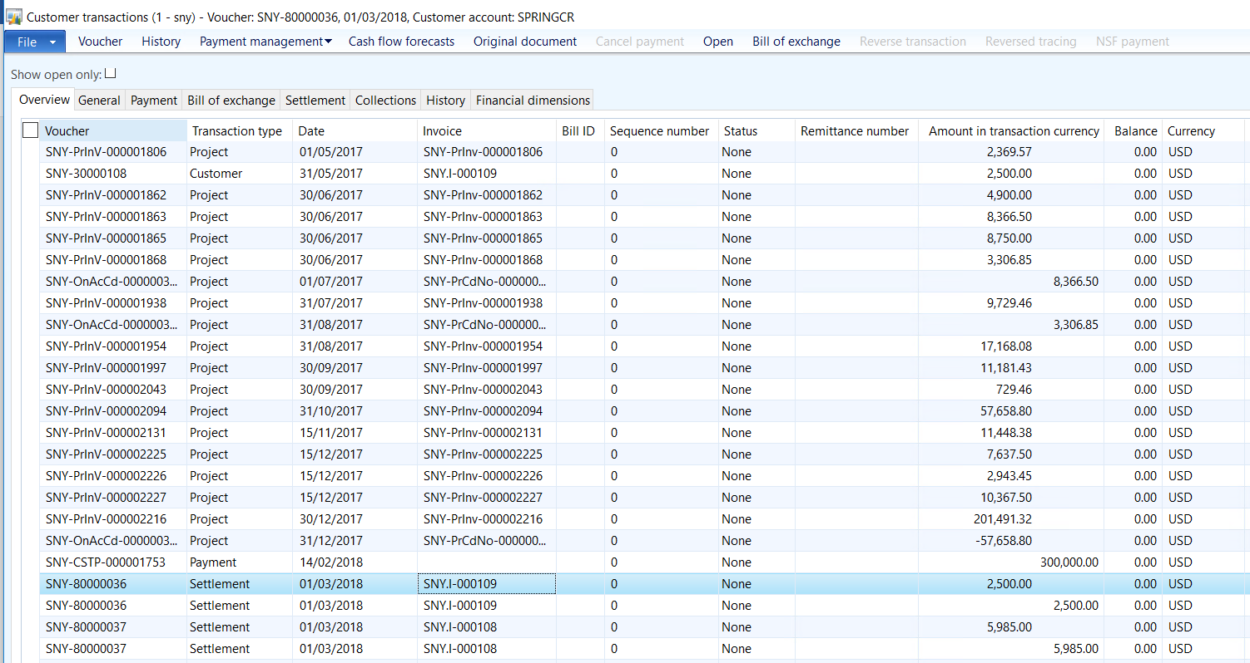

I first verified by clicking on the original document at the top. But, no detail found so it seems, is not something customized. Also, have verified in back-end to identify if customization is there or not.

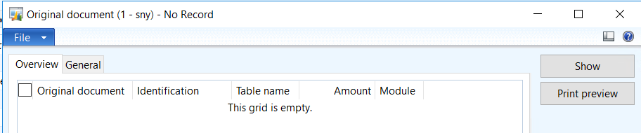

Then, I researched on this and got that, when settling the customer invoice and payment, if either **the posting profile or the financial dimensions are different** in the settled customer invoice and payment then system auto generates the settlement transaction.

I have verified in my case and found the voucher detail for invoice and payment as below:

Voucher details for invoice transactions:

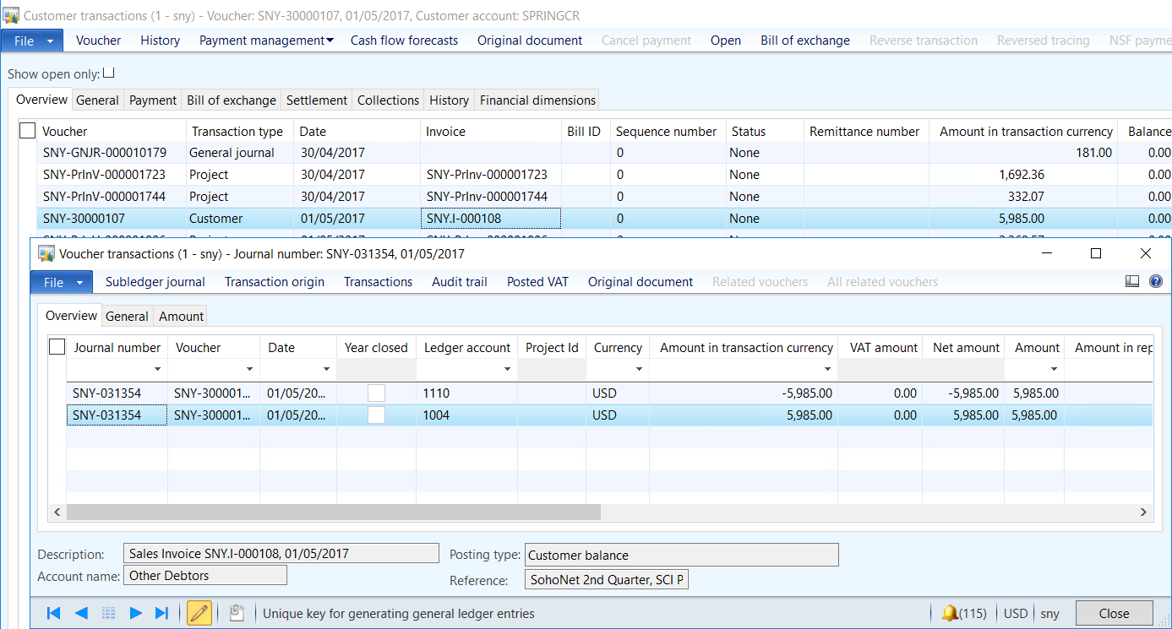

Voucher details for payment transactions:

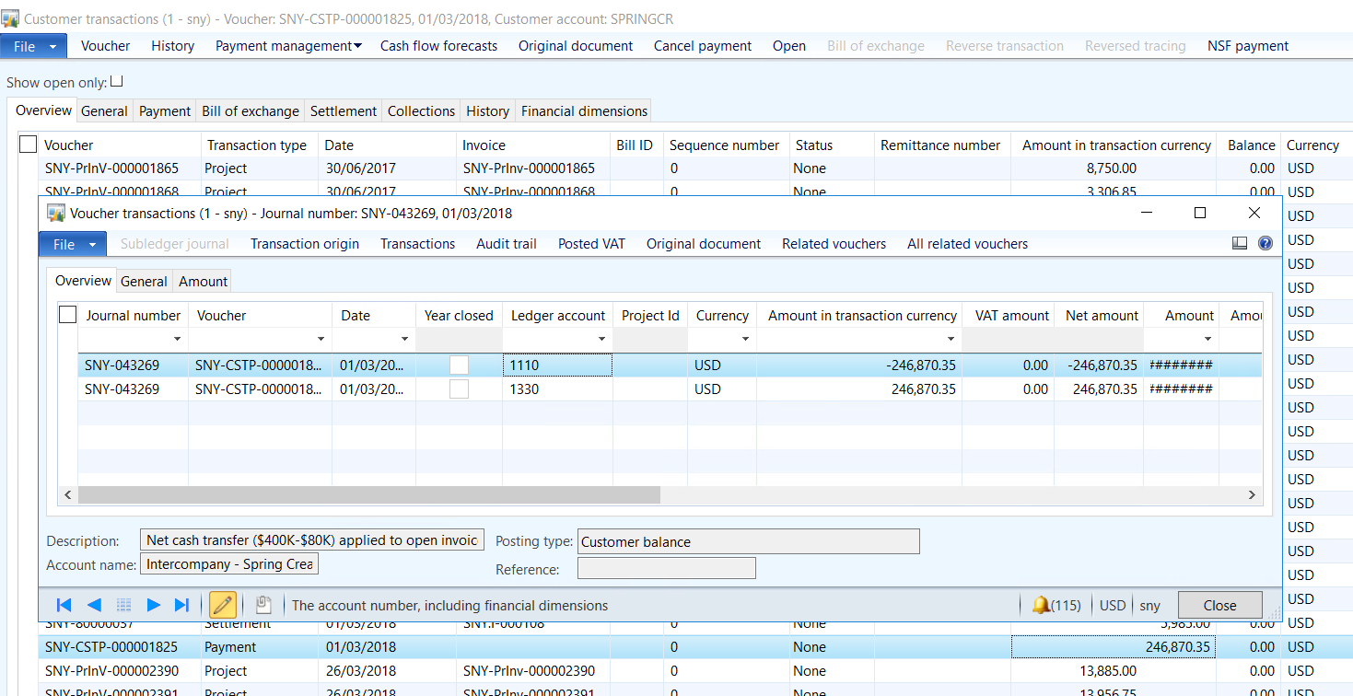

Looking into the voucher details:

* On invoicing, customer summary account 1004 has been affected ($ 5985 Dr.)
* On payment, customer summary account 1110 has been affected ($ 246870.35 Cr.)

When settling both the transactions, system generated extra transaction for adjusting the amount by crediting $ 5985 to 1004 and debiting $ 5985 to ledger 1110 so that ledger balance maintained properly.

