**Recurring workflow**

**Recurring Workflow :** A recurring workflow is, basically, a workflow that starts itself. The recurring workflows in Dynamics CRM can be implemented using child workflow (for example, by adding “wait” step and, then, starting a child workflow of the same type). However, I’ve never been able to really make it work since Dynamics turned out to be very diligent when it comes to terminating this sort of workflows. It usually allows the workflow to run for a few times, and, then, just when you think you’ve finally tricked it into allowing the workflow to go on indefinitely, you see that message that a workflow has been terminated.

**To create a workflow, follow these steps.**

1. Navigate to Microsoft Dynamics CRM > Settings > Processes, or, in a Solution, in the solution explorer, click Processes.

2. On the menu bar, click New.

3. In the Create Process dialog box, enter a Name for the process. The name of the process does not have to be unique. However, the name should be meaningful for users who have to select a process to switch to. You can change this name later.

4. In Category, select workflow. You cannot change the process Category after you click OK to save the process.

5. In Entity, select the entity that will be used for the first stage of the process. You cannot select a different Entity after you click OK to save the process.

6. Click OK. The process is saved and the workflow editor form is displayed.

**Step 1 & 2**

**Step 3,4 & 5**

**Step 6**

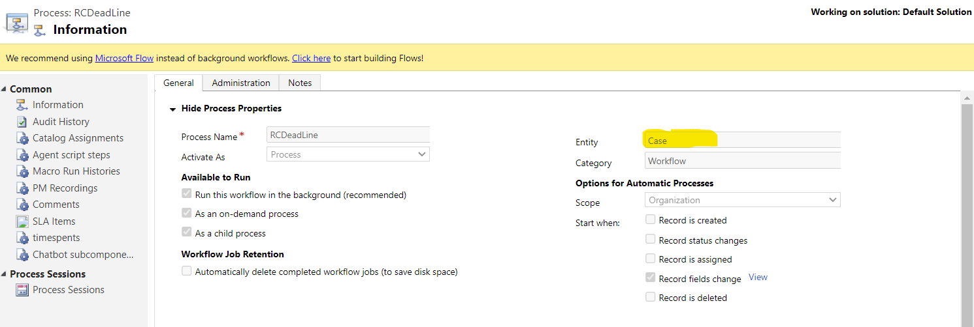Add the custom workflow message

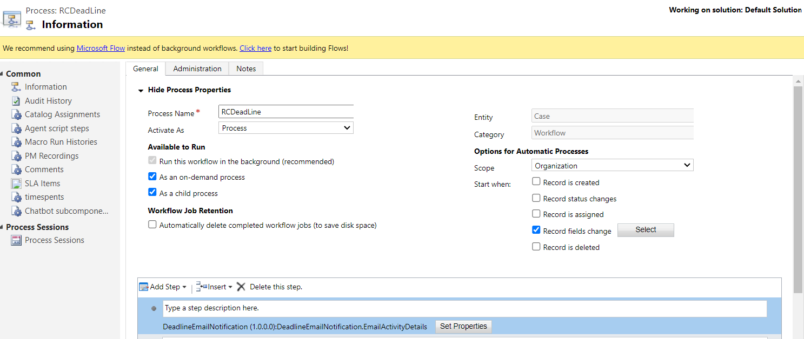

**To create a child workflow, follow these steps.**

1. Navigate to Microsoft Dynamics CRM > Settings > Processes, or, in a Solution, in the solution explorer, click Processes.

2. On the menu bar, click New.

3. In the Create Process dialog box, enter a Name for the process. The name of the process does not have to be unique. However, the name should be meaningful for users who have to select a process to switch to. You can change this name later.

4.Click on run as a child process.

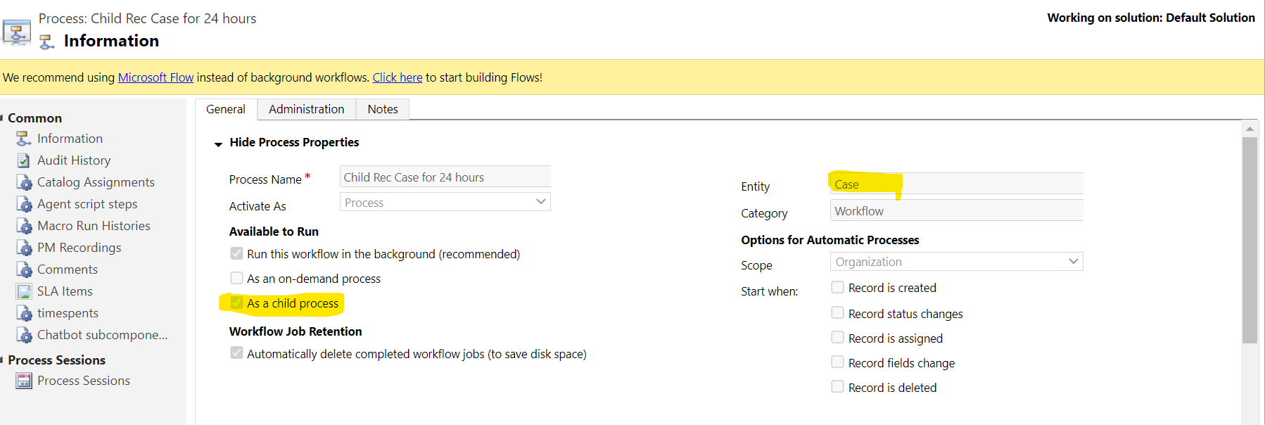

Now, call the child workflow from the main workflow after the wait condition.

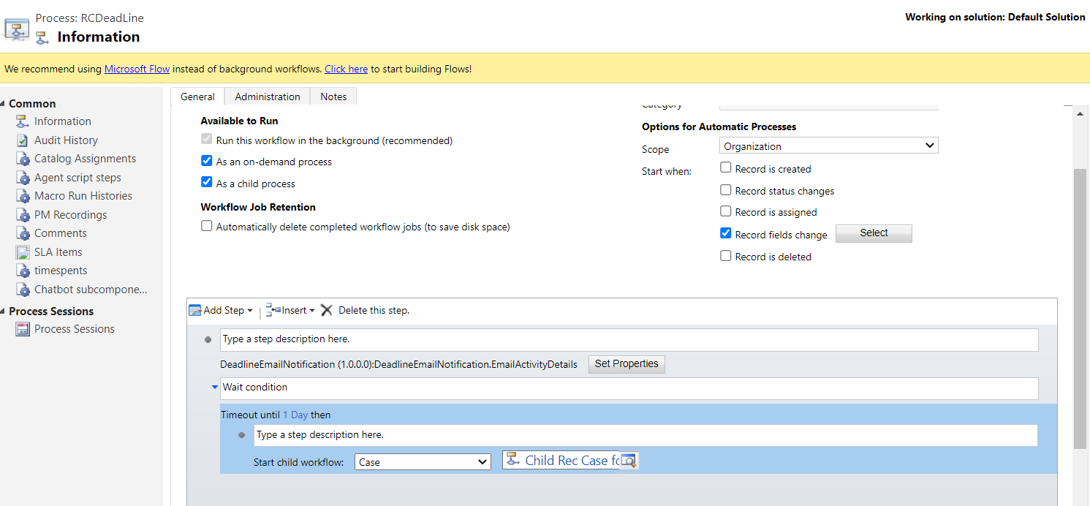

This process will make sure the workflow is triggered initially according to the condition (create of the record, update of the field/status) and set the recurring workflow jobs in action. If you want to stop the workflow after certain conditions are met, you can specify those conditions in the child workflow as a check condition before looping back to the original process.