### Retail Modern POS

* Retail Modern POS is a Windows 8 style application which only runs on Windows 8.1 and above. For x86/x64 computers, Modern POS can be installed completely using Dynamics AXSetup.
* Note: Modern POS needs to be installed on Windows 8.1 client OS or Windows Server 2012 R2 or above.
* Use the following procedures to install Modern POS in this demo installation.

1. **Enable enterprise sideloading**

* Press Windows + R key to launch the **Run** menu
* Type **gpedit.msc**  to open the Group Policy editor
* In the Group Policy console, navigate to **Local Computer Policy > Computer Configuration > Administrative Templates > Windows Components > App Package Deployment**
* Double-click to open the **Allow all trusted apps to install** option in the right hand section.
* Set the policy to **Enabled** and click **OK** to apply.

1. **Set up and configure Modern POS**
   * Windows Server 2012 R2 does not ship with WinJS & VCLibs, which are required pre-requisites for deploying Modern POS. If you wish to deploy Modern POS on Windows Server 2012 R2, perform the following additional steps:
     1. Download VS Express from here <http://www.microsoft.com/en-us/download/details.aspx?id=40787> and install it.
     2. Copy and paste the following packages and create the necessary folders as per the below details.
        1. VCLibs:
           1. Source: **"**C:\Program Files (x86)\Microsoft SDKs\Windows\v8.1\ExtensionSDKs\Microsoft.VCLibs\12.0\AppX\Retail\x64\**Microsoft.VCLibs.x64.12.00.appx"**
           2. Destination: **“**C:\Program Files (x86)\Microsoft Dynamics AX\60\Retail Modern POS**\Dependencies\x64\”**
        2. WinJS
           1. Source: **“**C:\Program Files (x86)\Microsoft SDKs\Windows\v8.1\ExtensionSDKs\Microsoft.WinJS.2.0\1.0\**Microsoft.WinJS.2.0.appx”**
           2. Destination: **“**C:\Program Files (x86)\Microsoft Dynamics AX\60\Retail Modern POS\**Dependencies\”**
     3. Launch Powershell in administrator mode and run the following 2 commands:
        1. **Add-AppxPackage “C:\Program Files (x86)\Microsoft SDKs\Windows\v8.1\ExtensionSDKs\Microsoft.WinJS.2.0\1.0\Microsoft.WinJS.2.0.appx”**
        2. **Add-AppxPackage "C:\Program Files (x86)\Microsoft SDKs\Windows\v8.1\ExtensionSDKs\Microsoft.VCLibs\12.0\AppX\Retail\x64\Microsoft.VCLibs.x64.12.00.appx"**

After this step, you will now continue on to standard installation with the remaining steps, for both Server and Client editions of Windows.

1. **Install Modern POS component using Dynamics AX setup:**
   * Run Dynamics AX setup
   * On the **Modify Microsoft Dynamics AX installation** page, click **Add or modify components,** and then click **Next**
   * On the **Add or modify components** page, under Retail Components, select **Retail Modern POS**, and then click Next.
   * On the **File extraction** page, you will verify that the **Configure Retail Modern POS** check box is marked and click **Next** to continue
   * On the Prerequisite validation page, verify that all prerequisites have been met, and then click next.
   * Click Finish to close the installer.
   * **Note: If after installation modern POS not showing in application list then configure it using power shell using below command**.
   * Open power shell as Administrator and open C:\Program Files (x86)\Microsoft Dynamics AX\60\Retail Modern POS\Tools location and Run Below command to install and configure Modern POS:
   * Command: PS C:\Program Files (x86)\Microsoft Dynamics AX\60\Retail Modern POS\Tools> **.\Install-RetailModernPOS.ps1 'C:\Program Files (x86)\Microsoft Dynamics AX\60\Retail Modern POS\'**
2. **Device Activation** 
   * In Dynamics AX, click Retail > Setup > Devices

On the **Devices** form, you will need to verify that the following exists. (Each instance of a Modern POS app needs a unique record in this form).

* + **Device ID:** Device (Computer, laptop etc.) Name like **PHO048**
  + **Application**: Verify the type of app to authenticate. In this demo installation you’ll be working with a “**Windows 8**” app for Modern POS
  + **Description:** A description to help to recognize the device. Here you’ll verify **PHO048**
  + **Register number:** Add POS register Id which is in POS register form in AX**.**Each register can be associated with multiple instance of Modern POS
  + **Activation status:** Be sure to set the activation status as **Pending.**
  + When you first launch Modern POS, you are greeted with a configuration screen. Enter the configurations as described below:
* **Server URL:** Enter the URL of the Retail Server that you’ll be connecting to. In this demo installation, you can connect to the retail server hosted on AX2012R2A using the following url:
  1. **http://***<IP Address of computer running Retail Server>***:5100/RetailServer/V1** (steps to obtain the IP address are detailed above).
* **Device number**: Enter a valid Device ID from the devices form in Dynamics AX.
  1. In this demo installation, you will use **PHO048**as the device ID
* **Register number**: Enter the register number corresponding to the device that you wish to activate.
  1. In this demo installation, you can use **000001** the Register ID
* **Operator ID**: Enter an operator ID for a worker who has **Manager POS.** Manage device must be enable in **Permission** **group form** in AX.
  1. In this demo installation you will use **000160** as the personal ID.
* **Password**: Enter the corresponding worker password.
  1. In this demo installation, you will use **123** as the password

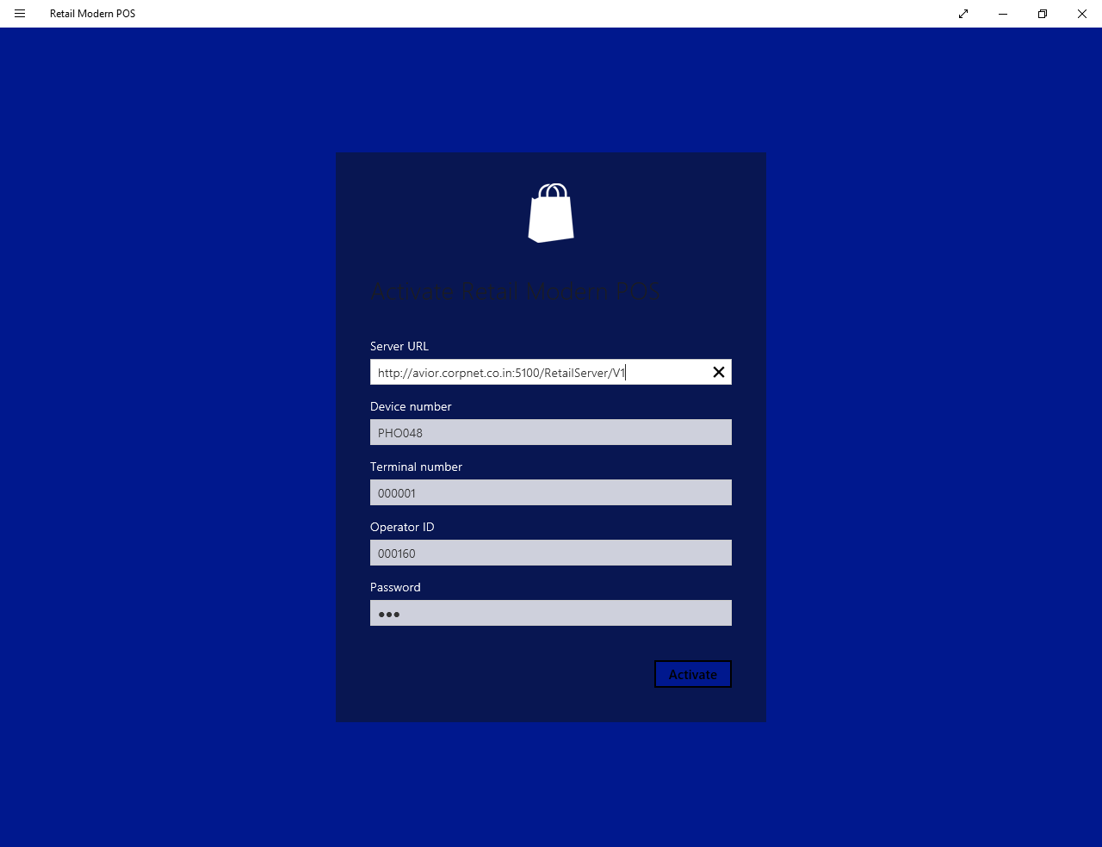

* Tip: To find out the correct service URL, you can navigate to IIS and locate the Retail Server web application:

1. Navigate to IIS Server by typing **IIS** on the start screen.
2. Follow the steps in the screenshot below.

Replace “localhost” with the name of the computer. E.g. <http://avior.corpnet.co.in:5100/RetailServer/V1>

* In Dynamics AX, the device will show as Activated.
* On the Devices form, confirm that the device shows as Activated.
* On the Modern POS app, login with the credentials mentioned above. You should now be able to login. Select the option to “Create a new shift”.

