There are a couple of ways to reverse a journal in [Microsoft Dynamics AX](http://www.trideapartners.com/products/microsoft-dynamics-ax-2012). One is to use the “Reverse transaction” option from the GL inquiry screens.  This is a quick and easy way to reverse entries, but there are many entries which cannot be reversed, and when transactions are reversed, they are automatically posted without being processed by a workflow or an approval group which is a problem for many organizations.

The other option is to use the “Load ledger transactions” functionality in the journal screen to load a journal that has already been posted. This is really a copy function that can be used to copy a prior journal with reversed transactions which can then be routed through an approval process.

**To copy a journal:**

1. Create a general journal as you normally would and click **Lines**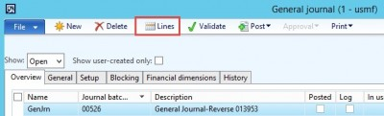
2. In the lines form, click on **Functions** and then select **Load ledger transactions**.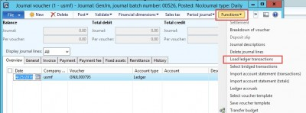
3. On the Load ledger transactions form:
   * Verify the voucher is set to **New voucher number per voucher.**
   * Click the **Invert sign** check box if you would like to reverse the journal. Click select.

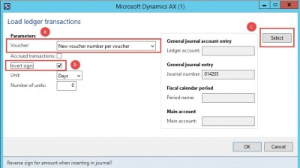

1. On the **Select** screen, enter the **Journal number** that you would like to reverse or copy and click ok.

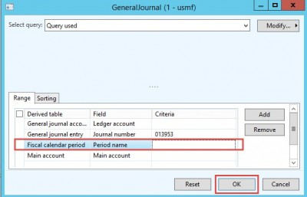

1. You are now back on the Load ledger transactions screen, click OK.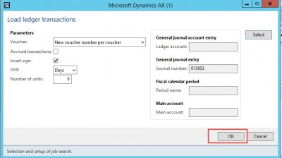
2. Upon clicking OK, AX will load a copy or reversal of the journal you selected in the current journal form. Notice in the case of a reversal, AX inserts the description of Void and the voucher number. If is cross currency, then system will consider the exchange rate as per the old voucher and not as per the current exchange rate setup.

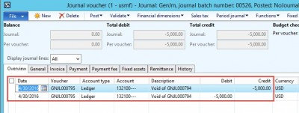

1. You can now submit your journal through the review and approval process and post!