# Enable/Disable a ribbon button dynamically based on field value

Recently in development, we had a requirement, that the custom button (ribbon workbench) must be visible based on the form value.

we can achieve this requirement in two ways

1. Value Rule
2. Custom Code Rule

## Value Rule

Based on one and only one value, the button will be visible or disabled. if you have to hide button based on 2 or more form field values go with “Custom Rule” or “OR Rule between value rule”.

Go to- Command- Display Rule- Value Rule

Manually enter filed name and value. If value equal to that filed then only the button will be visible otherwise button will be on hidden mode.

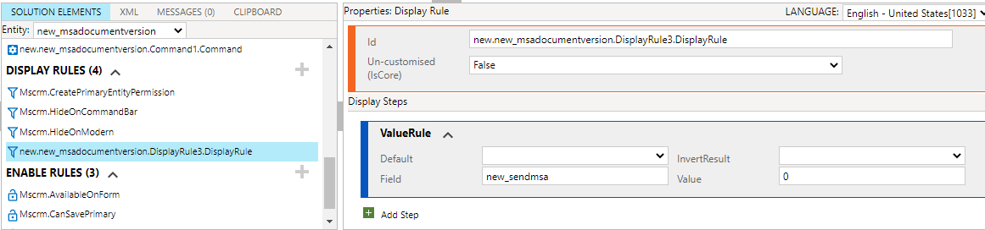

## Custom Code Rule

Go to- Enable rules- Custom Rule.

It will ask the function name and web resource name. Before that add the web resource in your solution, so that when you click on search button it will display and select that web resource. give Exact function name.

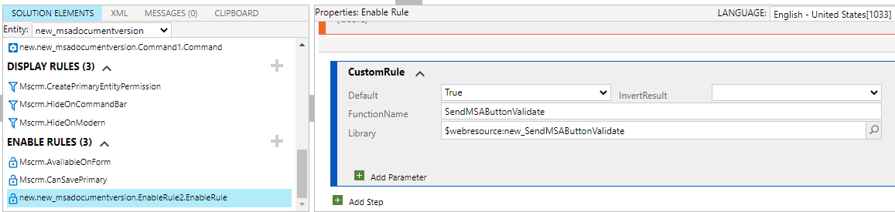

web resource – JavaScript code as follows

Button will be visible when Send MSA value equals to “No” (option set). Otherwise button Goes to hide.

function SendMSAButtonValidate()

{

try

{

Xrm.Page.ui.refreshRibbon();

var varSendMSA = Xrm.Page.getAttribute("new_sendmsa").getValue();

if( varSendMSA== false)

{

return true;

}

else

{

return false;

}

}

catch (e)

{

Xrm.Utility.alertDialog(functionName + "Error: " + e.message || e.description);

}

}

Add the above Enable rule to command and attach the command to button.

That’s it. Enjoy 🙂