**Mysteries of Route Group**

* A route group defines policies that control how operations of routes are processed. Settings in a route group apply to all operations of routes that are included in the group.
* Following is snapshot of route group set up that are require for routes. We are going to learn same set up in two parts i.e. General and setup.

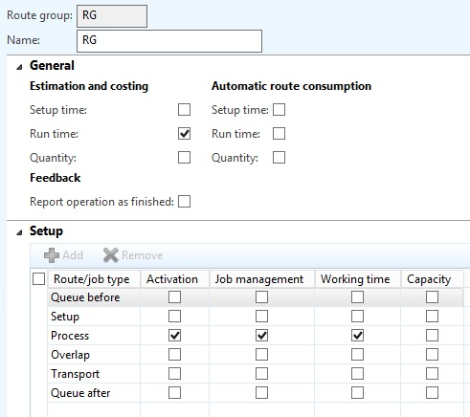

* General

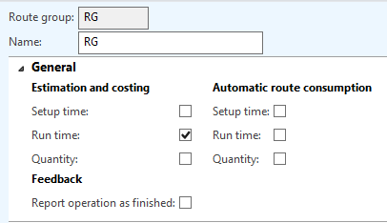

* Estimation and costing
  + - This section controls the inclusion of a routing operation in the cost estimate of the production order.
    - Note that the Setup time and Run time represent the traditional routing.
    - Quantity part is still pending for testing.
    - The three fields should never be all checked, it is either or. Using regular routings, no piecework, I only check setup time and run time here.
* Automatic route consumption
  + - This option work for back flushing principle and this function is left for R&D
    - What I noticed under this head is automatic creation of route journal after starting of production order even if you are going through Job base production.
* Set up

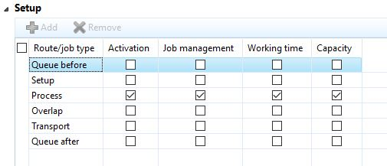

* This set up is heart of route card and it controls all time setting and job/route setting of operation of production order.
* **Activation**
  + - This controls whether a route/job type of a routing operation can be used. It controls everything. If a row is not active, you cannot schedule these hours, you also cannot report actual hours against it.
* **Job management**
  + - This column is exclusively for job scheduling.
    - The checked time elements will become a job that can be scheduled and reported against in Time and Attendance.
    - I have seen a few cases where queue time before or after are becoming a Job Most of the time it is just setup and run that are checked here.
* **Working time**
  + - This column determines whether the times in the routing operation are actually using the calendar defined for the resource.
    - If the check box is selected, the system uses the working calendar to plan the operation. If the check box is cleared, the system uses the standard 24-hour Gregorian calendar.
* **Capacity**
  + - This is another checkbox that is normally checked. The system will include the hours of our production order operations as “reserved hours” on the resource or resource group*.*