**General Query**

select INVENTITEMGROUPITEM.ITEMGROUPID, INVENTITEMGROUPITEM.ITEMID,INVENTTABLE.NAMEALIAS

from INVENTITEMGROUP

inner join INVENTITEMGROUPITEM on INVENTITEMGROUP.ITEMGROUPID=INVENTITEMGROUPITEM.ITEMGROUPID

and INVENTITEMGROUP.DATAAREAID=INVENTITEMGROUPITEM.ITEMGROUPDATAAREAID

inner join INVENTTABLE on INVENTITEMGROUPITEM.ITEMID=INVENTTABLE.ITEMID and INVENTITEMGROUPITEM.ITEMDATAAREAID=INVENTTABLE.DATAAREAID

where INVENTITEMGROUP.DATAAREAID='appl' and INVENTTABLE.DATAAREAID='appl'

order by INVENTITEMGROUPITEM.ITEMGROUPID, INVENTITEMGROUPITEM.ITEMID,INVENTTABLE.NAMEALIAS

Output :

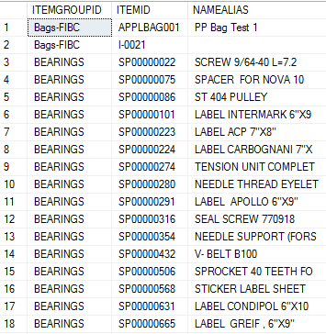

**Use ROW_NUMBER () function to find the count of multiple Row values in a column**

select INVENTITEMGROUPITEM.ITEMGROUPID,INVENTITEMGROUPITEM.ITEMID,INVENTTABLE.NAMEALIAS

,ROW_NUMBER() over(partition by INVENTITEMGROUPITEM.ITEMGROUPID order by INVENTITEMGROUPITEM.ITEMID,INVENTTABLE.NAMEALIAS)

from INVENTITEMGROUP

inner join INVENTITEMGROUPITEM on INVENTITEMGROUP.ITEMGROUPID=INVENTITEMGROUPITEM.ITEMGROUPID

and INVENTITEMGROUP.DATAAREAID=INVENTITEMGROUPITEM.ITEMGROUPDATAAREAID

inner join INVENTTABLE on INVENTITEMGROUPITEM.ITEMID=INVENTTABLE.ITEMID and INVENTITEMGROUPITEM.ITEMDATAAREAID=INVENTTABLE.DATAAREAID

where INVENTITEMGROUP.DATAAREAID='appl' and INVENTTABLE.DATAAREAID='appl'

order by INVENTITEMGROUPITEM.ITEMGROUPID,INVENTITEMGROUPITEM.ITEMID,INVENTTABLE.NAMEALIAS

Output :

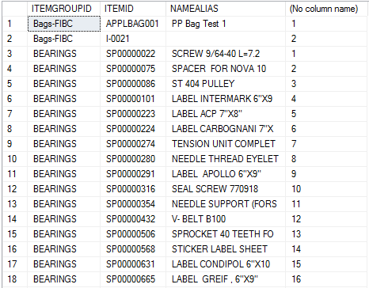

**Set Null/Blank value on ROW on duplicate value in a column**

select CASe when ROW_NUMBER() over(partition by INVENTITEMGROUPITEM.ITEMGROUPID order by INVENTITEMGROUPITEM.ITEMID,INVENTTABLE.NAMEALIAS) =1

then INVENTITEMGROUPITEM.ITEMGROUPID else '' end as ItemGroup,

INVENTITEMGROUPITEM.ITEMGROUPID,INVENTITEMGROUPITEM.ITEMID,INVENTTABLE.NAMEALIAS

,ROW_NUMBER() over(partition by INVENTITEMGROUPITEM.ITEMGROUPID order by INVENTITEMGROUPITEM.ITEMID,INVENTTABLE.NAMEALIAS)

from INVENTITEMGROUP

inner join INVENTITEMGROUPITEM on INVENTITEMGROUP.ITEMGROUPID=INVENTITEMGROUPITEM.ITEMGROUPID

and INVENTITEMGROUP.DATAAREAID=INVENTITEMGROUPITEM.ITEMGROUPDATAAREAID

inner join INVENTTABLE on INVENTITEMGROUPITEM.ITEMID=INVENTTABLE.ITEMID and INVENTITEMGROUPITEM.ITEMDATAAREAID=INVENTTABLE.DATAAREAID

where INVENTITEMGROUP.DATAAREAID='appl' and INVENTTABLE.DATAAREAID='appl'

order by INVENTITEMGROUPITEM.ITEMGROUPID,INVENTITEMGROUPITEM.ITEMID,INVENTTABLE.NAMEALIAS

Output :

