Dealing with Dynamics AX 2012 Reporting Timeouts

The report execution timeout at the report server level should be set to a value greater than the time required for the largest report to render. Alternately it can be set to never time out. This can be done in one of two ways –

You can open from AX System admin - > Setup - > business Intelligence - > Report Services -> Report server -> Reporting Server information -> Report manager URL: **Click**

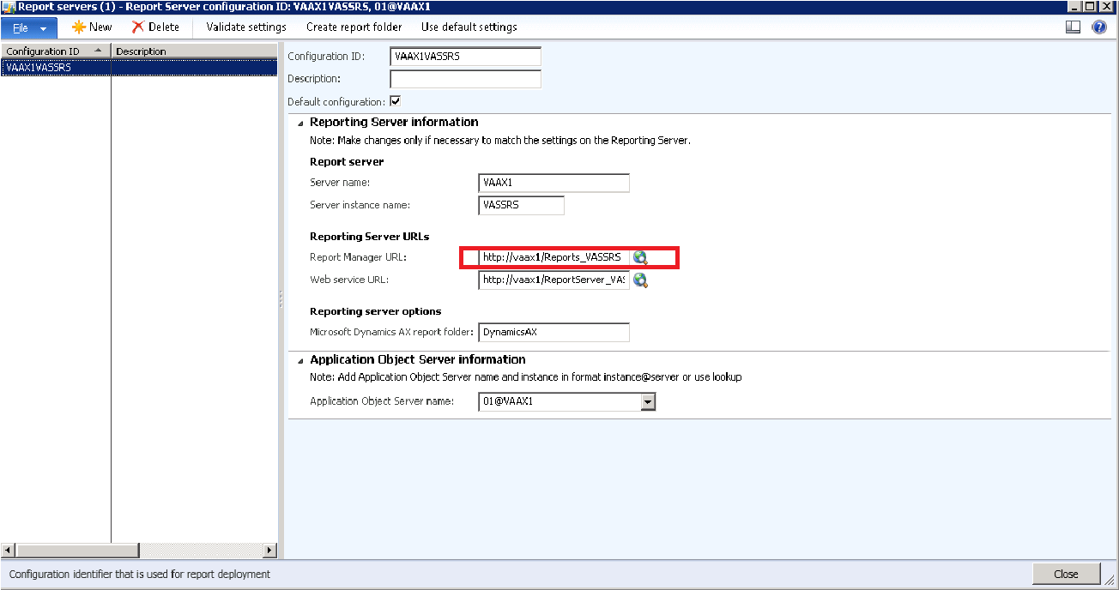

Home- Report Manager page is open.

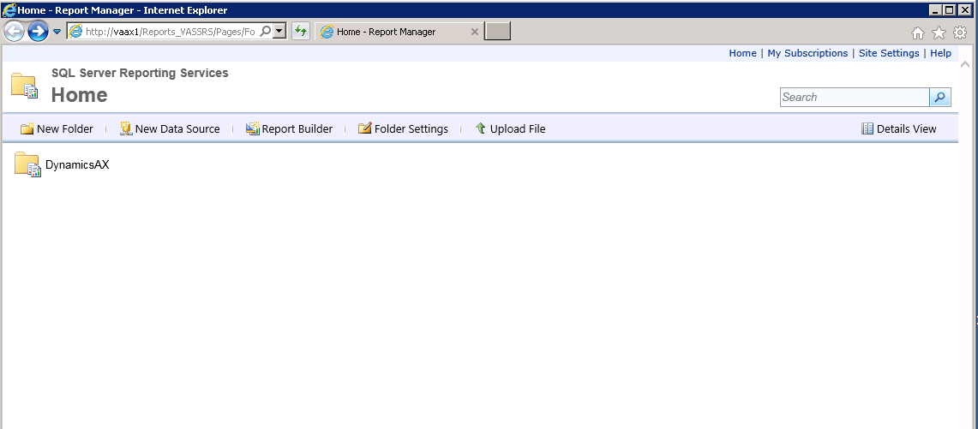

##### **Site level Settings**

Using the Server Reporting Services - **Site settings,** the Report Timeout property can be changed under **General** Tab.

Default page is open with Time 1800 SEC (30 minutes)

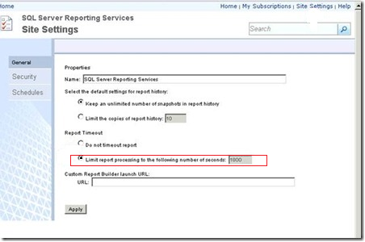

Now we have to change.

1. You can select **Do not timeout** report.

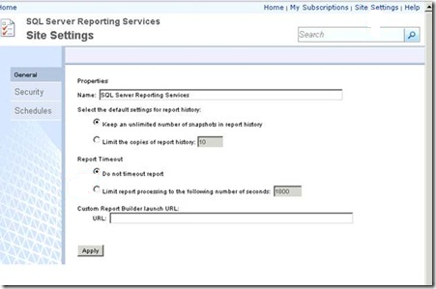

Or you can change with limit that you want to, here I have update with 7200 seconds and **Apply**.

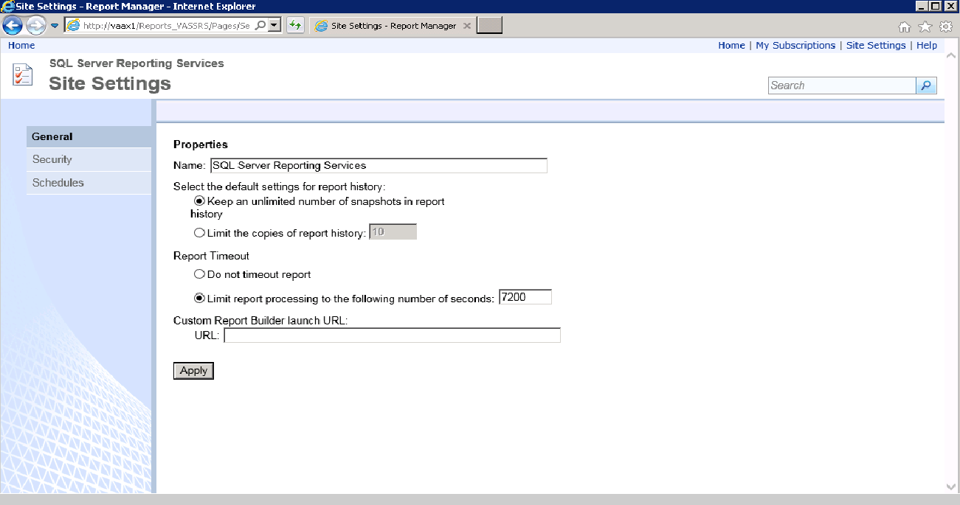

##### **Report level Settings**

The report execution timeout can also be set on each report, using Report Manager home page you have to search for that report.

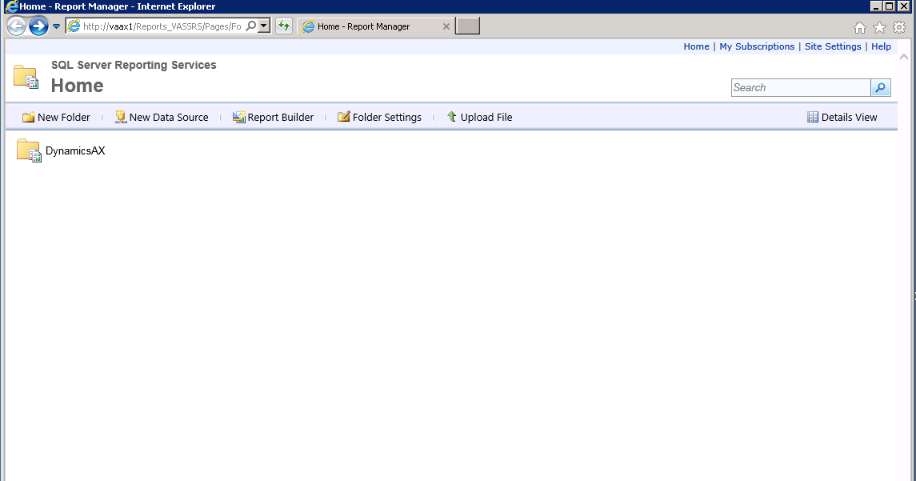

In my case “CustAging” report that I have to update.

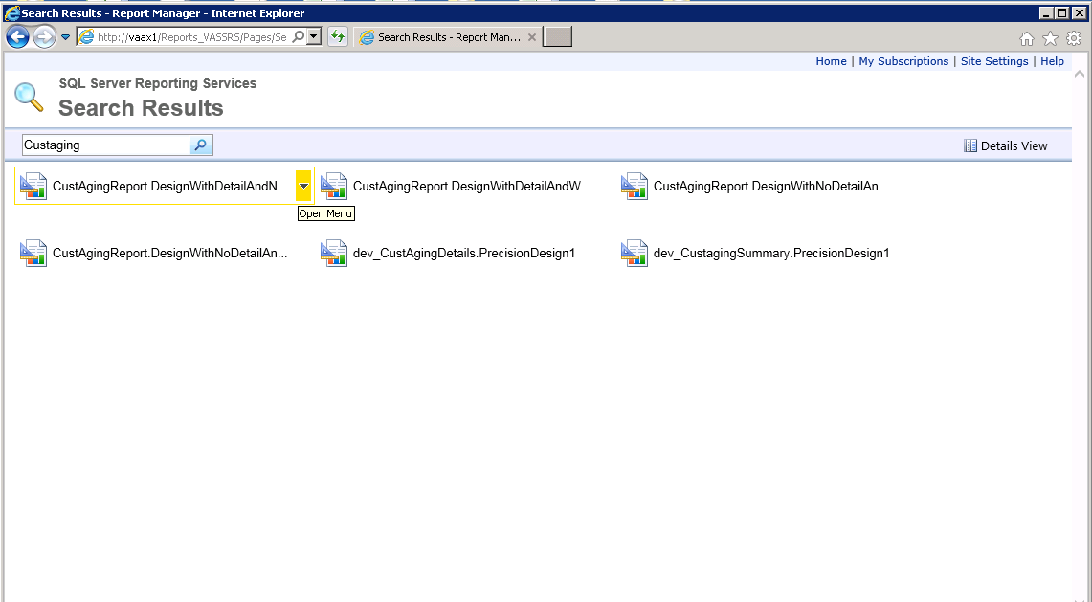

After that Click on the arrow you can see the options, go to **Manage**

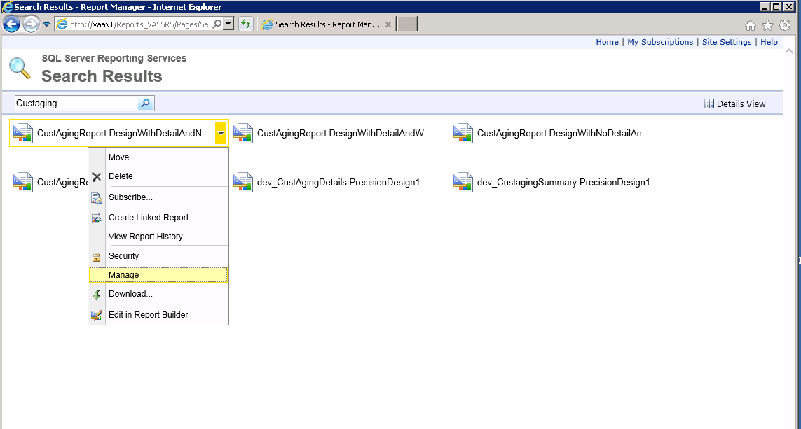

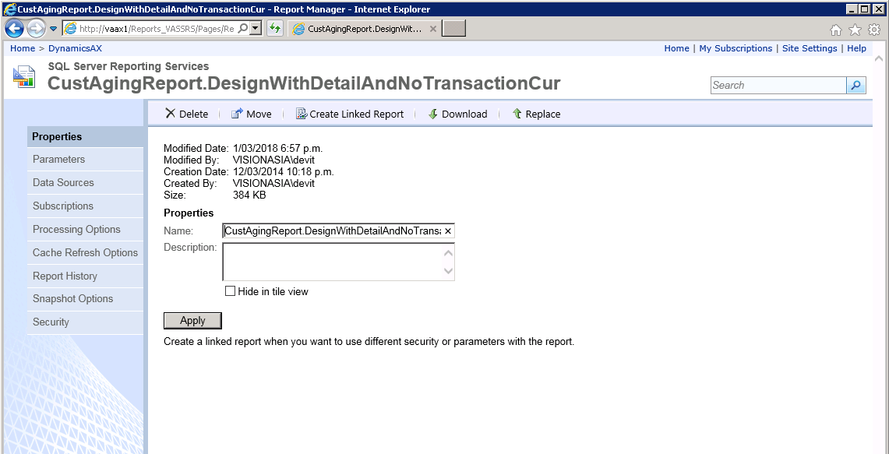

There you can see the multiple properties we can set for selected report.

So, we have to set time property from **Processing option**, here you can see the default set as “Use the system default setting”.

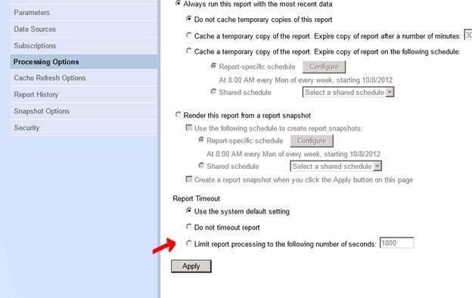

We can select **Do not timeout** report or Limit with specific seconds as below you can see what I have done and then **Apply.**

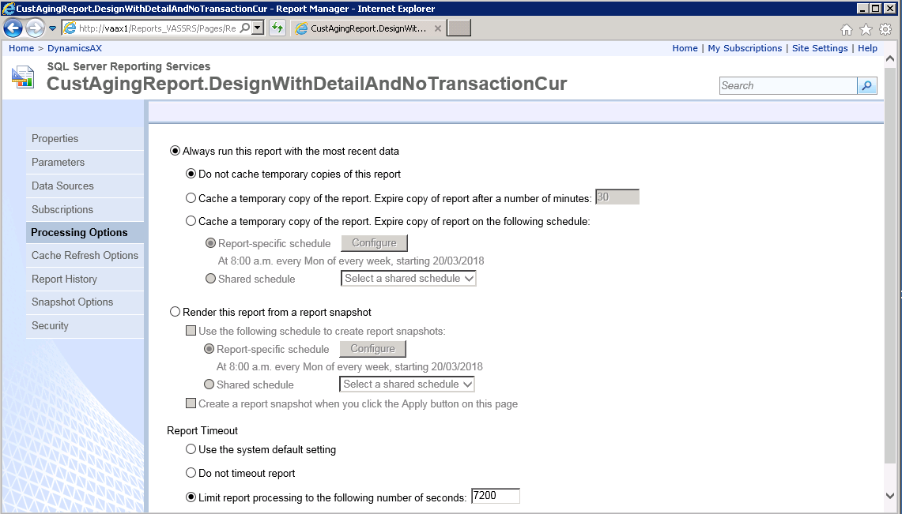

From this changes you can see the report execution time is extended and it is running fine.