Accounts receivable parameters > updates > safety level of invoiced order mark as “**Locked**”

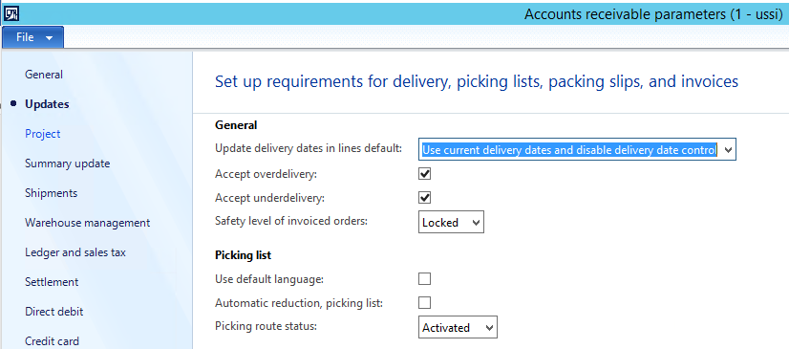

Generate sales order and post the invoice. You can view, as shown in the screen below, the edit button for the sales order is disabled.

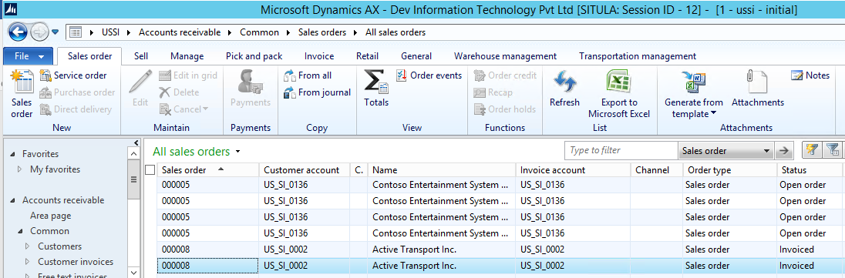

Now, change the safety level of invoiced orders in accounts receivable parameters to “**None**”

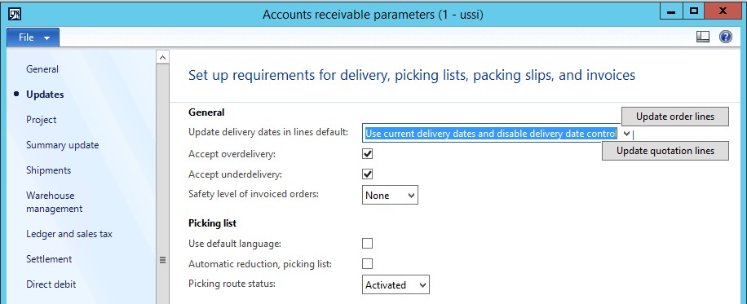

Open all sales order form, you can view the edit button for the sales order is now enable.

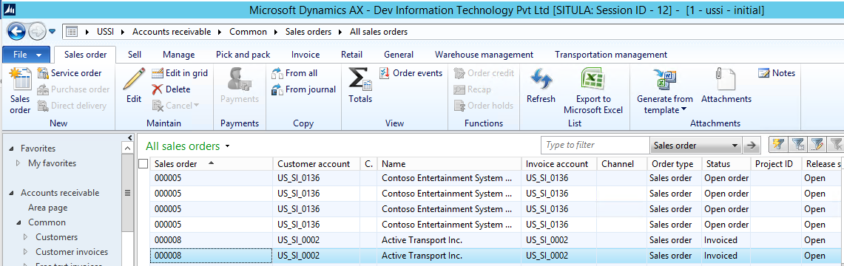

You can edit the sales order, can add more items in the sales order, confirm the sales order and invoice update. You can view, two invoices for this sales order.

If you select the safety level of invoiced orders in accounts receivable parameters to “**Warning**” then on editing the sales order, system will give you the warning message and will ask if you want to modify the sales order or not.