**Set Default Financial Dimension with Main Account**

We can set the default financial dimension with the ledgers, so that the transaction do not give us the error if we forget to select the dimension.

Below are the steps to set the default financial dimensions with the Main account

1. General Ledger → Common → Main Accounts
2. Filter the Ledger for which you want to set the default dimension like #92000
3. Click on Edit button

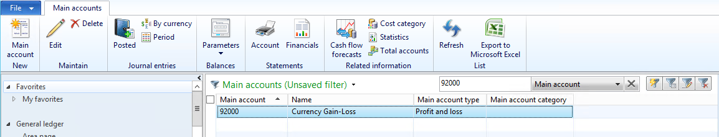

1. Below form will open to Edit the Main account

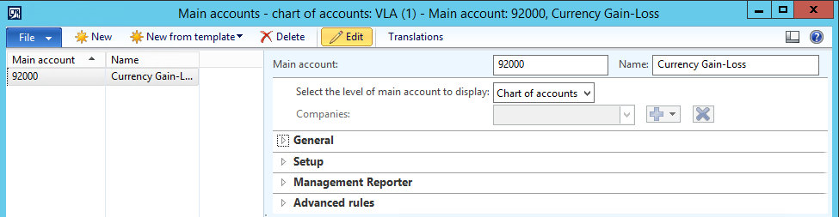

1. Click on Edit button again in the above form.
2. Set the value “Companies” for the field “Select the level of main account to display”, so that the tab “Financial dimension” will be displayed.
3. Click on the “+” sign button to add the new entry for the entity in which you want to set default, if it is not there in the list.
4. Select the entity
5. Enter the default value for Department

