**Issue:** Some vouchers (old) were not displayed in the closed transaction editing form after reversing the check payment.

**Solution:** There is a functionality in AX that allows to display all older transactions for settlement.

In the Vendor’s closed transaction editing form, there is a checkbox named “Show all”. If this check box is tick marked, then AX will display all old transactions.

There is another field in the Accounts Payable Parameters form >> Settlement >> “Edit pre-version 2.5 settlements”. If this field is tick marked then the field “Show all” will be visible in the closed transaction editing form.

So, below are the steps to show all old transactions in the closed transaction editing form:

1. AP >> Setup >> Accounts Payable Parameters >> Settlement :

Tick mark the filed “Edit pre-version 2.5 settlements” as per below screen shot:

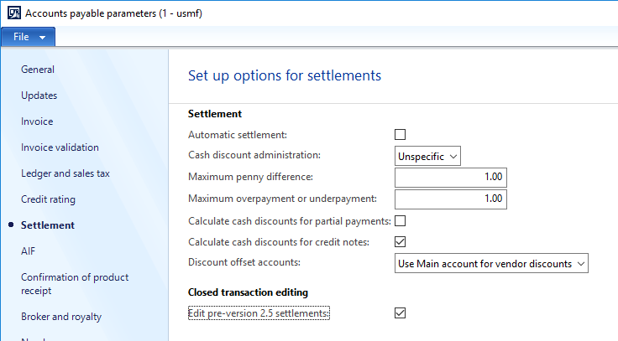

1. Go to the AP >> All vendors >> Invoice tab >> Closed transaction editing form. Now the field ”Show all” will be visible. Tick mark this field so that all old transactions will be visible for settlement :

