**SysLookupMultiSelectGrid and Re-Select record from grid.**

1. **Add below code in the lookup method :** 
   1. In the this code ,we have follow below steps :
2. Create new table : TEL_Dayofweek

* Add String field: WeekName

1. Add StringEdit control in design: DOW (used for passing container value).

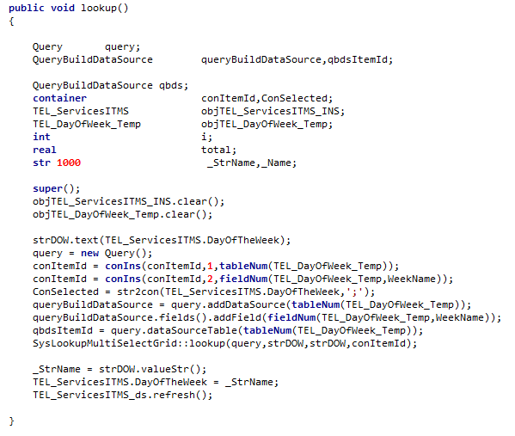

**2. Now, we modify existing class SysLookupMultiSelectGrid**

* **In “Lookup” method (Class : “SysLookupMultiSelectGrid”)**

**public** **static** **void** lookup(Query _query, FormStringControl _ctrlIds, FormStringControl _ctrlStrs, **container** _selectField, queryRun _queryRun = **null**)

{

SysLookupMultiSelectGrid lookupMS = **new** SysLookupMultiSelectGrid();

lookupMS.parmCallingControlId(_ctrlIds);

lookupMS.parmCallingControlStr(_ctrlStrs);

lookupMS.parmQuery(_query);

lookupMS.parmQueryRun(_queryRun);

lookupMS.parmSelectField(_selectField);

**lookupMS.dev_ParmSelectId(conNull());*//****Add for Re Select Record in Grid in existing class method*

lookupMS.run();

}

**Example:**

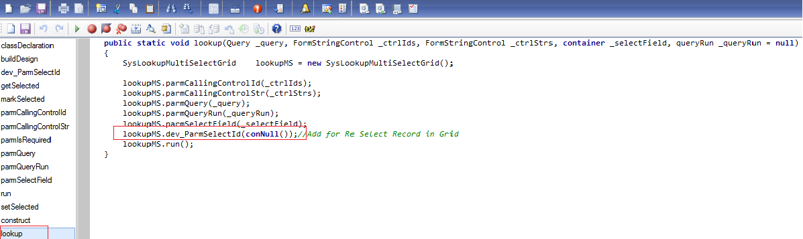

1. **Add new “parmSelectField” method in (Class : “SysLookupMultiSelectGrid”)**

**public** **container** parmSelectField(**container** _selectField = selectField)

{

selectField = _selectField;

**return** selectField;

}

**Example:**

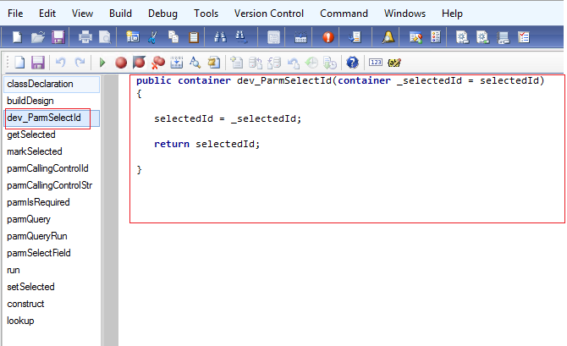

1. **After complete changes you can see lookup value auto re select in grid.**

