**For Email set up : Go to the System administration -- > Set up --- > System --- > E-mail parameters**

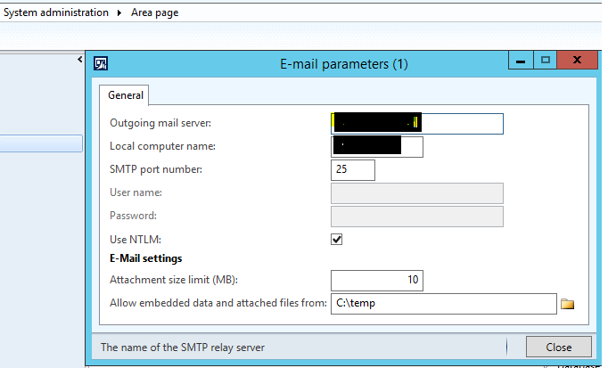

**Below code for E-mail sending using the SYSMailer :**

#SysMailer

SysMailerNet mailer;

SysMailerNetAddressField tos;

List toAddresses;

ListEnumerator enum;

FileIOPermission fileIOPermission;

InteropPermission interopPermission;

str _emailTarget,_emailSender,Body;

#define.htmlNewLine('<BR>')

str relayServer;

int portNumber;

str userName;

str password;

boolean ntlm;

str filePathName;

Notes staticvalue,staticvalue1;

SysEmailParameters parameters = SysEmailParameters::find();

_emailTarget = 'nimisha@sevacloud.com';

_emailSender = 'inprocess@telgian.com';

staticvalue = "Nimisha Patel";

staticvalue1 = "Test entryTest entryTest entryTest entryTest entryTest entryTest entryTest entryTest entryTest ";

Body = "";

Body += "Created by :";

Body += strFmt('%1',staticvalue);

Body += #htmlNewLine;

Body += #htmlNewLine;

Body += "ITMS SO :";

Body += strFmt('%1',staticvalue);

Body += #htmlNewLine;

Body += #htmlNewLine;

Body += "REP SO :";

Body += strFmt('%1',staticvalue);

Body += #htmlNewLine;

Body += #htmlNewLine;

Body += "Service Object :";

Body += strFmt('%1',staticvalue);

Body += #htmlNewLine;

Body += #htmlNewLine;

Body += "Deficiency Description :";

Body += strFmt('%1',staticvalue1);

Body += #htmlNewLine;

Body += #htmlNewLine;

Body += "Stage Reason code :";

Body += strFmt('%1',staticvalue);

Body += #htmlNewLine;

Body += #htmlNewLine;

Body += "Quatation :";

Body += strFmt('%1',staticvalue);

Body += #htmlNewLine;

Body += #htmlNewLine;

if (parameters.smtpRelayServerName)

relayServer = parameters.smtpRelayServerName;

else

relayServer = parameters.smtpServerIPAddress;

portNumber = parameters.smtpPortNumber;

userName = parameters.smtpUserName;

password = SysEmailParameters::password();

ntlm = parameters.ntlm;

interopPermission = new InteropPermission(InteropKind::ComInterop);

interopPermission.assert();

mailer = new SysMailerNet();

CodeAccessPermission::revertAssert();

mailer.smtpRelayServer(relayServer,portNumber,userName,password,ntlm);

mailer.fromAddress(_emailSender,'Telgian');

tos = mailer.tos();

toAddresses = SysEmailDistributor::splitEmail(_emailTarget);

enum = toAddresses.getEnumerator();

while(enum.moveNext())

{

tos.add(enum.current());

}

mailer.priority(System.Net.Mail.MailPriority::Normal);

mailer.subject('Test Email Subject12');

mailer.bodyCharSet('UTF-8');

mailer.htmlBody(Body);

filePathName = "C:\\Test Documents\\10013155_No Tax.doc";

mailer.attachments().add(filePathName);

mailer.sendMail();

mailer.messageReset();

info("mail sent");