**How to Generate TDS Report in AX 2012 R3 CU12**

1. **Go to General Ledger (1), and then click on Periodic-> India Withholdings tax (2) Withholding tax payment (3).**

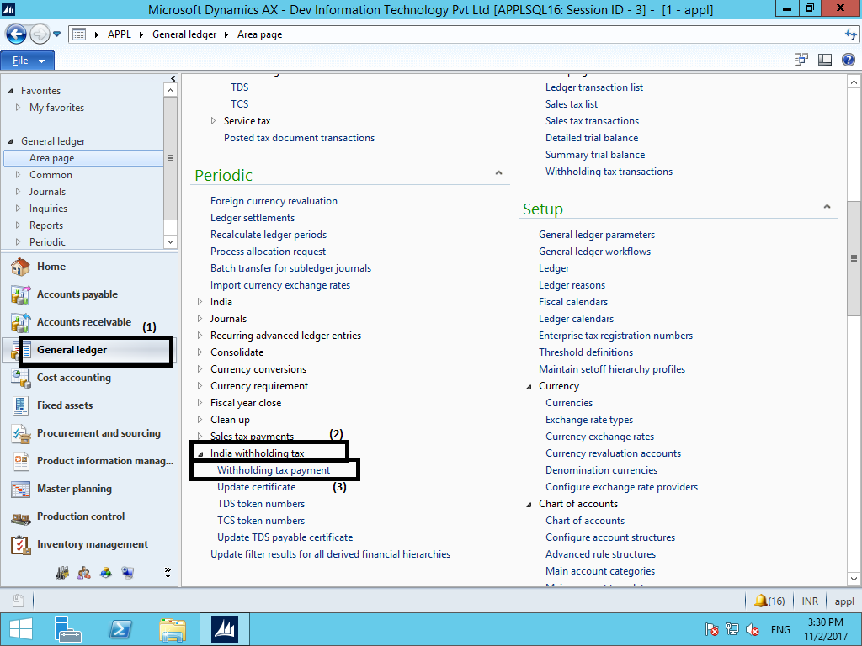

1. **Fill the details as required from the drop down list and specify the period for which you want to make payment click on UPDATE check box (1) and then press OK (2).** 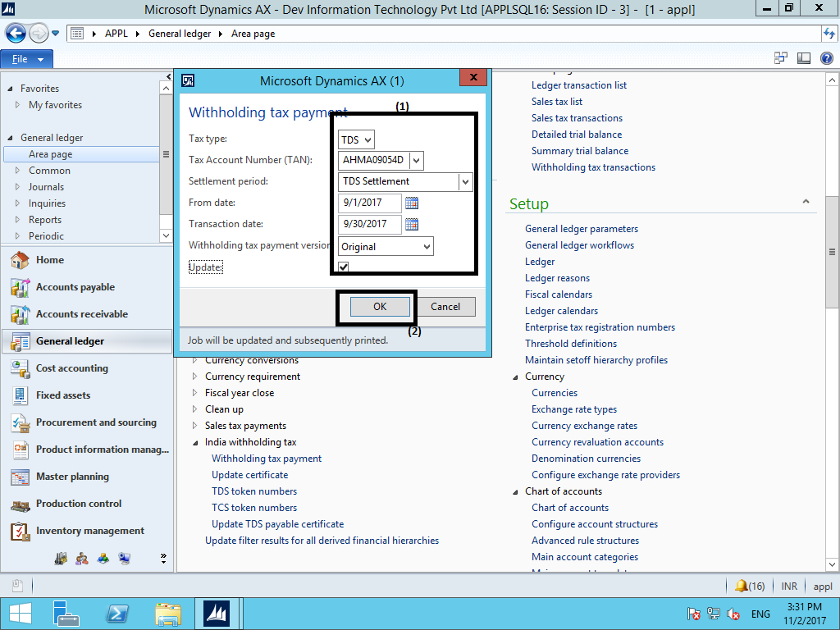
2. **Go to General Ledger (1), and then click on Journal-> General Journal (2).**

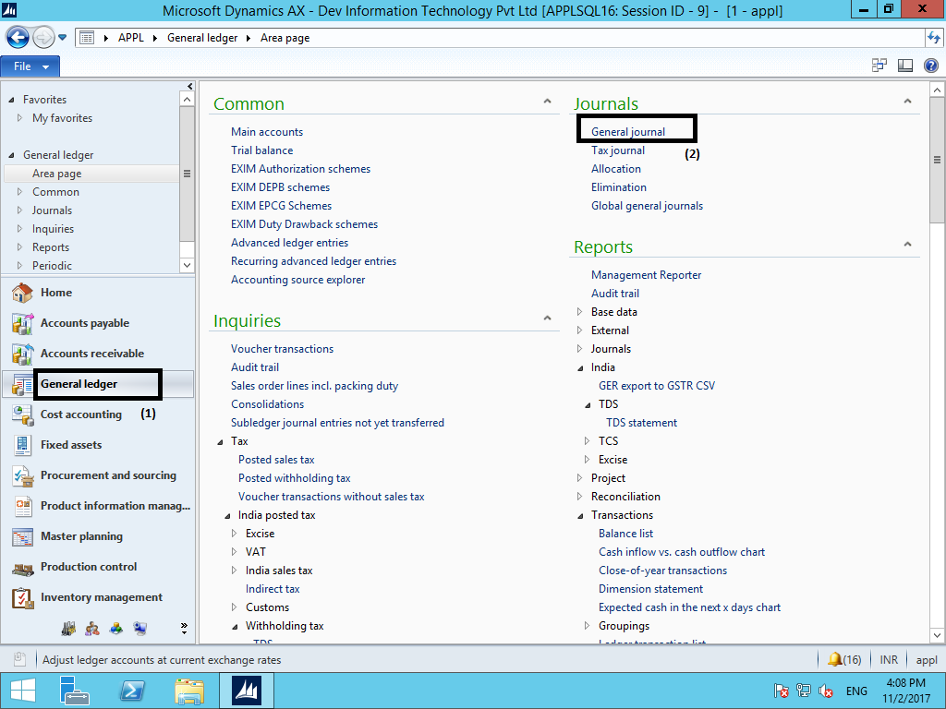

1. **Click on new (1) and select Journal number (2).**

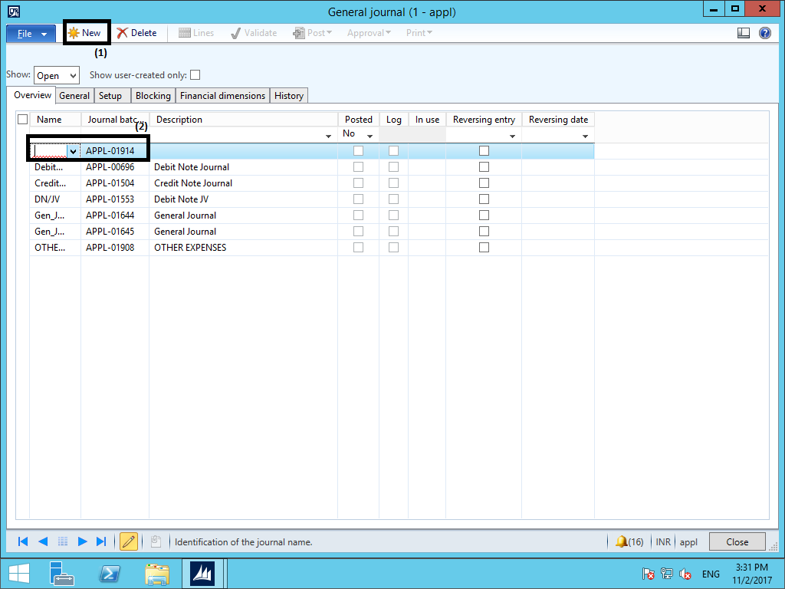

1. **Select the vendor account which is selected as authority and select offset account by which you will make payment.**

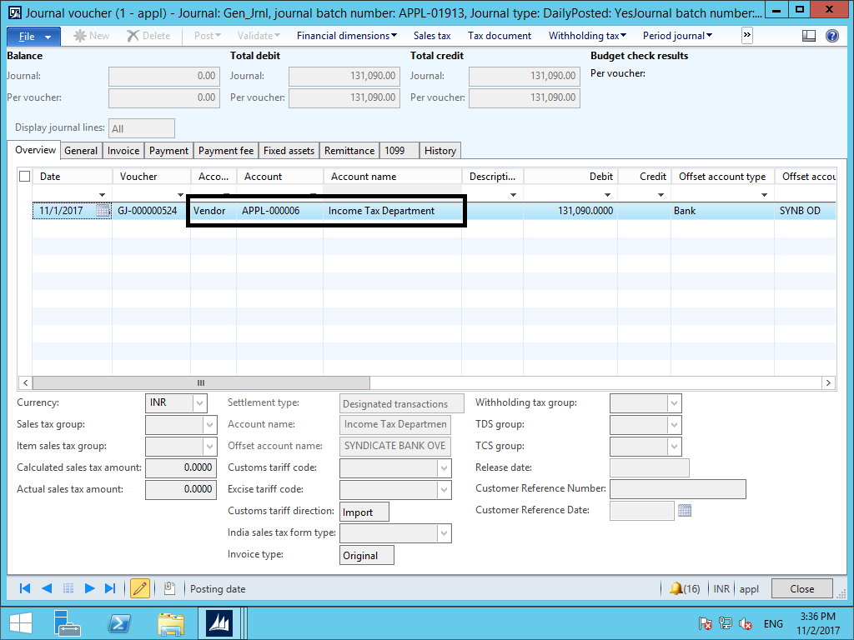

1. **Click on Function (1) tab and select settlement (2) the entry selected in screen shot number 2 will automatically populated then mark that entry after that amount for that period is auto populate in line entry.**

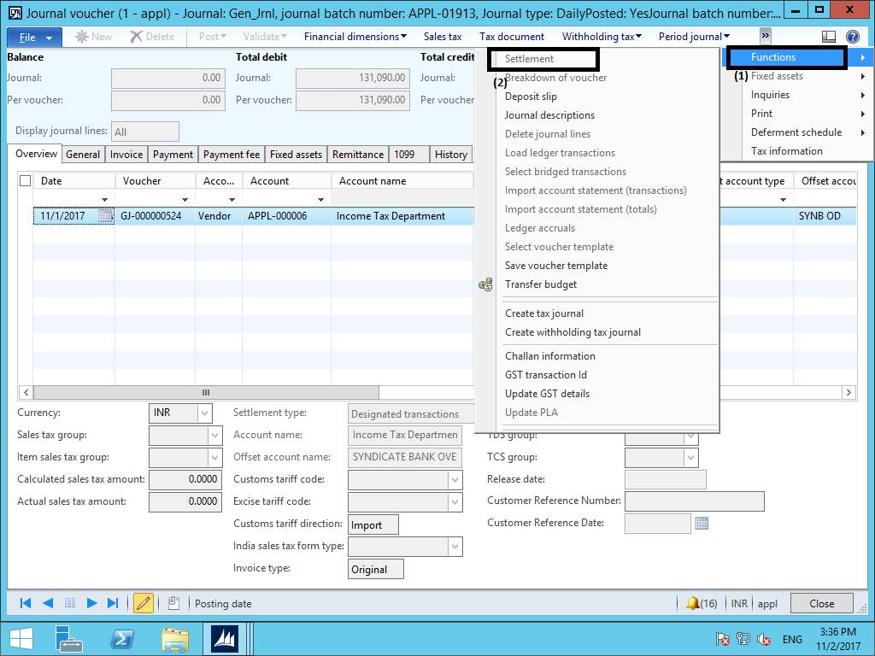

1. **Click on validate (1) and then post the entry (2).**

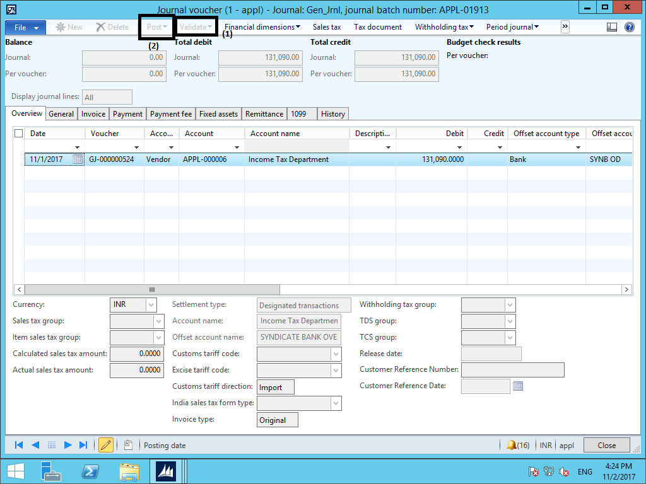

1. **After posting entry close it and reopen that entry after that click on withholding tax (1) and then click on Challan information (2).**

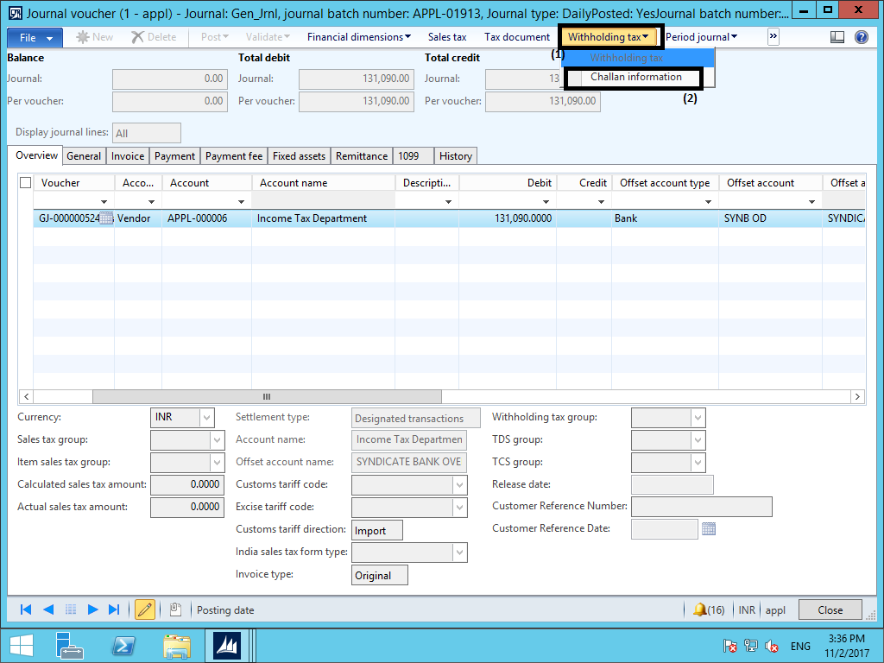

1. **Fill all the details as required in challan information form and then close it.**

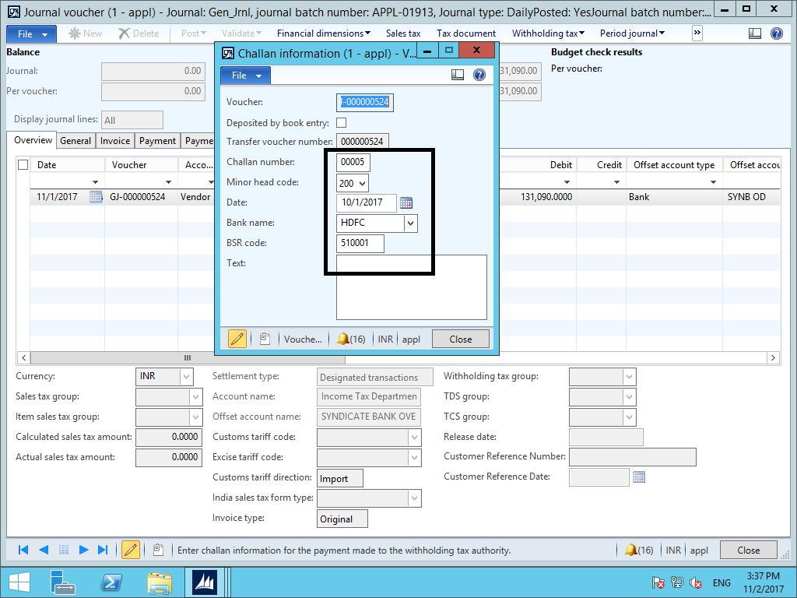

1. **Go to General Ledger (1), and then click on Journal-> General Journal (2).**

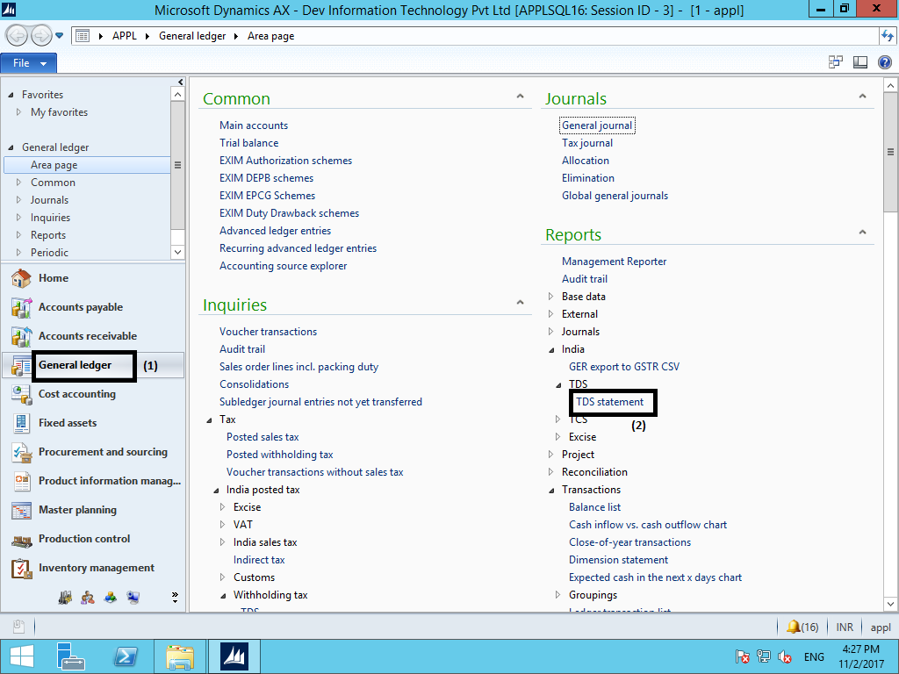

1. **Fill all the detail as required in TDS statement form and then click on OK.**

