Issue: Size issue or Timeout issue in .net application when generate XML document

Resolution: Setup as below in web.config file of the .net application

<binding name="NetTcpBinding_DevTrainings_AIFService" sendTimeout="00:10:00"

maxReceivedMessageSize="2147483647" />

Issue: Sometimes we get issue as below on deploying the service group created to deploy the AIF services

Type name  does not exist.

The …..getAttribute() reflection API could not create and return the AifCollectionTypeAttribute object. Please check the parameters.

Resolution:

1. Stop service
2. Rename XPPL folder >> C:\Program Files\Microsoft Dynamics AX\60\Server\<Instance Name>\bin
3. Start Service
4. Verify new folder with same name created or not
5. Go to command prompt – open with “Run as administrator”
6. Run the below command :
   1. Cd Program Files\Microsoft Dynamics AX\60\Server\<Instance Name>\bin\
   2. axbuild.exe xppcompileAll /aos=01 /workers=4
7. Full CIL

Issue: Invalid data type

While creating service from AIF document service wizard error below

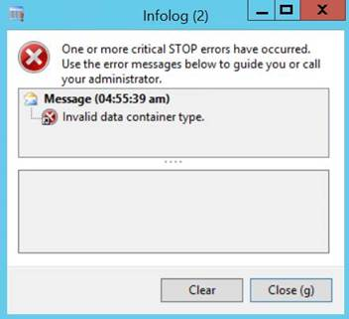

Solution:

1. Compile forward AfStronglyTypedDataContainer class ( this will take approx.. 15 to 20 minutes)
2. Full CIL