**Issue:**

We had upgraded AX 2009 application to AX 2012R3. All transaction data had been transferred from AX 2009 to AX2012R3, but some vendor addresses were missing in the AX 2012R3 not of all vendors’. Therefore, we verified in the AX and created a job to transfer vendor addresses from AX 2009 to AX 2012R3.

**Resolution:**

Below are the steps, which we had followed to transfer vendor address from AX 2009 to AX 2012R3:

1. Created a query in AX 2009 SQL server database to get vendor addresses. You can download the query, which we had used, also below is the screen of it.

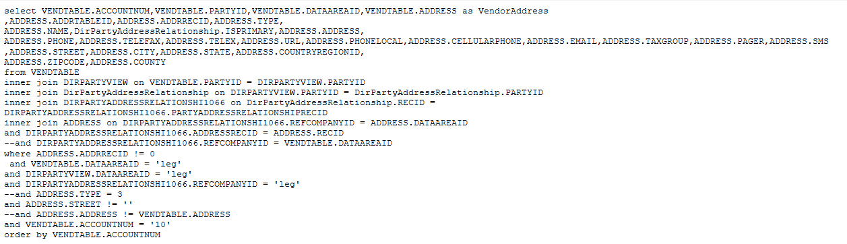

1. Copy the data (output) from the above SQL query to the Excel file and save the file to import the data in AX 2012R3. The excel file will look like as below screen :

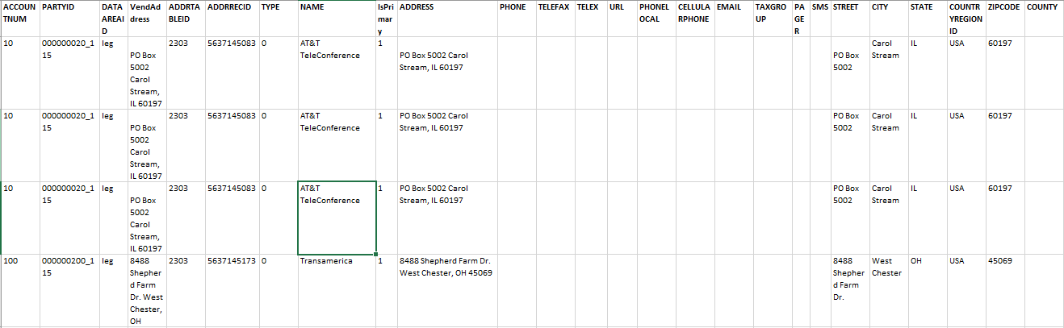

1. Now Import the attached XPO of the tables and class, so you will get the code to import vendor addresses.
2. Compile and run the class. Now vendor addresses in AX 2012 R3 will be updated as per in AX 2009.