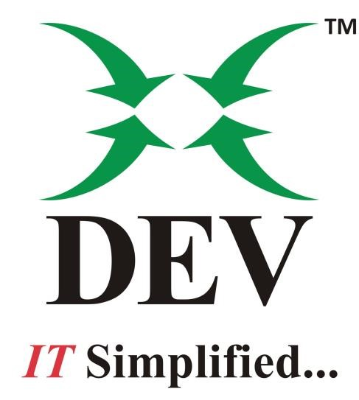

**Using IDMF in AX 2012**

*Prepared By Mukesh Jethwani*

Contents

1. Installation 2

1.1. Prerequisites: 2

1.2. Install IDMF: 3

2. Using IDMF: 6

2.1. **Analysis Snapshot:** 6

2.2. **Health Check:** 9

2.3. **Metadata Schedule:** 9

2.4. **Master data Schedule:** 10

3. **Difference between Purge and Archive:** 11

**4. Archive Database:** 12

# 1. Installation

## 1.1. Prerequisites:

1.1.1. Open Run and type dcomcnfg . Right Click Local DTC and open properties.

1.1.2. Configure Local DTC properties as shown in below screenshot.

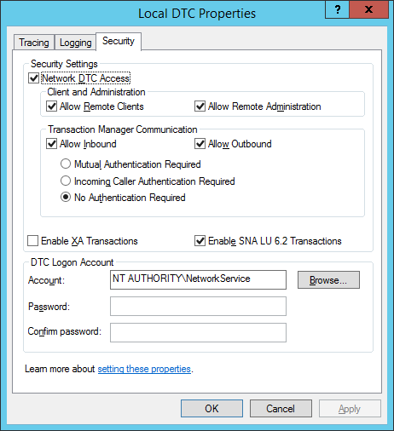

## 1.2. Install IDMF:

1.2.1. Once the configuration has been done, run IDMF set up file. When you will run the setup, it will first redirect you to the Introduction page. Click Next. Then accept the terms and agreements and click next. Then please select the path where files should be saved.

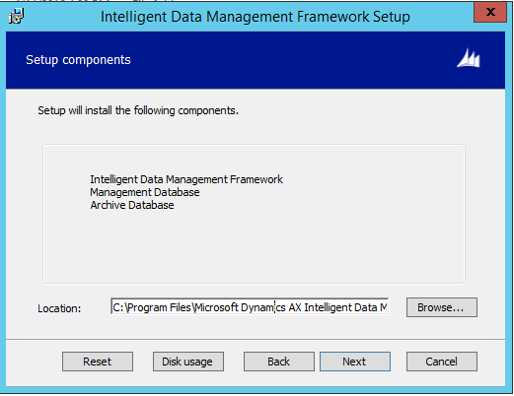

1.2.2. Fill the details of Management database that is server name and database name,

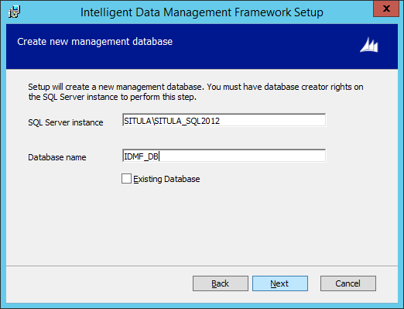

1.2.3. Fill the details of Production database that is server name and database name,

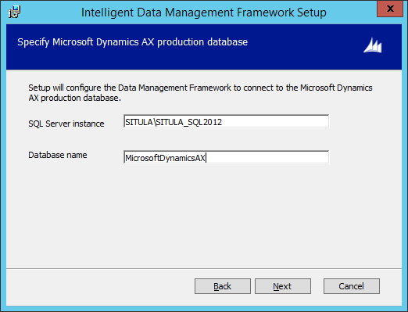

1.2.4. Then run post installation checklist.

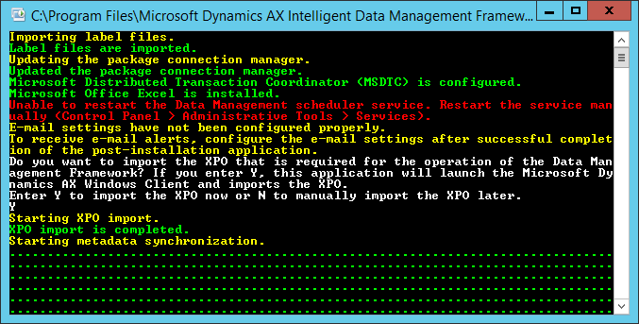

# 2. Using IDMF:

Once Installation has been done, open IDMF tool, you will see below screen:

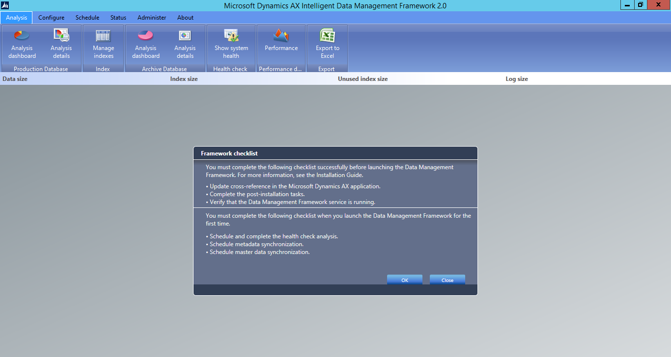

### 2.1. **Analysis Snapshot:**

Then Go to Schedule tab and schedule the production database job. Fill the name for schedule.

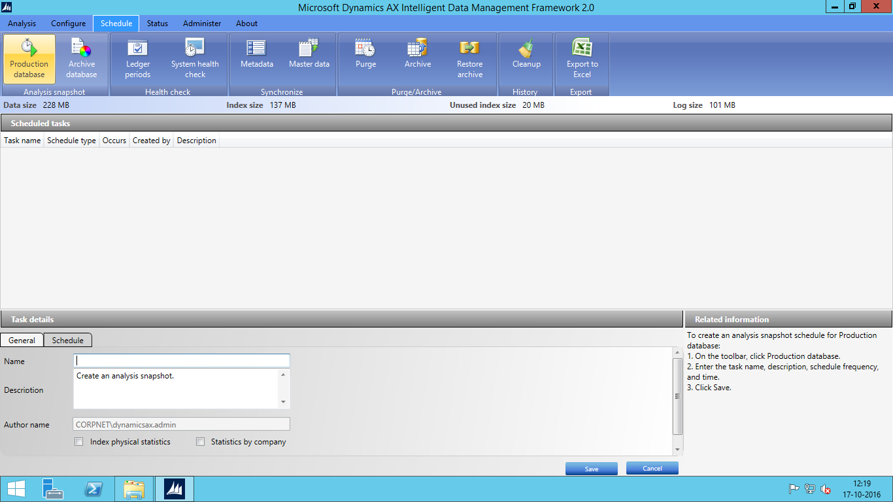

Then go to schedule tab and schedule job by filling details.

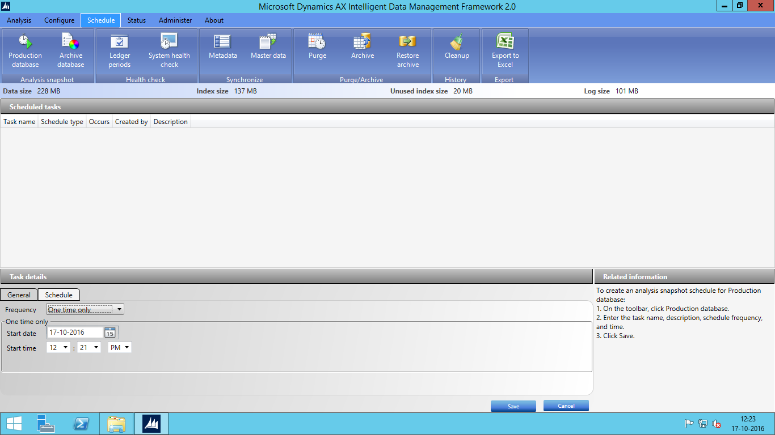

You can view the status of the job by moving to the status tab,

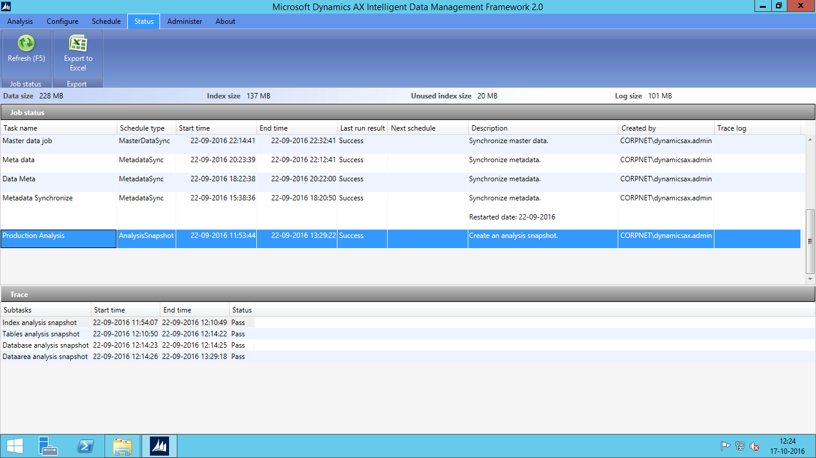

Job will take a long time, once job will get ran, you can see the analysis dashboard as shown below:

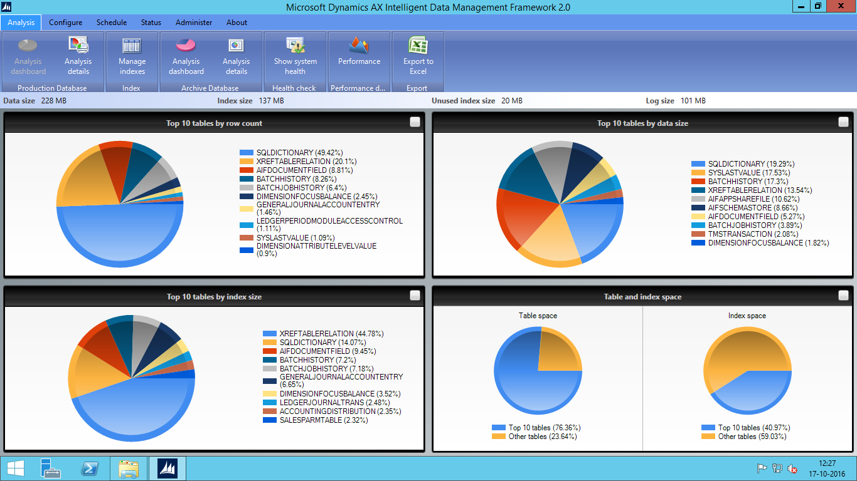

You can also manage the indexes by clicking on Manage index:

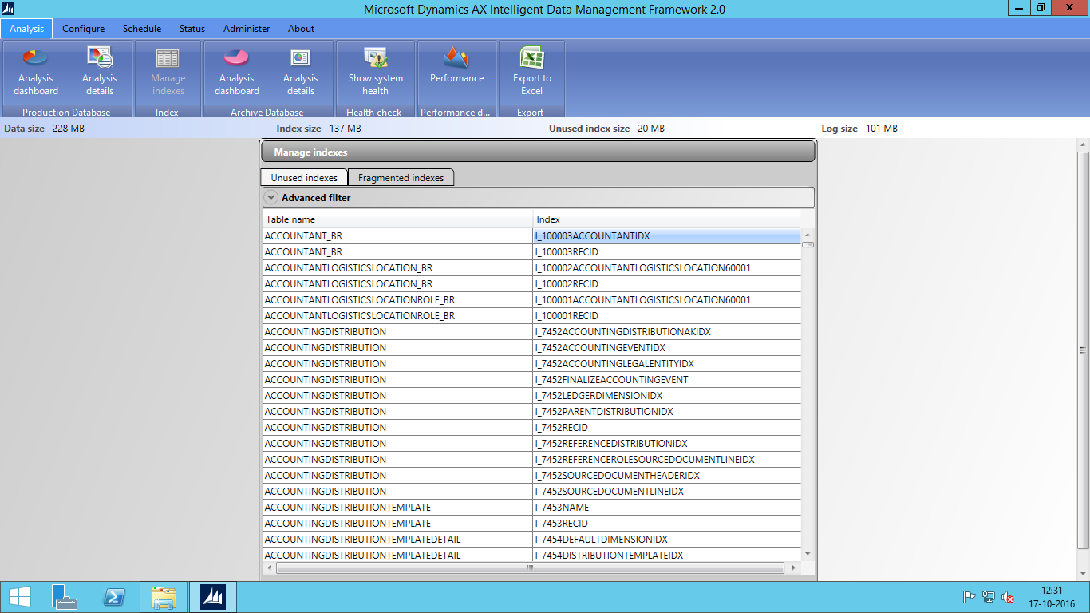

Here you can see the list of Unused and Fragmented Index. You can also see the analysis of top 50 tables in terms of size in database, by clicking analysis details button.

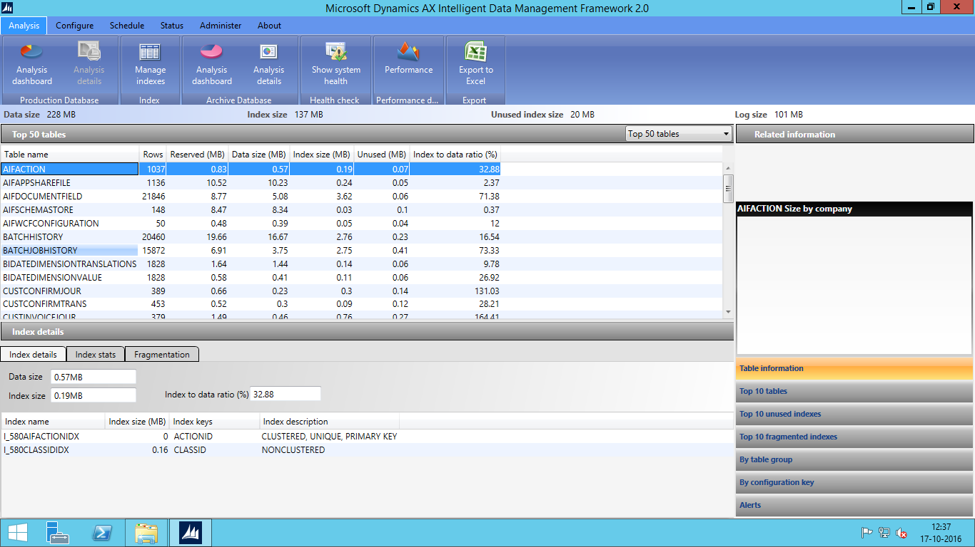

### 2.2. **Health Check:**

1. Click **Administer** > **Application health check** to work with the health check queries. In the **Application health check queries** window, click **Validate queries**, and wait for the validation to be completed. Upon successful validation, the **Validate queries** button becomes hidden, and all the queries in the **Queries** node appear in black.
2. Click **Schedule** > **Ledger periods** to create the ledger periods for the health check analysis. Enter the required information in the **Task details** pane of the **Scheduled tasks** window, and then click **Save**. For this task, select **One time only** from the **Frequency** list. Wait for the ledger periods schedule to be completed successfully before going to the next step.
3. Click **Schedule** > **System health check** to create the baseline health check analysis task. This task must start after successful completion of the ledger periods task that you created in the previous step. Enter the required information in the **Task details** pane of the **Scheduled tasks** window, and then click **Save**. For this task, select **one time only** from the **Frequency** list.
4. Click **Status** > **Refresh** to refresh the task. Verify that both the ledger periods task and the baseline health check analysis tasks have been completed with a **Pass** status. You are now ready to use the **Analysis** menu for health check analysis.

### 2.3. **Metadata Schedule:**

The metadata synchronization task copies the metadata from the production database to the archive database. If you have to purge the database, then no need to run these job else for the archive the database, you have to run these job.

1. Click **Schedule** > **Metadata** to work with the metadata synchronization task. Enter the required information in the **Task details** pane of the **Scheduled tasks** window, and then click **Save**. For this task, select **One time only** from the **Frequency** list.
2. Click **Status** > **Refresh** to refresh the task. Verify that the metadata synchronization task has been completed with a **Pass** status.

### 2.4. **Master data Schedule:**

Replicate master data from the production database to the archive database. You must complete the previous step before creating a master data replication task. The master data replication task copies the master data tables from the production database to the archive database. You can configure the master tables by going to administer tab and click on master data tables.

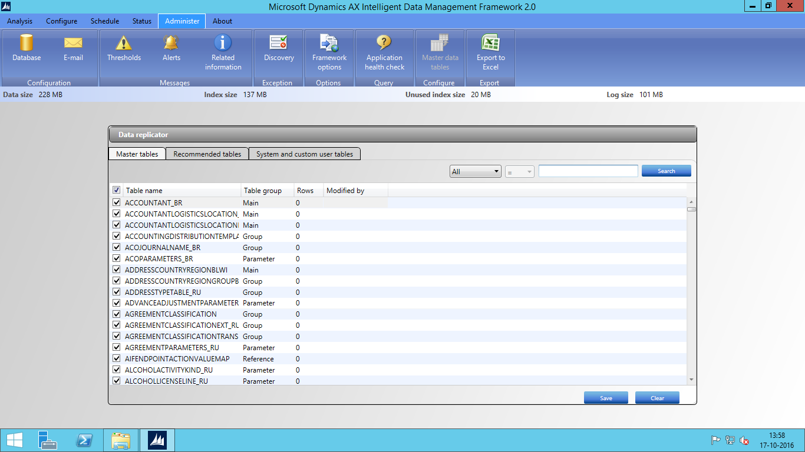

To run the master data job, follow following steps:

1. Click **Schedule** > **Master data** to work with the master data replication task. Enter the required information in the **Task details** pane of the **Scheduled tasks** window, and then click **Save**. For this task, select **one time only** from the **Frequency** list.

1. Click **Status** > **Refresh** to refresh the task. Verify that the master data replication task has been completed with a **Pass** status.

# 3. **Difference between Purge and Archive:**

The purge function removes or deletes data from a set of related entities, or tables, from the production database. The archive function moves data from a set of related tables from the production database to a standby database called the archive database. Users can use the archive database for reporting, but we recommend that they not be allowed to update it. IDMF and this document use the term off lining interchangeably with the term archiving, and recycling interchangeably with purge or delete operation.

Both the purge and archive operations depend on a carefully determined hierarchical relationship tree of related tables based on the Microsoft Dynamics AX metadata. For example, when a user creates, updates, or deletes a sales order, the **SalesTable** table and other tables that are related to **SalesTable** are updated. When you archive or purge data from a main table, such as SalesTable, you must archive or purge data from all the tables that are related to that main table. The archive and purge operations always work on a set of related tables. This set of related tables forms a hierarchical relationship. Each hierarchical relationship starts with the main table, called a driver table, at the root level, level 0, of the hierarchical tree. All the child tables that are related to the driver table are at the next level, level 1. All the child tables of tables in level 1 are at the next level, level 2. The nested hierarchy of parent-child relationships continues until there are no more child tables for the lowest level of tables.

To help you understand the hierarchical relationships, IDMF includes some templates that show sample hierarchical relationships. Templates for the archive function are called archive templates. Templates for the purge function are called purge templates. Each template provides a sample hierarchy based on a standard installation without any customizations. You cannot use these templates directly. You must open these templates, review them to verify applicability in your environment, and then save them before you can use them for the archive or purge function. Inbuilt Purge template has been shown in below screenshot:

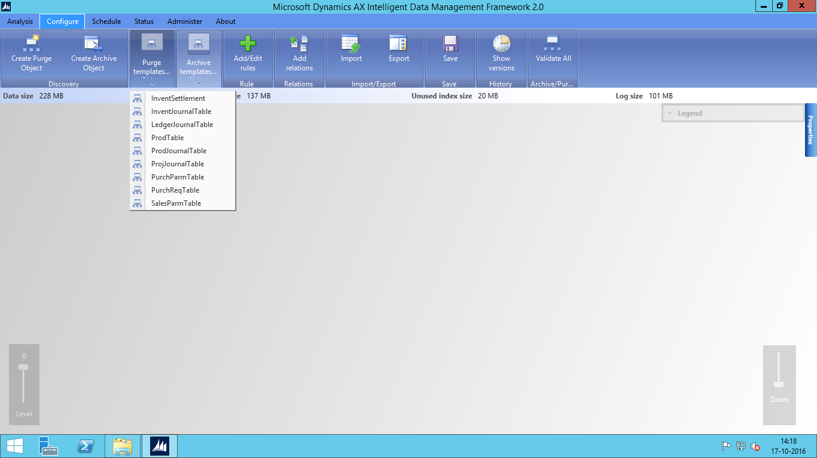

# **4. Archive Database:**

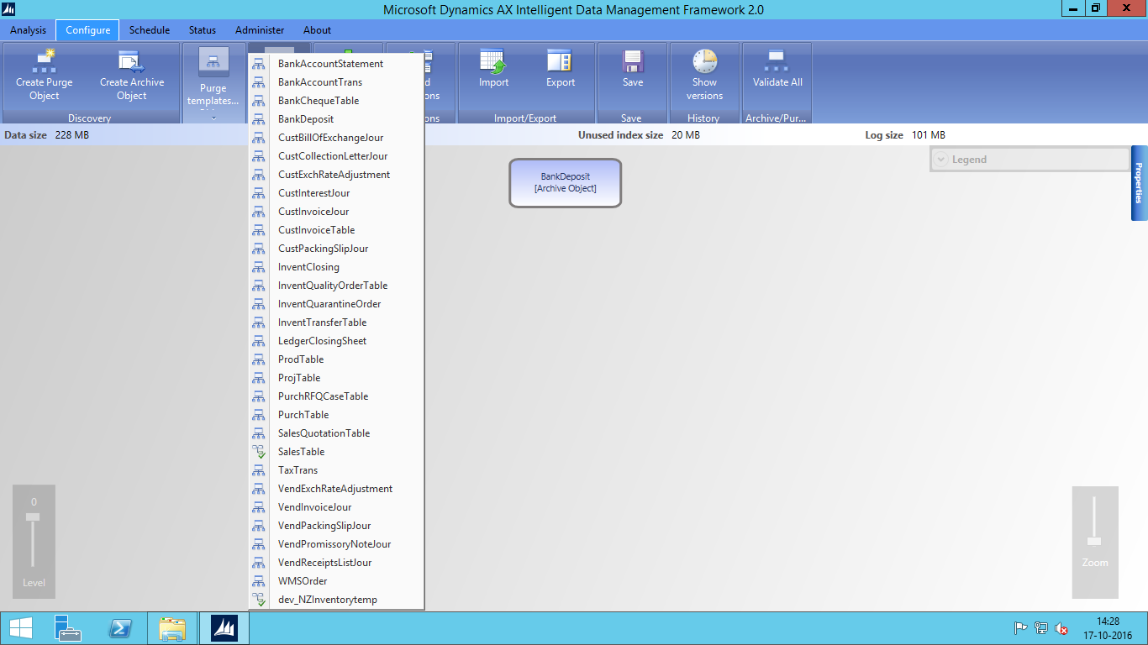

You can use in built templates or you can make your own template, by moving to the Configure tab and click on “Create Archive object”. When you will click on button, a new screen will open. Select the driver table and unique keys and Click Discover

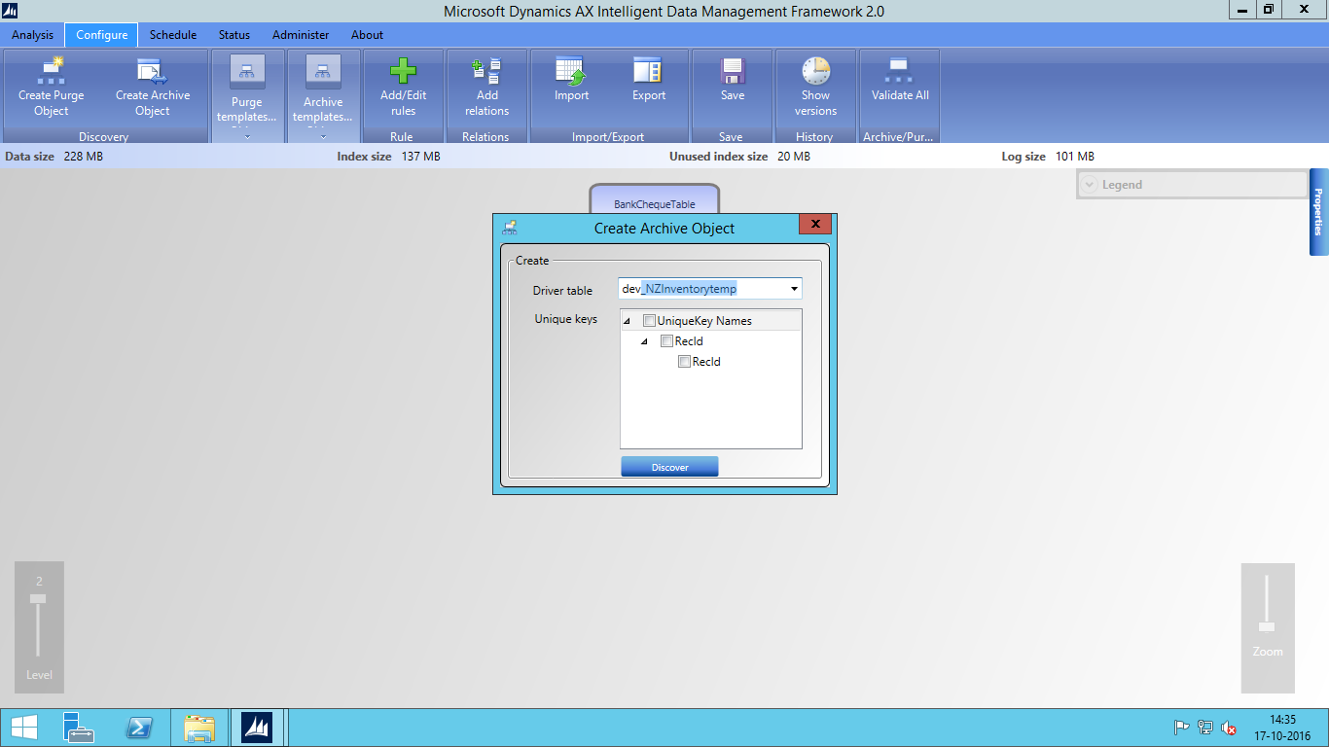

A new archive object will get created as shown below, then you can add archive objects to existing archive objects.

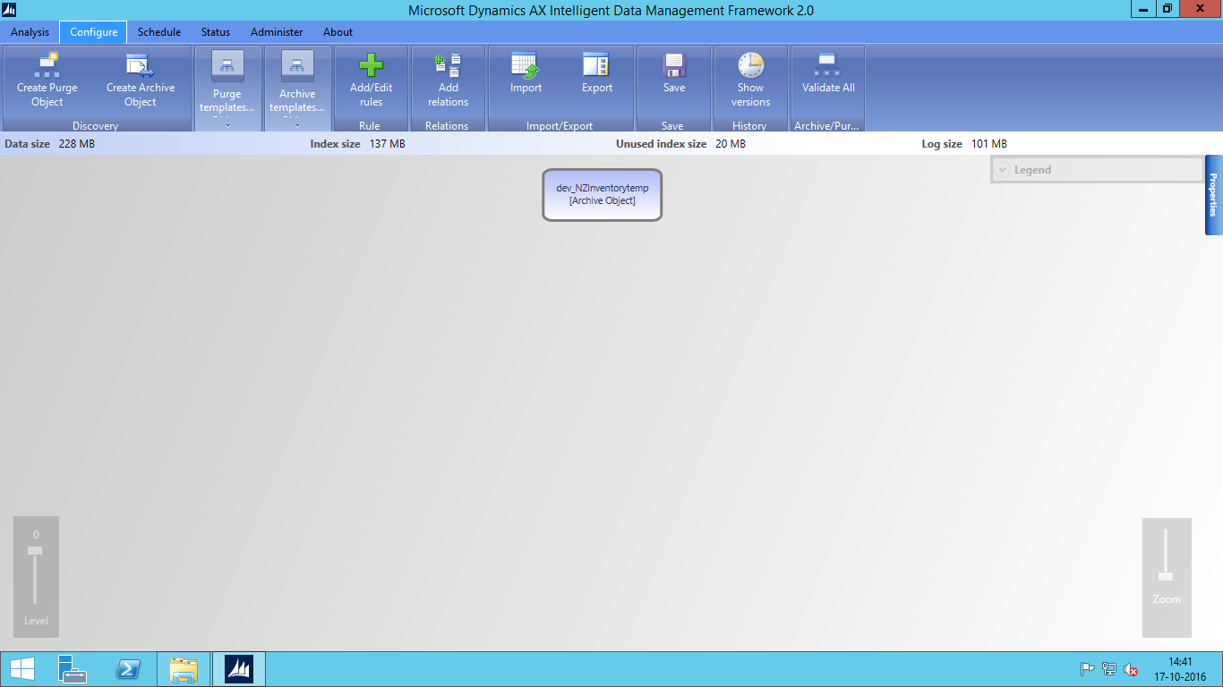

Now you have to add rules by clicking on button Add/Edit rules:

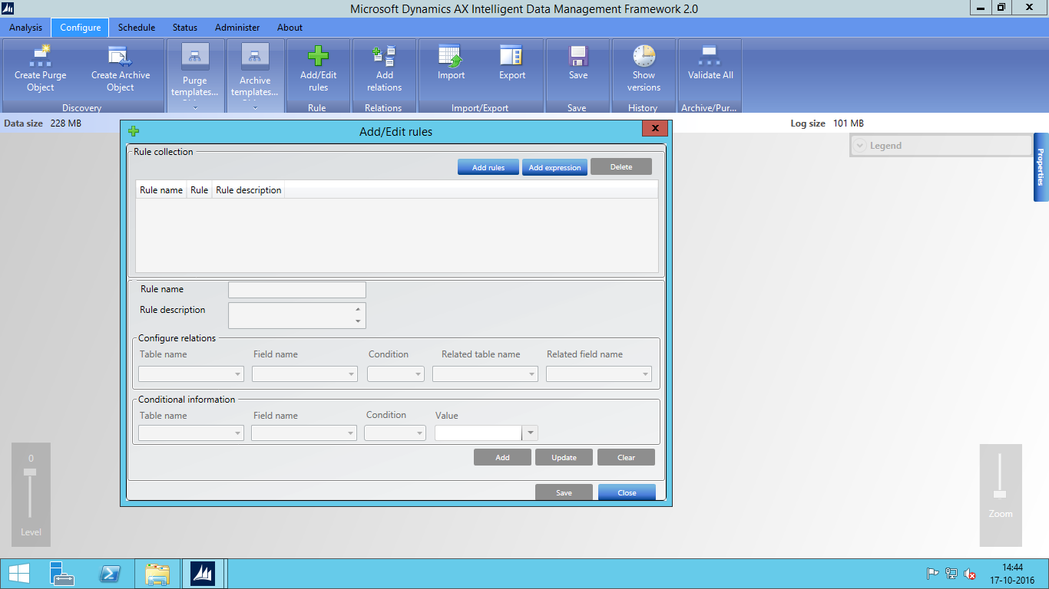

Fill the Expression on the basis of which you want to archive database, then click add

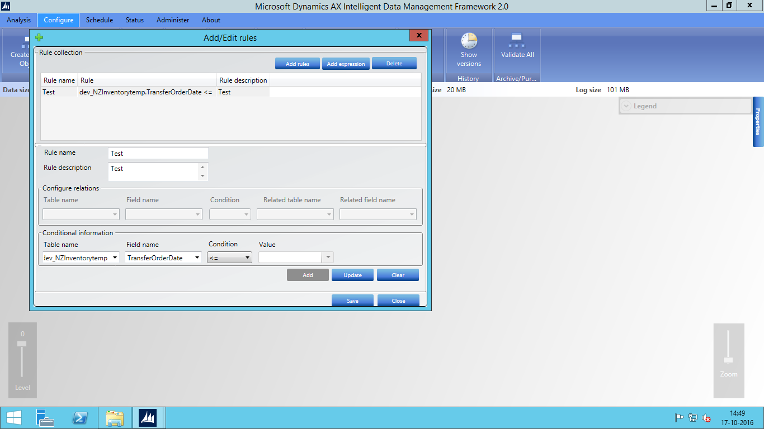

Then click save. Then save the template as shown below:

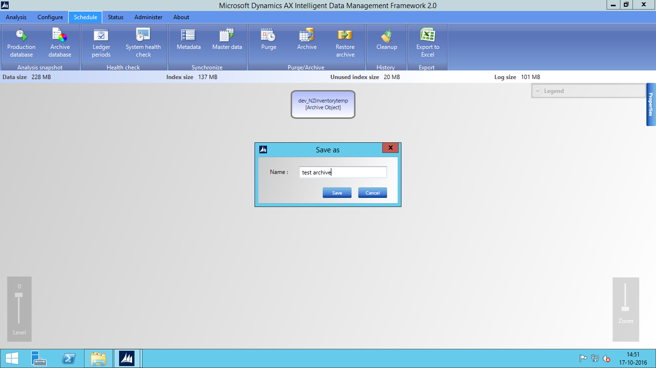

Now run the archive job by moving to schedule tab and click on archive button as below:

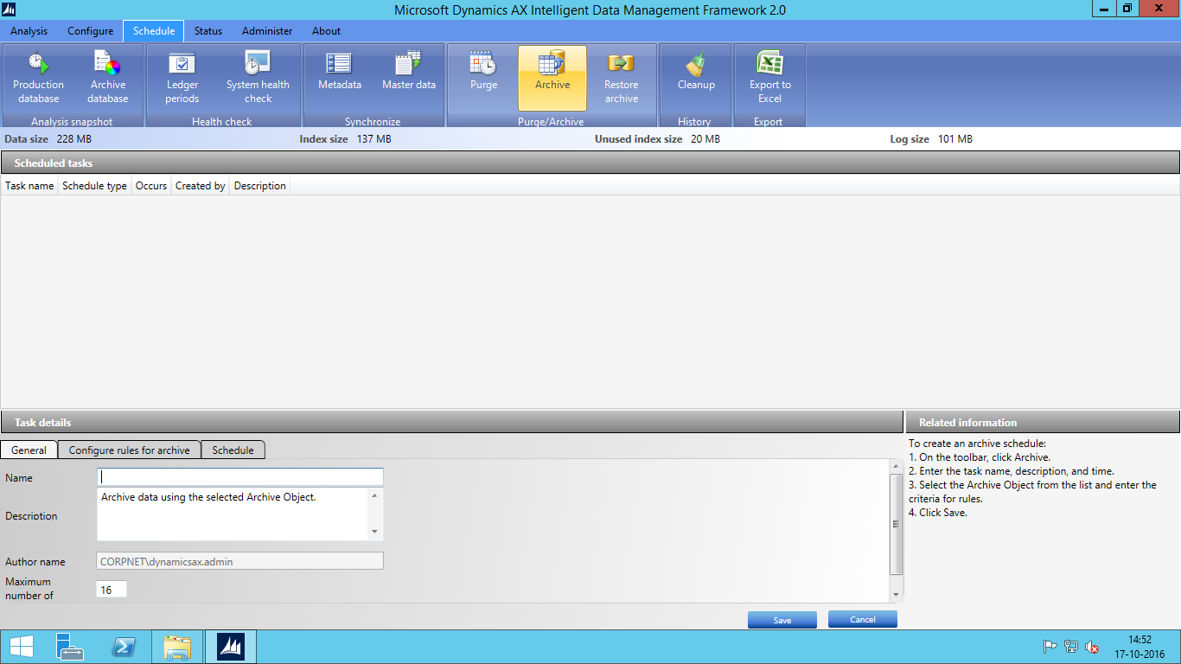

Enter the name for the schedule and then Configure rule for archive selecting archive object and select condition by entering the value in value field and then click save.

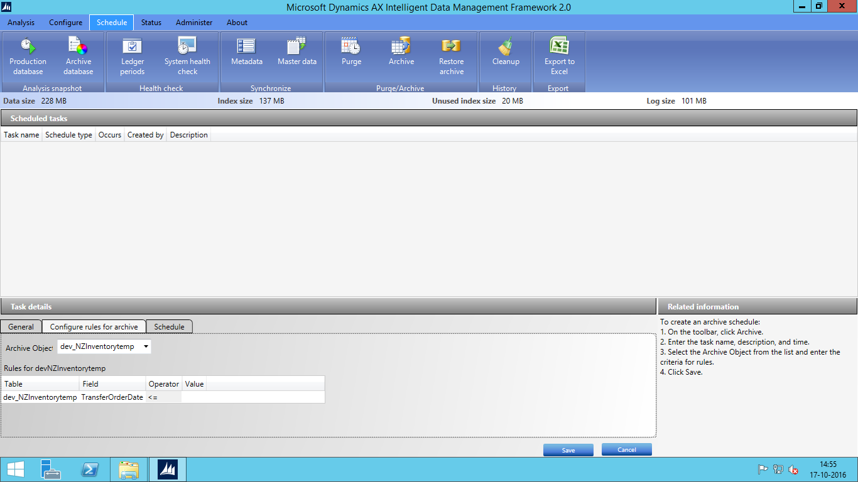

Next schedule the job and see status of job in status tab. Once the job get ran , when you will see in the table of production database , you can view that the rows which were not matching your specified condition has been moved to the archive database.