Once a while, one of our client had an issue with the VAT amount in general journal.

Though, VAT amount was calculated and updated when enter the data in General Journal; after posting the transaction, VAT amount was not affected and updated with 0.

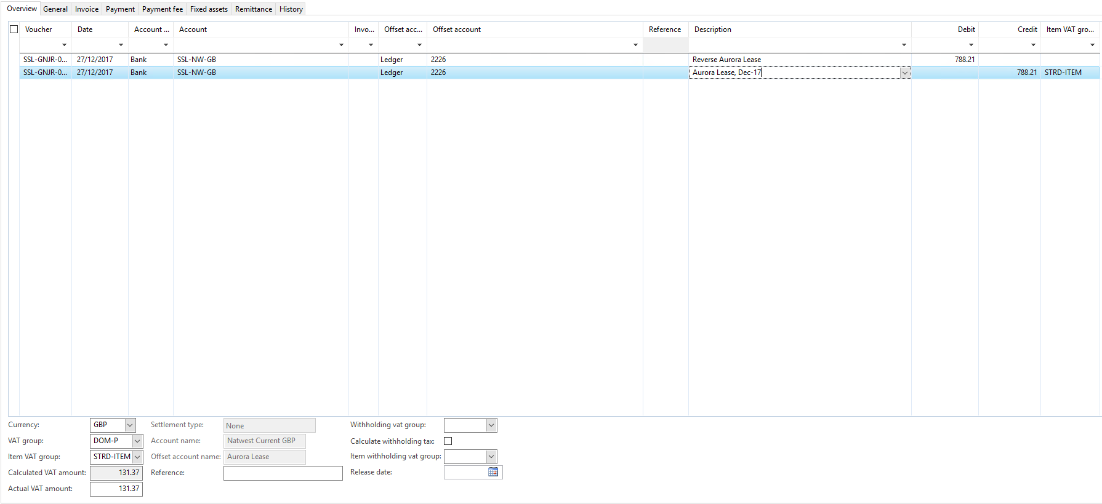

To resolve the issue, we have followed below steps:

* Full CIL
* Compile the class from where VAT was calculating. i.e. LedgerJournalEngine, LedgerJournalEngine_Server, Tax, TaxWithholdJournal_IN,
* Debug the code on posting the journal