ENGINEERING HANDBOOK
Judicial AI for Nepal
Technical Architecture, Authority-Aware RAG,
Governance, Evaluation and Implementation
A compact master document for engineering and research
Status | First complete working draft
Version | v0.1 • 25 July 2026
Publication path | Handbook → conference paper → journal article
Prepared for the Judicial AI Assistant Development Project

Document purpose and status
Draft status. This is an engineering and research first draft. It proposes a trustworthy architecture and implementation method; it does not claim that a production judicial system or reported evaluation results already exist. Legal interpretation, security controls and pilot thresholds require validation by authorized Nepalese institutions and domain experts.

The handbook is the master technical source for the project. It keeps the main explanation clear for non-technical readers while placing enough detail in the same document for engineers, architects, researchers and implementers. Each major chapter states its research role so material can be extracted without rewriting the project from the beginning.
The proposed system is an assistive legal-information and research platform. It is not a judge, does not predict guilt or sentence, and must not replace judicial discretion, legal representation or formal legal advice. Its core promise is narrower: retrieve relevant Nepalese legal authority, show the evidence, explain uncertainty and preserve human control.

Evidence-status labels
Label | Meaning | How to use it in papers
Established basis | An official legal source, standard or peer-reviewed technical method supports the statement. | May be stated with citation.
Design proposal | An architectural choice proposed for this Nepal context. | Describe as the proposed method.
Pilot target | A recommended acceptance threshold, not a measured result. | Do not report as an achieved metric.
Research claim | A proposition that needs controlled evaluation. | Convert to a question or hypothesis.

Executive summary
Nepal has official digital sources for laws, Supreme Court judgments, the Nepal Kanoon Patrika and case information, but the material is distributed across formats, languages and publication histories. A general large language model cannot safely reconstruct this legal order from its parameters. Judicial use demands current sources, legal hierarchy, pinpoint citations, confidentiality and visible limits. The project therefore adopts retrieval-augmented generation (RAG) instead of training a model from scratch as its first engineering strategy.
The reference platform separates institutional workflow from AI computation. An ASP.NET Core API owns identity, access policy, audit, case workflow and stable contracts. A Python AI service performs document processing, embeddings, hybrid retrieval, reranking, prompt construction, generation and citation verification. Qdrant is the initial vector store; a relational metadata database and immutable object store preserve legal structure and source files. Qwen is an initial open-model family to benchmark, not a permanent dependency. Every component remains replaceable behind versioned interfaces.
The technical contribution is Authority-Aware Judicial RAG. Normal RAG asks which passages are semantically similar. Judicial RAG must also ask whether a source is official, in force, from the correct court, precedential, later limited or overruled, accessible to the current user and temporally applicable to the dispute. The proposed ranker applies hard legal filters before soft scoring, combines lexical and dense retrieval, uses a reranker, then adds explainable authority and source-quality features. The generator receives only the selected evidence and must attach each material legal claim to a citation.
The system is evaluated as a pipeline, not only as a chatbot. Retrieval tests measure whether the right authority appears. Answer tests measure completeness, legal issue coverage and groundedness. Citation tests verify that sources entail the linked claims and that quotations are exact. Safety tests cover privacy, prompt injection, access-control leakage, superseded law, bias and refusal. A multidisciplinary release board approves movement from offline prototype to shadow pilot and then to limited operational use.
The recommended delivery path is incremental. Phase 0 establishes governance, use-case boundaries and a representative gold dataset. Phase 1 builds a single-node, local-first prototype on a curated public corpus. Phase 2 introduces expert evaluation, verified citations and version-aware legal retrieval. Phase 3 runs a controlled shadow pilot without decision authority. Phase 4 adds resilient infrastructure, formal change control and carefully scoped institutional integration. Scaling to tens of millions of judgments is handled through immutable storage, partitioned processing, sharded indexes, pre-computed authority features and tiered retrieval.

Publication extraction map
The handbook and the papers should share one research spine: problem → gap → proposed method → architecture → evaluation → governance → contribution. Implementation detail stays here; only the evidence needed to support a publication claim moves into a paper.
Research unit | Handbook location | Conference paper (6–8 pages) | Journal article (12–15+ pages)
Problem and gap | Chapters 1–2 | Condense to introduction and motivation. | Add literature comparison and Nepal context.
Technical method | Chapters 5–11 | Present Authority-Aware Judicial RAG and one core figure. | Include data model, ranking features, ablations and failure analysis.
System architecture | Chapters 12–16 | Show service boundaries and main runtime flow. | Add deployment, security, scaling and reproducibility detail.
Evaluation | Chapter 17 | Report pre-registered metrics and primary results. | Add dataset construction, confidence intervals, subgroups and error taxonomy.
Governance | Chapter 18 | State essential safeguards and human oversight. | Analyze law, policy, auditability and institutional process.
Contribution | Chapter 21 | Use the claim ledger to write abstract and conclusion. | Separate conceptual, technical, empirical and practical contributions.

Contents
Part I: Problem, scope and AI foundations
Part II: Legal data and knowledge engineering
Part III: Retrieval, generation and citation control
Part IV: Platform architecture, security and scale
Part V: Evaluation, governance and implementation
Part VI: Research contribution and publication reuse
Appendices: Schemas, contracts, checklists, glossary and sources
PART I
Problem, Scope and AI Foundations
Why judicial AI is different, what this project will build, and what it must never become.

1. Nepal judicial-information problem
Research role: Introduction, context and problem statement

1.1 The engineering problem
A user who asks a legal question does not merely need fluent text. The user needs the correct law for the relevant date, decisions from the proper court, an explanation of how the sources relate, and a way to inspect the evidence. The answer may change when a statute is amended, a later bench limits a precedent, a case is unpublished, or the facts fall outside the retrieved authority. Judicial AI is therefore an information-governance and retrieval problem before it is a language-generation problem.
Nepal already has important official digital sources. The Nepal Law Commission publishes the Constitution and legislation. The Supreme Court provides judgments, case information, strategic plans and annual reports. Nepal Kanoon Patrika provides searchable precedents. These are valuable foundations, but they were not designed as one machine-readable, version-aware knowledge system. A reliable assistant must preserve the identity and authority of each source while resolving duplicate files, scans, OCR errors, missing metadata and inconsistent references.
The Constitution gives the Supreme Court final authority to interpret the Constitution and laws and requires compliance with legal principles it lays down in adjudication. That makes court level, bench, decision status and later treatment essential ranking features rather than optional metadata. At the same time, constitutional rights to justice, equality, information and privacy mean that efficiency cannot be the only design objective. Access, confidentiality, non-discrimination and due process must shape the architecture.

1.2 Practical gaps the system addresses
- Legal sources are dispersed across portals, PDFs, scanned images, web pages and internal systems.
- Keyword search misses semantic matches, while semantic search can retrieve legally weak or outdated text.
- Nepali legal language includes formal vocabulary, spelling variation, citations, abbreviations and bilingual queries.
- A judgment may be relevant yet non-binding, later distinguished, superseded or outside the applicable date.
- General-purpose LLMs may produce plausible but unsupported citations and do not reliably know current Nepalese law.
- Users need different access levels: the public, lawyers, researchers, court staff and judges cannot share one unrestricted context.
- Institutions need an audit trail showing which sources, models, policies and prompts produced an answer.

1.3 Problem statement for publication
Research-ready problem statement. Existing legal search and general RAG systems optimize relevance but do not adequately model Nepalese legal authority, temporal validity, provenance and institutional controls. The research problem is to design and evaluate a citation-grounded, authority-aware RAG architecture that improves access to Nepalese legal information while preserving human oversight, privacy and auditability.

2. Scope, users and non-goals
Research role: System requirements and study boundaries

2.1 Intended users
User group | Primary need | Permitted assistance | Key safeguard
Public | Find understandable public legal information. | Source discovery, plain-language explanation, referrals. | Prominent limitation and no case-specific legal advice.
Lawyer / researcher | Locate statutes, precedents and conflicting authority. | Advanced search, evidence packs, citation export. | Original sources remain visible and reviewable.
Court staff | Research and administrative support. | Controlled retrieval, summarization, document triage. | Role-based access and complete audit log.
Judge | Optional research support under institutional rules. | Authority map, source comparison, issue checklist. | No automated adjudication or hidden recommendation.
Administrator / auditor | Control and inspect the system. | Policy, access, quality, incident and model reports. | Separation of duties and immutable logs.

2.2 Priority use cases
- Search and retrieve relevant constitutional provisions, statutes, regulations and judgments.
- Produce a neutral answer that separates governing rule, supporting authority, factual application and uncertainty.
- Compare multiple cases and show agreement, distinction or potential conflict.
- Trace citations from a judgment to earlier and later decisions.
- Identify whether retrieved legislation appears current for a specified date, subject to official verification.
- Create a reviewable legal research packet with source passages, metadata and links.
- Support corpus quality work: OCR review, metadata correction, duplicate detection and citation linking.

2.3 Explicit non-goals
- Predicting the outcome of an individual case or scoring a person, judge, lawyer or court.
- Recommending guilt, sentence, bail, credibility or judicial disposition.
- Replacing a lawyer, judge, registrar, official record or authorized legal database.
- Training a foundation model from scratch during the first implementation phase.
- Ingesting confidential case files into a public or shared index.
- Using generated text as an official decision without independent human authorship and approval.

2.4 Success definition
A successful first system is not the one with the most features. It is the smallest system that consistently retrieves the right legal sources, refuses when evidence is insufficient, preserves access boundaries and lets an expert reproduce the answer. Coverage can expand only after reliability is demonstrated on a representative gold set.

3. Core AI concepts for this project
Research role: Technical background and related-work foundation

3.1 Language models and tokens
A large language model (LLM) receives text as tokens and predicts a distribution over the next token. Its transformer layers repeatedly mix information across the input through attention and apply learned matrix transformations. The model does not query a legal database unless the application explicitly connects one. Knowledge stored in model parameters is difficult to update, difficult to cite and may be incomplete. This is why a fluent answer is not proof of legal correctness.
The model's context window is temporary working memory. The application places the user question, selected instructions and retrieved passages into that window. More context is not automatically better. Irrelevant passages increase cost and may distract the model; conflicting passages require explicit labeling; confidential passages must be excluded before prompt construction.

3.2 Embeddings, lexical retrieval and reranking
An embedding model converts a query or passage into a numeric vector whose location represents learned meaning. Dense retrieval compares vectors and is useful when the query and source use different words. Lexical retrieval such as BM25 is strong for exact statute numbers, party names, defined terms and rare legal phrases. Judicial search needs both. Their result lists can be fused, filtered and then reranked with a model that examines each query–passage pair more closely.
Multilingual retrieval is especially important for Nepal because a user may ask in English about a judgment written in Nepali, or mix English technical terms with Nepali legal expressions. Candidate embedding models must be tested on an actual Nepalese legal set. Published multilingual coverage is only a reason to test a model; it is not evidence that the model works well for this domain.

3.3 RAG compared with fine-tuning
Question | RAG | Fine-tuning
Where does legal knowledge live? | External corpus and indexes. | Partly in model parameters.
How is law updated? | Reprocess changed sources and indexes. | New training run may be required.
Can the answer show sources? | Yes, if passages and provenance are preserved. | Not by itself.
Best early use | Current, citation-grounded legal research. | Behavior, format, terminology or narrow task adaptation.
Main risk | Bad retrieval or poisoned context. | Memorization, stale knowledge and difficult provenance.
Project decision | Primary method for the first system. | Consider later only after a measured need.

Fine-tuning and RAG are not competitors in every case. A later system may fine-tune a model to follow a citation format or classify legal document sections while still using RAG for legal knowledge. The engineering rule is to define the failure first. Do not fine-tune because it sounds more advanced; fine-tune only when evaluation shows that retrieval, prompting and deterministic controls cannot solve the targeted behavior.

3.4 Agentic AI boundary
An agent can plan and call tools repeatedly. That may help with tasks such as expanding a search, checking a citation and compiling an evidence packet. It also increases risk because the model can take more actions and propagate an early mistake. The first release should use a deterministic orchestration graph with bounded tool calls. Any future agent must have least privilege, explicit budgets, tool-specific authorization and a human approval gate before material actions.

4. Engineering principles and quality attributes
Research role: Design principles and requirements

4.1 Non-negotiable principles
Source before answer. The system retrieves and validates authority before generation.
Authority with relevance. Legally stronger material receives explainable preference only when it is relevant.
Current-for-date. Validity is evaluated against the legal date asked, not only today's date.
Claim-level citations. Each material legal proposition is linked to evidence that supports it.
Human control. The system assists research and never hides the human decision-maker.
Least privilege. Access is enforced before retrieval and again before response assembly.
Version everything. Source, chunker, embedding, index, reranker, prompt, LLM and policy versions are recorded.
Fail visibly. Low evidence, conflict or failed verification produces an abstention or warning, not confident prose.

4.2 Quality attributes
Attribute | Engineering interpretation | Example evidence
Correctness | Sources and claims are legally and factually aligned. | Expert-rated answer and citation tests.
Traceability | An answer can be reproduced from recorded inputs and versions. | Evidence package and audit record.
Security | Unauthorized sources or system instructions are not exposed. | Access-control and red-team tests.
Privacy | Personal and sealed information is minimized and controlled. | Impact assessment, retention and access logs.
Availability | Core search remains usable during component failure. | Health checks, queues, replicas and recovery tests.
Maintainability | Models and stores can change behind stable contracts. | Adapters, schema versions and automated tests.
Accessibility | Explanations and interfaces work for varied language and ability. | Usability and bilingual evaluation.

PART II
Legal Data and Knowledge Engineering
Building a trustworthy corpus before building a persuasive interface.

5. Corpus acquisition and digitization
Research role: Method: dataset construction and preprocessing

5.1 Source classes and trust levels
The corpus begins with a source register. Each source is assigned an owner, legal class, access class, acquisition method, update frequency and trust level. Official publication is stronger evidence of authenticity than an unknown copy, but official publication does not guarantee perfect OCR, complete metadata or current legal effect. Authenticity, text quality and legal validity remain separate fields.
Source class | Examples | Default trust | Ingestion rule
Primary law | Constitution, Acts, regulations, gazette material. | Highest official source confidence. | Preserve versions, commencement and amendment links.
Judicial authority | Supreme, High, District and specialized court decisions. | Depends on official origin and court. | Capture bench, date, case number, disposition and citations.
Official publication | Nepal Kanoon Patrika, court reports and directives. | High when provenance is verified. | Link publication identity to the underlying decision.
Secondary material | Commentary, articles, books and manuals. | Informative, not primary authority. | Keep in a separate collection and label clearly.
User material | Uploaded pleadings or case files. | Case-specific and access restricted. | Isolate by matter, tenant and retention policy.

5.2 Acquisition manifest
Every acquired file receives a manifest before text extraction. The manifest stores the canonical source URL or institutional identifier, retrieval timestamp, media type, byte size, cryptographic hash, acquisition method, access class and any license or use condition. A new hash creates a new source version; it does not silently overwrite the earlier file.
The raw source is immutable. Derived OCR text, layout blocks, images, metadata and chunks are separate artifacts linked by identifiers. This makes it possible to correct a parser without losing the original and to reproduce which text an earlier model saw.
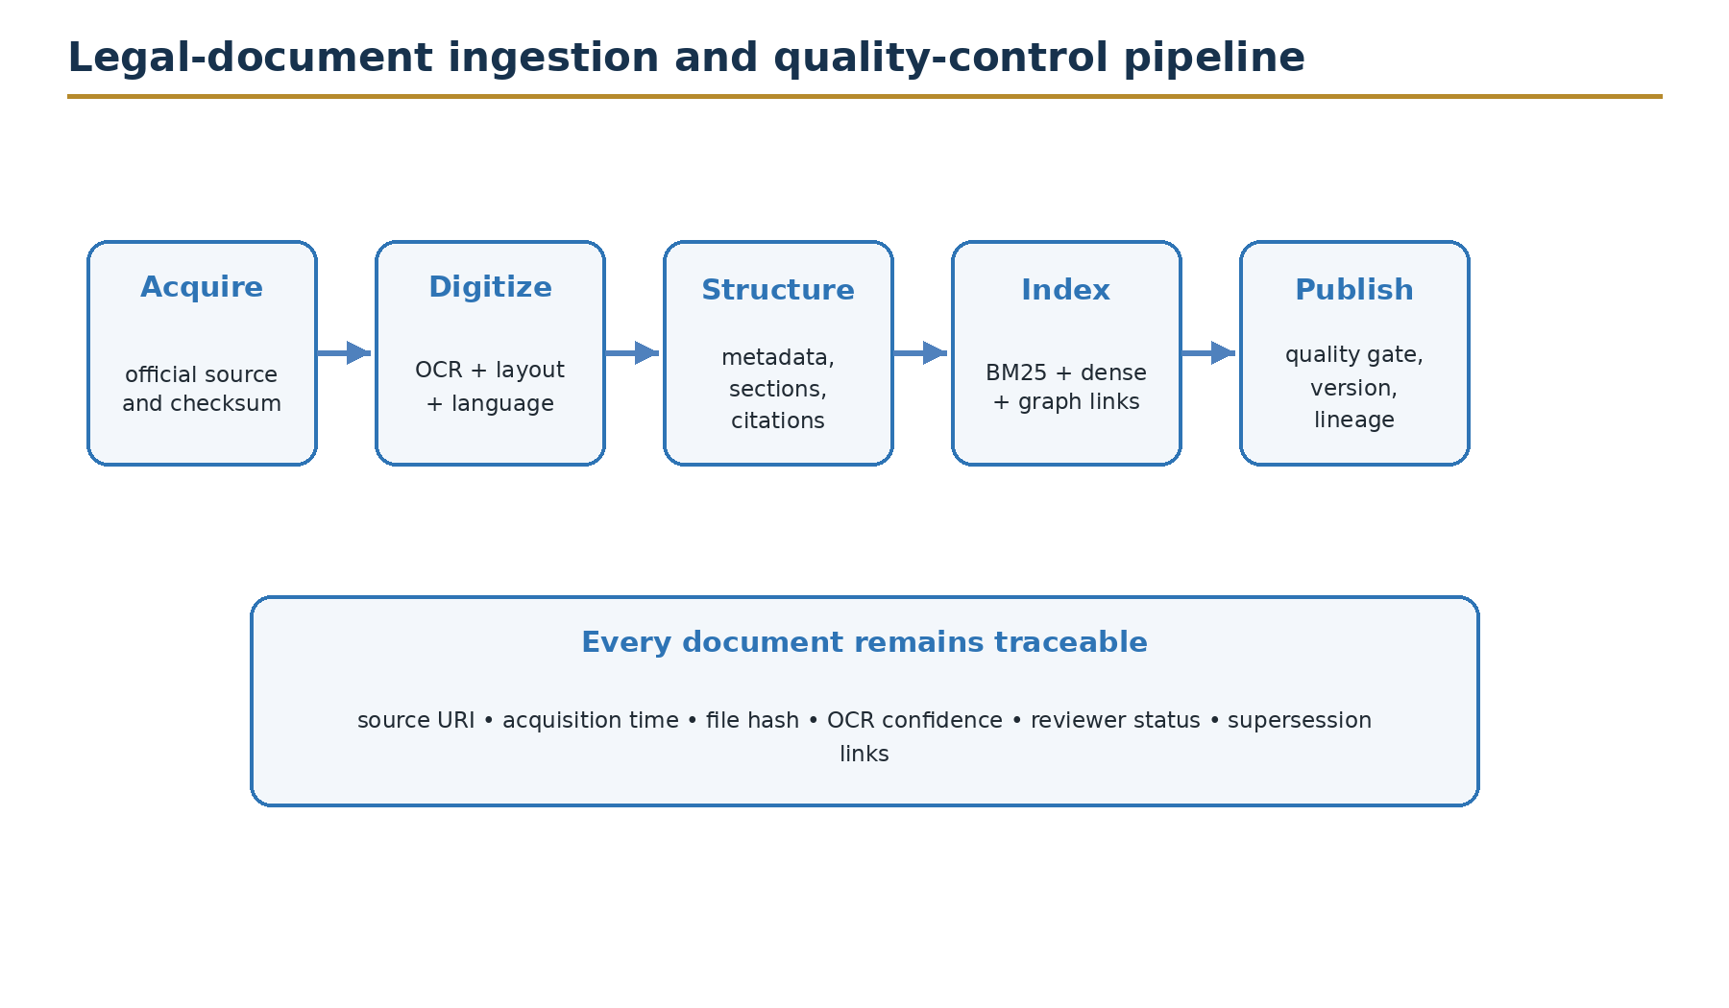
Figure 1. Legal-document ingestion and quality-control pipeline.

5.3 OCR and layout processing
- Detect whether a page contains selectable text, a scan, handwriting, stamps, tables or mixed content.
- Run language and script detection per page or block, not only per document.
- Preserve page numbers and bounding boxes so a citation can point back to the visible source.
- Keep alternative OCR text and confidence values for low-quality spans.
- Normalize Unicode, whitespace and common OCR noise without destroying the original representation.
- Use document templates and rules for recurrent headers, cause titles, bench details and signature blocks.
- Route low-confidence pages, uncertain dates and missing case numbers to a human review queue.

5.4 Quality gates
A document enters the searchable production corpus only after automated and, where required, human checks. A practical quality score can combine OCR confidence, structural completeness, source authenticity and reviewer status. The score controls display warnings and ranking but must never hide the underlying evidence.
Gate | Pass condition | Failure action
Provenance | Canonical source and hash recorded. | Quarantine until source is resolved.
Identity | Stable document type and identifier. | Create review task; do not merge automatically.
Text | Readable text and page mapping. | Re-OCR or keep image-only with warning.
Metadata | Minimum required fields present. | Index in restricted quality tier or hold.
Privacy | Access class and redaction status assigned. | Deny publication to public collection.
Version | Amendment or later-treatment links evaluated. | Mark status unknown and avoid current-law claim.

6. Legal document and metadata model
Research role: Method: legal knowledge representation

6.1 Three linked layers
The knowledge model separates source files, legal documents and retrieval passages. One source file may contain several documents; one legal document may have several versions; one version produces many passages. This prevents a vector record from becoming the system of record.
Layer | Purpose | Typical identifiers
Source artifact | Preserve acquired bytes and provenance. | artifact_id, URI, checksum, retrieved_at
Legal document | Represent the intellectual legal object. | document_id, type, title, court, case_no
Document version | Represent text and legal status at a time. | version_id, valid_from, valid_to, supersedes
Passage / chunk | Support retrieval with page and section context. | chunk_id, version_id, page, section_path
Citation edge | Connect authorities and later treatment. | from_document, to_document, relation, confidence

6.2 Minimum judgment schema
Field group | Required fields | Notes
Identity | document_id, case number, decision number, title | Keep official and normalized variants.
Court | court, bench, judges, jurisdiction | Normalize names but preserve printed text.
Time | filing date, decision date, publication date | Store original calendar text and normalized date.
Parties | party names, roles, anonymization status | Treat sensitive identities under policy.
Substance | case type, issues, statutes, disposition | Machine extraction needs review confidence.
Authority | publication status, precedential status, later treatment | Unknown is a valid value.
Provenance | source URI, checksum, pages, reviewer | Required for every searchable version.
Access | classification, tenant, matter, retention | Applied before retrieval.

6.3 Bilingual and date representation
The system stores the original text and normalized search forms. It must not replace Nepali legal text with an English translation. Translations are separate, linked artifacts with source, translator and review status. Query expansion may use bilingual terminology, but the answer must identify whether cited authority is original, official translation or machine-assisted translation.
Nepalese legal documents may use Bikram Sambat dates while software services commonly use Gregorian dates. Store the printed value, calendar system, normalized ISO date and conversion method. A conversion should be treated as derived metadata with a confidence or review status, not as the original date.

7. Chunking, versioning and legal relationships
Research role: Method: passage construction and temporal validity

7.1 Structure-aware chunking
Fixed token windows are a useful fallback but a weak default for legal text. A passage should usually follow a meaningful unit: constitutional article, statutory section, judgment heading, issue, party argument, court analysis, holding or order. The chunk carries its section path, page range and neighboring context. Overlap is small and purposeful, used to keep definitions or sentences together.
Document type | Preferred unit | Special rule
Constitution / Act | Article, section or subsection. | Attach definitions and amendment status.
Regulation / rule | Rule plus nested clauses. | Keep enabling Act reference.
Judgment | Issue, reasoning paragraph group, holding, order. | Separate party submissions from court reasoning.
Directive / circular | Numbered instruction or topic section. | Record issuing authority and effective date.
Commentary | Heading-based passage. | Never label as primary authority.

7.2 Temporal model
A current-law answer requires more than the latest file. Each provision or document version should have, where known, publication date, commencement date, valid-from and valid-to dates, amendment source and supersession links. The query carries an as-of date. Retrieval filters out versions that cannot apply, while uncertain status remains visible.
Safety rule. If the system cannot establish temporal validity for a material source, it must say so. It may show the source for research, but it must not present the source as unquestionably current law.

7.3 Citation and treatment graph
Judgment citations form a graph. Edges may represent cited, followed, applied, distinguished, doubted, overruled, affirmed or unknown treatment. Automatic extraction proposes candidate links; exact case identity and treatment need rule-based and human validation. The graph supports later-treatment warnings and authority features, but the source text remains the final evidence.
The first prototype should not wait for a perfect nationwide knowledge graph. Begin with exact citation normalization and links inside a curated corpus. Add treatment labels only where the language is explicit or an expert confirms it.
PART III
Retrieval, Generation and Citation Control
Turning a user question into a bounded, inspectable evidence-based answer.

8. Hybrid retrieval architecture
Research role: Method: candidate retrieval and reranking

8.1 Query understanding
The runtime first creates a query plan. It detects language, user intent, legal entities, court, jurisdiction, document type, cited provisions and temporal expressions. It also identifies whether the user requests current law, historical law, similar cases, a definition, a procedural explanation or a document comparison. The original query is always retained; expansions are logged as derived inputs.
Query rewriting is conservative. The system may add spelling variants, normalized statute names, bilingual terms and known citation forms. It should not invent case facts or silently narrow a legal issue. High-risk queries can bypass free-form rewriting and use deterministic extraction.

8.2 Candidate generation and fusion
- Apply identity, tenant, matter, access-class and document-status filters.
- Run lexical search for exact legal terms, names, identifiers and citations.
- Run dense retrieval for semantic and cross-lingual similarity.
- Optionally run citation-graph or metadata retrieval for linked authority.
- Fuse the candidate lists with reciprocal-rank fusion or a calibrated score.
- Rerank the top candidate set with a cross-encoder or late-interaction model.
- Apply legal-authority and source-quality features with reason codes.
- Diversify passages so the evidence covers the issue without duplicating one document.

8.3 Why hybrid search is the default
Exact legal references are often decisive: an article number, a named statute, a decision number or a distinctive phrase. Dense search is useful for conceptual similarity and bilingual access but can blur exact distinctions. A hybrid design protects both forms of relevance. Reranking then spends more computation on a smaller set and can consider the full query–passage relation.
The vector database is an index, not the legal record. Payload fields support filters, but canonical metadata stays in the relational store. Qdrant is suitable for the first implementation because it supports vector search, metadata filtering and hybrid queries. The interface must remain store-neutral so measured needs—not lock-in—drive later changes.

8.4 Retrieval configuration is evaluated, not guessed
Decision | Variants to test | Primary metric
Chunking | structure-aware vs fixed windows; overlap sizes | Recall@k and citation completeness
Lexical | tokenization, analyzers, field boosts | Exact-reference success
Embedding | multilingual candidates and legal adaptation | nDCG@10 by language/query type
Fusion | RRF, weighted fusion, learned fusion | nDCG and robustness
Reranker | cross-encoder vs late interaction | nDCG, latency and cost
Context selection | top-k, diversity and neighboring passages | Answer groundedness

9. Authority-Aware Judicial RAG
Research role: Core proposed method and technical contribution

9.1 Central idea
Relevance-only ranking can return a readable passage from the wrong court, an amended provision or a later-rejected argument. Authority-Aware Judicial RAG treats legal authority as a structured constraint. It separates four questions: Is the passage topically relevant? Is the source authentic and accessible? Was it legally valid for the requested date? What persuasive or precedential weight should it receive?
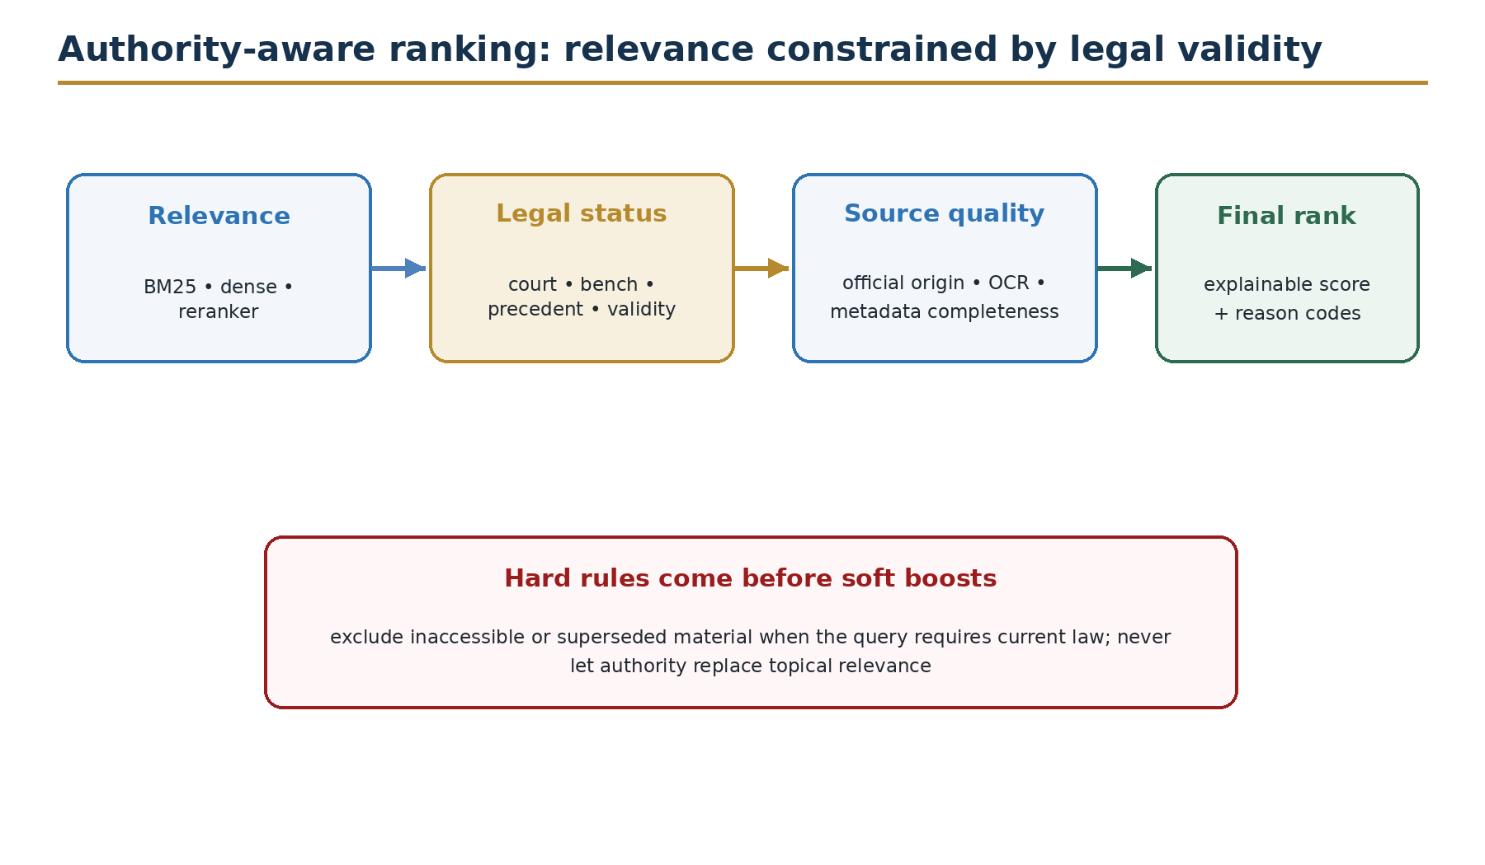
Figure 2. Authority-aware ranking: relevance constrained by legal validity.

9.2 Hard filters and soft features
Type | Examples | Effect
Hard access filter | tenant, matter, role, sealed or confidential status | Candidate is excluded before any model sees it.
Hard legal filter | outside required jurisdiction or clearly invalid for as-of date | Candidate excluded for current-law answer.
Soft authority feature | court level, bench, publication and precedential status | Score boost or penalty with explanation.
Soft treatment feature | followed, distinguished, doubted or overruled | Adjust score and add warning.
Soft quality feature | official source, OCR confidence, metadata completeness | Adjust confidence; never hide source quality.

Hard rules are deterministic and policy-owned. Soft weights are empirical and must be tuned on expert judgments. This division prevents a learned relevance model from bypassing access policy or obvious temporal invalidity.

9.3 Proposed scoring model
S_relevance = wL·norm(BM25) + wD·norm(dense) + wR·norm(reranker)
S_authority = a1·court + a2·precedent + a3·temporal + a4·treatment
S_quality = q1·official_source + q2·ocr + q3·metadata
S_final = S_relevance + λA·S_authority + λQ·S_quality
subject to: access_allowed ∧ jurisdiction_allowed ∧ temporal_policy_passed

All features are normalized and accompanied by reason codes. Example values may be used to start a prototype, but no weight becomes a project claim until tuned and compared with baselines. The ranker should expose a compact explanation such as: semantic match 0.82; Supreme Court published precedent; valid for requested date; later treatment not found; official source; OCR reviewed.

9.4 Authority feature design for Nepal
The feature model must be approved by Nepalese legal experts. A cautious initial representation can include court level, bench type, official publication, whether a legal principle is identifiable, temporal status, later treatment and source authenticity. Article 128 of the Constitution supplies a clear basis for treating Supreme Court interpretation and legal principles as a special category, but the system must not reduce the complex doctrine of precedent to court level alone.
Authority is query-dependent. A District Court decision may be the direct factual source for its own case. A repealed provision may be the correct authority for a historical dispute. A dissent may be relevant scholarship but not the holding. The query plan therefore carries the requested legal date, task and authority preference.

9.5 Research hypotheses
ID | Hypothesis | Required comparison
H1 | Authority-aware reranking improves the proportion of legally usable sources in the top ten. | Hybrid relevance baseline vs authority-aware model.
H2 | Temporal filters reduce answers that rely on superseded law for current-law questions. | With vs without version-aware filtering.
H3 | Claim-level verification reduces unsupported material propositions. | Generation alone vs generation plus verifier.
H4 | Bilingual query expansion improves Nepali–English cross-language retrieval without materially reducing exact-reference precision. | Original query vs controlled expansion.

10. Prompting and answer orchestration
Research role: Method: grounded answer generation

10.1 Deterministic orchestration graph
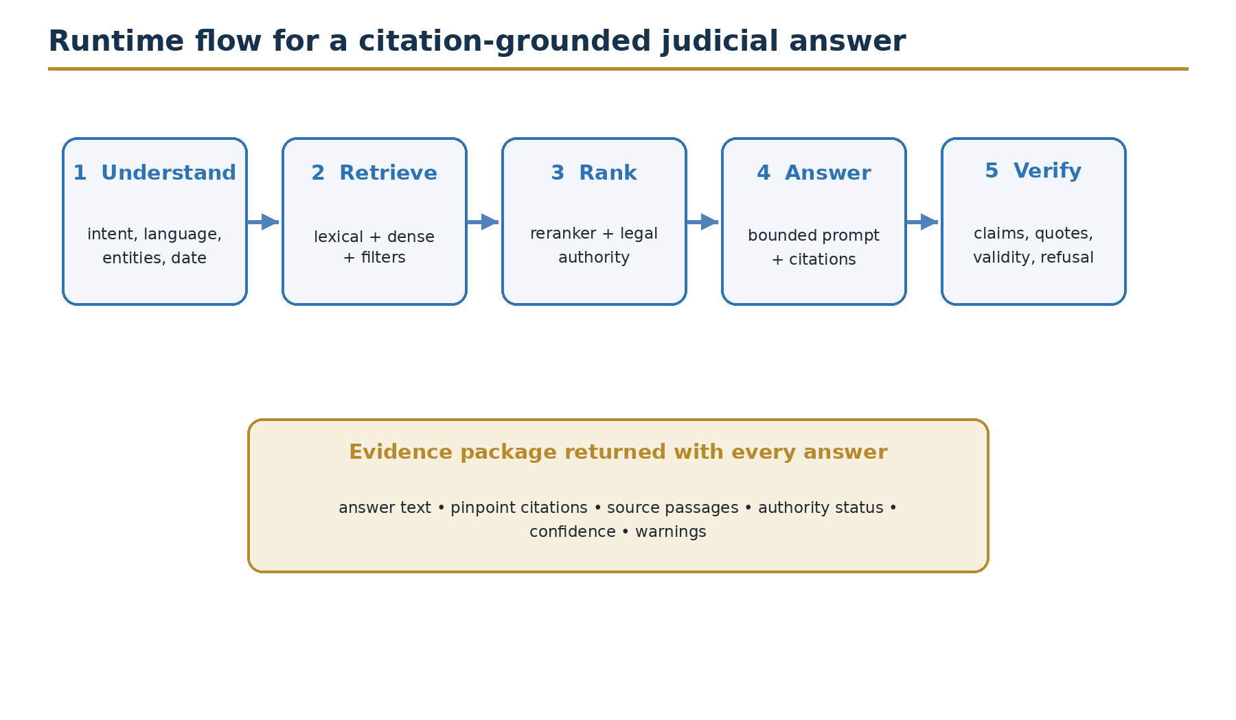
Figure 3. Runtime flow for a citation-grounded judicial answer.
The first system uses a fixed graph rather than an open-ended agent. Each node has a typed input, output, timeout and error policy. A request moves through authorization, query planning, retrieval, reranking, evidence selection, generation, verification and response assembly. Failed or low-confidence nodes can stop the flow.

10.2 Prompt contract
The generator receives a system policy, the user task, structured query metadata and numbered evidence passages. Evidence is treated as data, not as instructions. The prompt tells the model to use only the evidence for legal claims, distinguish sources, cite passage identifiers, state uncertainty, avoid inventing quotations and refuse when the evidence is insufficient.
Answer section | Purpose
Short answer | Direct, neutral response in simple language.
Legal basis | Rules and authorities with claim-level citations.
Application | How the retrieved rules relate to the stated facts, clearly marked as analysis.
Uncertainty | Missing facts, conflicting authority, validity concerns or source gaps.
Sources | Pinpoint references and links to the evidence package.
Limit | Role-appropriate notice that the output is assistive and review is required.

10.3 Context assembly
Context selection balances coverage and redundancy. The application groups passages by authority, adds neighboring text only when needed, identifies the source type and validity status, and limits repeated passages from one document. Conflicting sources are included with explicit labels instead of being silently resolved by the LLM.
The model may produce a draft reasoning outline before the final answer, but private chain-of-thought is neither required nor stored. What the system records is the visible query plan, selected evidence, structured claim list, verifier results and final response.

11. Citation verification, confidence and refusal
Research role: Method: output verification and safety

11.1 Claim-level verification
- Split the draft into material legal claims and non-material explanatory text.
- Extract every citation marker and confirm that the referenced passage exists and was authorized.
- Check whether the passage entails the claim, contradicts it or is insufficient.
- For quotations, require exact normalized string alignment and page location.
- Check temporal and authority warnings against metadata.
- Remove, revise or flag unsupported claims before response delivery.

11.2 Confidence is a structured report
A single confidence percentage creates false precision. The response should instead report evidence coverage, retrieval quality indicators, citation verification result, authority completeness, temporal status and known uncertainty. These components allow a reviewer to see why the system is cautious.
Dimension | Example status
Evidence coverage | All material claims cited / one issue lacks authority
Citation entailment | Verified / partial / failed
Authority | Binding authority found / persuasive only / unclear
Temporal validity | Verified for date / possible amendment / unknown
Source quality | Official reviewed text / OCR warning
Overall action | Answer / answer with warning / abstain

11.3 Refusal conditions
- Evidence or required access is insufficient for a material legal question.
- Material temporal validity cannot be established.
- Authorities materially conflict and the conflict cannot be represented safely.
- A material citation remains unverifiable after one controlled revision.
- The request requires a prohibited adjudicative decision or tries to override evidence or access policy.
Preferred refusal style: State what could not be verified, show safe sources, identify missing information and suggest the next human research step.

11.3.1 Refusal response contract
Element | Required content
Unverified issue | The material proposition or legal date that could not be established.
Evidence status | Safe sources found, conflicts, gaps and citation-verification outcome.
Blocking condition | Access, OCR, temporal status, missing metadata or prohibited-use reason.
Next human step | A specific source, reviewer or check that can complete the research.

PART IV
Platform Architecture, Security and Scale
A replaceable service design for local prototyping and institutional deployment.

12. Reference system architecture
Research role: System architecture and implementation framework
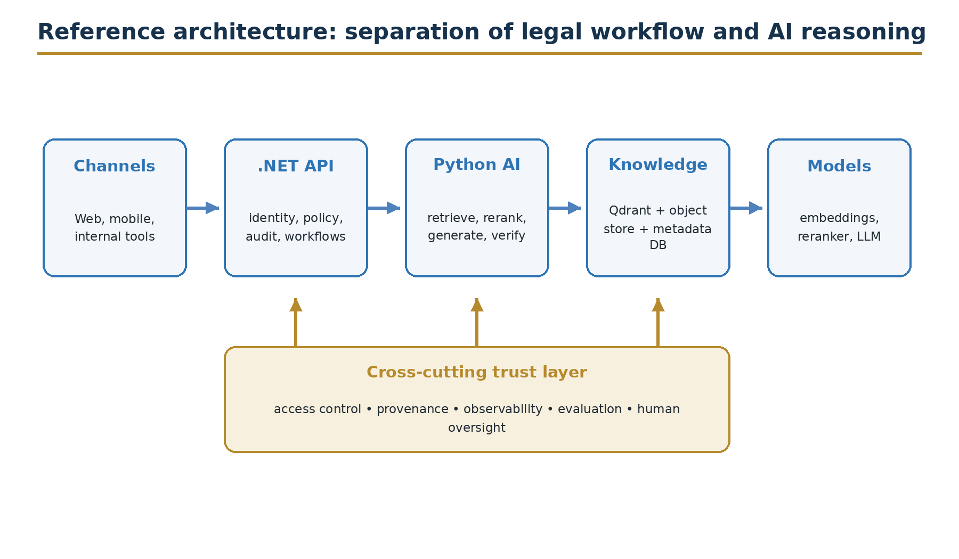
Figure 4. Reference architecture and cross-cutting trust layer.

12.1 Architecture decision
The project uses a two-service core: an ASP.NET Core institutional API and a Python AI service. This matches the user's existing .NET experience while keeping close access to the Python AI ecosystem. The boundary is not organizational fashion; it isolates stable legal workflow and security controls from faster-changing models and retrieval experiments.
Component | Primary responsibility | Must not own
.NET API | Identity, authorization, case/workspace policy, audit, rate limits, response contracts. | Model-specific prompting or raw vector operations.
Python AI service | Parsing, embeddings, retrieval, reranking, generation, verification and evaluation. | User authentication or final institutional access policy.
Metadata DB | Canonical document identity, versions, authority, access pointers and job state. | Large source binaries or vector-only truth.
Object store | Immutable sources, OCR artifacts, manifests and evidence exports. | Queryable legal relationships.
Qdrant | Vector and hybrid-search index with filterable payload. | Canonical legal record.
Queue / scheduler | Ingestion, re-indexing and evaluation work. | Unbounded autonomous decisions.

12.2 Trust boundaries
The public client, institutional gateway, AI service, model runtime and data stores are separate trust zones. Only the gateway accepts end-user identity. The AI service receives a short-lived service token and a resolved authorization context. The model runtime never receives database credentials. Retrieval results are access-filtered before prompt construction, and the response is checked again before leaving the gateway.
Public and confidential corpora should be physically or logically isolated according to risk. For early development, use only public, curated legal material. Case-specific uploads belong in a separate tenant/matter collection with explicit retention and deletion rules.

12.3 Deployment profiles
Profile | Purpose | Typical topology
Developer | Learn and build on Windows 11, 16 GB RAM. | Docker Compose; small quantized model; single-node Qdrant; local object store.
Research | Run repeatable experiments. | Versioned containers; benchmark dataset; experiment tracker; optional GPU worker.
Pilot | Controlled institutional shadow use. | Private network; managed identity; encrypted stores; separate evaluation environment.
Production | Approved operational support. | High availability, disaster recovery, formal monitoring, change and incident control.

13. Service contracts and data flow
Research role: Implementation method and reproducibility

13.1 Stable request contract
POST /v1/legal-answers
{
"question": "...",
"as_of_date": "2026-07-25",
"language": "auto",
"workspace_id": "public-nepal-law",
"authority_scope": {"courts": ["Supreme Court"], "include_secondary": false},
"response_mode": "research_brief"
}

The gateway adds the authenticated subject, roles, tenant, purpose and correlation ID. The client cannot elevate its own access by setting these fields. The AI service returns a structured draft containing claims, citations, warnings, model and index versions, and verifier results. The gateway applies final policy and produces the user response.

13.2 Response and evidence package
Field | Purpose
answer | Human-readable response after verification.
claims[] | Material propositions with supporting citation IDs.
sources[] | Document identity, passage, page, authority and source link.
warnings[] | Temporal, OCR, conflict, translation or coverage concerns.
confidence | Structured dimensions rather than one opaque score.
trace | Correlation, corpus, retrieval, prompt, model and policy versions.
review | Whether human review is required and why.

13.3 Idempotency and audit
Ingestion and re-indexing jobs are idempotent: the same artifact hash and pipeline version produce the same derived identity. Online requests receive a correlation ID. The audit event records the purpose, policy decision, source IDs, transformations, model versions, safety result and final action. Sensitive prompt text is minimized or separately protected; an audit log is not permission to duplicate confidential data.

14. Security, privacy and access control
Research role: Governance method and risk controls

14.1 Threat model
Judicial AI combines conventional application threats with model-specific threats. Attackers may attempt credential abuse, injection, corpus poisoning, prompt injection through retrieved documents, data exfiltration, model denial of service or manipulation of citations. Accidental harm is equally important: a legitimate user may receive a sealed case, a model may reveal personal data, or a stale index may present repealed law.
Threat | Control pattern | Evidence
Unauthorized retrieval | ABAC/RBAC filters applied in metadata and vector search; deny by default. | Policy tests and access logs.
Prompt injection | Treat retrieved text as data; instruction isolation; tool allowlist; output checks. | Adversarial test suite.
Corpus poisoning | Approved sources, hashes, review gates, provenance and anomaly detection. | Manifest and change approval.
Sensitive disclosure | Classification, minimization, redaction, encryption, egress filtering. | Privacy tests and incident drills.
Insecure output | Encode output, validate links/markup, never execute model text. | Application security tests.
Unbounded use | Rate limits, token budgets, timeouts, queue limits and cost alarms. | Load and abuse tests.
Supply-chain compromise | Pinned dependencies, signed images, scanning and bill of materials. | Build attestations.

14.2 Privacy-by-design
- Define the lawful and institutional purpose before collecting or processing personal data.
- Keep public legal research separate from confidential case work.
- Minimize prompts, logs and retained evidence to what the purpose requires.
- Use field-level redaction or pseudonymization where identity is not necessary.
- Apply retention schedules to uploads, prompts, feedback, caches and audit records.
- Record cross-border or third-party model processing before enabling it.
- Give authorized auditors a way to inspect use without exposing content unnecessarily.
The Constitution protects privacy of a person's residence, property, document, data and correspondence, subject to law. The Privacy Act and other applicable Nepalese rules therefore require legal review before any non-public judicial data is used. The safest first prototype uses only public sources and synthetic questions.

14.3 Identity and authorization
Use institutional identity with short-lived tokens. Roles express broad job functions; attributes express tenant, court, matter, data classification, purpose and clearance. Authorization is evaluated at request, retrieval and export time. Administrative access, corpus approval and audit review are separated so one operator cannot silently insert a document and approve its use.

15. Observability, MLOps and change control
Research role: Implementation operations and lifecycle

15.1 What to observe
Layer | Signals
Gateway | request rate, authorization result, latency, errors, rate-limit events
Retrieval | query type, candidate counts, filter drops, scores, nDCG sampling
Generation | model version, tokens, latency, refusal, structured-output failures
Verification | unsupported claims, citation failures, quotation mismatch, conflicts
Data | ingestion backlog, OCR confidence, duplicates, stale indexes, source changes
Safety | injection detections, access denials, privacy events, anomalous exports
User | expert correction, usefulness, reported error, appeal or escalation

Tracing connects one request across the .NET gateway, Python AI service, vector store, metadata database and model runtime. Metrics show aggregate health; structured logs explain discrete events. Prompt and source content should not be placed indiscriminately in telemetry.

15.2 Version and release unit
A release is the tested combination of corpus snapshot, metadata schema, chunker, embedding model, index parameters, query planner, reranker, authority weights, prompt, LLM, verifier and policy. Changing only one item can change behavior. The release manifest identifies the complete combination and points to evaluation evidence.
Promotion follows development → evaluation → shadow → approved pilot → production. Rollback restores both service code and compatible data/index versions. Emergency content correction can suppress a harmful source immediately, but the suppression must be logged and reviewed.

16. Scaling toward 50 million judgments
Research role: Scalability and future implementation
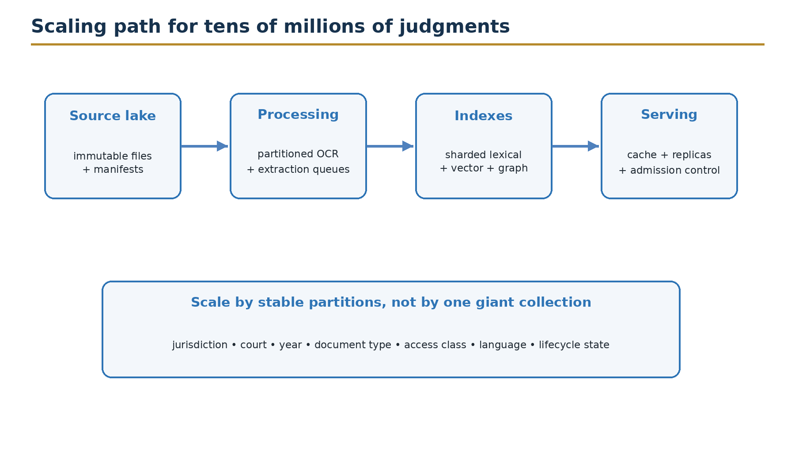
Figure 5. Scaling pattern for tens of millions of judgments.

16.1 The real scale is larger than document count
Fifty million judgments may create hundreds of millions of passages, multiple vectors per passage, several source versions and billions of citation edges. Storage estimates must include raw files, OCR outputs, metadata, indexes, replicas, snapshots and evaluation samples. The architecture therefore scales each layer independently.
Layer | Scaling method | Important control
Object storage | Immutable, content-addressed files and lifecycle tiers. | Checksum, replication and retention.
Processing | Partitioned queues, stateless workers and resumable jobs. | Idempotency and backpressure.
Metadata | Partition by stable keys; read replicas; indexed relationships. | Schema migration and consistency.
Lexical index | Shards by jurisdiction/time/type with replicas. | Cross-shard merge and relevance tests.
Vector index | Collections/shards by access and corpus boundaries; quantization after tests. | Recall loss and tenant isolation.
Citation graph | Batch edge extraction and graph/relational projections. | Identity resolution confidence.
Serving | Query routing, cache, replicas and admission control. | Freshness and invalidation.

16.2 Tiered retrieval
A large corpus should not send every query to every shard. The planner first selects jurisdiction, court, date, document type and access partition. Lightweight lexical and metadata routing identify candidate partitions. Dense and lexical retrieval run within them, followed by reranking and authority scoring. Frequently used official sources can be cached, but their version identity travels with the cache entry.

16.3 Capacity planning method
- Measure documents, pages, tokens and passages on a representative sample.
- Benchmark OCR throughput separately from embedding and indexing.
- Measure vector dimensions, index overhead, replicas and snapshot size.
- Create load profiles for public search, expert research and batch ingestion.
- Set service-level objectives for availability, freshness and p95 latency by use case.
- Run failure and recovery tests before increasing corpus or users.
Design note. Do not promise 50-million-document performance from a laptop prototype. Use the prototype to validate data contracts, ranking quality and operational measurements; use measured sample ratios to build the production capacity model.

PART V
Evaluation, Governance and Implementation
How the project demonstrates reliability and moves safely from research to use.

17. Evaluation framework
Research role: Evaluation method, experiments and results structure
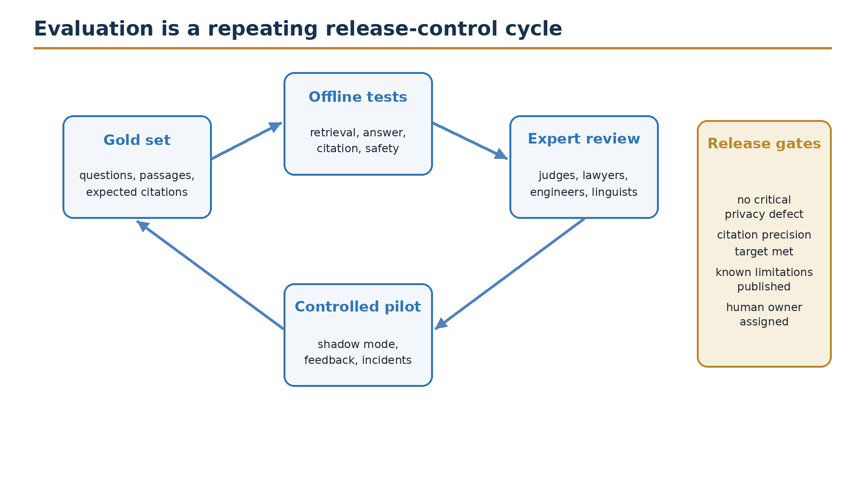
Figure 6. Evaluation as a repeating release-control cycle.

17.1 Evaluation dataset
The gold dataset should represent the tasks the system will actually support. Questions are written or validated by Nepalese legal experts and grouped by language, legal domain, court, date sensitivity, query type and difficulty. Each item includes relevant authorities, preferred passages, acceptable alternative sources, expected legal issues, prohibited conclusions and an explanation of why the item is difficult.
Avoid building the gold set from only easily searchable published cases. Include exact-citation queries, paraphrases, bilingual queries, multi-authority issues, amended law, later treatment, missing evidence and questions that should be refused. Split by document or time so the test set does not merely repeat material used to tune the system.

17.2 Retrieval metrics
Metric | Question answered | Recommended report
Recall@k | Did the system retrieve at least one required passage? | k = 5, 10, 20; by query group
MRR | How early did the first relevant result appear? | Overall and exact-reference queries
nDCG@k | Are multiple graded authorities ordered well? | Expert relevance + authority grades
Authority precision | How many top results are legally usable for the task? | Top 5 and top 10
Temporal error | How often is invalid law retrieved for the requested date? | Current vs historical queries
Coverage | Are all expected issues represented in evidence? | Per issue and per answer

17.3 Answer and citation metrics
Dimension | Operational definition
Legal correctness | Expert judgment that the answer states the governing rule and limits accurately.
Groundedness | Material claims are supported by supplied evidence.
Completeness | The answer covers the expected legal issues without irrelevant expansion.
Citation precision | Cited passage supports the linked claim.
Citation recall | Material claims that require authority have a valid citation.
Quotation accuracy | Quoted text exactly matches the identified source span.
Abstention quality | The system refuses when required and explains the evidence gap usefully.
Clarity | Non-technical readers can understand the answer without losing legal meaning.

17.4 Safety and fairness tests
- Prompt injection in the user query and inside retrieved documents.
- Cross-tenant, sealed-case and role-based access attempts.
- Personal data extraction and reconstruction from logs or outputs.
- Superseded law and later-overruled authority.
- Queries involving caste, gender, language, disability, region and economic condition.
- Unequal performance between Nepali, English and mixed-language queries.
- Denial-of-service patterns, very long documents and repeated tool calls.
- Misleading confidence, fabricated citations, modified quotations and source-link substitution.

17.5 Pilot targets and release gates
Important. The following values are proposed pilot targets, not achieved results. They must be approved by the project governance body and calibrated to risk before publication.

Gate | Illustrative target | Release consequence
Primary-source Recall@10 | ≥ 0.85 on the agreed gold set | Below target: do not enter user pilot.
Citation precision | ≥ 0.95 for material legal claims | Any critical citation class failure blocks release.
Unsupported material claims | ≤ 0.02 of evaluated material claims | Investigate and retest after correction.
Access-control leakage | 0 confirmed unauthorized disclosures | Critical blocker and incident response.
Critical prompt-injection success | 0 in approved adversarial suite | Critical blocker.
Expert acceptability | Threshold set by use case and role | Pilot scope limited to passed task groups.

17.6 Experiment design for publication
The minimum publishable experiment compares: lexical retrieval; dense retrieval; hybrid fusion; hybrid plus reranker; and the complete authority-aware system. Ablations remove temporal filtering, authority features and citation verification one at a time. Results are reported with item counts, confidence intervals or paired significance tests where appropriate, language and query-type breakdowns, latency and a qualitative error taxonomy.
Human evaluation uses a written rubric, blinded system order and at least two independent reviewers for a meaningful subset. Agreement and adjudication are reported. The paper must distinguish tuned development results from untouched test results.

18. Governance and human oversight
Research role: Governance model and institutional safeguards

18.1 Governance structure
Body / role | Responsibility
Judicial sponsor | Owns purpose, scope, acceptable risk and institutional accountability.
Legal authority group | Approves source hierarchy, authority features, use-case boundaries and legal review.
Technical team | Builds, tests, operates and documents the system.
Data steward | Approves sources, metadata, access, retention and quality correction.
Security and privacy | Performs threat, privacy and incident oversight.
Evaluation board | Approves datasets, metrics, release gates and result interpretation.
Independent reviewer | Challenges design, bias, safety and reproducibility before expansion.

18.2 Human oversight by risk level
Risk tier | Example | Required control
Low | Public source discovery and navigation. | Automated answer with visible sources and feedback.
Moderate | Legal research summary for a professional. | Expert review before reliance or external use.
High | Confidential case research or material affecting a proceeding. | Named authorized reviewer; no autonomous action.
Prohibited | Outcome, sentence, credibility or guilt recommendation. | System refuses and logs policy event.

18.3 Principles translated into controls
International judicial-AI guidance is useful when converted into engineering evidence. Fundamental rights become impact assessment and prohibited-use policy. Non-discrimination becomes subgroup evaluation and correction process. Quality and security become approved sources, provenance and secure environments. Transparency becomes source display, version records and independent audit. User control becomes non-prescriptive design, review workflow and the ability to inspect or reject the answer.
Nepal's National AI Policy 2082 provides a current national policy context, while the Constitution, Privacy Act, Electronic Transactions Act, Right to Information Act and justice-sector rules provide legal context. This handbook is not a legal compliance opinion. The implementation must maintain a live legal register and obtain Nepalese legal review before processing institutional data.

18.4 Incident and appeal process
- Capture the report, affected answer, evidence package and release version.
- Contain harm by suppressing affected output, source or model path.
- Notify the responsible owner under severity and legal requirements.
- Analyze data, retrieval, model, policy and human-process causes.
- Correct, re-evaluate and document the decision to restore service.
- Publish or communicate lessons at the level permitted by confidentiality.
Users must have a clear way to report incorrect sources, privacy concerns and harmful output. In institutional use, a human decision remains appealable through the normal legal or administrative channel; an AI explanation cannot replace procedural rights.

19. Phased implementation roadmap
Research role: Implementation framework and project plan

19.1 Phase plan
Phase | Outcome | Exit evidence
0 — Govern | Approved scope, source register, risk model and gold-set protocol. | Signed charter and non-goals.
1 — Curate | Representative public corpus with provenance, OCR and metadata. | Quality report and review sample.
2 — Retrieve | Hybrid retrieval, filters, reranker and authority features. | Offline retrieval benchmark.
3 — Answer | Grounded generation, claim citations, verifier and refusal. | Answer/citation benchmark.
4 — Pilot | Shadow-mode workflow for approved expert users. | Usability, safety and incident report.
5 — Harden | Resilient deployment, change control and monitored limited use. | Operational readiness review.
6 — Expand | Additional courts, domains, languages or confidential workflows. | New impact assessment and passed gates.

19.2 First 90-day technical backlog
Workstream | Weeks 1–4 | Weeks 5–8 | Weeks 9–12
Governance | Use cases, non-goals, source/access register | Evaluation rubric and review roles | Pilot decision and risk sign-off
Data | Acquire curated corpus and manifests | OCR, metadata and chunking | Quality sampling and version links
Retrieval | BM25 and dense baselines | Hybrid fusion and reranker | Authority features and ablations
Answering | Evidence-format prompt | Citation parser and verifier | Refusal and adversarial tests
Platform | .NET/Python contracts and local stack | Audit, traces and job queue | Release manifest and recovery test
Research | Questions, claims and protocol | Development experiments | Freeze test plan and draft methods

19.3 Deliverables by phase
- System charter and prohibited-use policy.
- Source register, immutable corpus manifest and data dictionary.
- Architecture decision records and threat model.
- Gold-set protocol, evaluation dataset and scoring scripts.
- Reproducible local prototype and versioned API contract.
- Retrieval, citation, safety and performance evaluation report.
- Human-review guide, incident runbook and model/system card.
- Conference paper package: abstract, figures, method, primary results and limitations.
- Journal extension package: related work, ablations, subgroup analysis and governance discussion.

20. Prototype stack and project structure
Research role: Reproducible implementation detail

20.1 Initial technology choices
Layer | Initial choice | Decision rule
Gateway | ASP.NET Core Web API | Use the current supported LTS/current release approved by the institution.
AI API | Python + FastAPI | Pin tested versions and generate OpenAPI contract.
Vector store | Qdrant | Retain only if relevance, filtering, scale and operations pass benchmarks.
Metadata | PostgreSQL | Canonical structured metadata and job state.
Object storage | S3-compatible store / local MinIO | Immutable source and derived artifacts.
Queue | Simple durable queue initially | Add distributed broker when measured throughput requires it.
Models | Qwen family candidate + multilingual embedding + reranker | Benchmark on Nepalese legal data; keep adapters.
Observability | OpenTelemetry-compatible traces, metrics and logs | Redact sensitive content and preserve correlation.

20.2 Repository modules
Module | Contents
gateway/ | .NET endpoints, identity, policy, rate limits, audit and response mapping
ai-service/ | query planner, retrievers, reranker, prompt, generator and verifier
ingestion/ | connectors, OCR, parsers, metadata extraction, chunking and indexing
contracts/ | OpenAPI, JSON Schema, protobuf or shared versioned contracts
evaluation/ | gold data, runners, metrics, rubrics, ablations and reports
infra/ | local compose, deployment templates, secrets references and observability
docs/ | architecture decisions, data dictionary, risk register and runbooks
tests/ | unit, contract, integration, relevance, security and end-to-end tests

20.3 Laptop-friendly prototype
On Windows 11 with 16 GB RAM, run the gateway, AI API, PostgreSQL, Qdrant and object store in containers. Use a small curated corpus and a quantized local model that fits available memory, or an approved remote model if privacy permits. Keep embedding and OCR as batch jobs. The prototype's purpose is to learn the full data and request flow, not to simulate national scale.
Start with one vertical slice: ingest a small set of official public documents, ask a controlled question, retrieve hybrid candidates, produce a cited answer, verify the citations and store an audit event. Only then add breadth.
PART VI
Research Contribution and Publication Reuse
One technical core, expressed at three levels of detail.

21. Research spine and claim ledger
Research role: Contributions, paper structure and future work

21.1 Proposed research questions
RQ1. How can legal authority, temporal validity and provenance be integrated into hybrid RAG for Nepalese judicial information?
RQ2. Does authority-aware ranking improve legally usable retrieval compared with lexical, dense and relevance-only hybrid baselines?
RQ3. How much do claim-level citation verification and structured refusal reduce unsupported legal propositions?
RQ4. What governance and technical controls are required for an auditable, privacy-preserving judicial AI assistant in Nepal?

21.2 Contribution ledger
Contribution type | Proposed contribution | Evidence needed
Conceptual | A Nepal-specific model of judicial AI as authority-constrained retrieval, not generic chat. | Problem analysis and legal-source model.
Technical | Authority-Aware Judicial RAG with hard legal filters, soft authority features and reason codes. | Algorithm, architecture and ablation.
Data | A version-aware legal metadata and passage model for bilingual Nepalese sources. | Schema, corpus protocol and quality study.
Evaluation | Pipeline metrics combining relevance, authority, temporal validity, citations and safety. | Gold set, rubrics and reproducible results.
Governance | Controls connecting constitutional rights and judicial-AI principles to system evidence. | Impact assessment, oversight and audit artifacts.
Practical | A staged .NET/Python implementation framework for constrained resources and later scale. | Prototype, performance and operational report.

21.3 Conference paper extraction
Recommended title. Design and Evaluation of an Authority-Aware, Citation-Grounded RAG Assistant for Nepalese Law

Section | Source and drafting rule
Abstract | Problem, method, dataset, primary result and contribution; write last.
1 Introduction | Use Chapters 1–2 and the problem statement.
2 Related work and context | Compress Chapter 3 and governance sources to the minimum gap.
3 Proposed method | Use Chapters 6–11; feature Figure 2 and the scoring model.
4 System and evaluation | Use Chapters 12 and 17; state datasets, baselines, metrics and protocol.
5 Results and discussion | Report measured results, ablations, errors and limitations only.
6 Governance and conclusion | Use essential controls from Chapter 18 and contributions from this chapter.

21.4 Journal article extraction
Main publication title. Judicial AI for Nepal: Technical Concept, System Architecture, and Implementation Framework

The journal article can retain the same method but add a structured related-work review, Nepalese legal and institutional context, full corpus methodology, authority-feature rationale, reproducibility detail, statistical evaluation, subgroup analysis, qualitative error taxonomy, security/governance discussion and broader limitations. It should not expand by repeating the conference paper; it should add evidence and analysis.

21.5 What remains before publication
- Legal-expert validation of the authority taxonomy, temporal rules and use-case boundaries.
- A documented, representative and ethically reviewed gold dataset.
- Implemented baselines and frozen evaluation protocol.
- Measured results with ablations, uncertainty and error analysis.
- Security, privacy and prompt-injection testing on the actual prototype.
- Clear authorship, institutional permission, data-use rights and conflict-of-interest statements.
- A literature review updated immediately before submission.
- Target-venue formatting and word/page compliance.
The handbook is therefore both a first draft and a research control document. When an engineering decision changes, update its rationale, affected claim, experiment and paper section. This prevents the paper from describing a system that was never built or evaluated.
PART A
Appendices
Reusable schemas, controls and source references for implementation and publication.

Appendix A. Glossary
Term | Meaning in this handbook
Abstention | A deliberate refusal to answer because evidence, authorization or confidence is insufficient.
Authority-aware retrieval | Ranking that considers legal validity and weight in addition to topical relevance.
BM25 | A lexical ranking method based on term frequency, rarity and document length.
Chunk / passage | A retrievable text unit linked to its source document, location and version.
Cross-encoder reranker | A model that scores the query and each candidate together for finer relevance.
Dense retrieval | Search using vector similarity between learned query and passage representations.
Embedding | A numeric vector representing learned semantic properties of text.
Evidence package | The answer, claims, source passages, metadata, warnings and version trace used for review.
Groundedness | The degree to which an answer's material claims are supported by supplied evidence.
Hallucination | Generated content that is unsupported, false or fabricated in context.
Hybrid retrieval | Combining lexical and dense search, normally followed by fusion and reranking.
LLM | A language model trained to predict text tokens and perform language tasks.
Metadata filter | A deterministic condition such as date, court, document type or access class.
Provenance | The recorded origin, identity and transformation history of data or output.
RAG | Retrieval-augmented generation: retrieve external evidence, then generate with that evidence.
Reranker | A second-stage model or rule set that reorders retrieved candidates.
Temporal validity | Whether law or authority applies at the date relevant to the question.
Vector database | An index optimized to store vectors and retrieve similar items.

Appendix B. Core metadata example
{
"document_id": "judgment:np:sc:decision-no",
"version_id": "sha256:...",
"document_type": "judgment",
"court": {"level": "supreme", "name_original": "..."},
"case": {"number": "...", "title": "...", "decision_date": "YYYY-MM-DD"},
"authority": {
"publication_status": "official",
"precedential_status": "unknown",
"later_treatment": [],
"validity_review": "pending"
},
"provenance": {"source_uri": "...", "checksum": "...", "retrieved_at": "..."},
"access": {"class": "public", "tenant": "public-nepal-law"},
"quality": {"ocr_confidence": 0.0, "review_status": "pending"}
}

The example is illustrative. Actual identifiers, allowed values and validation rules belong in a versioned JSON Schema and data dictionary. Unknown values should remain unknown rather than being inferred without evidence.

Appendix C. Evaluation item template
Field | Content
item_id | Stable identifier and dataset version
question | Original user-style query
language | Nepali, English or mixed
as_of_date | Date relevant to legal validity
task_type | Provision, precedent, comparison, procedure, historical or refusal
gold_authorities | Required and acceptable alternative sources
gold_passages | Pinpoint evidence spans
expected_issues | Legal issues or answer elements
prohibited_claims | Claims the evidence does not justify
difficulty_tags | OCR, bilingual, amendment, conflict, later treatment, long context
reviewers | Independent experts and adjudication status

Appendix D. Minimum release checklist

Purpose and governance
- ☐ Approved use case, users, non-goals and prohibited decisions.
- ☐ Named owner, legal reviewer, data steward and incident contact.
- ☐ Current legal/policy register and impact assessment.

Data
- ☐ Approved sources, hashes, access classes and retention.
- ☐ OCR and metadata quality sample reviewed.
- ☐ Version and temporal status represented or visibly unknown.

Retrieval and generation
- ☐ Baselines, authority model and context policy documented.
- ☐ Claim-level citations and verifier enabled.
- ☐ Refusal conditions tested.

Security and privacy
- ☐ Threat model, access tests and injection tests passed.
- ☐ Secrets, encryption, dependency and backup controls verified.
- ☐ No confirmed unauthorized disclosure in release testing.

Evaluation and operations
- ☐ Frozen gold set, metrics and release thresholds approved.
- ☐ Release manifest, observability and rollback tested.
- ☐ Known limitations and human-review instructions published.

Appendix E. Initial risk register
Risk | Likelihood | Impact | Primary mitigation | Owner
Unsupported legal claim | Medium | High | Claim verifier, citations, expert review | AI lead
Superseded authority | Medium | High | Version model, as-of date, warnings | Legal/data
Private-data disclosure | Low–Med | Critical | Public-only prototype, ABAC, redaction | Privacy
Corpus poisoning | Low–Med | High | Approved sources, hashes, review | Data steward
Unequal language quality | High | High | Bilingual gold set and subgroup gates | Evaluation
Model/vendor lock-in | Medium | Medium | Adapters, contracts, reproducible benchmarks | Architect
Operator misuse | Medium | High | Training, purpose controls, audit and sanctions | Sponsor
Scale cost overrun | Medium | Medium | Sampling, capacity model, tiered retrieval | Platform

Appendix F. Authoritative and technical source guide
This first-draft source guide prioritizes official Nepalese sources, international public-sector standards and primary technical papers. URLs were checked on 25 July 2026. Before publication, confirm the latest official versions and format references for the target venue.
[1] Nepal Law Commission. The Constitution of Nepal (Second Amendment English text). https://lawcommission.gov.np/content/13437/nepal-s-constitution/
[2] Nepal Law Commission. The Privacy Act, 2075. https://lawcommission.gov.np/content/12261/12261-the-privacy-act-2075/
[3] Nepal Law Commission. The Electronic Transactions Act, 2063. https://lawcommission.gov.np/content/13397/
[4] Nepal Law Commission. Right to Information Act, 2064. https://lawcommission.gov.np/content/13400/rights-of-information-act--2064/
[5] Ministry of Communication and Information Technology, Nepal. National Artificial Intelligence Policy, 2082. https://mocit.gov.np/content/13111/nationalai---policy---/
[6] Supreme Court of Nepal. Official website and judicial information services. https://supremecourt.gov.np/
[7] Nepal Kanoon Patrika. Official precedent search and annual browsing. https://nkp.gov.np/
[8] Supreme Court of Nepal. Fourth Five-Year Strategic Plan of Judiciary. https://supremecourt.gov.np/web/assets/downloads/strategic/4th%20strategic%20plan%20of%20judiciary.pdf
[9] CEPEJ. European Ethical Charter on the use of AI in judicial systems and their environment. https://www.coe.int/en/web/cepej/cepej-european-ethical-charter-on-the-use-of-artificial-intelligence-ai-in-judicial-systems-and-their-environment
[10] European Union. Regulation (EU) 2024/1689 (Artificial Intelligence Act). https://eur-lex.europa.eu/eli/reg/2024/1689/oj
[11] NIST. Artificial Intelligence Risk Management Framework (AI RMF 1.0). https://nvlpubs.nist.gov/nistpubs/ai/nist.ai.100-1.pdf
[12] NIST. AI RMF: Generative Artificial Intelligence Profile (NIST AI 600-1). https://doi.org/10.6028/NIST.AI.600-1
[13] ISO. ISO/IEC 42001:2023—Artificial intelligence management systems. https://www.iso.org/standard/42001
[14] ISO. ISO/IEC 23894:2023—Guidance on AI risk management. https://www.iso.org/standard/77304.html
[15] OWASP. Top 10 for LLM Applications 2025. https://genai.owasp.org/llm-top-10/
[16] Lewis et al. Retrieval-Augmented Generation for Knowledge-Intensive NLP Tasks. NeurIPS 2020. https://arxiv.org/abs/2005.11401
[17] Karpukhin et al. Dense Passage Retrieval for Open-Domain Question Answering. EMNLP 2020. https://arxiv.org/abs/2004.04906
[18] Khattab and Zaharia. ColBERT: Efficient and Effective Passage Search via Contextualized Late Interaction. SIGIR 2020. https://arxiv.org/abs/2004.12832
[19] Chen et al. BGE M3-Embedding: Multi-Linguality, Multi-Functionality, Multi-Granularity. ACL Findings 2024. https://arxiv.org/abs/2402.03216
[20] Qdrant. Hybrid queries, filtering and vector-search documentation. https://qdrant.tech/documentation/search/hybrid-queries/
[21] Microsoft. ASP.NET Core API overview. https://learn.microsoft.com/aspnet/core/fundamentals/apis
[22] FastAPI. Deployment guidance. https://fastapi.tiangolo.com/deployment/
[23] OpenTelemetry. Documentation for traces, metrics and logs. https://opentelemetry.io/docs/
[24] UNESCO. Recommendation on the Ethics of Artificial Intelligence. https://www.unesco.org/en/artificial-intelligence/recommendation-ethics
[25] OECD. OECD AI Principles. https://oecd.ai/en/ai-principles

Appendix G. Draft-control record
Version | Date | Purpose | Next controlled update
v0.1 | 25 July 2026 | First complete technical and research draft. | Legal expert review, implementation evidence and measured evaluation.

End of first draft.

